Fresh Fruit & Vegetable Program (FFVP)
Application for Funding SY 2024-2025

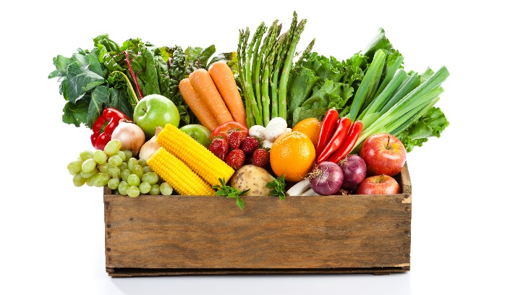

The Fresh Fruit and Vegetable Program (FFVP) provides children in participating elementary schools with a variety of free fresh fruits and vegetables. This grant opportunity must be applied for annually. The level of funds provided to any one school depends on the school’s enrollment and the available funding provided by the USDA.

Those schools selected for participation will receive additional funds to offer free fresh fruits and vegetables to elementary students in one or more areas at times other than meal service periods. The majority of funds provided to schools must be used for the purchase of fruits and vegetables.

Priority will be given to schools with the highest percentage of students eligible for reduced price or free school meals. This is the key selection criterion, which ensures that the Program benefits low-income children that generally have fewer opportunities to consume fresh fruits and vegetables on a regular basis.

To apply for FFVP funding in school year 2024-2025, return this application via email to aanderson@ksde.org or mail to:

Child Nutrition & Wellness
Kansas State Department of Education
Landon State Office Building
900 SW Jackson St, Suite #251
Topeka, KS 66612

Applications must be received or postmarked Friday, May 24, 2024
Direct questions to Arleen Anderson:
aanderson@ksde.org OR 785-296-2276

Part A. Application and Eligibility Requirements

- FFVP funds will be provided only to Kansas schools that participate in the National School Lunch Program or the School Breakfast Program.

- Participating sites will be selected using established criteria to include percent of students eligible for reduced price or free meals based on the 2023-24 Principal’s Building Report, past performance in the FFVP, results of previous audits, administrative review findings, Federal awarding agency monitoring.

- All FFVP activities must be implemented in Kansas schools during the 2024-2025 academic year. The program must start in October 2024 through September 2025.

- Applicant must agree to use the Fresh Fruit and Vegetable Program Handbook for Schools to guide FFVP implementation, participate in required training, return all required agreements and reports to KSDE, and track, budget, and not exceed awarded funds.

- Late applications will not be accepted unless an inadequate number of applications are received by the deadline date.

- Incomplete applications or those missing signatures will be disqualified.

- Submission of a FFVP application does not guarantee selection for participation.

Part B. School Information

Complete a separate application for each school.

School District or Private School Number and Name (USD, X0, etc.):
School’s Name:
Grade levels enrolled in the school:
Total Enrollment (based on the 2023-2024 Principal’s Building Report):
Percentage of students eligible for free/reduced price meals:

Part C. Contact Person Information

Name: Job Title:
E-mail address: Work Phone Number:
Mailing Address:
City, State, Zip:

Part D. Implementation Plans
- Please describe plans for implementation of the FFVP in your school if selected for participation (include in your description 1) method of delivery, 2) time of day the fruits and vegetables will be provided, and 3) the number of times per week you plan to provide the program to students).

- Will service of the fresh fruits and vegetables be conducted at a time separate from service of the School Breakfast or National School Lunch Programs?
Yes No

- Will service of the fresh fruits and vegetables be conducted separate from times that other snacks (for example, those brought from home) are being consumed?
Yes No

- If this school has participated in the FFVP previously, is the plan described in question 1 a substantial change in implementation?
Yes No

- Please list the person(s) responsible for administering the program at this school.

- If the school has participated in the FFVP previously, how many years has the person listed in question 5 been responsible for administering the program?

- Does the school applying for this program receive any other Federal award money (such as Title funds)?
Yes No

If yes, please list the funds this school has received.

- Has the school identified any potential partners that have committed to provide non-federal resources to support the FFVP? (Examples – volunteer labor hours, discounted or free produce, or donated supplies necessary to run the FFVP)
Yes No

If yes, list the name of each partner and describe the resource(s) the partner will provide to support the FFVP:

- How will the students in your school benefit from this program?

- How will nutrition education be linked to the service of fresh fruits and vegetables?

- How will you involve the entire school community (students, teachers, administrators, food service staff, custodial staff, parents, etc.) in the FFVP?

- What do you anticipate being your major barrier to success with the FFVP and how will you overcome it?
- Why should your school be selected for the FFVP?

Part E. School Health Initiatives

- Has this school/district participated in any other programs to improve student health/wellness during the last three years? (Examples – Body Venture, USDA Team Nutrition curriculums, etc.)
Yes No

If so, please name and briefly describe the program(s):

Part F. Agreement and Signature

We have reviewed this application and attest to the accuracy of the information provided. If selected, we agree to implement the Fresh Fruit and Vegetable Program as outlined in Section A of this application and in a manner consistent with the policies and procedures established by USDA. Further, we agree to participate in any USDA-sponsored evaluations and to provide information requested by the specified deadlines.

District Superintendent |  | Date
School Principal |  | Date
School Food Service Manager |  | Date
Authorized Representative for School Nutrition Program |  | Date

To apply for FFVP funding in school year 2024-2025, return this application by May 24, 2024, via email to aanderson@ksde.org or mail to:

Child Nutrition & Wellness
Kansas State Department of Education
Landon State Office Building
900 SW Jackson St, Suite #251
Topeka, KS 66612

Applicants will receive an email upon receipt of their application.
If you do not hear back within a week of submitting your application, contact Arleen Anderson, aanderson@ksde.org or 785-296-2276, to ensure your application was received.

In accordance with federal civil rights law and U.S. Department of Agriculture (USDA) civil rights regulations and policies, this institution is prohibited from discriminating on the basis of race, color, national origin, sex (including gender identity and sexual orientation), disability, age, or reprisal or retaliation for prior civil rights activity.
Program information may be made available in languages other than English. Persons with disabilities who require alternative means of communication to obtain program information (e.g., Braille, large print, audiotape, American Sign Language), should contact the responsible state or local agency that administers the program or USDA’s TARGET Center at (202) 720-2600 (voice and TTY) or contact USDA through the Federal Relay Service at (800) 877-8339.
To file a program discrimination complaint, a Complainant should complete a Form AD-3027, USDA Program Discrimination Complaint Form which can be obtained online at: https://www.usda.gov/sites/default/files/documents/ad-3027.pdf, from any USDA office, by calling (866) 632-9992, or by writing a letter addressed to USDA. The letter must contain the complainant’s name, address, telephone number, and a written description of the alleged discriminatory action in sufficient detail to inform the Assistant Secretary for Civil Rights (ASCR) about the nature and date of an alleged civil rights violation. The completed AD-3027 form or letter must be submitted to USDA by:
(1) mail
U.S. Department of Agriculture
Office of the Assistant Secretary for Civil Rights
1400 Independence Avenue, SW
Washington, D.C. 20250-9410; or
(2) fax:
(833) 256-1665 or (202) 690-7442; or
(3) email:
program.intake@usda.gov
This institution is an equal opportunity provider.

