Healthier Kansas Menus

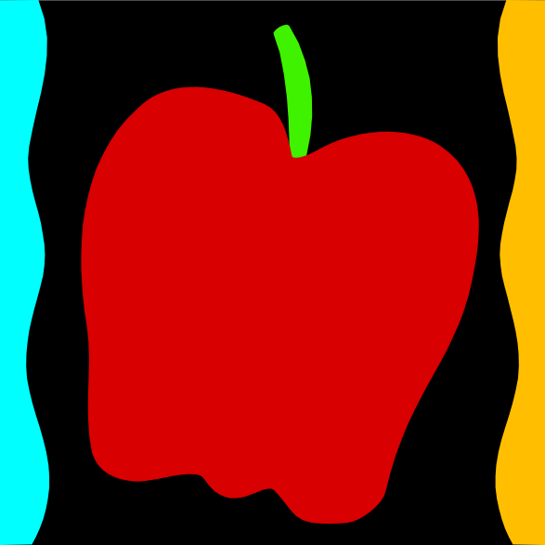

FALL WEEK 2 – DAILY PRODUCTION RECORDS

Child Nutrition & Wellness, Kansas State Department of Education

Updated September 2014

 | Child Nutrition & Wellness  Kansas State Department of Education  900 SW Jackson St. Suite 251  Topeka, Kansas 66612  785-296-2276  FAX: 785-296-0232  www.kn-eat.org

For further information about this publication, please contact Cheryl Johnson, Director, Child Nutrition & Wellness at the phone number above or email: csjohnson@ksde.org.

The U.S. Department of Agriculture prohibits discrimination against its customers, employees, and applicants for employment on the bases of race, color, national origin, age, disability, sex, gender identity, religion, reprisal, and where applicable, political beliefs, marital status, familial or parental status, sexual orientation, or all or part of an individual's income is derived from any public assistance program, or protected genetic information in employment or in any program or activity conducted or funded by the Department. (Not all prohibited bases will apply to all programs and/or employment activities.)
If you wish to file a Civil Rights program complaint of discrimination, complete the USDA Program Discrimination Complaint Form, found online at http://www.ascr.usda.gov/complaint_filing_cust.html, or at any USDA office, or call (866) 632-9992 to request the form. You may also write a letter containing all of the information requested in the form. Send your completed complaint form or letter to us by mail at U.S. Department of Agriculture, Director, Office of Adjudication, 1400 Independence Avenue, S.W., Washington, D.C. 20250-9410, by fax (202) 690-7442 or email at program.intake@usda.gov.
Individuals who are deaf, hard of hearing or have speech disabilities may contact USDA through the Federal Relay Service at (800) 877-8339; or (800) 845-6136 (Spanish).
USDA is an equal opportunity provider and employer.
The following person has been designated to handle inquiries regarding the non-discrimination policies at the Kansas State Department of Education: Office of General Counsel, Landon State Office Building, 900 SW Jackson St, Suite #102, Topeka, KS 66612, (785)296-3201.

This publication has been funded at least in part with Federal funds from the U.S. Department of Agriculture, Food and Nutrition Service. The contents of this publication do not necessarily reflect the views or policies of the Department, nor does mention of trade names, commercial products, or organizations imply endorsement by the U.S. Government.

Healthier Kansas Menus recipes were developed by Child Nutrition & Wellness, Kansas State Department of Education or adapted from the following sources:
- Food for Fifty, Ninth Edition (1989) Grace Shugart, Mary Molt.
- Healthier Kansas Menus – Breakfast, Child Nutrition & Wellness, Kansas State Department of Education
- Iowa Gold Star Cycle Menus, Iowa Department of Education
- Menus that Move, Ohio Department of Education.
- Fruit and Veggie Quantity Cookbook, New Hampshire Department of Health and Human Services.
- Preparing Whole Grain Foods, Child Nutrition & Wellness, Kansas State Department of Education
- Singing the Praises of Beans & Legumes, Child Nutrition & Wellness, Kansas State Department of Education
- USDA Recipes for Schools, U.S. Department of Agriculture, Food & Nutrition Service, Child Nutrition Programs, 2006.
- USD 225 Fowler
- USD 234 Fort Scott
- USD 267 Renwick
- USD 306 Southeast of Saline
- USD 308 Hutchinson
- USD 320 Wamego
- USD 349 Stafford
- USD 364 Marysville
- USD 503 Parsons
- USD 512 Shawnee Mission

Thank you to the following schools for assisting with menu development and recipe testing:
- Logan Elementary School – USD 345 Seaman
- St. Joseph Catholic School – Mt. Hope, KS
- Winfield Scott Elementary School – USD 234 Fort Scott

Menus for the Week

PLEASE NOTE:
Milk choice includes a choice of non-fat (flavored or unflavored) or 1% (unflavored) milk.
Reduced fat dressing is served with salads and fresh vegetables.
All Grain items are Whole Grain Rich.

MONDAY | TUESDAY | WEDNESDAY | THURSDAY | FRIDAY | Weekly Nutrient Averages
 |  |  |  |  |  | K-5 | 6-8 | 9-12
Mini Meatball Sub  Ranch Potato Wedges  Tossed Salad  Fresh Peach  Fruit Choice - Canned  Milk Choice | BBQ Chicken Drumstick  Whole Wheat Roll  & Jelly  Baked Beans  Creamy Cole Slaw  Apricot Halves  Fruit Choice - Fresh  Milk Choice | White Chicken Chili  Cornbread Muffin  Cherry Tomatoes  Cucumber Slices  Fresh Banana  Fruit Choice - Canned  Milk Choice | Cheese Pizza  Broccoli Florets  Fresh Baby Carrots  Fresh Citrus Fruit Cup  Fruit Choice - Canned  Milk Choice | Biscuits & Gravy  Sausage Patty  (6-12)  Fresh Sugar Snap Peas  Hash Brown Patty  Fresh Plum  Fruit Choice - Canned  Milk Choice | Calories  Sodium (mg)  % of Total Calories from Sat. Fat | 640  1078  5.6% | 654  1107  5.8% | 839  1302  5.6%

Recipes for the Week

Day | Recipe Name | Recipe Number | HKM Recipe  Page Number
Monday | Mini Meatball Sub  Ranch Potato Wedges  Tossed Salad | 132  131  74 | 25  56  62
Tuesday | BBQ Chicken Drumstick  Whole Wheat Roll  Baked Beans  Creamy Cole Slaw | 130  877  188  20 | 2  91  50  52
Wednesday | White Chicken Chili  Cornbread Muffin | 128  127 | 43  69
Thursday | Fresh Citrus Fruit Cup | 134 | 53
Friday | Biscuits & Sausage Gravy  Angel Biscuits | 118  120 | 7  63

Abbreviations
Abbreviation | What it Means | Abbreviation | What it Means
HKM | Healthier Kansas Menus | Tbsp | tablespoon
EP | edible portion | tsp | teaspoon
AP | as purchased | CCP | Critical Control Point
fl | fluid | PC | portion controlled *
oz | ounce | w/ | with
lb | pound | M/MA | meat/meat alternate
gm | gram
mg | milligram
* For example, purchase pre-portioned servings of condiments.

Portion Guide
Ladles & Spoodles | Scoops
1 fl oz = 2 Tbsp | #50 = 3 3/4 tsp
2 fl oz = 1/4 cup | #40 = 1 2/3 Tbsp
3 fl oz = 3/8 cup | #30 = 2 Tbsp
4 fl oz = 1/2 cup | #20 = 3 1/3 Tbsp
6 fl oz = 3/4 cup | #16 = 1/4 cup
8 fl oz = 1 cup | #12 = 1/3 cup
 | #8 = 1/2 cup
 | #6 = 2/3 cup

Purchasing, Preparation & Serving Instructions
Week 2 – Monday
Menu Item | Purchasing & Preparation | Serving
Mini Meatball Sub | - Prepare HKM Recipe 132, Mini Meatball Sub.  - Purchase pre-cooked meatballs where 5 meatballs equal 2 M/MA (or use number of meatballs needed to provide 1 M/MA to K-8 and 2 M/MA to 9-12), and each meatball has no more than 60 mg sodium and no more than 2 g fat. If product is not Child Nutrition (CN) labeled, obtain a Product Formulation Statement.  - Refer to Fruit & Vegetable Order Guide for amount spaghetti sauce needed.  - CCP: Hold for hot service at 135°F or above. | K-8: 1 sandwich (made with 3 meatballs)  12: 1 sandwich (made with 5 meatballs)
Ranch Potato Wedges | - Prepare HKM Recipe 131, Ranch Potato Wedges.  - Purchase frozen, ovenable, unseasoned potato wedges. Choose skin-on wedges for additional fiber. Refer to Fruit & Vegetable Order Guide for amount needed.  - Weigh out each portion size indicated and use as a sample.  - CCP: Hold for hot service at 135°F or above. | K-12: ½ cup
Tossed Salad | - Prepare HKM Recipe 74, Tossed Salad.  - Refer to Fruit & Vegetable Order Guide for amount needed.  - CCP: Refrigerate and hold at 41°F or below for cold service. | K-12: 1 cup
Peach, fresh | - Refer to Fruit & Vegetable Order Guide for amount needed.  - With gloved hands, wash peaches.  - Cover and refrigerate or store at room temperature until serving.  - CCP: Refrigerate and hold at 41°F or below for cold service | K-12: 1 each
Fruit Choice, canned | - Select an additional fruit choice to offer on the menu. The serving(s) offered must credit as ½ cup of fruit, to meet the minimum daily requirement, for grades 9-12.  *Note: The fruit choice is encouraged for grades K-5 and 6-8, but not required. The fruit choice is not included in the nutrient analysis for grades K-5 and 6-8. | K-8: N/A*  9-12: ½ cup
Milk | - Provide a variety of milk. May be 1% fat (unflavored) or skim (flavored or unflavored).  - CCP: Refrigerate and hold at 41°F or below for cold service. | K-12: 8 fl oz
Ranch Dressing, Reduced Fat | - Purchase or prepare Ranch dressing containing no more than 6 gm of fat  per 1 fl oz. Purchase .8 gallons for every 100 1 fl oz portions.  - CCP: Refrigerate and serve at 41°F or below if school-prepared dressing is used. | K-12: 1 fl oz or 2 Tbsp

Pre-preparation for Week 2 – Tuesday: Chill apricots. Thaw chicken under refrigeration.
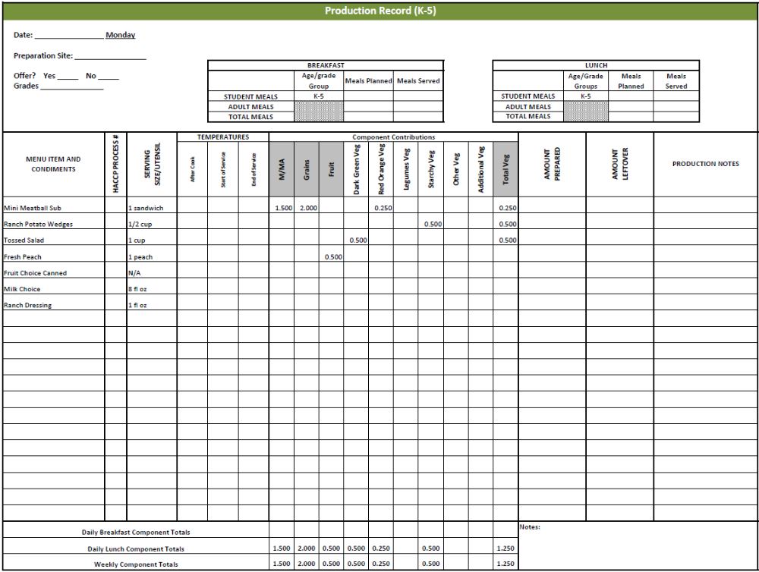
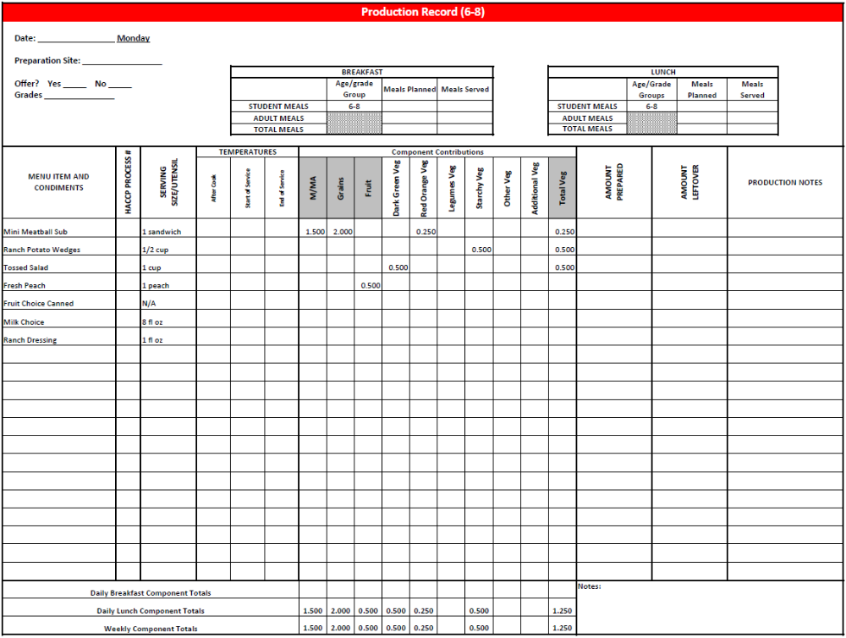
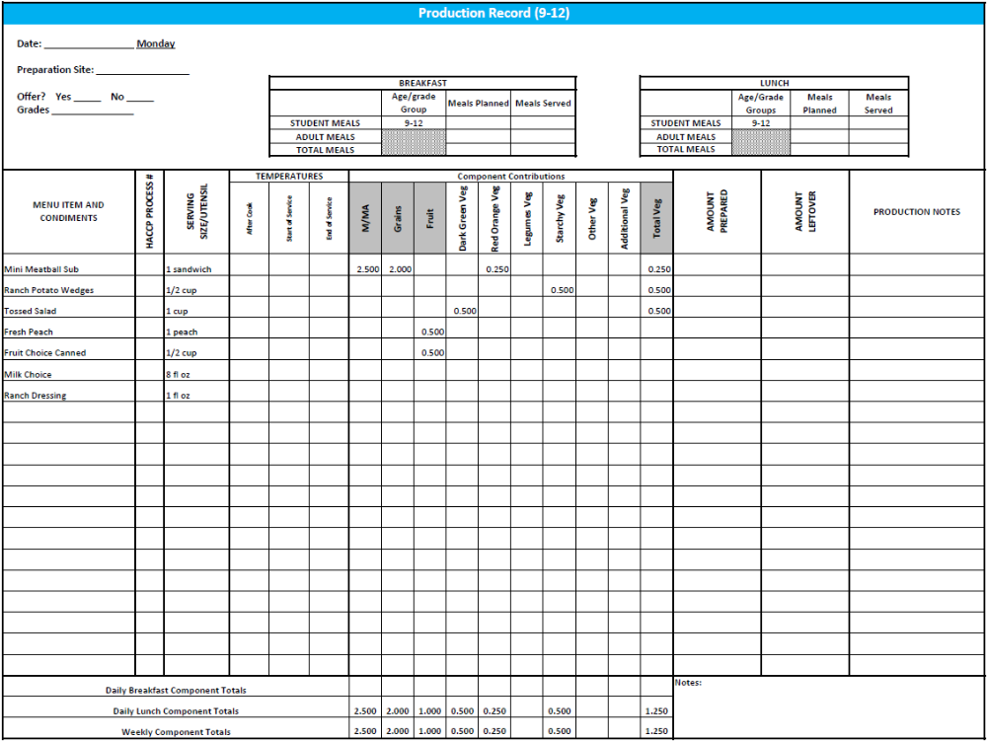
Purchasing, Preparation & Serving Instructions
Week 2 - Tuesday
Menu Item | Purchasing & Preparation | Serving
BBQ Chicken | - Prepare HKM Recipe 130, BBQ Chicken.  - Purchase raw, frozen chicken legs with skin that provide 1.5 oz equivalent M/MA per serving OR purchase a CN labeled, pre-cooked product that provides 1.5 oz equivalent M/MA per serving and prepare according to manufacturer’s instructions. If product is not Child Nutrition (CN) labeled, obtain a Product Formulation Statement.  - CCP: Hold for hot service at 135°F or above. | K-8: 1 drumstick  9-12: 2 drumsticks
Whole Wheat Roll | - Prepare HKM Recipe 877, Whole Wheat Rolls, Bread Sticks and Buns, 51%. | K-8: 1 each  9-12: 2 each
Baked Beans | - Prepare HKM Recipe 188, Baked Beans or purchase canned baked beans.  - Refer to Fruit & Vegetable Order Guide for amount needed.  - CCP: Hold for hot service at 135°F or above. | K-12: ½ cup
Creamy Cole Slaw | - Prepare HKM Recipe 20, Creamy Cole Slaw.  - Refer to Fruit & Vegetable Order Guide for amount needed.  - Purchase pre-shredded green cabbage.  - CCP: Hold for cold service at 41°F or below. | K-12: ½ cup
Apricot Halves | - Purchase apricot halves packed in light syrup or 100% juice. Refer to Fruit & Vegetable Order Guide for amount needed.  - Chill cans overnight. Wipe can tops clean before opening.  - Drain, cover and refrigerate until serving.  - Serve with slotted utensil.  - CCP: Refrigerate and hold at 41°F or below for cold service. | K-12: ½ cup
Fruit Choice, fresh | - Select an additional fruit choice to offer on the menu. The serving(s) offered must credit as ½ cup of fruit, to meet the minimum daily requirement, for grades 9-12.  *Note: The fruit choice is encouraged for grades K-5 and 6-8, but not required. The fruit choice is not included in the nutrient analysis for grades K-5 and 6-8. | K-8: N/A*  9-12: ½ cup

Continued on next page

Purchasing, Preparation & Serving Instructions
Week 2 – Tuesday, continued
Menu Item | Purchasing & Preparation | Serving
Milk | - Provide a variety of milk. May be 1% fat (unflavored) or skim (flavored or unflavored).  - CCP: Refrigerate and hold at 41°F or below for cold service. | K-12: 8 fl oz
Jelly | - Purchase .5 oz packets or purchase in bulk container. | K-12: ½ oz each  or 1 Tbsp

Pre-preparation for Week 2 - Wednesday: Thaw chicken under refrigeration.
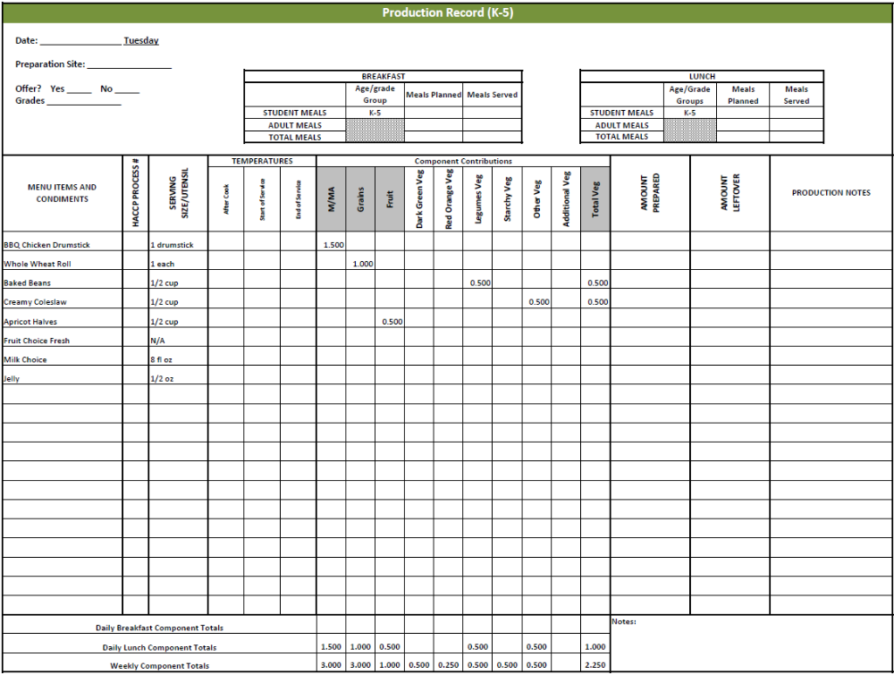
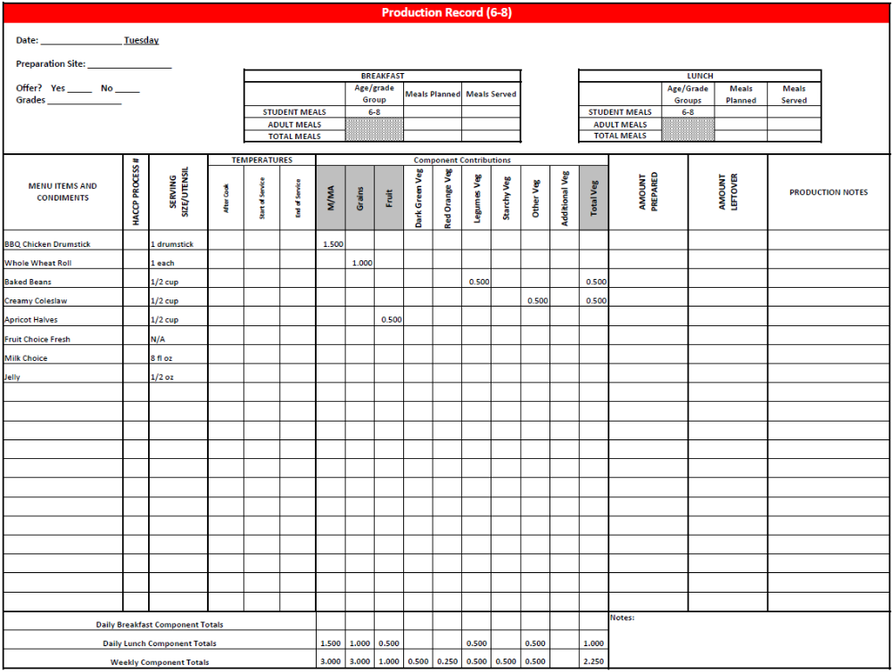
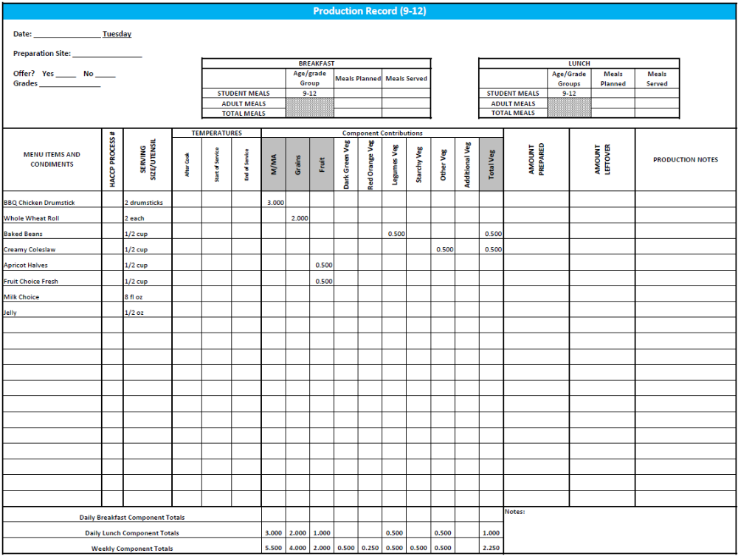

Notes

Purchasing, Preparation & Serving Instructions
Week 2 – Wednesday
Menu Item | Purchasing & Preparation | Serving
White Chicken Chili | - Prepare HKM Recipe 128, White Chicken Chili.  - Refer to Fruit & Vegetable Order Guide for amount onions, great northern beans, and green chili peppers needed.  - CCP: Hold for hot service at 135°F or higher. | K-12: ¾ cup
Cornbread Muffins | - Prepare HKM Recipe 127, Cornbread Muffins. | K-8: 1 muffin  9-12: 2 muffins
Cherry Tomatoes | - Refer to Fruit & Vegetable Order Guide for amount needed.  - With gloved hands, wash and stem tomatoes.  - CCP: Refrigerate and hold at 41°F or below for cold service. | K-8: 3 tomatoes (1/4 cup)  9-12: 6 tomatoes (½ cup)
Cucumber Slices | - Refer to Fruit & Vegetable Order Guide for amount needed.  - With gloved hands, wash and slice cucumbers.  - CCP: Refrigerate and hold at 41°F or below for cold service. | K-12: ¼ cup
Banana, Fresh | - Refer to Fruit & Vegetable Order Guide for amount needed.  - Use gloved hands. Dip cut ends in lemon, orange or pineapple juice or antioxidant solution to preserve color. | K-12: 1 each
Fruit Choice, canned | - Select an additional fruit choice to offer on the menu. The serving(s) offered must credit as ½ cup of fruit, to meet the minimum daily requirement, for grades 9-12.  *Note: The fruit choice is encouraged for grades K-5 and 6-8, but not required. The fruit choice is not included in the nutrient analysis for grades K-5 and 6-8. | K-8: N/A*  9-12: ½ cup
Milk | - Provide a variety of milk. May be 1% fat (unflavored) or skim (flavored or unflavored).  - CCP: Refrigerate and hold at 41°F or below for cold service. | K-12: 8 fl oz
Ranch Dressing, Reduced Fat | - Purchase or prepare Ranch dressing containing no more than 6 gm of fat  per 1 fl oz. Purchase .8 gallons for every 100 1 fl oz portions.  - CCP: Refrigerate and serve at 41°F or below if school-prepared dressing is served. | K-12: 1 fl oz or 2 Tbsp

Pre-preparation for Week 2 – Thursday: Prepare Fresh Citrus Fruit Cup.
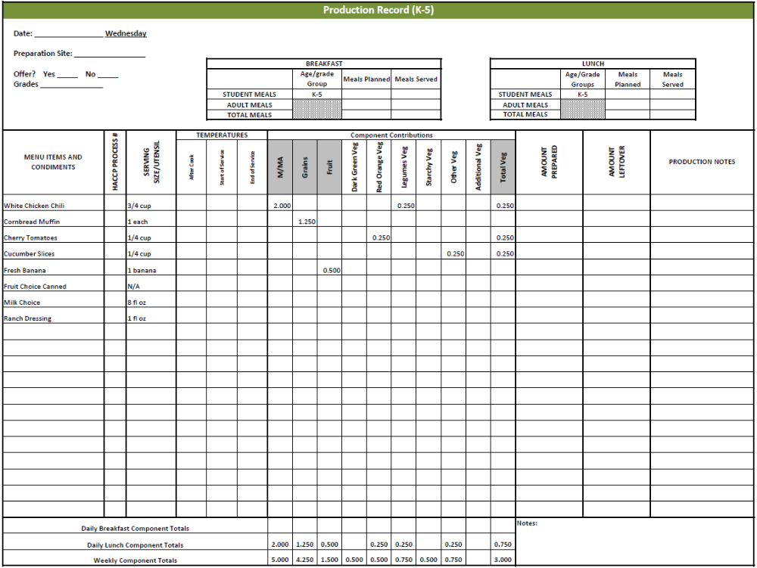
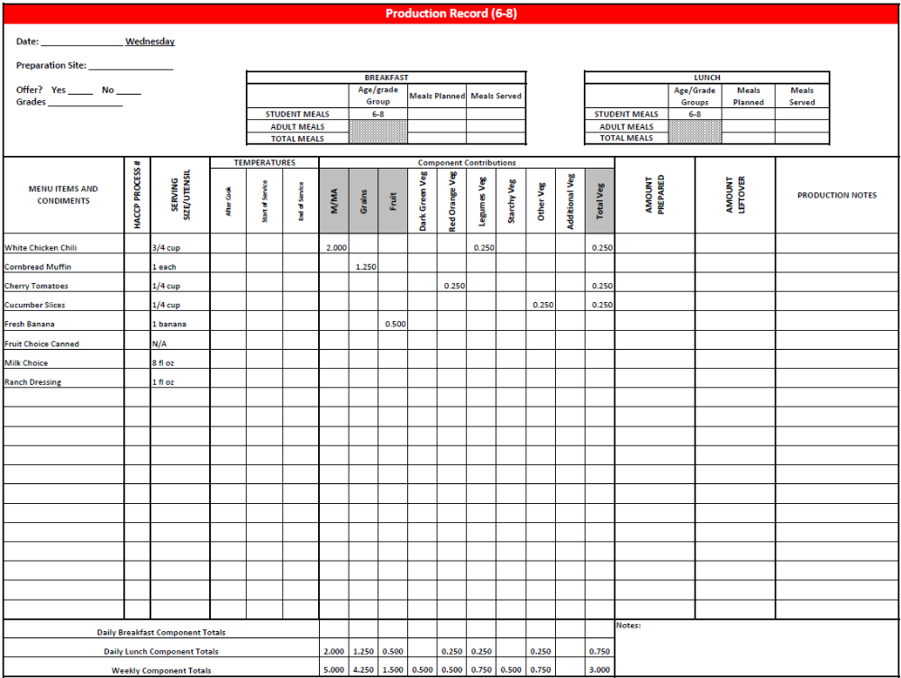
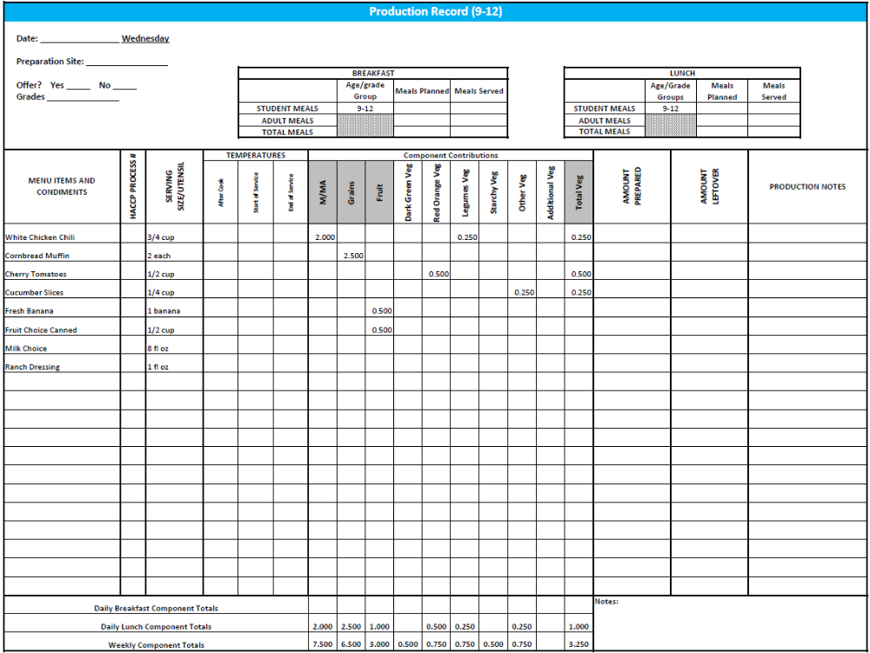
Purchasing, Preparation & Serving Instructions
Week 2 - Thursday
Menu Item | Purchasing & Preparation | Serving
Cheese Pizza | - Purchase pre-prepared cheese pizza that provides 2 oz equivalent M/MA, 2 oz equivalent Grains, and 0.125 cup vegetables, RO; no more than 8 gm of fat; and no more than 600 mg sodium per serving. If product is not Child Nutrition (CN) labeled, obtain a Product Formulation Statement.  - Heat in oven according to manufacturer’s instructions.  - CCP: Hold for hot service at 135°F or above. | K-12: 1 piece
Broccoli Florets | - Refer to Fruit & Vegetable Order Guide for amount needed. Purchase fresh broccoli florets, ready to serve.  - Wash broccoli.  - Cover and refrigerate until serving.  - CCP: Refrigerate and hold at 41°F or below for cold service. | K-12: ½ cup
Carrots, baby, fresh | - Refer to Fruit & Vegetable Order Guide for amount needed.  - Handle with gloved hands or serving utensils. Cover and refrigerate until serving.  - Weigh or count number needed per portion.  - CCP: Refrigerate and hold at 41°F or below for cold service. | K-12: ½ cup
Fresh Citrus Fruit Cup | - Prepare HKM Recipe 134, Fresh Citrus Fruit Cup.  - Refer to Fruit & Vegetable Order Guide for amount needed.  - CCP: Hold for cold service at 41°F or below. | K-12: ½ cup
Fruit Choice, canned | - Select an additional fruit choice to offer on the menu. The serving(s) offered must credit as ½ cup of fruit, to meet the minimum daily requirement, for grades 9-12.  *Note: The fruit choice is encouraged for grades K-5 and 6-8, but not required. The fruit choice is not included in the nutrient analysis for grades K-5 and 6-8. | K-8: N/A*  9-12: ½ cup
Milk | - Provide a variety of milk. May be 1% fat (unflavored) or skim (flavored or unflavored).  - CCP: Refrigerate and hold at 41°F or below for cold service. | K-12: 8 fl oz
Ranch Dressing, Reduced Fat | - Purchase or prepare Ranch dressing containing no more than 6 gm of fat  per 1 fl oz. Purchase .8 gallons for every 100 1 fl oz portions.  - CCP: Refrigerate and serve at 41°F or below if school-prepared dressing is served. | K-12: 1 fl oz or 2 Tbsp

Pre-preparation for Week 2 - Friday: Thaw sausage under refrigeration.
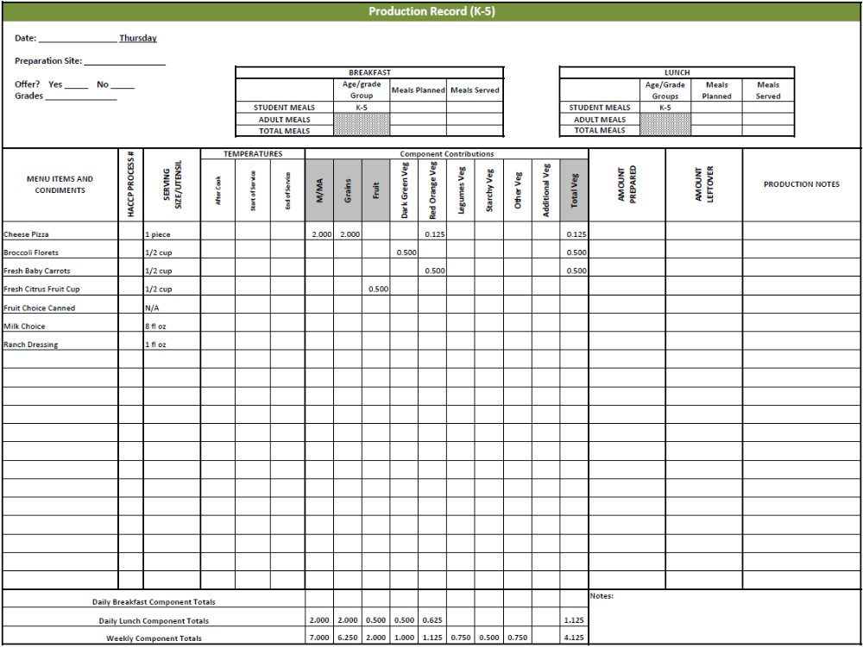
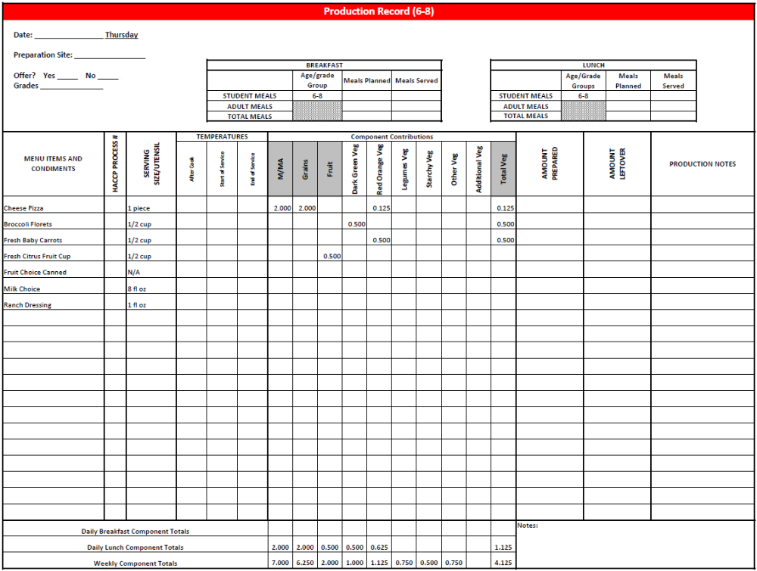
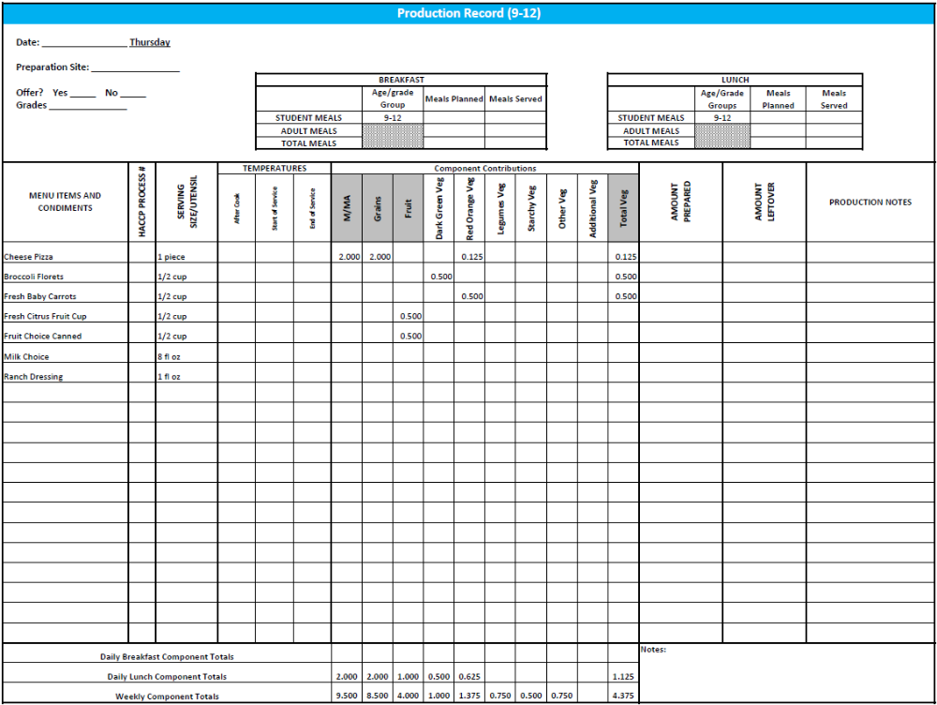

Purchasing, Preparation & Serving Instructions
Week 2 - Friday
Menu Item | Purchasing & Preparation | Serving
Biscuits & Sausage Gravy | - Prepare HKM Recipe 118, Biscuits and Sausage Gravy.  - If purchasing biscuits, purchase whole grain rich biscuit that provides 2 oz equivalent Grains.  - If preparing biscuits, prepare HKM Recipe 120, Angel Biscuits.  - CCP: Hold gravy for hot service at 135°F or above. | Biscuits  K-12: 1 biscuit  Gravy  K-12: 3 oz
Sausage Patty | - Purchase pre-cooked sausage patties where 1 serving provides 0.75 oz equivalent M/MA, contains no more than 360 mg of sodium and no more than 8 grams of fat. If product is not Child Nutrition (CN) labeled, obtain a Product Formulation Statement.  - Heat according to manufacturer’s instructions.  - CCP: Hold for hot service at 135°F or above. | K-5: N/A  6-12: 1 each
Hash Brown Patty | - Purchase 2.25 oz hash brown patties.  - Refer to Fruit & Vegetable Order Guide for amount needed.  - Follow manufacturer’s directions for baking and holding. Batch cook.  - CCP: Hold for hot service at 135°F or above. | K-8: 1 patty  9-12: 2 patties
Sugar Snap Peas, fresh | - Refer to Fruit & Vegetable Order Guide for amount needed.  - Handle with gloved hands or serving utensils. Cover and refrigerate until serving.  - Weigh or count number needed per portion.  - CCP: Refrigerate and hold at 41°F or below for cold service. | K-12: ½ cup
Plum, fresh | - Refer to Fruit & Vegetable Order Guide for amount needed.  - With gloved hands, wash pears.  - Cover and refrigerate or store at room temperature until serving.  - CCP: Refrigerate and hold at 41°F or below for cold service | K-12: 1 each
Fruit Choice, canned | - Select an additional fruit choice to offer on the menu. The serving(s) offered must credit as ½ cup of fruit, to meet the minimum daily requirement, for grades 9-12.  *Note: The fruit choice is encouraged for grades K-5 and 6-8, but not required. The fruit choice is not included in the nutrient analysis for grades K-5 and 6-8. | K-8: N/A*  9-12: ½ cup
Milk | - Provide a variety of milk. May be 1% fat (unflavored) or skim (flavored or unflavored).  - CCP: Refrigerate and hold at 41°F or below for cold service. | K-12: 8 fl oz
Pre-preparation for Week 3 - Monday: None
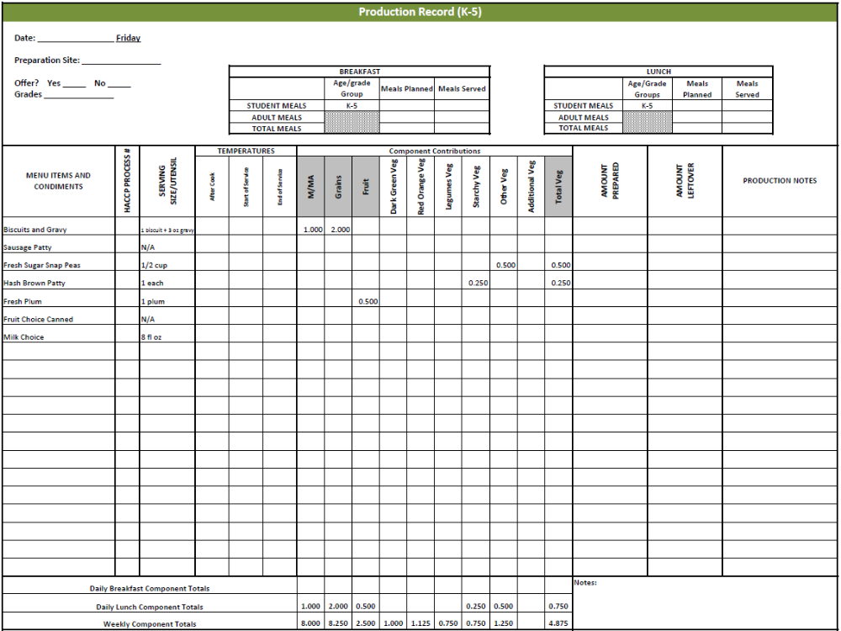
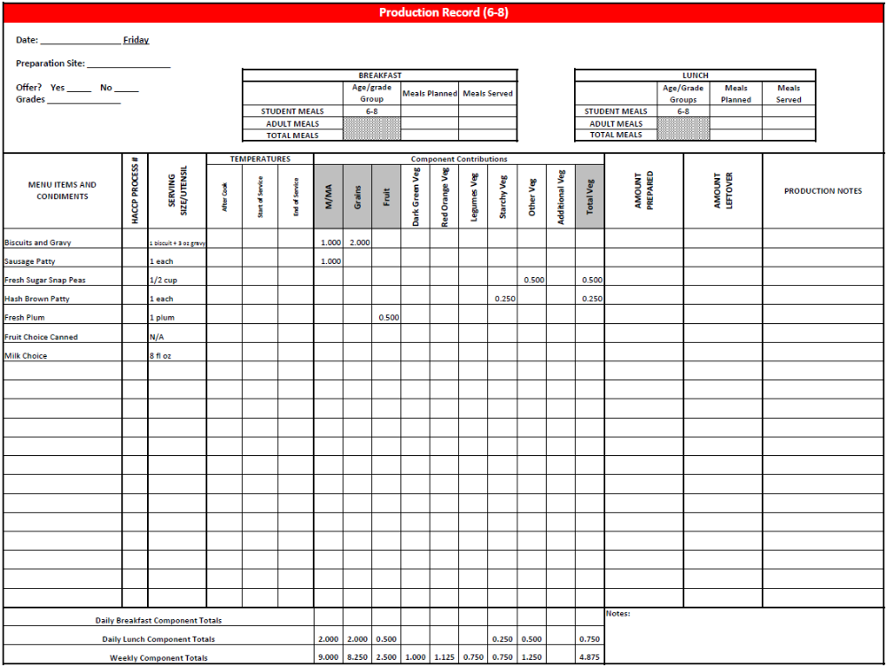
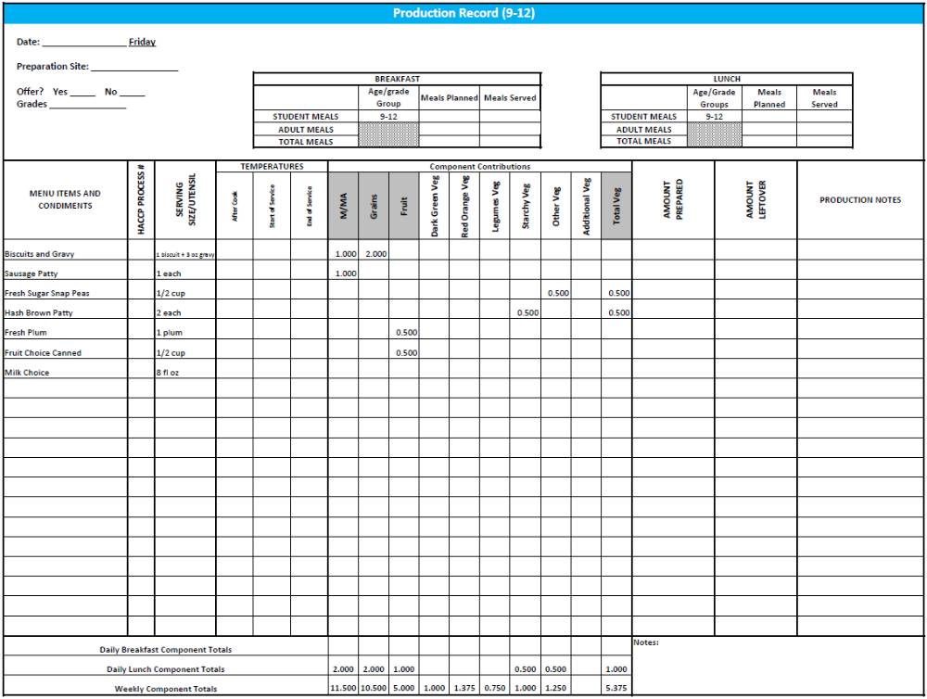

Fruit & Vegetable Order Guide
Week 2

The chart below provides amounts to be ordered per 100 servings based on the serving sizes listed on Week 4 of Healthier Kansas Menus Production Records for students in grades groups K-6 and 7-12. Amounts to order are based on standard yields and leveled serving utensils or weighed portions. Use the following procedures to determine the amounts to order:
- Forecast the number of servings needed for each fruit and vegetable menu item for each grade group served.
- Divide the number of servings needed by 100 for each portion size (K-6 or 7-12).
- Multiply the “Amount to order per 100 servings” by the factor determined in step 2 above for each portion size.
- Add amounts needed for all serving sizes together to determine the amounts to order.

Abbreviations Key: EP = Edible Portion AP = As Purchased lb = Pound oz = ounce # = Number

Day | Fruit or Vegetable | K-5  Portion Size | K-5  Amount to Order per 100 Servings | 6-8  Portion Size | 6-8  Amount to Order  per 100 Servings | 9-12 Portion Size | 9-12 Amount to Order per 100 Servings
Monday | Spaghetti Sauce, canned |  | 2.1 #10 cans |  | 2.1 #10 cans |  | 2.1 #10 cans
Monday | Potato Wedges, IQF, frozen | ½ cup | 17 lb | ½ cup | 17 lb | ½ cup | 17 lb
Monday | Tossed Salad | 1 cup |  | 1 cup |  | 1 cup
Monday | Spinach, fresh, trimmed, AP |  | 7 lb |  | 7 lb |  | 7 lb
Monday | Romaine Lettuce, AP |  | 7 lb |  | 7 lb |  | 7 lb
Monday | Peaches, fresh, 80 count, AP | 1 each | 22 lb 5 oz  or 100 each | 1 each | 22 lb 5 oz  or 100 each | 1 each | 22 lb 5 oz  or 100 each
Tuesday | Baked Beans | ½ cup |  | ½ cup |  | ½ cup
Tuesday | Beans, baked, canned, vegetarian |  | 4.25 #10 cans |  | 4.25 #10 cans |  | 4.25 #10 cans
Tuesday | Tomato Sauce, canned |  | 6 cups |  | 6 cups |  | 6 cups
Tuesday | Creamy Cole Slaw | ½ cup |  | ½ cup |  | ½ cup
Tuesday | Cabbage, fresh, green, shredded ready to use |  | 12 lb |  | 12 lb |  | 12 lb
Tuesday | Carrots, fresh, AP |  | 1 lb 8 oz |  | 1 lb 8 oz |  | 1 lb 8 oz
Tuesday | Apricot Halves, canned in 100% juice or light syrup | ½ cup | 4.2 #10 cans | ½ cup | 4.2 #10 cans | ½ cup | 4.2 #10 cans
Fruit & Vegetable Order Guide
Week 2, continued
Day | Fruit or Vegetable | K-5  Portion Size | K-5  Amount to Order per 100 Servings | 6-8  Portion Size | 6-8  Amount to Order  per 100 Servings | 9-12 Portion Size | 9-12 Amount to Order per 100 Servings
Wednesday | White Chicken Chili | ¾ cup |  | ¾ cup |  | ¾ cup
Wednesday | Onions, yellow, AP |  | 3 lb 8 oz |  | 4 lb |  | 4 lb
Wednesday | Great Northern Beans, canned, low sodium |  | 3.25 #10 cans |  | 3.25 #10 cans |  | 3.25 #10 cans
Wednesday | Green Chili Peppers, canned, diced |  | 15 oz |  | 15 oz |  | 15 oz
Wednesday | Tomatoes, cherry, AP | 3 tomatoes | 8 lb 5 oz | 3 tomatoes | 8 lb 5 oz | 6 tomatoes | 16 lb 10 oz
Wednesday | Cucumber, fresh, AP | ¼ cup | 8 lb 2 oz | ¼ cup | 8 lb 2 oz | ¼ cup | 8 lb 2 oz
Wednesday | Banana, fresh, 100-120 count, AP | 1 each | 37 lb 4 oz  or 100 each | 1 each | 37 lb 4 oz  or 100 each | 1 each | 37 lb 4 oz  or 100 each
Thursday | Broccoli, florets, fresh, EP | ½ cup | 7 lb | ½ cup | 7 lb | ½ cup | 7 lb
Thursday | Carrots, baby, fresh, EP | ½ cup | 15 lb 10 oz | ½ cup | 15 lb 10 oz | ½ cup | 15 lb 10 oz
Thursday | Fresh Citrus Fruit Cup | ½ cup |  | ½ cup |  | ½ cup
Thursday | Mandarin Oranges, canned in 100% juice or light syrup |  | 8 lb 8 oz |  | 8 lb 8 oz |  | 8 lb 8 oz
Thursday | Bananas, fresh, AP |  | 9 lb |  | 9 lb |  | 9 lb
Thursday | Apples, fresh, AP |  | 3 lb 8 oz |  | 3 lb 8 oz |  | 3 lb 8 oz
Thursday | Grapes, fresh, AP |  | 3 lb 8 oz |  | 3 lb 8 oz |  | 3 lb 8 oz
Friday | Hash Brown Patties, frozen, 2.25 oz each | 1 each | 14 lb 1 oz  or 100 each | 1 each | 14 lb 1 oz  or 100 each | 1 each | 14 lb 1 oz  or 100 each
Friday | Sugar Snap Peas, fresh | ½ cup | 20 lb 10 oz | ½ cup | 20 lb 10 oz | ½ cup | 20 lb 10 oz
Friday | Plum, fresh, 45-50 count, AP | 1 each | 20 lb 2 oz  or 100 each | 1 each | 20 lb 2 oz  or 100 each | 1 each | 20 lb 2 oz  or 100 each

