Healthier Kansas Menus

with Alternate Entrées

# C:\Documents and Settings\jmackey\My Documents\My Pictures\Microsoft Clip Organizer\j0349505.wmf

SPRING WEEK 4 – DAILY PRODUCTION RECORDS

Child Nutrition & Wellness, Kansas State Department of Education

Revised July 2019

This publication has been funded at least in part with Federal funds from the U.S. Department of Agriculture, Food and Nutrition Service. The contents of this publication do not necessarily reflect the views or policies of the Department, nor does mention of trade names, commercial products, or organizations imply endorsement by the U.S. Government.

**For further information about this publication, please contact:** Child Nutrition & Wellness, KSDE, Landon State Office Building, 900 SW Jackson Street, Suite #251, Avenue, Topeka, Kansas 66612, 785-296-2276, Fax: 785-296-0232,

[www.kn-eat.org](http://www.kn-eat.org/)

In accordance with Federal civil rights law and U.S. Department of Agriculture (USDA) civil rights regulations and policies, the USDA, its Agencies, offices, and employees, and institutions participating in or administering USDA programs are prohibited from discriminating based on race, color, national origin, sex, disability, age, or reprisal or retaliation for prior civil rights activity in any program or activity conducted or funded by USDA.  
  
Persons with disabilities who require alternative means of communication for program information (e.g. Braille, large print, audiotape, American Sign Language, etc.), should contact the Agency (State or local) where they applied for benefits. Individuals who are deaf, hard of hearing or have speech disabilities may contact USDA through the Federal Relay Service at (800) 877-8339. Additionally, program information may be made available in languages other than English.  
  
To file a program complaint of discrimination, complete the [USDA Program Discrimination Complaint Form](http://www.ocio.usda.gov/sites/default/files/docs/2012/Complain_combined_6_8_12.pdf), (AD-3027) found online at: [http://www.ascr.usda.gov/complaint_filing_cust.html](https://www.ascr.usda.gov/filing-discrimination-complaint-usda-customer), and at any USDA office, or write a letter addressed to USDA and provide in the letter all of the information requested in the form. To request a copy of the complaint form, call (866) 632-9992. Submit your completed form or letter to USDA by:  
  
(1)   Mail: U.S. Department of Agriculture  
Office of the Assistant Secretary for Civil Rights  
1400 Independence Avenue, SW  
Washington, D.C. 20250-9410;  
  
(2)   Fax: (202) 690-7442; or  
  
(3)   Email: [program.intake@usda.gov](mailto:program.intake@usda.gov).  
  
This institution is an equal opportunity provider.

The following person has been designated to handle inquiries regarding the non-discrimination policies at the Kansas State Department of Education: Office of General Counsel, Landon State Office Building, 900 SW Jackson St, Suite #102, Topeka, KS 66612, (785)296-3201.

Healthier Kansas Menus recipes were developed by Child Nutrition & Wellness, Kansas State Department of Education or adapted from the following sources:

* *Food for Fifty,* Ninth Edition (1989) Grace Shugart, Mary Molt*.*
* *Healthier Kansas Menus – Breakfast,* Child Nutrition & Wellness, Kansas State Department of Education
* *Iowa Gold Star Cycle Menus*, Iowa Department of Education
* *Menus that Move,* Ohio Department of Education.
* *Fruit and Veggie Quantity Cookbook,* New Hampshire Department of Health and Human Services.
* *Preparing Whole Grain Foods,* Child Nutrition & Wellness, Kansas State Department of Education
* *Singing the Praises of Beans & Legumes*, Child Nutrition & Wellness, Kansas State Department of Education
* *USDA Recipes for Schools,* U.S. Department of Agriculture, Food & Nutrition Service, Child Nutrition Programs, 2006.
* USD 225 Fowler
* USD 234 Fort Scott
* USD 267 Renwick
* USD 306 Southeast of Saline
* USD 308 Hutchinson
* USD 320 Wamego
* USD 349 Stafford
* USD 364 Marysville
* USD 503 Parsons
* USD 512 Shawnee Mission

Thank you to the following schools for assisting with menu development and recipe testing:

* Logan Elementary School – USD 345 Seaman
* St. Joseph Catholic School – Mt. Hope, KS
* Winfield Scott Elementary School – USD 234 Fort Scott

## Menus for the Week

**PLEASE NOTE:**

Milk choice includes a variety of non-fat or 1% (flavored or unflavored) milk. One milk choice must be unflavored.

Reduced fat dressing is served with salads and fresh vegetables.

Menus were planned using all whole grain-rich products. Beginning July 1, 2019, at least half of the weekly grains in the school lunch menu and the school breakfast menu must be whole grain-rich.

|  |  |  |  |  |  |  |  |  |
| --- | --- | --- | --- | --- | --- | --- | --- | --- |
| **MONDAY** | **TUESDAY** | **WEDNESDAY** | **THURSDAY** | **FRIDAY** | **Weekly Nutrient Averages** | | | |
|  | K-5 | 6-8 | 9-12 |
| Beef & Bean Burrito  **Tortilla Chips (9-12)**  **Or**  Yogurt & Blueberry Oat Muffin Plate  **Tortilla Chips (9-12)**  Tomato Salsa  Romaine Lettuce  Mexican Corn  Fresh Pear  Canned Fruit Choice  Milk Choice | Stromboli Squares  **Garlic Breadstick (9-12)**  **Or**  Chicken Crispito  Garden Salad  Fresh Baby Carrots  Fresh Plum  Canned Fruit Choice  Milk Choice | BBQ Beef on a Bun  **Or**  Grilled Chicken Sandwich  Fresh Snow Peas  Baked Beans  Fresh Watermelon  **Royal Brownie**  **(6-12)**  Canned Fruit Choice  Milk Choice | Turkey & Cheese Sub Sandwich  **Or**  Hamburger on a Bun  Dark Green Leaf Lettuce  Tomato Slice  Sweet Potato Fries  Applesauce  Fresh Fruit Choice  Milk Choice | Country Style  Beef Pattie  **Whole Wheat Roll (6-12)**  **Or**  Cheese Pizza  Mashed Potatoes  & Gravy  Steamed Broccoli  Fresh Orange  Canned Fruit Choice  Milk Choice | **Calories**  **Sodium (mg)**  **% of Total Calories from Sat. Fat** | **613**  **782**  **7.6%** | **655**  **821**  **7.5%** | **780**  **870**  **6.9%** |

C:\Documents and Settings\jmackey\My Documents\My Pictures\Microsoft Clip Organizer\j0349505.wmf

## Recipes for the Week

|  |  |  |  |
| --- | --- | --- | --- |
| Day | Recipe Name | Recipe Number | HKM Recipe  Page Number |
| Monday | Blueberry Oat Muffin  Tomato Salsa | 28  129 | 64  61 |
| Tuesday | Stromboli Squares  Garden Salad  Whole Wheat Garlic Breadstick | 181  164  877 | 33  55  91 |
| Wednesday | BBQ Beef on a Bun  Whole Wheat Bun  Baked Beans  Royal Brownies | 135  877  188  62 | 3  91  50  78 |
| Thursday | Turkey & Cheese Sub  Whole Wheat Bun | 144  877 | 42  91 |
| Friday | Whole Wheat Roll | 877 | 91 |

## Abbreviations

|  |  |  |  |
| --- | --- | --- | --- |
| **Abbreviation** | **What it Means** | **Abbreviation** | **What it Means** |
| HKM | Healthier Kansas Menus | Tbsp | tablespoon |
| EP | edible portion | tsp | teaspoon |
| AP | as purchased | CCP | Critical Control Point |
| fl | fluid | PC | portion controlled * |
| oz | ounce | w/ | with |
| lb | pound | M/MA | meat/meat alternate |
| gm | gram |  |  |
| mg | milligram |  |  |

* For example, purchase pre-portioned servings of condiments.

## Portion Guide

|  |  |
| --- | --- |
| **Ladles & Spoodles** | **Scoops** |
| 1 fl oz = 2 Tbsp | #50 = 3 3/4 tsp |
| 2 fl oz = 1/4 cup | #40 = 1 2/3 Tbsp |
| 3 fl oz = 3/8 cup | #30 = 2 Tbsp |
| 4 fl oz = 1/2 cup | #20 = 3 1/3 Tbsp |
| 6 fl oz = 3/4 cup | #16 = 1/4 cup |
| 8 fl oz = 1 cup | #12 = 1/3 cup |
|  | #8 = 1/2 cup |
|  | #6 = 2/3 cup |

## Purchasing, Preparation & Serving Instructions

Week 4 – Monday

|  |  |  |
| --- | --- | --- |
| **Menu Item** | **Purchasing & Preparation** | **Serving** |
| Beef & Bean Burrito | * Purchase a pre-cooked Beef & Bean Burrito that provides 2 oz equivalent M/MA and 2 oz equivalent Grains; no more than 8 gm of fat; and no more than 500 mg of sodium per serving. If product is not Child Nutrition (CN) labeled, obtain a Product Formulation Statement. * Prepare according to manufacturer’s instructions. * **CCP: Hold for hot service at 135°F or above.** | K-12: 1 each |
| **Alternate Entrée:**  Yogurt & Blueberry Oat Muffin Meal | * Prepare HKM Recipe 28, Blueberry Oat Muffin or purchase pre-prepared whole grain-rich muffins that provide 1 oz equivalent Grain. * Purchase low-fat, flavored yogurt in bulk and pre-portion 1 cup (8 oz) servings. * **CCP: Refrigerate and hold at 41o F or below for cold service.** | K-12: 8oz yogurt,  2 muffins each |
| Tortilla Chips | * Purchase whole grain tortilla chips with no more than 50 mg sodium per oz. (Restaurant style usually has less sodium). * May be pre-portioned. Weigh a sample. Serve with gloved hands or tongs. | K-8: N/A  9-12: 1 oz |
| Romaine Lettuce | * Refer to *Fruit & Vegetable Order Guide* for amount needed. * Handle produce with gloved hands. May be pre-portioned. * **CCP: Refrigerate and hold at 41°F or below for cold service.** | K-12: ½ cup |
| Mexican Corn | * Refer to *Fruit & Vegetable Order Guide* for amount needed. Purchase frozen or canned Mexican corn or plain corn. * If using plain corn, clean, seed and dice one fresh green pepper and one fresh red pepper for each 20 lb. frozen corn or 5 #10 cans used. Add to corn just before end point of cooking. * Wipe tops of cans clean before opening. Batch cook close to serving time by steaming or by cooking in stock pot with minimal liquid. * **CCP: Hold for hot service at 135°F or above.** | K-12: ½ cup |
| Tomato Salsa | * Purchase salsa that is low in sodium or prepare HKM Recipe 129, Tomato Salsa. * Refer to *Fruit & Vegetable Order Guide* for amount needed. * May be served, self-serve or pre-portioned for service. * **CCP: Refrigerate and hold at 41°F or below for cold service.** | K-12: ¼ cup |

*Continued on next page*

## Purchasing, Preparation & Serving Instructions

Week 4 – Monday, continued

|  |  |  |
| --- | --- | --- |
| **Menu Item** | **Purchasing & Preparation** | **Serving** |
| Pear, fresh | * Refer to *Fruit & Vegetable Order Guide* for amount needed. * With gloved hands, wash pears. * Cover and refrigerate or store at room temperature until serving. * **CCP: Refrigerate and hold at 41°F or below for cold service.** | K-12: 1 each |
| Fruit Choice, canned | Select an additional fruit choice to offer on the menu.  The serving(s) offered must credit as ½ cup of fruit, to meet the minimum daily requirement, for grades 9-12.  *Note: The fruit choice is encouraged for grades K-5 and 6-8, but not required.  The fruit choice is not included in the nutrient analysis for grades K-5 and 6-8. | K-8: N/A*  9-12: ½ cup |
| Milk | * Provide a variety of milk. May be 1% fat (unflavored) or skim (flavored or unflavored). * **CCP: Refrigerate and hold at 41°F or below for cold service.** | K-12: 8 fl oz |

**Pre-preparation for Week 4 – Tuesday:** N/A

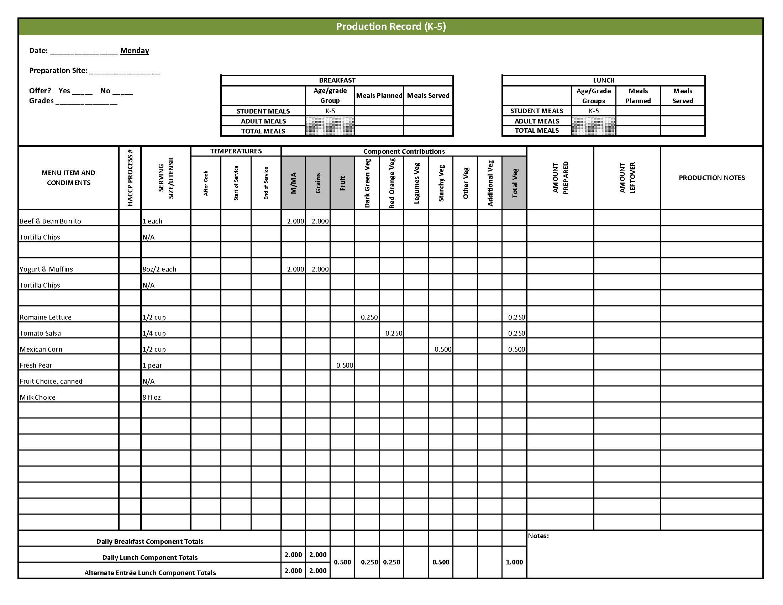

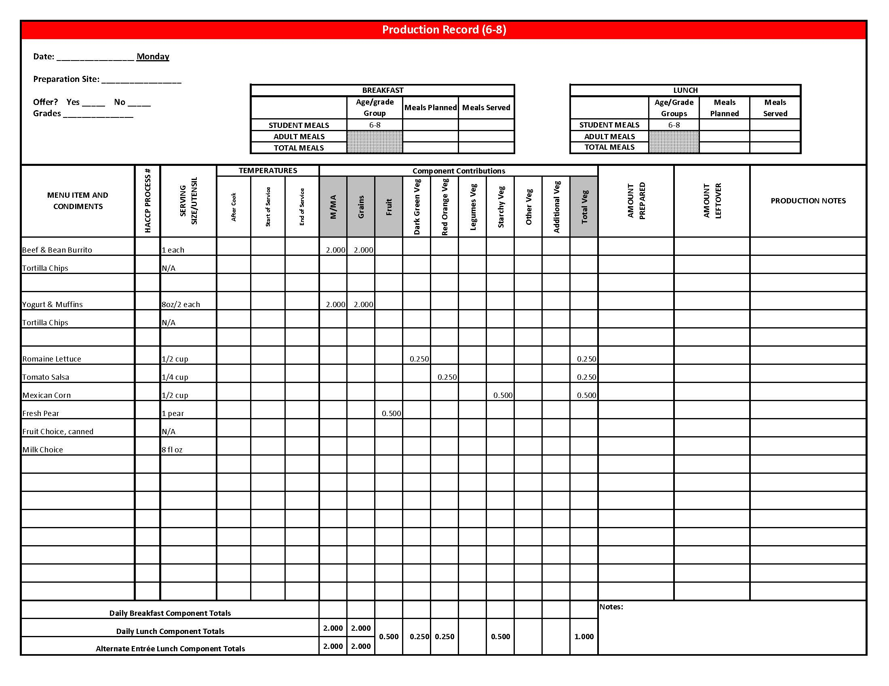

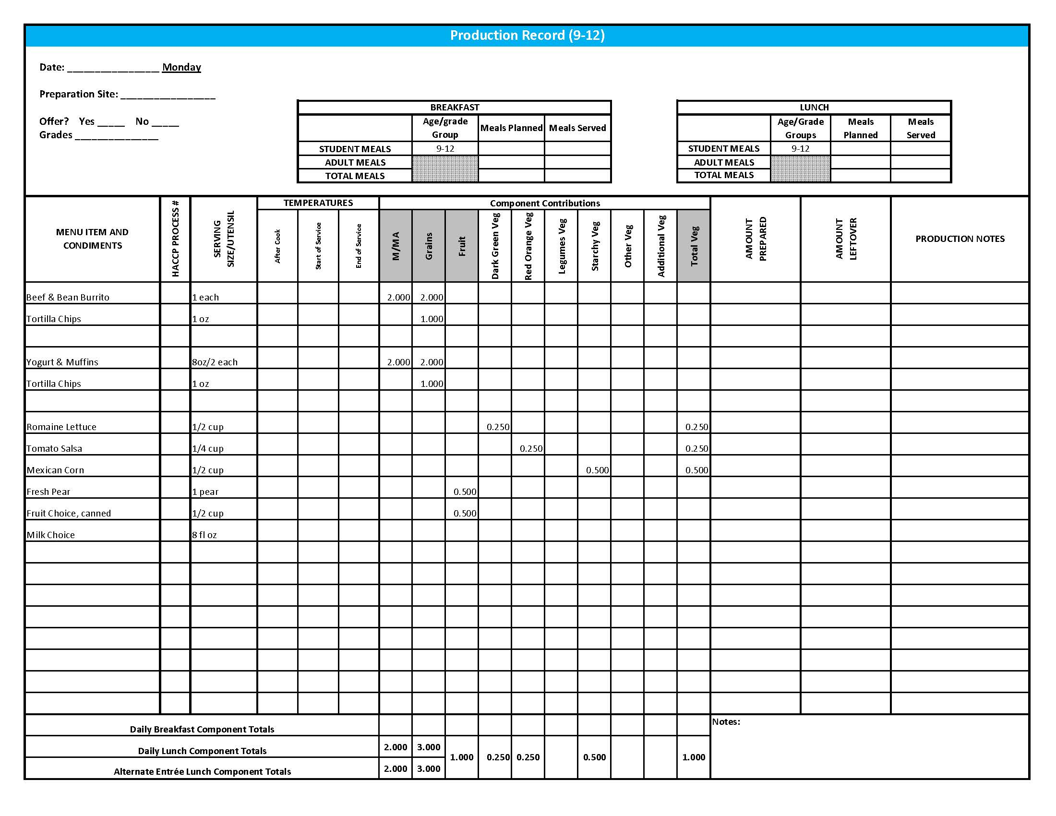

## Purchasing, Preparation & Serving Instructions

Week 4 – Tuesday

|  |  |  |
| --- | --- | --- |
| **Menu Item** | **Purchasing & Preparation** | **Serving** |
| Stromboli Squares | * Prepare HKM Recipe 181, Stromboli Squares. * **CCP: Hold for hot service at 135°F or above.** | K-12: 1 piece |
| Garlic Breadstick | * Prepare HKM Recipe 877, Whole Wheat Rolls, Breadsticks, Buns, 51%, garlic breadstick variation. | K-8: N/A  9-12: 1 each |
| **Alternate Entrée:**  Crispito, chicken chili | * Purchase Crispito providing 1 oz equivalent M/MA and 1 oz equivalent Grain, no more than 14 gm of fat; and no more than 370 mg sodium per piece. If product is not Child Nutrition (CN) labeled, obtain a Product Formulation Statement. * Heat according to manufacturer’s instructions. * **CCP: Hold for hot service at 135°F or above.** | K-8: 1 each  9-12: 2 each |
| Garden Salad | * Prepare HKM Recipe 164, Garden Salad. Refer to *Fruit & Vegetable Order Guide* for amounts of individual ingredients needed. * Handle salad with gloved hands, tongs or serving utensils. * May estimate serving sizes using measured portions as samples. * **CCP: Refrigerate and hold at 41°F or below for cold service.** | K-12: 1 cup |
| Carrots, baby, fresh | * Refer to *Fruit & Vegetable Order Guide* for amount needed. * Handle with gloved hands or serving utensils. Cover and refrigerate until serving. * Weigh or count number needed per portion. * **CCP: Refrigerate and hold at 41°F or below for cold service.** | K-12: ½ cup |
| Plum, fresh | * Refer to *Fruit & Vegetable Order Guide* for amount needed. * With gloved hands, wash plums. * Cover and refrigerate or store at room temperature until serving. * **CCP: Refrigerate and hold at 41°F or below for cold service.** | K-12: 1 each |

*Continued on next page*

## Purchasing, Preparation & Serving Instructions

Week 4 – Tuesday, continued

|  |  |  |
| --- | --- | --- |
| **Menu Item** | **Purchasing & Preparation** | **Serving** |
| Fruit Choice, canned | Select an additional fruit choice to offer on the menu.  The serving(s) offered must credit as ½ cup of fruit, to meet the minimum daily requirement, for grades 9-12.  *Note: The fruit choice is encouraged for grades K-5 and 6-8, but not required.  The fruit choice is not included in the nutrient analysis for grades K-5 and 6-8. | K-8: N/A*  9-12: ½ cup |
| Milk | * Provide a variety of milk. May be 1% fat (unflavored) or skim (flavored or unflavored). * **CCP: Refrigerate and hold at 41°F or below for cold service.** | K-12: 8 fl oz |
| Ranch Dressing, Reduced Fat | * Purchase or prepare Ranch dressing containing no more than 6 gm of fat  per 1 fl oz. Purchase .8 gallons for every 100 1 fl oz portions. * **CCP: Refrigerate and serve at 41°F or below if school-prepared dressing is served.** | K-12: 1 fl oz **or** 2 Tbsp |

**Pre-preparation for Week 4 - Wednesday:** Thaw beef under refrigeration. Cut and chill watermelon.

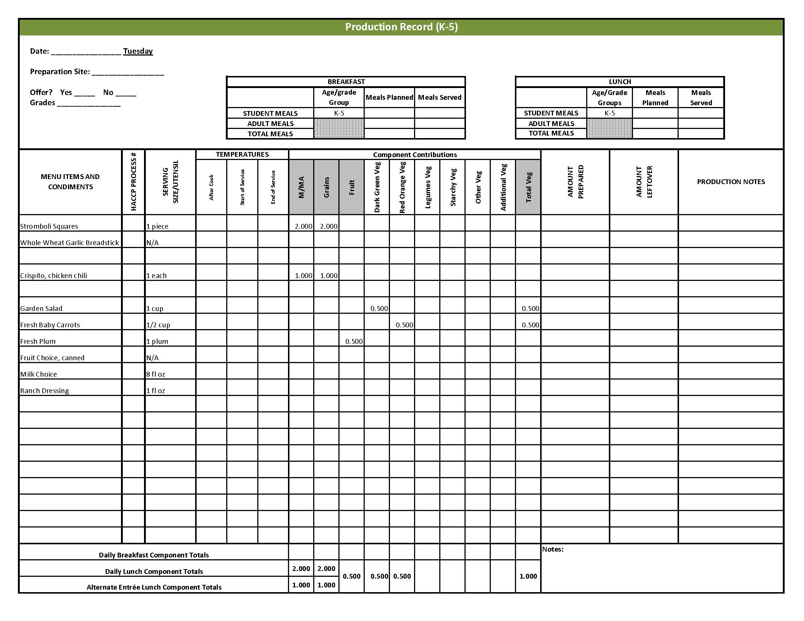

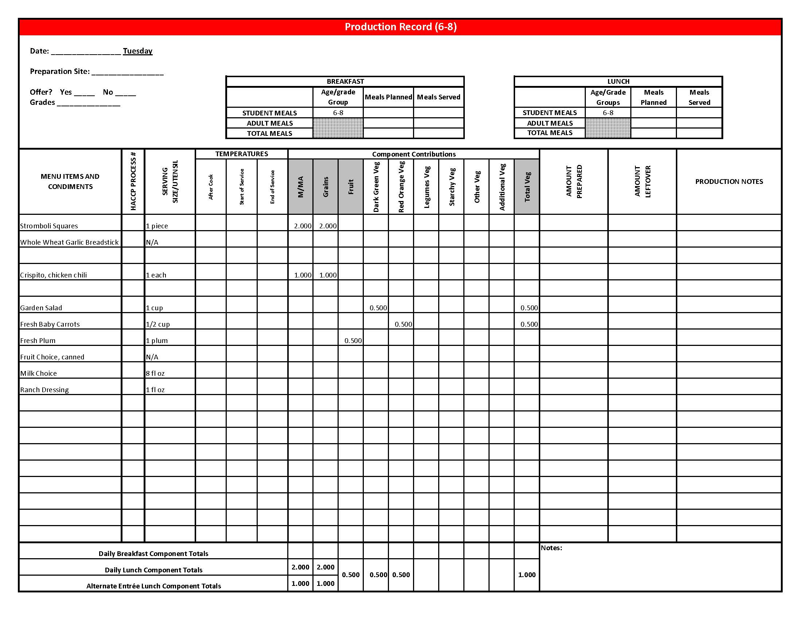

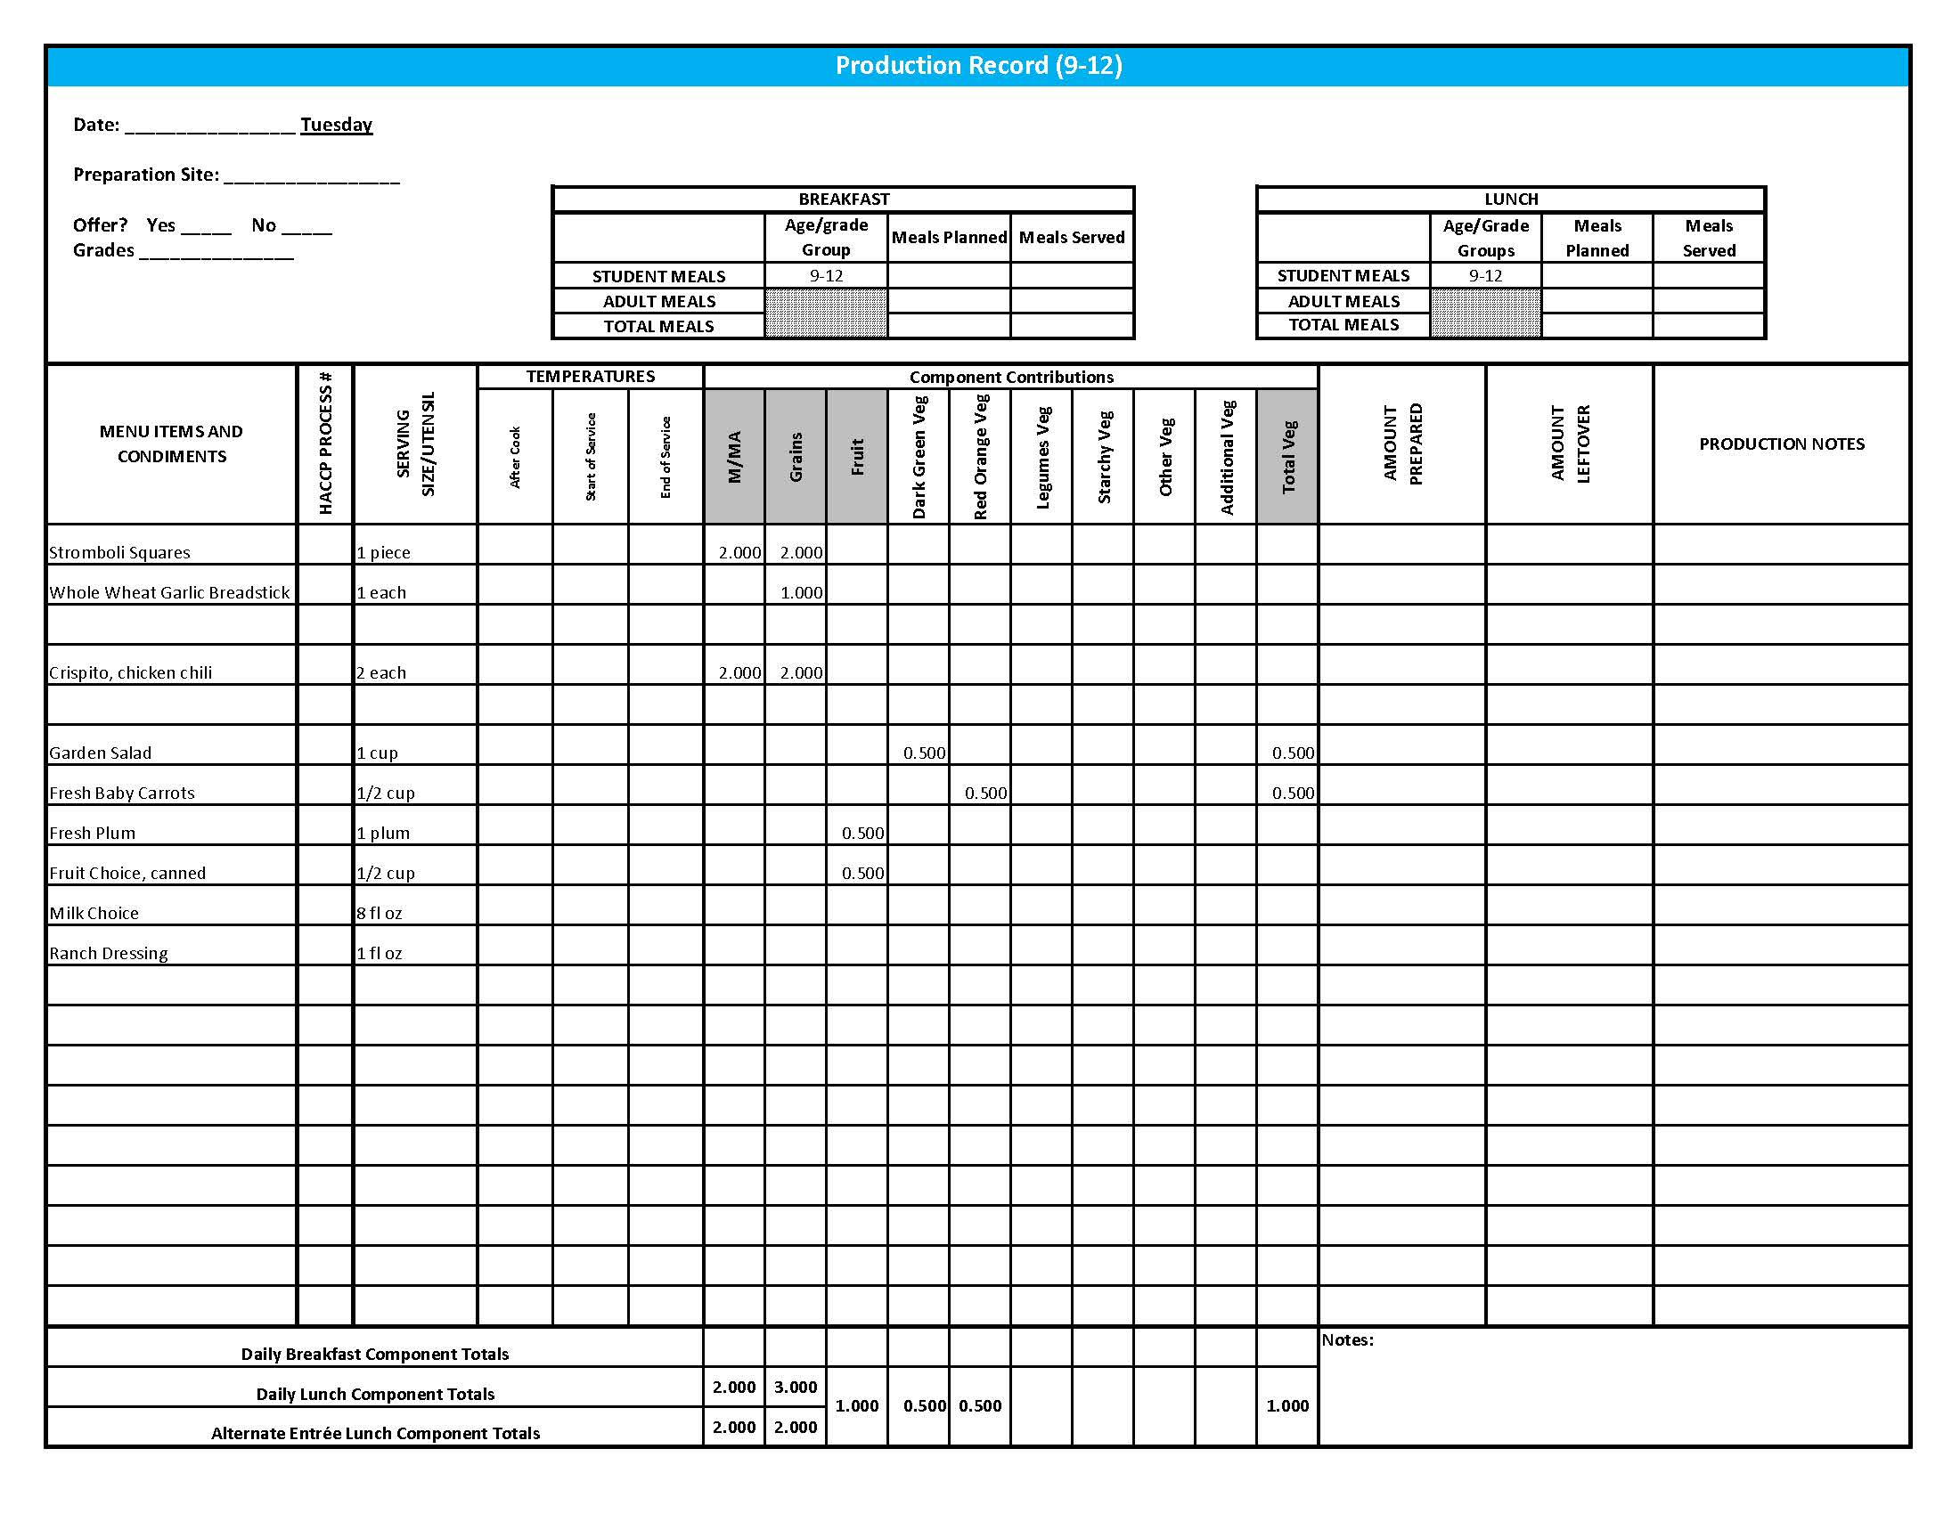

## Purchasing, Preparation & Serving Instructions

Week 4 – Wednesday

|  |  |  |  |  |
| --- | --- | --- | --- | --- |
| **Menu Item** | | **Purchasing & Preparation** | **Serving** | |
| BBQ Beef on a Bun | | * Prepare HKM Recipe 135, BBQ Beef on a Bun. * Purchase a raw sliced and shaped beef product that is provides no more than 250 mg of sodium per serving. * Purchase BBQ sauce with no more than 500 mg sodium per fl oz. * Purchase a 2 oz whole wheat bun (first ingredient is whole wheat) or prepare following HKM Recipe 877, Whole Wheat Rolls, Bread Sticks, Buns. * **CCP: Hold for hot service at 135°F or above.** | | K-12: 1 sandwich |
| **Alternate Entrée:**  Grilled Chicken Sandwich | | * Purchase pre-cooked, un-breaded chicken patties that provide 2 oz equivalent M/MA, no more than 3.5 gm of fat; and no more than 210 mg sodium per serving. If product is not Child Nutrition (CN) labeled, obtain a Product Formulation Statement. * Prepare according to manufacturer’s instructions. * Purchase a 2 oz whole wheat bun (first ingredient is whole wheat) or prepare following HKM Recipe 877, Whole Wheat Rolls, Bread Sticks, Buns, Hamburger Bun Variation. * **CCP: Hold for hot service at 135°F or above.** | | K-12: 1 each |
| Snow Peas, fresh | | * Refer to *Fruit & Vegetable Order Guide* for amount needed. * Handle with gloved hands or serving utensils. Cover and refrigerate until serving. * Weigh or count number needed per portion. * **CCP: Refrigerate and hold at 41°F or below for cold service.** | | K-12: ½ cup |
| Baked Beans | | * Prepare HKM Recipe 188, Baked Beans or purchase canned baked beans. * Refer to *Fruit & Vegetable Order Guide* for amount needed. * **CCP: Hold for hot service at 135°F or above.** | | K-12: ½ cup |
| Watermelon, Fresh | | * Refer to *Fruit &Vegetable Order Guide* for amount needed. * With gloved hands, wash outside of rind well to remove any surface dirt. Remove rind and cut into ½” cubes. * **CCP: Refrigerate and hold at 41°F or below for cold service.** | | K-12: ½ cup |

*Continued on next page*

## Purchasing, Preparation & Serving Instructions

**Week 4 – Wednesday, continued**

|  |  |  |
| --- | --- | --- |
| **Menu Item** | **Purchasing & Preparation** | **Serving** |
| Fruit Choice, canned | Select an additional fruit choice to offer on the menu.  The serving(s) offered must credit as ½ cup of fruit, to meet the minimum daily requirement, for grades 9-12.  *Note: The fruit choice is encouraged for grades K-5 and 6-8, but not required.  The fruit choice is not included in the nutrient analysis for grades K-5 and 6-8. | K-8: N/A*  9-12: ½ cup |
| Royal Brownie | * Prepare HKM Recipe 62, Royal Brownie. * This menu item will count as a grain based dessert. | K-5: N/A  6-12: 1 piece |
| Milk | * Provide a variety of milk. May be 1% fat (unflavored) or skim (flavored or unflavored). * **CCP: Refrigerate and hold at 41°F or below for cold service.** | K-12: 8 fl oz |
| Ketchup | * Purchase in bulk or individual packets (9-gm or 12-gm). If bulk, purchase 1 #10 can or .8 gallon for every 100 1-fluid oz servings. | K-12: 1 fl oz  **or** 2 Tbsp **or** 2 PC |
| Mustard | * Purchase bulk or packets. If bulk, purchase 2 cups for every 100 1 tsp servings. | K-12: 1 tsp |

**Pre-preparation for Week 4 – Thursday:** Chill applesauce.

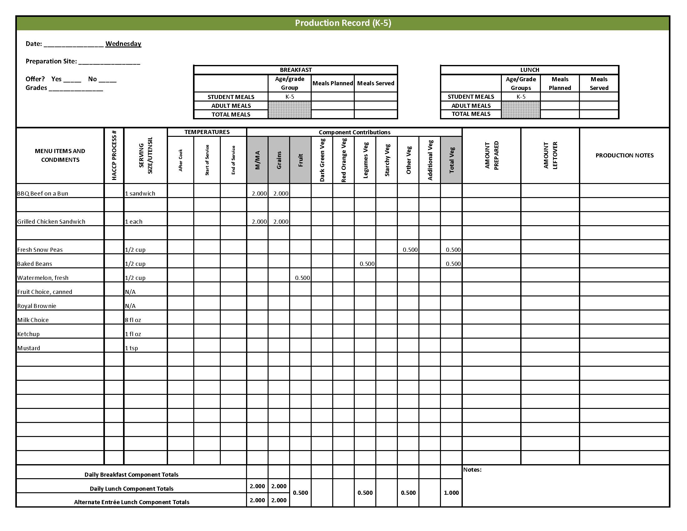

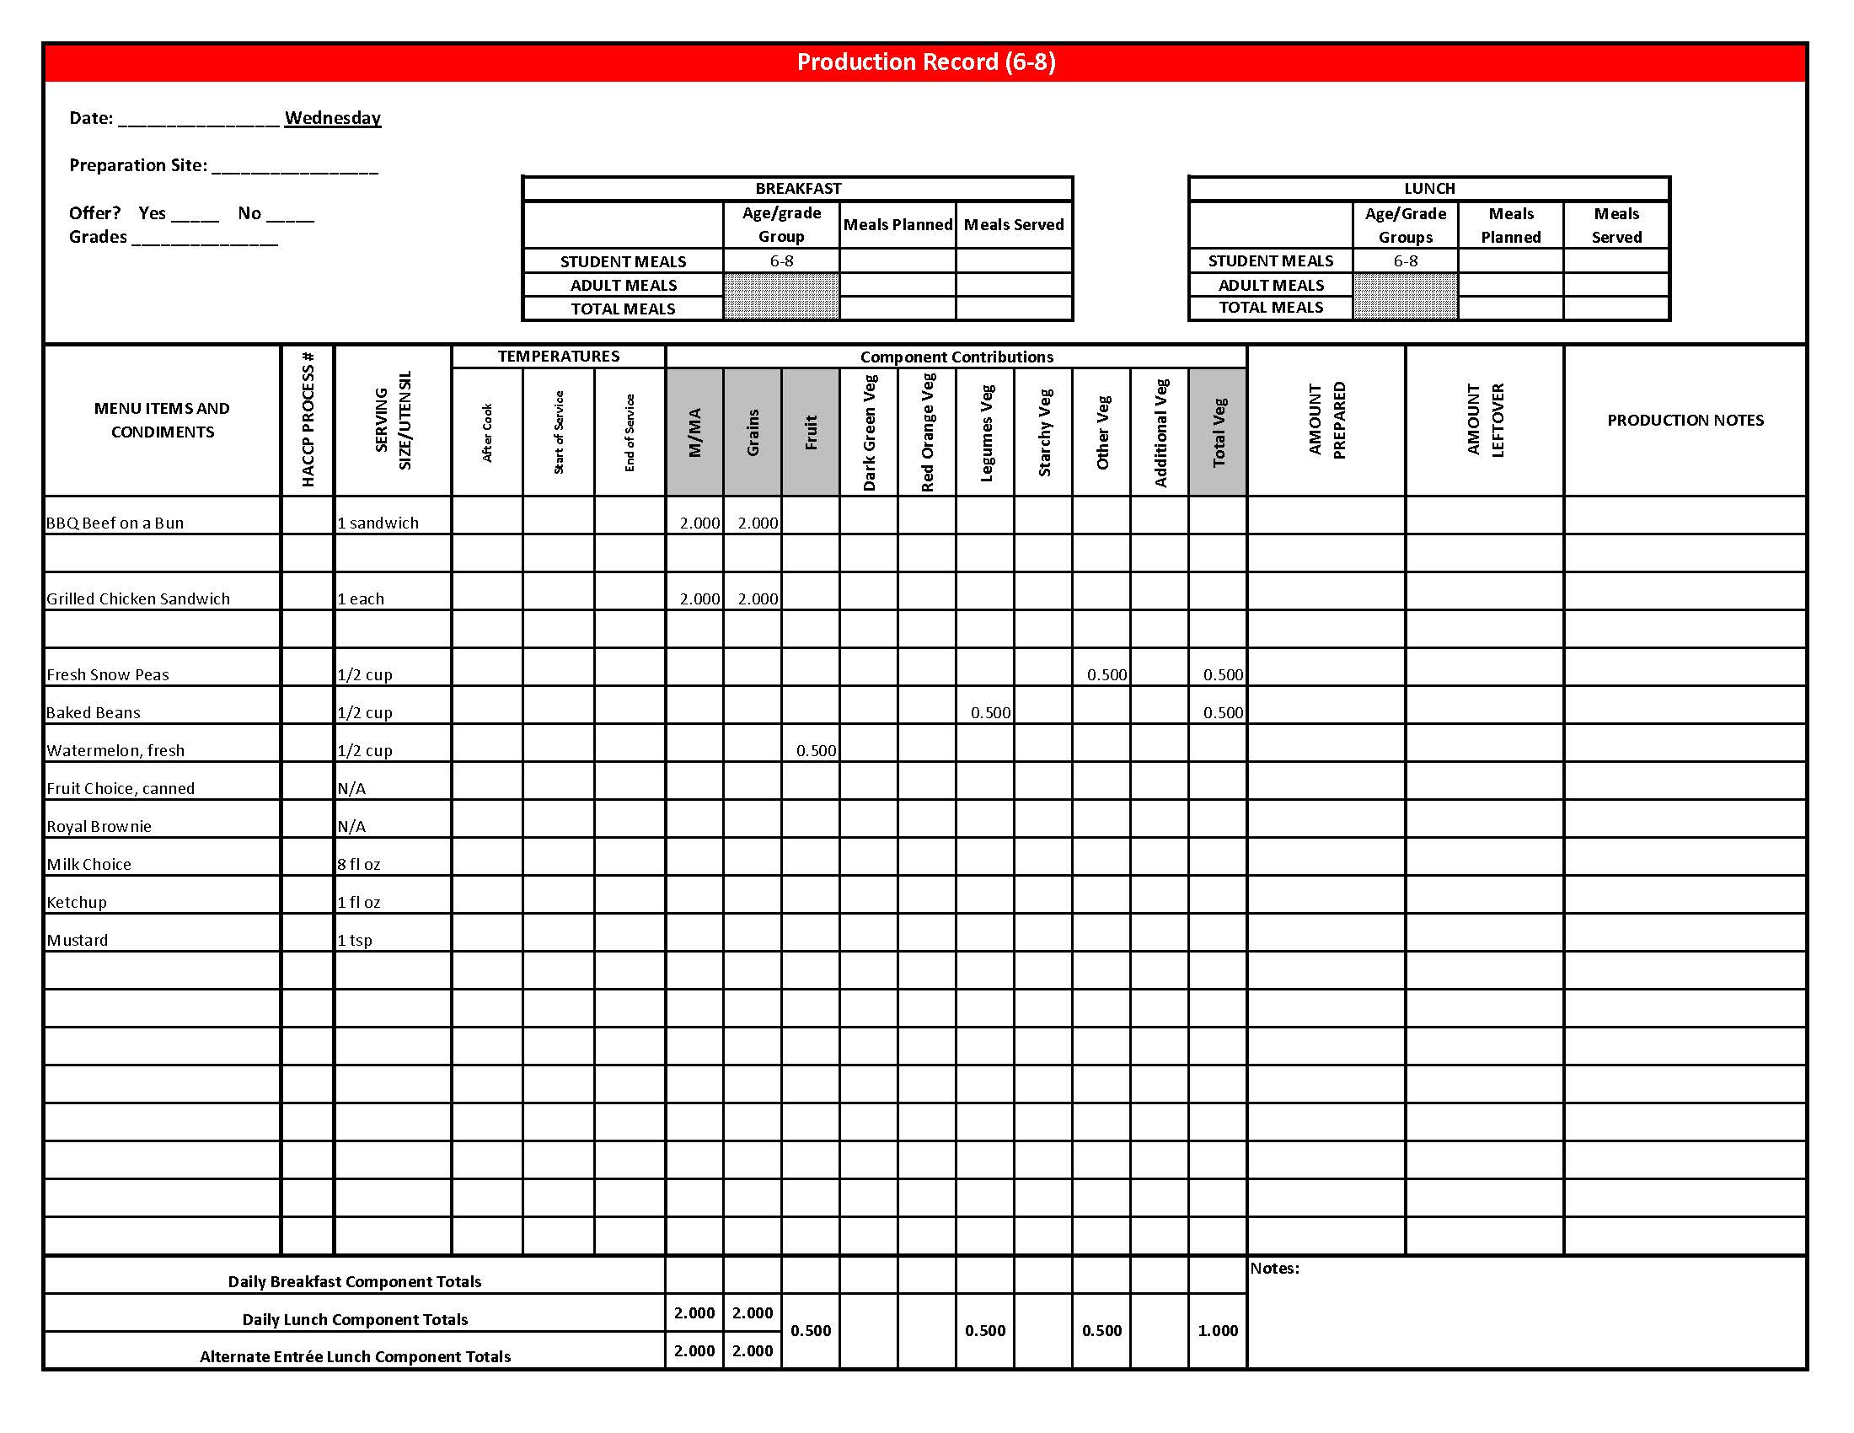

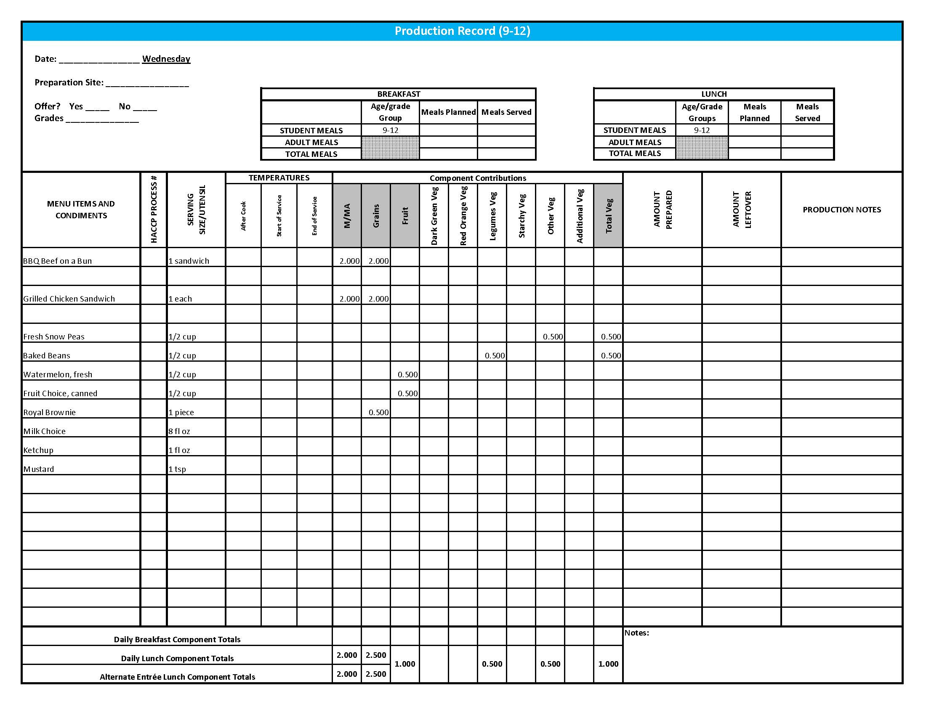

Purchasing, Preparation & Serving Instructions

Week 4 – Thursday

|  |  |  |
| --- | --- | --- |
| **Menu Item** | **Purchasing & Preparation** | **Serving** |
| Turkey & Cheese Sub | * Prepare HKM Recipe 144, Turkey & Cheese Sub. * Purchase lean, deli-sliced, turkey with no more than 500 mg of sodium per 2 oz serving. Product should be CN labeled or have a product formulation statement with crediting information. * Purchase a 2 oz whole wheat bun (first ingredient is whole wheat) or prepare HKM Recipe 877, Whole Wheat Rolls, Bread Sticks, Buns. * **CCP: Hold at 41°F or below for cold service.** | K-12: 1 sandwich |
| **Alternate Entrée:**  Hamburger on a Bun | * Purchase pre-cooked, oven-ready hamburger patties that provides 2 oz equivalent M/MA; no more than 13 gm of fat; and no more than 300 mg sodium. If product is not Child Nutrition (CN) labeled, obtain a Product Formulation Statement. * Heat according to manufacturer’s instructions. * Purchase a 2 oz whole wheat bun (first ingredient is whole wheat) or prepare following HKM Recipe 877, Whole Wheat Rolls, Bread Sticks, Buns, Hamburger Bun Variation. * **CCP: Hold for hot service at 135°F or above.** | K-12: 1 each |
| Dark Green Leaf Lettuce | * Refer to *Fruit & Vegetable Order Guide* for amount needed. * Handle produce with gloved hands. May be pre-portioned. * **CCP: Refrigerate and hold at 41°F or below for cold service.** | K-12: ½ cup |
| Tomato Slice | * Refer to *Fruit & Vegetable Order Guide* for amount needed. * Handle produce with gloved hands. * Slice ¼” thick. * **CCP: Refrigerate and hold at 41°F or below for cold service.** | K-8: 1 slice  9-12: 2 slices |
| Sweet Potato Fries | * Purchase crinkle-cut, ovenable sweet potato fries. * Refer to *Fruit & Vegetable Order Guide* for amount needed. Heat in oven according to manufacturer’s instructions. * **CCP: Hold for hot service at 135°F or above.** | K-12: ½ cup |

*Continued on next page*

## Purchasing, Preparation & Serving Instructions

## **Week 4 – Thursday, continued**

|  |  |  |
| --- | --- | --- |
| **Menu Item** | **Purchasing & Preparation** | **Serving** |
| Applesauce, unsweetened | * Refer to *Fruit & Vegetable Order Guide* for amount needed. * Chill cans overnight. Wipe can tops clean before opening. * Cover and refrigerate until serving. * With gloved hands, wash strawberries. * **CCP: Refrigerate and hold at 41°F or below for cold service** | K-12: ½ cup |
| Fruit Choice, fresh | Select an additional fruit choice to offer on the menu.  The serving(s) offered must credit as ½ cup of fruit, to meet the minimum daily requirement, for grades 9-12.  *Note: The fruit choice is encouraged for grades K-5 and 6-8, but not required.  The fruit choice is not included in the nutrient analysis for grades K-5 and 6-8. | K-8: N/A*  9-12: ½ cup |
| Milk | * Provide a variety of milk. May be 1% fat (unflavored) or skim (flavored or unflavored). * **CCP: Refrigerate and hold at 41°F or below for cold service.** | K-12: 8 fl oz |
| Mayo-type Salad Dressing, reduced fat | * Purchase mayo-type salad dressing containing no more than 6 gm of fat per 1 fl oz. Purchase .8 gallons per 100 1fl oz servings. | K-12: ½ oz or 1 Tbsp |
| Ketchup | * Purchase in bulk or individual packets (9-gm or 12-gm). If bulk, purchase 1 #10 can or .8 gallon for every 100 1-fluid oz servings. | K-12: 1 fl oz **or** 2 Tbsp **or** 2 PC |
| Mustard | * Purchase bulk or packets. If bulk, purchase 2 cups for every 100 1 tsp servings. | K-12: 1 tsp |

**Pre-preparation for Week 4 - Friday:** Cut and chill oranges.

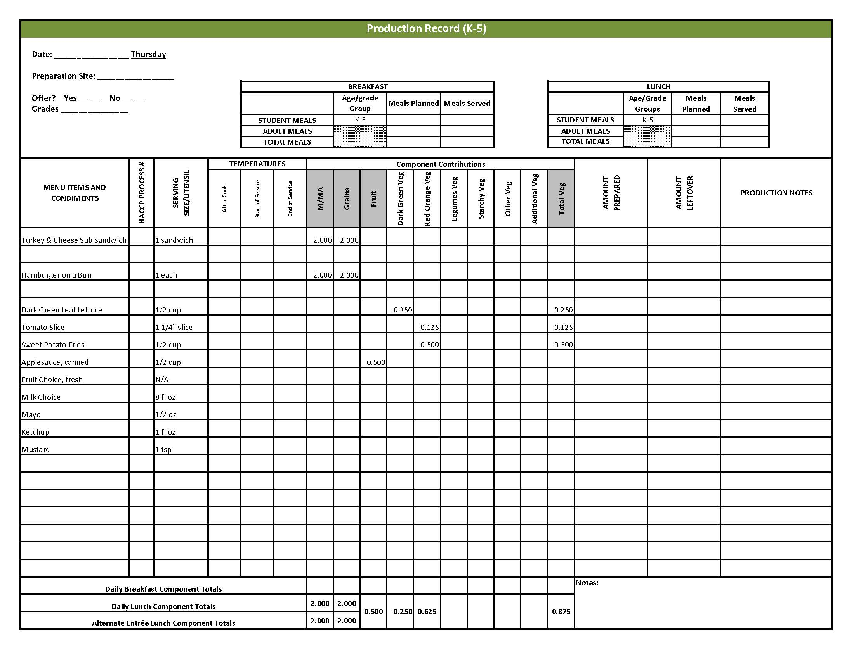

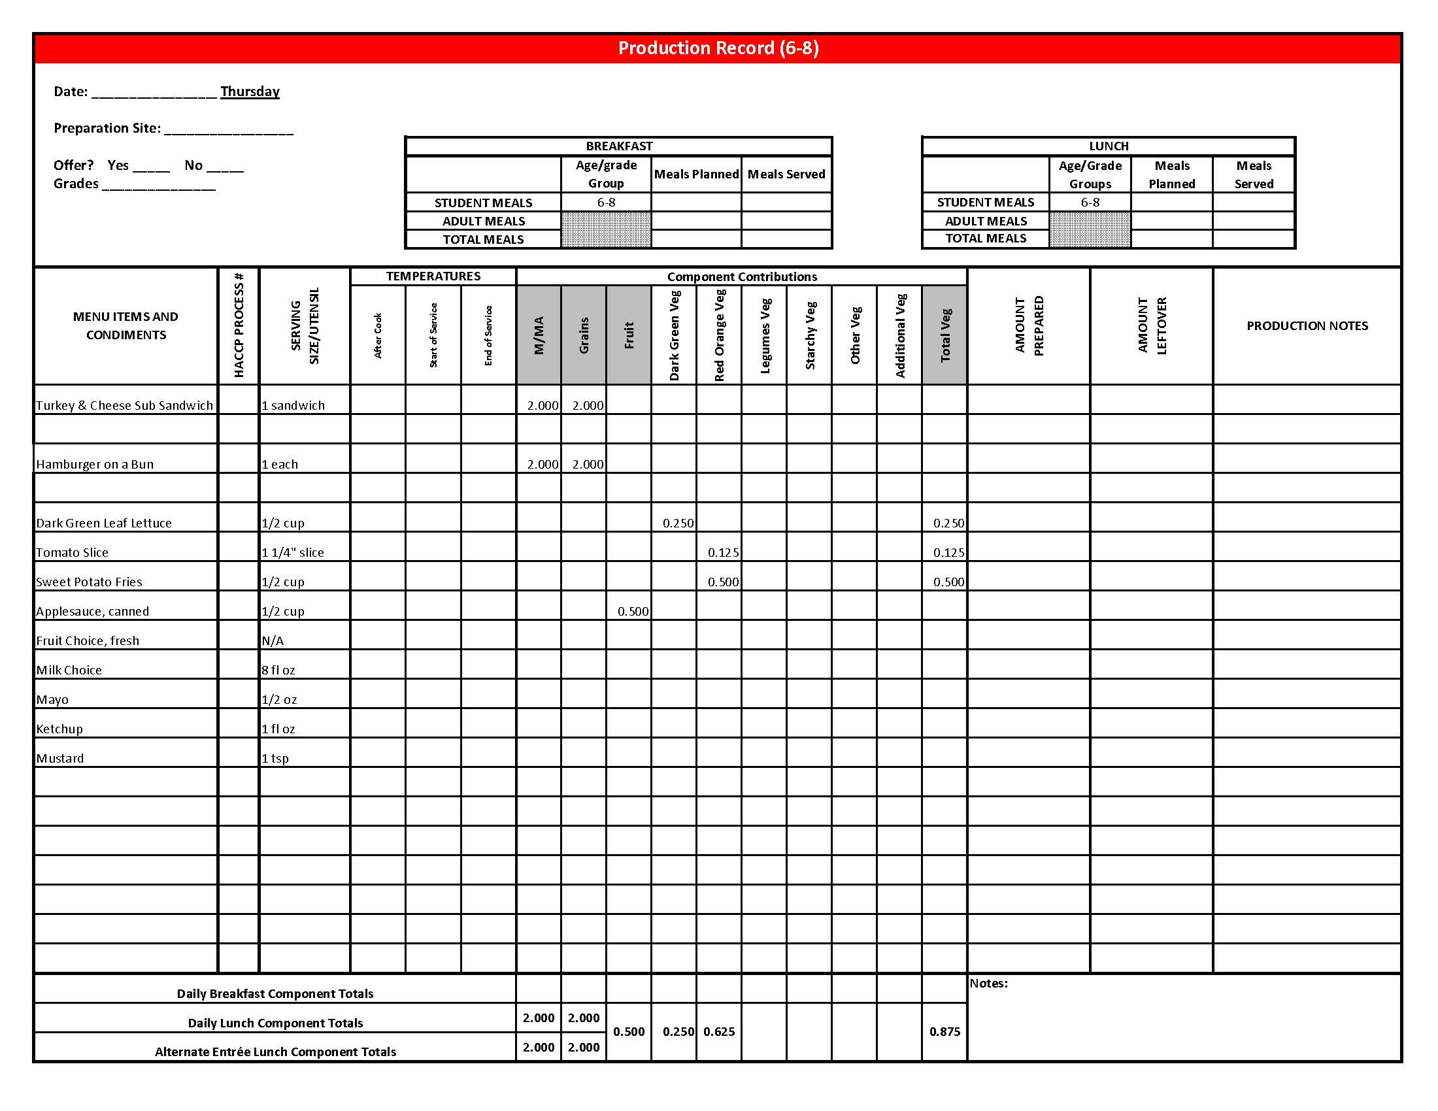

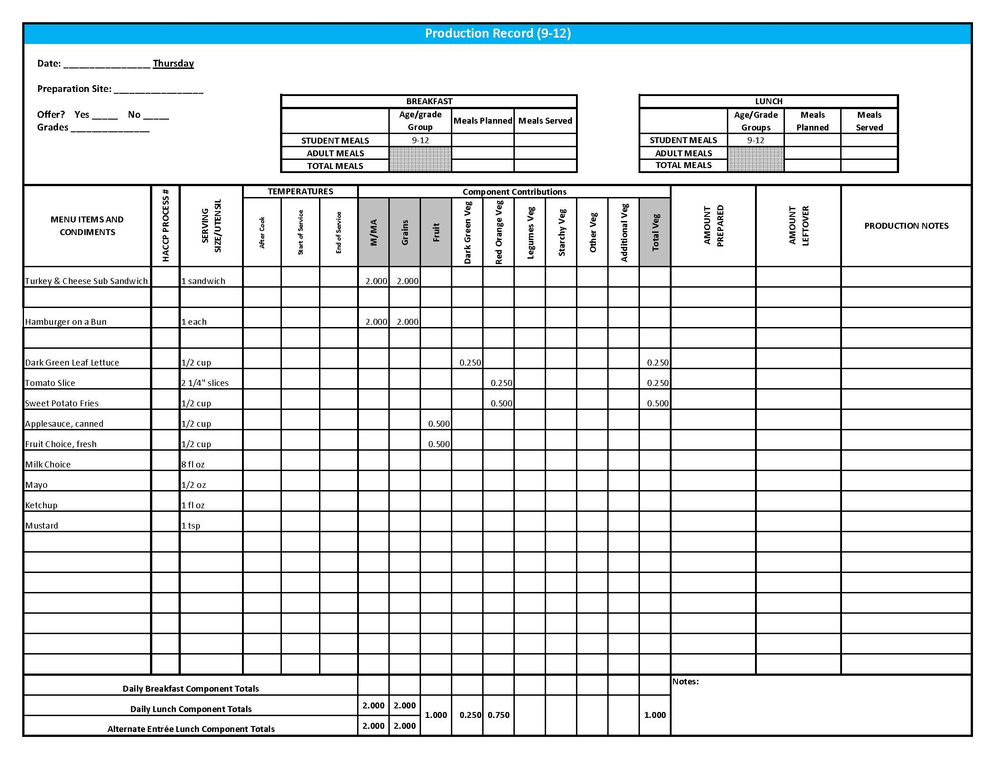

## Purchasing, Preparation & Serving Instructions

Week 4 – Friday

|  |  |  |
| --- | --- | --- |
| **Menu Item** | **Purchasing & Preparation** | **Serving** |
| Country Style Beef Patty | * Purchase a pre-cooked, breaded beef patty that provides at least 2 oz equivalent M/MA and 1 oz equivalent Grains; no more than 15 gm of fat; and no more than 400 mg of sodium per serving. If product is not Child Nutrition (CN) labeled, obtain a Product Formulation Statement. * Prepare according to manufacturer’s instructions. * **CCP: Hold for hot service at 135°F or above.** | K-12: 1 each |
| Whole Wheat Roll | * Prepare HKM Recipe 877, Whole Wheat Rolls, Bread Sticks and Buns. | K-5: N/A  6-12: 1 each (1 oz) |
| **Alternate Entrée:**  Cheese Pizza | * Purchase pre-prepared cheese pizza that provides 2 oz equivalent M/MA and 2 oz equivalent Grains; no more than 8 gm of fat; and no more than 600 mg sodium per serving. If product is not Child Nutrition (CN) labeled, obtain a Product Formulation Statement. * Heat in oven according to manufacturer’s instructions. * **CCP: Hold for hot service at 135°F or above.** | K-12: 1 piece |
| Mashed Potatoes | * Refer to *Fruit & Vegetable Order Guide* for amount needed. Purchase dehydrated mashed potatoes. * Do not add margarine. Add salt only if the product has less than 50 mg of sodium per ½ cup prepared. Add no more than 2 tablespoons of salt per 70 cups prepared potatoes. * **CCP: Hold for hot service at 135°F or above.** | K-12: ½ cup |
| Broccoli, steamed | * Refer to *Fruit & Vegetable Order Guide* for amount needed. * Batch cook close to serving time by steaming or by stock pot with minimal liquid. * **CCP: Hold for hot service at 135°F or above.** | K-12: ½ cup |

## 

*Continued on next page*

Purchasing, Preparation & Serving Instructions

Week 4 – Friday, continued

|  |  |  |
| --- | --- | --- |
| **Menu Item** | **Purchasing & Preparation** | **Serving** |
| Orange Wedges, fresh | * Refer to *Fruit & Vegetable Order Guide* for amount needed. Purchase oranges, size #138. * Handle with gloved hands. Rinse peel. * Cut in fourths. For orange wedges cut in quarters lengthwise. For orange smiles trim ends, cut in two circles and then slice circles in half. * Cover and refrigerate. * **CCP: Hold for cold service at 41°F or below.** | K-12: 1 orange |
| Fruit Choice, canned | Select an additional fruit choice to offer on the menu.  The serving(s) offered must credit as ½ cup of fruit, to meet the minimum daily requirement, for grades 9-12.  *Note: The fruit choice is encouraged for grades K-5 and 6-8, but not required.  The fruit choice is not included in the nutrient analysis for grades K-5 and 6-8. | K-8: N/A*  9-12: ½ cup |
| Milk | * Provide a variety of milk. May be 1% fat (unflavored) or skim (flavored or unflavored). * **CCP: Refrigerate and hold at 41°F or below for cold service.** | K-12: 8 fl oz |
| Gravy | * Purchase a gravy mix with no more than 1 gm of fat per fl oz and prepare according to package directions. * **CCP: Hold for hot service at 135°F or above.** | K-12: 1 fl oz |
| Jelly | * Purchase .5 oz packets or purchase in bulk container. | K-5: N/A  6-12: ½ oz each  **or**1 Tbsp |

**Pre-preparation for Week 1 - Monday:** Chill fruit cocktail.

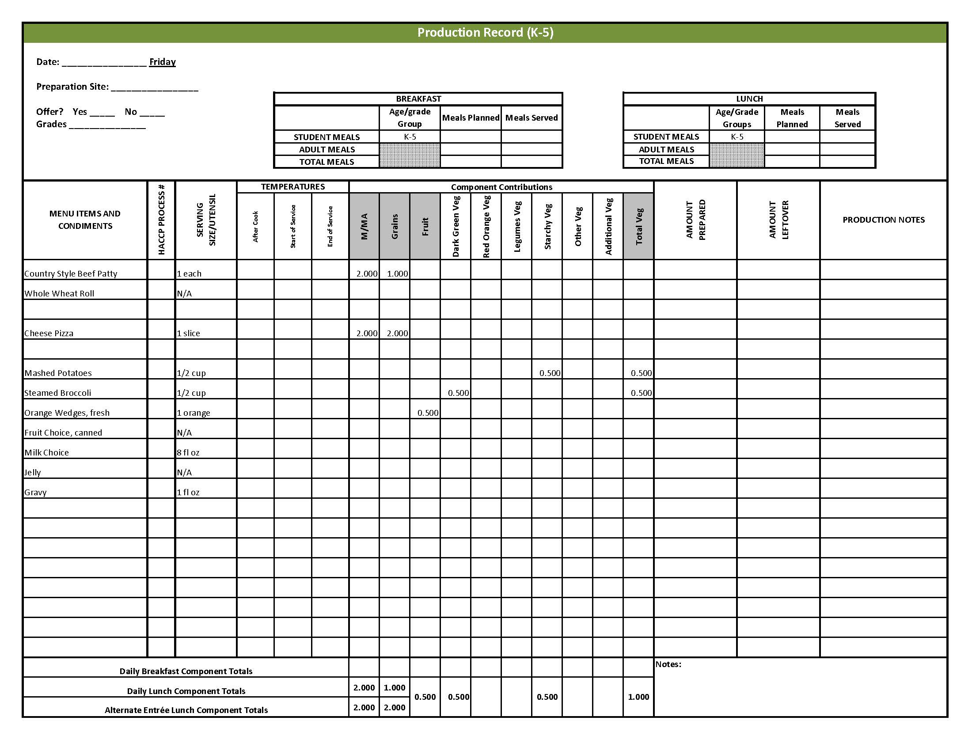

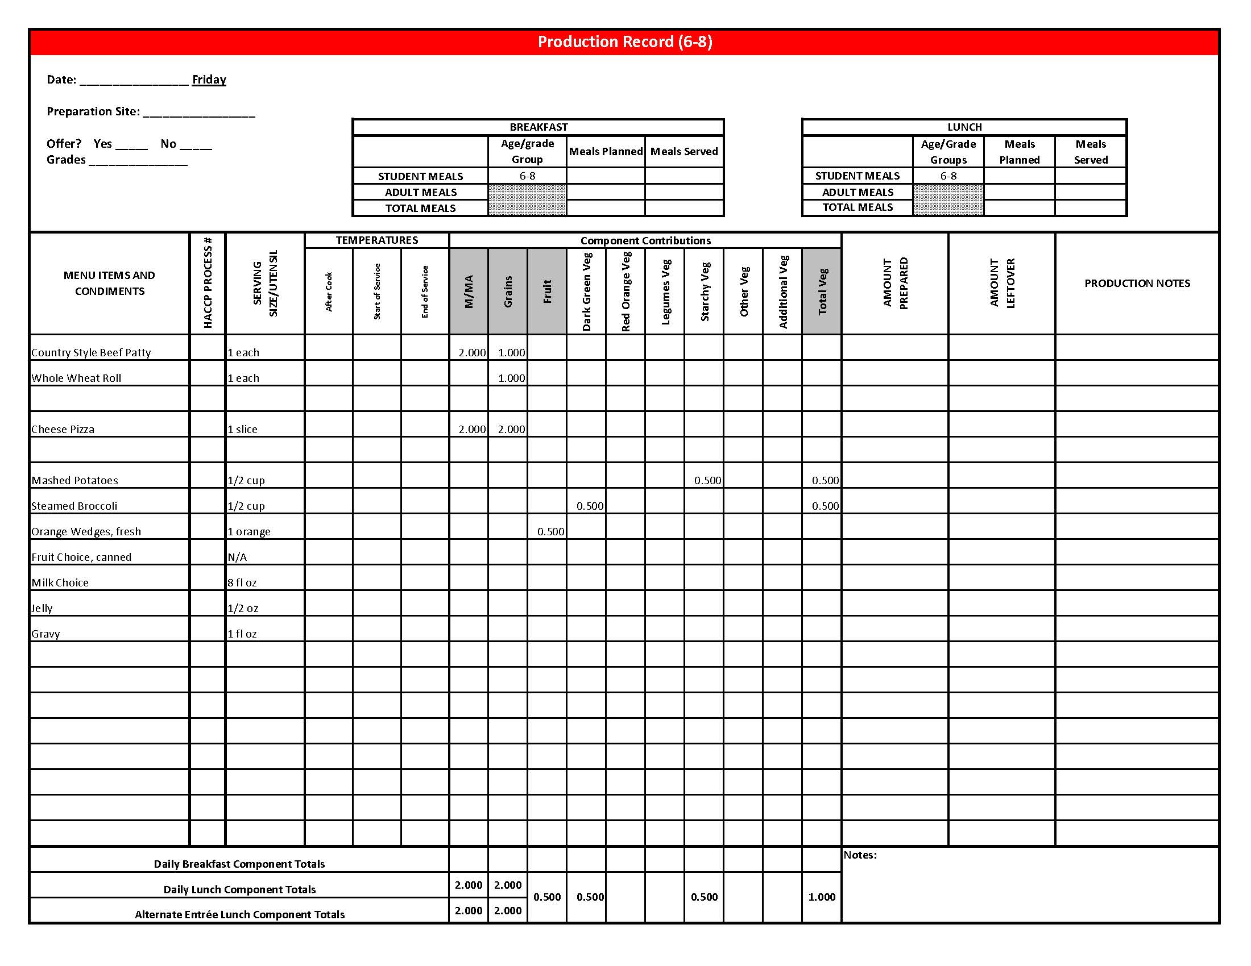

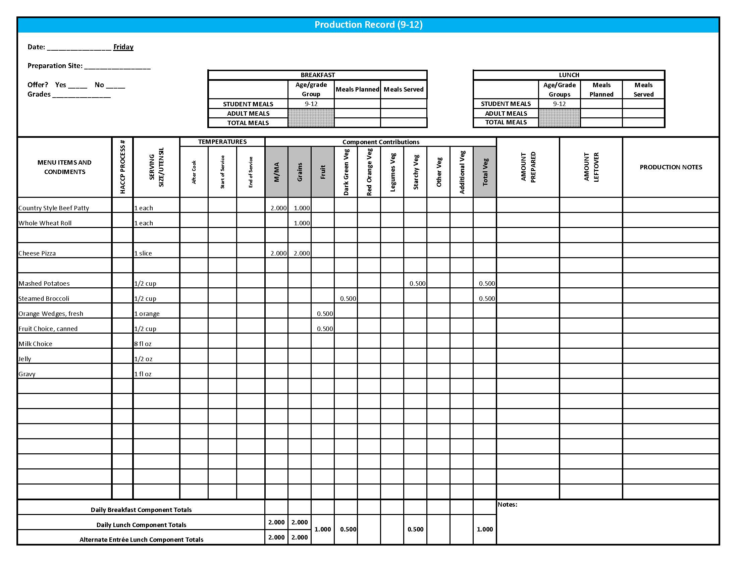

## Fruit & Vegetable Order Guide

**Week 4**

The chart below provides amounts to be ordered per 100 servings based on the serving sizes listed on Week 1 of *Healthier Kansas Menus Production Records* for students in grades groups K-5, 6-8, and 9-12. Amounts to order are based on standard yields and leveled serving utensils or weighed portions. Use the following procedures to determine the amounts to order:

1. **Forecast** the number of servings needed for each fruit and vegetable menu item for each grade group served.
2. **Divide** the number of servings needed by 100 for each portion size (K-5, 6-8 or 9-12).
3. **Multiply** the “Amount to order per 100 servings” by the factor determined in step 2 above for each portion size.
4. **Add** amounts needed for all serving sizes together to determine the amounts to order.

**Abbreviations Key: EP = Edible Portion AP = As Purchased lb = Pound oz = ounce # = Number**

|  |  |  |  |  |  |  |  |
| --- | --- | --- | --- | --- | --- | --- | --- |
| **Day** | **Fruit or Vegetable** | **K-5**  **Portion Size** | **K-5**  **Amount to Order per 100 Servings** | **6-8**  **Portion Size** | **6-8**  **Amount to Order**  **per 100 Servings** | **9-12 Portion Size** | **9-12 Amount to Order per 100 Servings** |
| Monday | Lettuce, Romaine, AP | ½ cup | 6 lb 7 oz | ½ cup | 6 lb 7 oz | ½ cup | 6 lb 7 oz |
| Mexican Corn | ½ cup |  |  |  |  |  |
| Corn, frozen, whole kernel **OR** |  | 18 lb 4 oz |  | 18 lb 4 oz |  | 18 lb 4 oz |
| Corn, canned, whole kernel, liquid packed |  | 5.2 #10 cans |  | 5.2 #10 cans |  | 5.2 #10 cans |
| Green Bell Pepper, fresh, AP |  | 1 medium pepper |  | 1 medium pepper |  | 1 medium pepper |
| Red Bell Pepper, fresh, AP |  | 1 medium pepper |  | 1 medium pepper |  | 1 medium pepper |
| Picante Sauce **OR** | ¼ cup | 1 gal 9 cups | ¼ cup | 1 gal 9 cups | ¼ cup | 1 gal 9 cups |
| Tomato, crushed, salsa- ready, canned (for Tomato Salsa) | 2 #10 can |  | 2 #10 can |  | 2 #10 can |  |
| Jalapeno Peppers, canned (for Tomato Salsa) | 4 oz |  | 4 oz |  | 4 oz |  |
| Pear, fresh, 120 count, AP | 1 each | 25 lb 7 oz or 100 each | 1 each | 25 lb 7 oz or 100 each | 1 each | 25 lb 7 oz or 100 each |
| Blueberry Oat Muffin | 2 muffins |  | 2 muffins |  | 2 muffins |  |
| Applesauce, canned, unsweetened |  | 1 ½ #10 can |  | 1 ½ #10 can |  | 1 ½ #10 can |
| Blueberries, frozen, unsweetened |  | 5 lb |  | 5 lb |  | 5 lb |

Fruit & Vegetable Order Guide

**Week 4, continued**

|  |  |  |  |  |  |  |  |
| --- | --- | --- | --- | --- | --- | --- | --- |
| **Day** | **Fruit or Vegetable** | **K-5**  **Portion Size** | **K-5**  **Amount to Order per 100 Servings** | **6-8**  **Portion Size** | **6-8**  **Amount to Order**  **per 100 Servings** | **9-12 Portion Size** | **9-12 Amount to Order per 100 Servings** |
| Tuesday | Garden Salad: | 1 cup |  | 1 cup |  | 1 cup |  |
| Lettuce, Romaine, AP |  | 6 lb 8 oz |  | 6 lb 8 oz |  | 6 lb 8 oz |
| Spinach, fresh, trimmed, AP | 6 lb 8 oz | 6 lb 8 oz | 6 lb 8 oz |
| Tomato, fresh, AP | 1 lb 5 oz | 1 lb 5 oz | 1 lb 5 oz |
| Carrots, fresh, AP | 15 oz | 15 oz | 15 oz |
| Cucumber, fresh, AP | 14 oz | 14 oz | 14 oz |
| Carrots, baby, fresh, EP | ½ cup | 15 lb 10 oz | ½ cup | 15 lb 10 oz | ½ cup | 15 lb 10 oz |
| Plum, fresh, 45-50 count, AP | 1 each | 20 lb 2 oz or 100 each | 1 each | 20 lb 2 oz or 100 each | 1 each | 20 lb 2 oz or 100 each |
| Wednesday | Snow Peas, fresh | ½ cup | 20 lb 10 oz | ½ cup | 20 lb 10 oz | ½ cup | 20 lb 10 oz |
| Baked Beans | ½ cup |  | ½ cup |  | ½ cup |  |
| Beans, baked, canned, vegetarian |  | 4.25 #10 cans |  | 4.25 #10 cans |  | 4.25 #10 cans |
| Tomato Sauce, canned | 6 cups | 6 cups | 6 cups |
| Watermelon, fresh, AP | ½ cup | 32 lb 13 oz | ½ cup | 32 lb 13 oz | ½ cup | 32 lb 13 oz |
| Thursday | Lettuce, Dark Green Leafy, AP | ½ cup | 9 lb 7 oz | ½ cup | 9 lb 7 oz | ½ cup | 9 lb 7 oz |
| Tomato, large, fresh, AP | ¼” slice | 5 lb 12 oz | ¼” slice | 5 lb 12 oz | 2 - ¼” slices | 11 lb 8 oz |
| Sweet Potato Fries, crinkle-cut, frozen | ½ cup | 16 lb | ½ cup | 16 lb | ½ cup | 16 lb |
| Applesauce, canned, unsweetened | ½ cup | 4.4 #10 cans | ½ cup | 4.4 #10 cans | ½ cup | 4.4 #10 cans |
| Friday | Potatoes, dehydrated, flakes | ½ cup prepared | 4 lb | ½ cup prepared | 4 lb | ½ cup prepared | 4 lb |
| Broccoli, frozen, chopped | ½ cup | 21 lb | ½ cup | 21 lb | ½ cup | 21 lb |
| Oranges, fresh, whole, #138 | 1 orange | 29 lb 8 oz or 100 each | 1 orange | 29 lb 8 oz or 100 each | 1 orange | 29 lb 8 oz or 100 each |