Healthier Kansas Menus

with Alternate Entrées

# C:\Documents and Settings\jmackey\My Documents\My Pictures\Microsoft Clip Organizer\j0349505.wmf

SPRING WEEK 3 – DAILY PRODUCTION RECORDS

Child Nutrition & Wellness, Kansas State Department of Education

Revised July 2019

This publication has been funded at least in part with Federal funds from the U.S. Department of Agriculture, Food and Nutrition Service. The contents of this publication do not necessarily reflect the views or policies of the Department, nor does mention of trade names, commercial products, or organizations imply endorsement by the U.S. Government.

**For further information about this publication, please contact:** Child Nutrition & Wellness, KSDE, Landon State Office Building, 900 SW Jackson Street, Suite #251, Avenue, Topeka, Kansas 66612, 785-296-2276, Fax: 785-296-0232,

[www.kn-eat.org](http://www.kn-eat.org/)

In accordance with Federal civil rights law and U.S. Department of Agriculture (USDA) civil rights regulations and policies, the USDA, its Agencies, offices, and employees, and institutions participating in or administering USDA programs are prohibited from discriminating based on race, color, national origin, sex, disability, age, or reprisal or retaliation for prior civil rights activity in any program or activity conducted or funded by USDA.  
  
Persons with disabilities who require alternative means of communication for program information (e.g. Braille, large print, audiotape, American Sign Language, etc.), should contact the Agency (State or local) where they applied for benefits. Individuals who are deaf, hard of hearing or have speech disabilities may contact USDA through the Federal Relay Service at (800) 877-8339. Additionally, program information may be made available in languages other than English.  
  
To file a program complaint of discrimination, complete the [USDA Program Discrimination Complaint Form](http://www.ocio.usda.gov/sites/default/files/docs/2012/Complain_combined_6_8_12.pdf), (AD-3027) found online at: [http://www.ascr.usda.gov/complaint_filing_cust.html](https://www.ascr.usda.gov/filing-discrimination-complaint-usda-customer), and at any USDA office, or write a letter addressed to USDA and provide in the letter all of the information requested in the form. To request a copy of the complaint form, call (866) 632-9992. Submit your completed form or letter to USDA by:  
  
(1)   Mail: U.S. Department of Agriculture  
Office of the Assistant Secretary for Civil Rights  
1400 Independence Avenue, SW  
Washington, D.C. 20250-9410;  
  
(2)   Fax: (202) 690-7442; or  
  
(3)   Email: [program.intake@usda.gov](mailto:program.intake@usda.gov).  
  
This institution is an equal opportunity provider.

The following person has been designated to handle inquiries regarding the non-discrimination policies at the Kansas State Department of Education: Office of General Counsel, Landon State Office Building, 900 SW Jackson St, Suite #102, Topeka, KS 66612, (785)296-3201.

Healthier Kansas Menus recipes were developed by Child Nutrition & Wellness, Kansas State Department of Education or adapted from the following sources:

* *Food for Fifty,* Ninth Edition (1989) Grace Shugart, Mary Molt*.*
* *Healthier Kansas Menus – Breakfast,* Child Nutrition & Wellness, Kansas State Department of Education
* *Iowa Gold Star Cycle Menus*, Iowa Department of Education
* *Menus that Move,* Ohio Department of Education.
* *Fruit and Veggie Quantity Cookbook,* New Hampshire Department of Health and Human Services.
* *Preparing Whole Grain Foods,* Child Nutrition & Wellness, Kansas State Department of Education
* *Singing the Praises of Beans & Legumes*, Child Nutrition & Wellness, Kansas State Department of Education
* *USDA Recipes for Schools,* U.S. Department of Agriculture, Food & Nutrition Service, Child Nutrition Programs, 2006.
* USD 225 Fowler
* USD 234 Fort Scott
* USD 267 Renwick
* USD 306 Southeast of Saline
* USD 308 Hutchinson
* USD 320 Wamego
* USD 349 Stafford
* USD 364 Marysville
* USD 503 Parsons
* USD 512 Shawnee Mission

Thank you to the following schools for assisting with menu development and recipe testing:

* Logan Elementary School – USD 345 Seaman
* St. Joseph Catholic School – Mt. Hope, KS
* Winfield Scott Elementary School – USD 234 Fort Scott

## Menus for the Week

**PLEASE NOTE:**

Milk choice includes a variety of non-fat or 1% (flavored or unflavored) milk. One milk choice must be unflavored.

Reduced fat dressing is served with salads and fresh vegetables.

Menus were planned using all whole grain-rich products. Beginning July 1, 2019, at least half of the weekly grains in the school lunch menu and the school breakfast menu must be whole grain-rich.

|  |  |  |  |  |  |  |  |  |
| --- | --- | --- | --- | --- | --- | --- | --- | --- |
| **MONDAY** | **TUESDAY** | **WEDNESDAY** | **THURSDAY** | **FRIDAY** | **Weekly Nutrient Averages** | | | |
|  | K-5 | 6-8 | 9-12 |
| Chicken Tetrazzini  Garlic Bread  **Or**  Pork Rib on a Bun  Tossed Salad  Sliced Cucumber  Baby Carrots  Fresh Apple  Canned Fruit Choice  Milk Choice | Hamburger on a Bun  **Or**  Popcorn Chicken  **Whole Wheat Roll (9-12)**  Dark Green Leaf Lettuce  Tomato Slice  Oven Fries  Red Bell Pepper Strips  Fruit Cocktail  Fresh Fruit Choice  Milk Choice | Pancakes  Sausage Patty  **Or**  Fruit, Yogurt & Granola Parfait  Hash Brown Patty  Green Beans  Fresh Raspberries  Canned Fruit Choice  Milk Choice | Baked Chicken Drumstick  w/ Savory Rice  & Oatmeal Roll  **Or**  Turkey & Cheese Sub Sandwich  Fresh Broccoli Cherry Tomatoes  Fresh Grapes  Canned Fruit Choice  Milk Choice | Yummy Sloppy Joe on a Bun  **Or**  Peanut Butter & Jelly Sandwich  Roasted Red Potatoes  Edamame  Fresh Peach  Canned Fruit Choice  Milk Choice | **Calories**  **Sodium (mg)**  **% of Total Calories from Sat. Fat** | **636**  **814**  **7.7%** | **666**  **847**  **7.7%** | **772**  **923**  **7.2%** |

C:\Documents and Settings\jmackey\My Documents\My Pictures\Microsoft Clip Organizer\j0349505.wmf

## Recipes for the Week

|  |  |  |  |
| --- | --- | --- | --- |
| Day | Recipe Name | Recipe Number | HKM Recipe  Page Number |
| Monday | Chicken Tetrazzini  Tossed Salad  French Garlic Bread | 7  74  163 | 13  62  89 |
| Tuesday | Whole Wheat Roll | 877 | 91 |
| Wednesday | N/A |  |  |
| Thursday | Baked Chicken Drumstick  Savory Rice  Oatmeal Roll  Turkey and Cheese Sub  Whole Wheat Bun | 27  17  14  144  877 | 1  79  75  42  91 |
| Friday | Yummy Sloppy Joe  Whole Wheat Bun | 123  877 | 45  91 |

## Abbreviations

|  |  |  |  |
| --- | --- | --- | --- |
| **Abbreviation** | **What it Means** | **Abbreviation** | **What it Means** |
| HKM | Healthier Kansas Menus | Tbsp | tablespoon |
| EP | edible portion | tsp | teaspoon |
| AP | as purchased | CCP | Critical Control Point |
| fl | fluid | PC | portion controlled * |
| oz | ounce | w/ | with |
| lb | pound | M/MA | meat/meat alternate |
| gm | gram |  |  |
| mg | milligram |  |  |

* For example, purchase pre-portioned servings of condiments.

## Portion Guide

|  |  |
| --- | --- |
| **Ladles & Spoodles** | **Scoops** |
| 1 fl oz = 2 Tbsp | #50 = 3 3/4 tsp |
| 2 fl oz = 1/4 cup | #40 = 1 2/3 Tbsp |
| 3 fl oz = 3/8 cup | #30 = 2 Tbsp |
| 4 fl oz = 1/2 cup | #20 = 3 1/3 Tbsp |
| 6 fl oz = 3/4 cup | #16 = 1/4 cup |
| 8 fl oz = 1 cup | #12 = 1/3 cup |
|  | #8 = 1/2 cup |
|  | #6 = 2/3 cup |

## Purchasing, Preparation & Serving Instructions

Week 3 – Monday

|  |  |  |
| --- | --- | --- |
| **Menu Item** | **Purchasing & Preparation** | **Serving** |
| Chicken Tetrazzini | * Prepare HKM Recipe 7, Chicken Tetrazzini. * Purchase chicken broth with no more than 500 mg of sodium per cup. * Purchase dry, whole grain spaghetti noodles and frozen pulled or diced cooked chicken with no skin or added salt. * **CCP: Hold for hot service at 135°F or above.** | K-8: ¾ cup  9-12: 1 cup |
| Garlic Bread | * Prepare HKM Recipe163, Whole Wheat French Garlic Bread. | K-12: 1 piece |
| **Alternate Entrée:**  Pork Rib on a Bun | * Purchase a pre-cooked rib patty that provides 2 oz equivalent M/MA; no more than 10 gm of fat; and no more than 400 mg of sodium per serving. If product is not Child Nutrition (CN) labeled, obtain a Product Formulation Statement. * Heat according to manufacturer’s instructions. * Purchase a 2 oz whole wheat bun (first ingredient is whole wheat) or prepare HKM Recipe 877, Whole Wheat Rolls, Bread Sticks, Buns, hamburger bun variation. * **CCP: Hold for hot service at 135°F or above.** | K-12: 1 sandwich |
| Tossed Salad | * Prepare HKM Recipe 74, Tossed Salad. * Refer to *Fruit & Vegetable Order Guide* for amount needed. * **CCP: Refrigerate and hold at 41°F or below for cold service.** | K-12: 1 cup |
| Cucumber Slices | * Refer to *Fruit & Vegetable Order Guide* for amount needed. * With gloved hands, wash and slice cucumbers. * **CCP: Refrigerate and hold at 41°F or below for cold service.** | K-8: ⅛ cup  9-12: ¼ cup |
| Carrots, baby, fresh | * Refer to *Fruit & Vegetable Order Guide* for amount needed. * Handle with gloved hands or serving utensils. Cover and refrigerate until serving. * Weigh or count number needed per portion. * **CCP: Refrigerate and hold at 41°F or below for cold service.** | K-8: ⅛ cup  9-12: ¼ cup |

*Continued on next page*

Purchasing, Preparation & Serving Instructions

Week 3 – Monday, continued

|  |  |  |
| --- | --- | --- |
| **Menu Item** | **Purchasing & Preparation** | **Serving** |
| Apple Slices, Fresh | * Refer to *Fruit & Vegetable Order Guide* for amount needed. Purchase apples, size #125-138. * Handle with gloved hands. Rinse and remove core. Cut in 4ths or 8ths. * Dip in lemon, orange, pineapple juice or antioxidant solution to preserve color. * Cover and refrigerate until serving. * **CCP: Refrigerate and hold at 41°F or below for cold service.** | K-12: ½ apple |
| Fruit Choice, canned | Select an additional fruit choice to offer on the menu. The serving(s) offered must credit as ½ cup of fruit, to meet the minimum daily requirement, for grades 9-12.  *Note: The fruit choice is encouraged for grades K-5 and 6-8, but not required. The fruit choice is not included in the nutrient analysis for grades K-5 and 6-8. | K-8: N/A*  9-12: ½ cup |
| Milk | * Provide a variety of milk. May be 1% fat (unflavored) or skim (flavored or unflavored). * **CCP: Refrigerate and hold at 41°F or below for cold service.** | K-12: 8 fl oz |
| Ranch Dressing, Reduced Fat | * Purchase or prepare Ranch dressing containing no more than 6 gm of fat  per 1 fl oz. Purchase .8 gallons for every 100 1 fl oz portions. * **CCP: Refrigerate and serve at 41°F or below if school-prepared dressing is served.** | K-12: 1 fl oz **or** 2 Tbsp |
| Ketchup | * Purchase in bulk or individual packets (9-gm or 12-gm). If bulk, purchase 1 #10 can or .8 gallon for every 100 1-fluid oz servings. | K-12: 1 fl oz  **or** 2 Tbsp **or** 2 PC |

**Pre-preparation for Week 3 – Tuesday:** None.

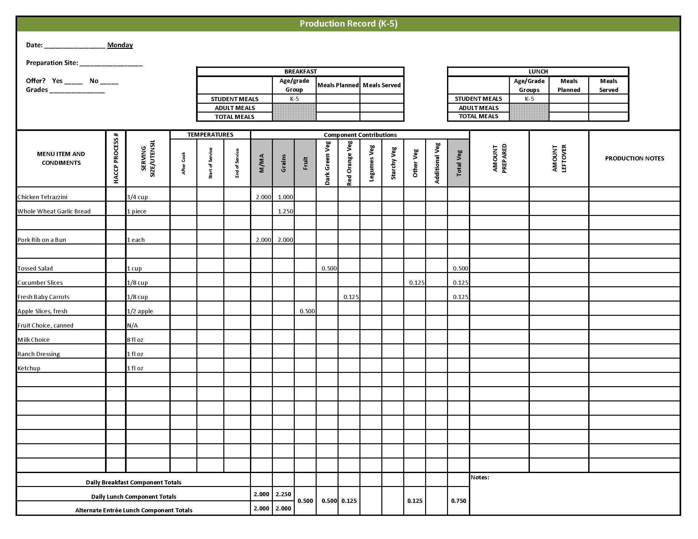

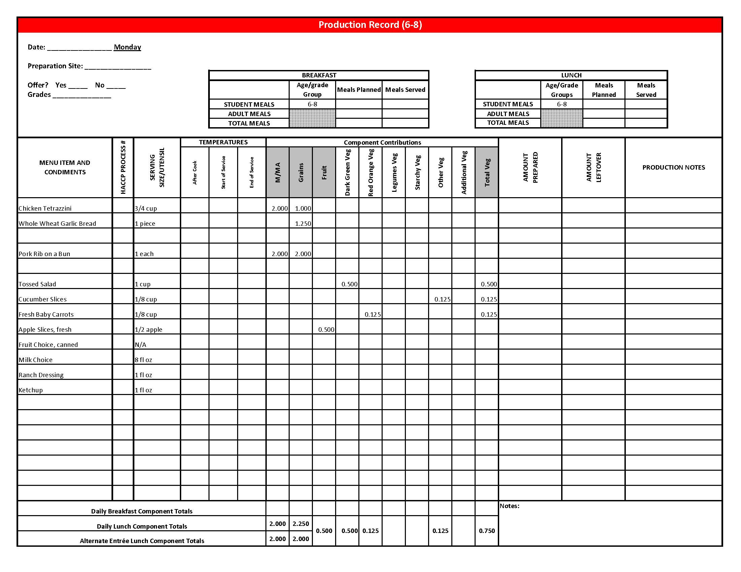

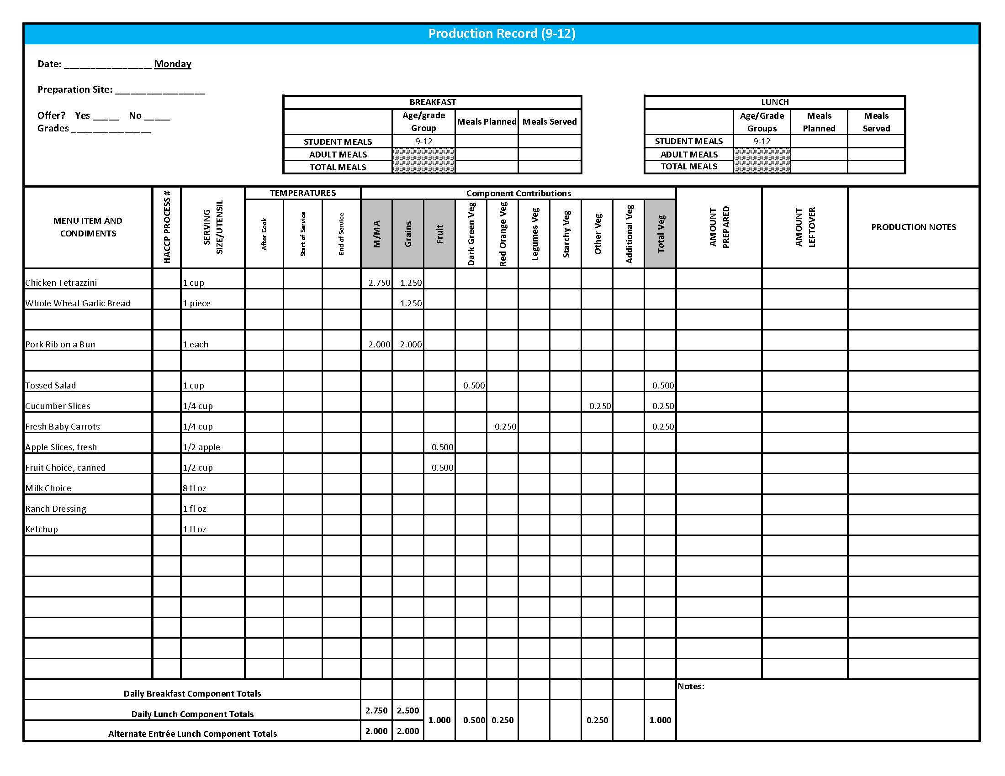

## Purchasing, Preparation & Serving Instructions

Week 3 – Tuesday

|  |  |  |
| --- | --- | --- |
| **Menu Item** | **Purchasing & Preparation** | **Serving** |
| Hamburger on a Bun | * Purchase a pre-cooked, oven-ready hamburger patty that provides 2 oz equivalent M/MA; no more than 16 gm fat; no more than 500 mg sodium. If product is not Child Nutrition (CN) labeled, obtain a Product Formulation Statement. * Heat according to manufacturer’s instructions. * Purchase a 2 oz whole wheat bun (first ingredient is whole wheat) or prepare following HKM Recipe 877, Whole Wheat Rolls, Bread Sticks, Buns. * **CCP: Hold for hot service at 135°F or above.** | K-12: 1 each |
| **Alternate Entrée:**  Chicken, popcorn | * Purchase pre-cooked, oven-ready popcorn chicken that provides 2 oz equivalent M/MA and 1 oz equivalent Grain, no more than 18 gm of fat; and no more than 290 mg sodium per serving. If product is not Child Nutrition (CN) labeled, obtain a Product Formulation Statement. * Heat according to manufacturer’s instructions. * **CCP: Hold for hot service at 135°F or above.** | K-12: 15 pieces (or number needed to provide 2 oz equivalent M/MA & 1 oz equivalent Grain) |
| **Alternate Entrée:**  Whole Wheat Roll | * Prepare HKM Recipe 877, Whole Wheat Rolls, Bread Sticks and Buns. | K-8: N/A  9-12: 1 each (1 oz) |
| Dark Green Leaf Lettuce | * Refer to *Fruit & Vegetable Order Guide* for amount needed. * Handle produce with gloved hands. May be pre-portioned. * **CCP: Refrigerate and hold at 41°F or below for cold service.** | K-12: ½ cup |
| Tomato Slice | * Refer to *Fruit & Vegetable Order Guide* for amount needed. * Handle produce with gloved hands. * Slice ¼” thick. * **CCP: Refrigerate and hold at 41°F or below for cold service.** | K-8: 1 slice  9-12: 2 slices |
| Oven Fries | * Refer to *Fruit & Vegetable Order Guide* for amount needed. Purchase ovenable straight cup fries. * Heat in oven according to manufacturer’s instructions. * **CCP: Hold for hot service at 135°F or above.** | K-12: ½ cup |

*Continued on next page*

## Purchasing, Preparation & Serving Instructions

Week 3 – Tuesday, continued

|  |  |  |
| --- | --- | --- |
| **Menu Item** | **Purchasing & Preparation** | **Serving** |
| Red Bell Pepper Strips | * Refer to *Fruit & Vegetable Order Guide* for amount needed. * With gloved hands, core and slice bell peppers into strips. * **CCP: Refrigerate and hold at 41°F or below for cold service.** | K-12: ½ cup |
| Fruit Cocktail, canned | * Refer to *Fruit & Vegetable Order Guide* for amount needed. * Purchase a canned product that includes peaches, pears, pineapple, grapes, and cherries packed in 100% juice or light syrup. * Chill cans overnight. Wipe tops of cans clean before opening. * Cover, drain, and refrigerate until serving. Serve with slotted utensil. * **CCP: Refrigerate and hold at 41°F or below for cold service.** | K-12: ½ cup |
| Fruit Choice, fresh | Select an additional fruit choice to offer on the menu. The serving(s) offered must credit as ½ cup of fruit, to meet the minimum daily requirement, for grades 9-12.  *Note: The fruit choice is encouraged for grades K-5 and 6-8, but not required. The fruit choice is not included in the nutrient analysis for grades K-5 and 6-8. | K-8: N/A*  9-12: ½ cup |
| Milk | * Provide a variety of milk. May be 1% fat (unflavored) or skim (flavored or unflavored). * **CCP: Refrigerate and hold at 41°F or below for cold service.** | K-12: 8 fl oz |
| Ketchup | * Purchase in bulk or individual packets (9-gm or 12-gm). If bulk, purchase 1 #10 can or .8 gallon for every 100 1-fluid oz servings. | K-12: 1 fl oz **or** 2 Tbsp **or** 2 PC |
| Mustard | * Purchase bulk or packets. If bulk, purchase 2 cups for every 100 1 tsp servings. | K-12: 1 tsp |
| Ranch Dressing, Reduced Fat | * Purchase or prepare Ranch dressing containing no more than 6 gm of fat  per 1 fl oz. Purchase .8 gallons for every 100 1 fl oz portions. * **CCP: Refrigerate and serve at 41°F or below if school-prepared dressing is served.** | K-12: 1 fl oz **or** 2 Tbsp |

**Pre-preparation for Week 3 - Wednesday:** N/A

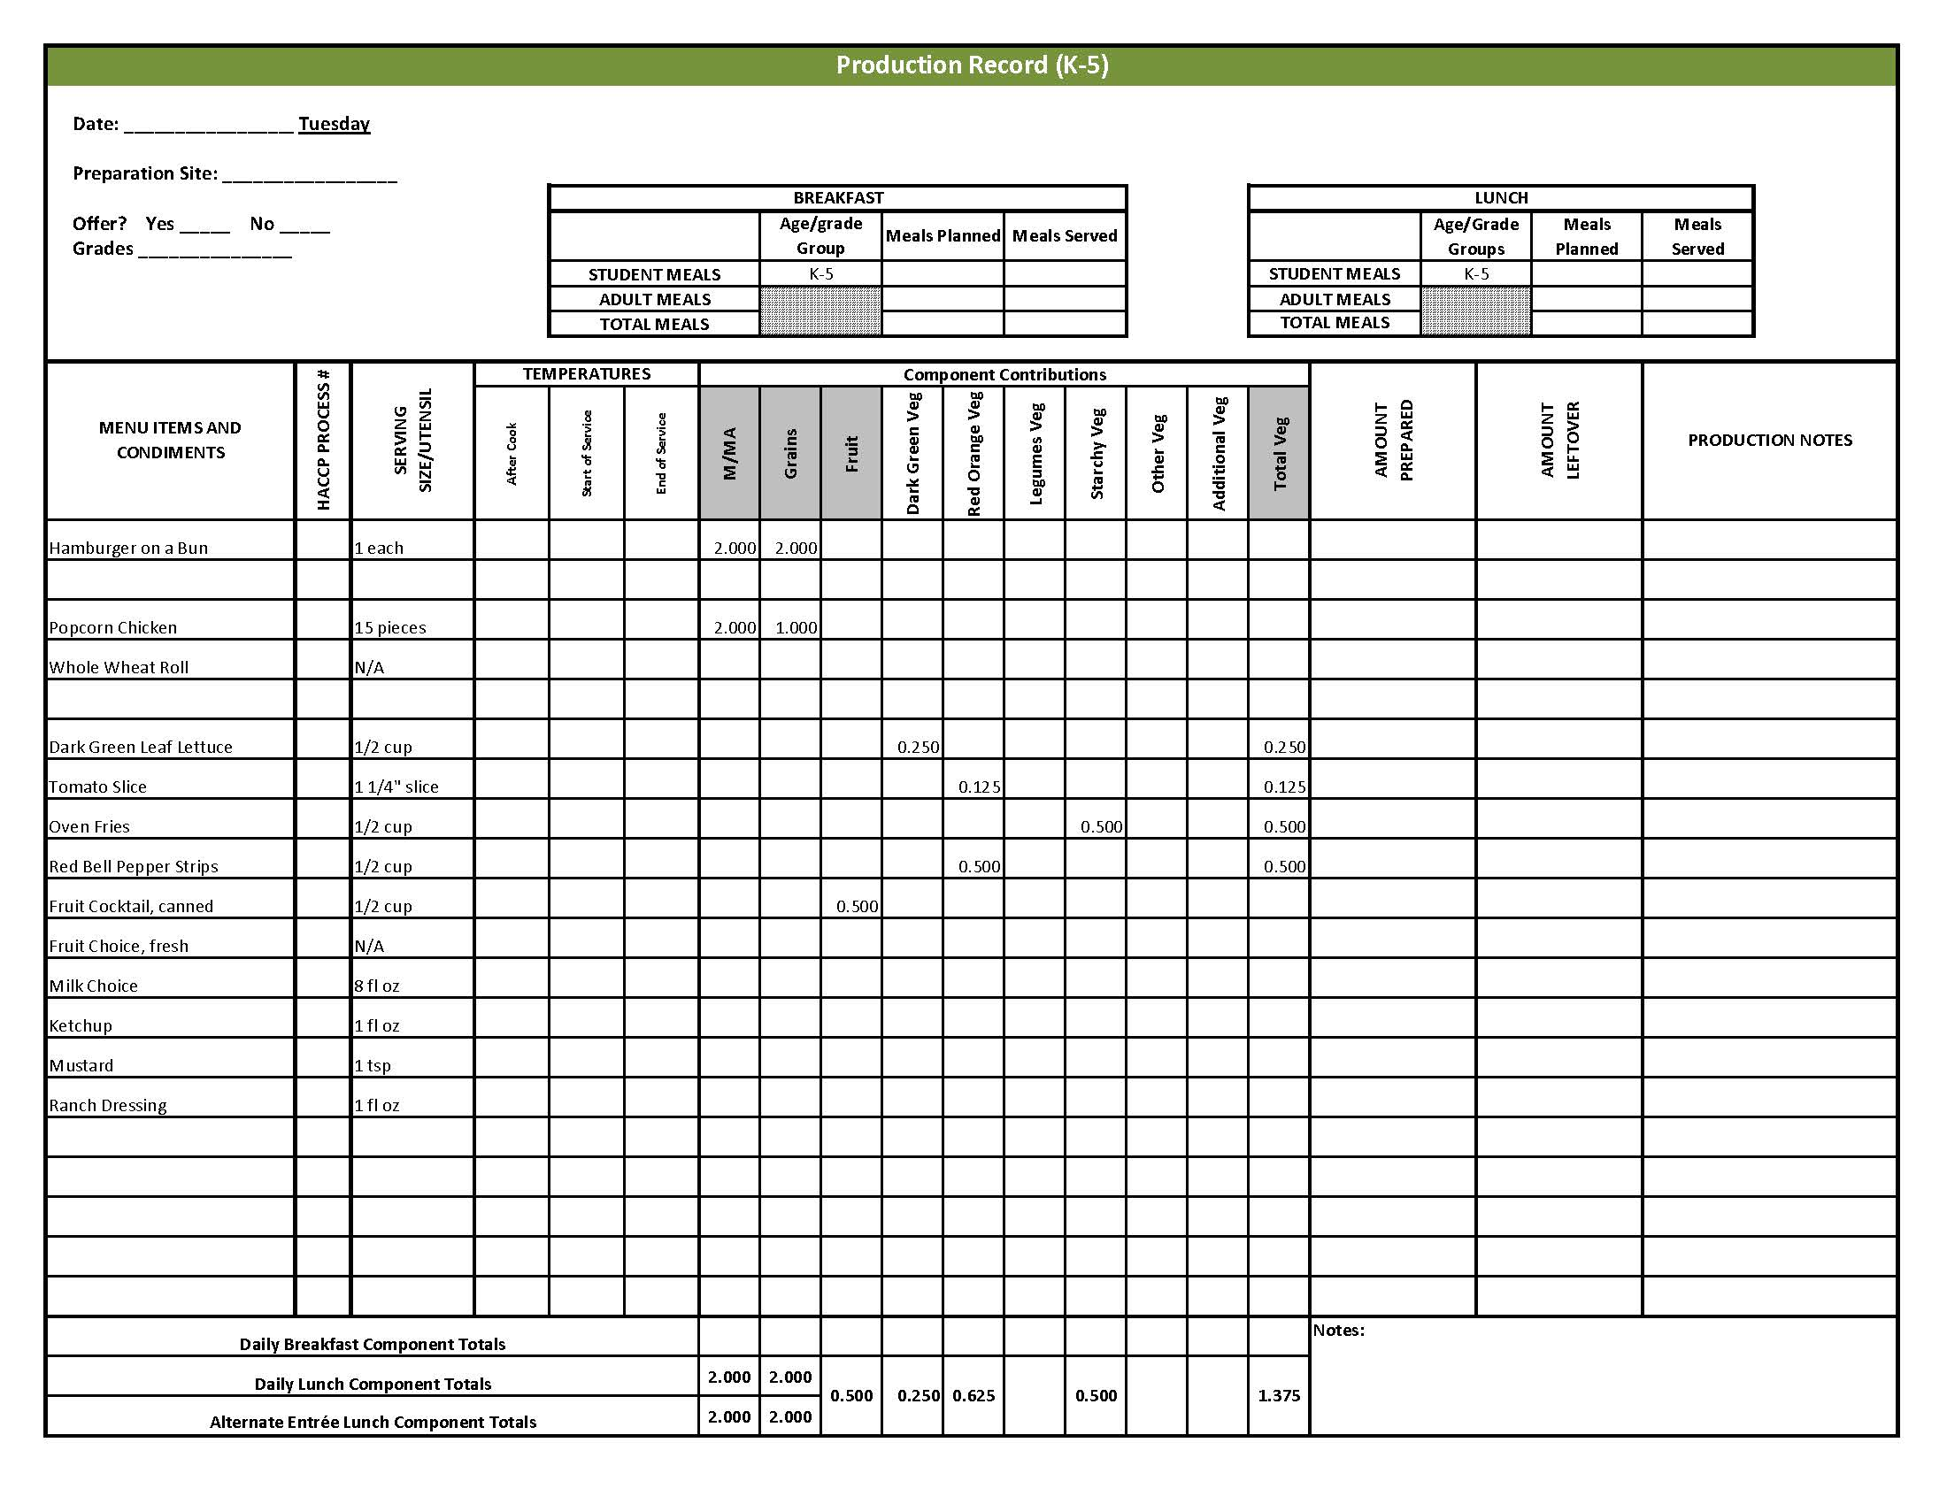

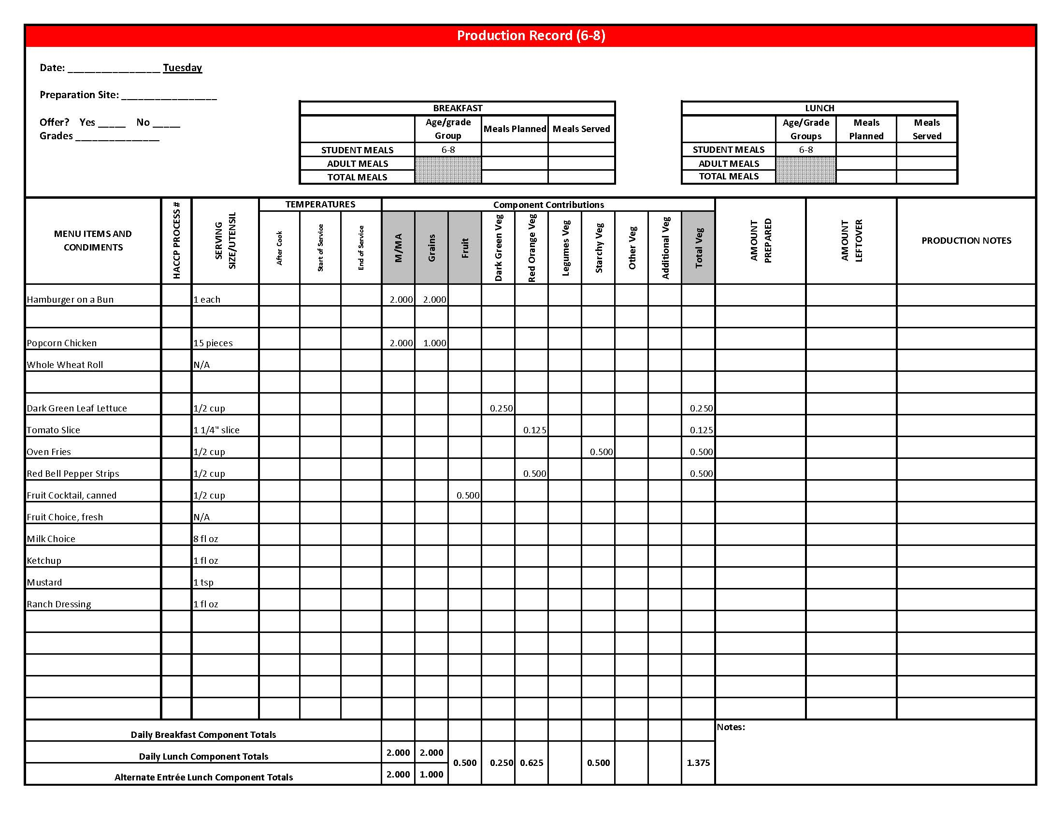x

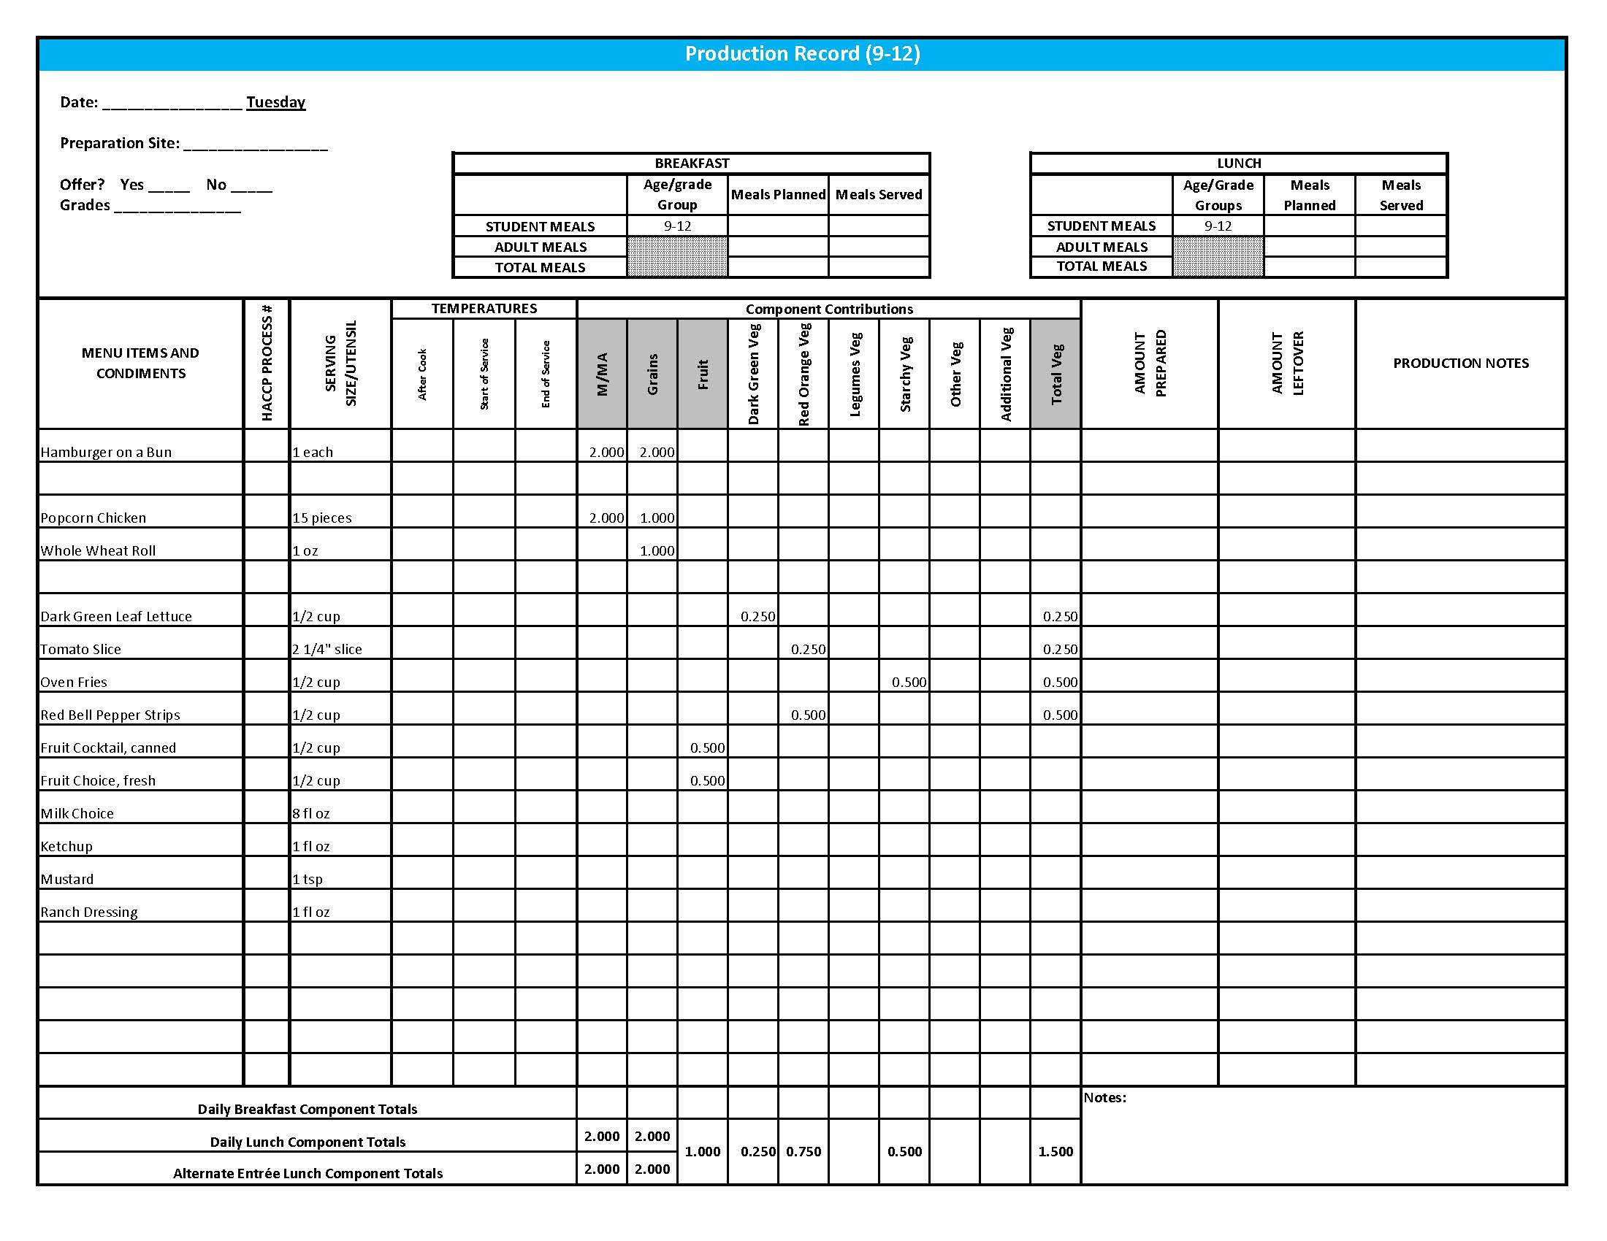

## Purchasing, Preparation & Serving Instructions

Week 3 – Wednesday

|  |  |  |  |
| --- | --- | --- | --- |
| **Menu Item** | **Purchasing & Preparation** | **Serving** | |
| Pancakes | | * Purchase packaged whole grain-rich pancakes that provide 2 oz equivalent Grain per serving. * Heat according to manufacturer’s instructions and hold hot for service. * **CCP: Hold for hot service at 135°F or above.** | K-12: 1 pack |
| Sausage Patty | | * Purchase pre-cooked turkey sausage patties where 1 patty provides 1 oz equivalent M/MA. * Heat according to manufacturer’s instructions. * **CCP: Hold for hot service at 135°F or above.** | K-5: 1 patty  6-12: 2 patties |
| **Alternate Entrée:**  Fruit, Yogurt & Granola Parfait | | * Purchase a fresh, frozen or canned fruit packed in light syrup or 100% juice. Refer to *Fruit & Vegetable Order Guide* for amount needed. * Purchase low-fat, flavored bulk yogurt and portion 1 cup (8 oz) for each serving. * Purchase pre-prepared granola that provides 2 oz Grains per ½ cup serving; no more than 7 gm of fat; and no more than 180 mg of sodium per serving. * Assemble parfait with fruit and yogurt in one cup and granola in different cup. Recommend layering ½ cup yogurt, ¼ cup fruit, ½ cup yogurt and ¼ cup fruit. Portioning granola separately will help to keep granola fresh and crunchy. * **CCP: Refrigerate and hold at 41o F or below for cold service.** | K-12: ½ cup fruit, 8 oz yogurt,  ½ cup granola |
| Hash Brown Patty | | * Purchase 2.25 oz hash brown patties. * Refer to *Fruit & Vegetable Order Guide* for amount needed. * Follow manufacturer’s directions for baking and holding. Batch cook. * **CCP: Hold for hot service at 135°F or above.** | K-8: 1 patty  9-12: 2 patties |
| Green Beans | | * Refer to *Fruit & Vegetable Order Guide* for amount needed. * Wipe can tops clean before opening. * Batch cook by steaming or by stock pot with minimal liquid close to serving time. * **CCP: Hold for hot service at 135°F or above.** | K-12: ½ cup |

*Continued on next page*

## Purchasing, Preparation & Serving Instructions

Week 3 – Wednesday, continued

|  |  |  |
| --- | --- | --- |
| **Menu Item** | **Purchasing & Preparation** | **Serving** |
| Raspberries, fresh | * Refer to *Fruit & Vegetable Order Guide* for amount needed. * With gloved hands, wash raspberries. * **CCP: Refrigerate and hold at 41°F or below for cold service.** | K-12: ½ cup |
| Fruit Choice, canned | Select an additional fruit choice to offer on the menu. The serving(s) offered must credit as ½ cup of fruit, to meet the minimum daily requirement, for grades 9-12.  *Note: The fruit choice is encouraged for grades K-5 and 6-8, but not required. The fruit choice is not included in the nutrient analysis for grades K-5 and 6-8. | K-8: N/A*  9-12: ½ cup |
| Milk | * Provide a variety of milk. May be 1% fat (unflavored) or skim (flavored or unflavored). * **CCP: Refrigerate and hold at 41°F or below for cold service.** | K-12: 8 fl oz |

**Pre-preparation for Week 3 – Thursday:** Thaw chicken under refrigeration.

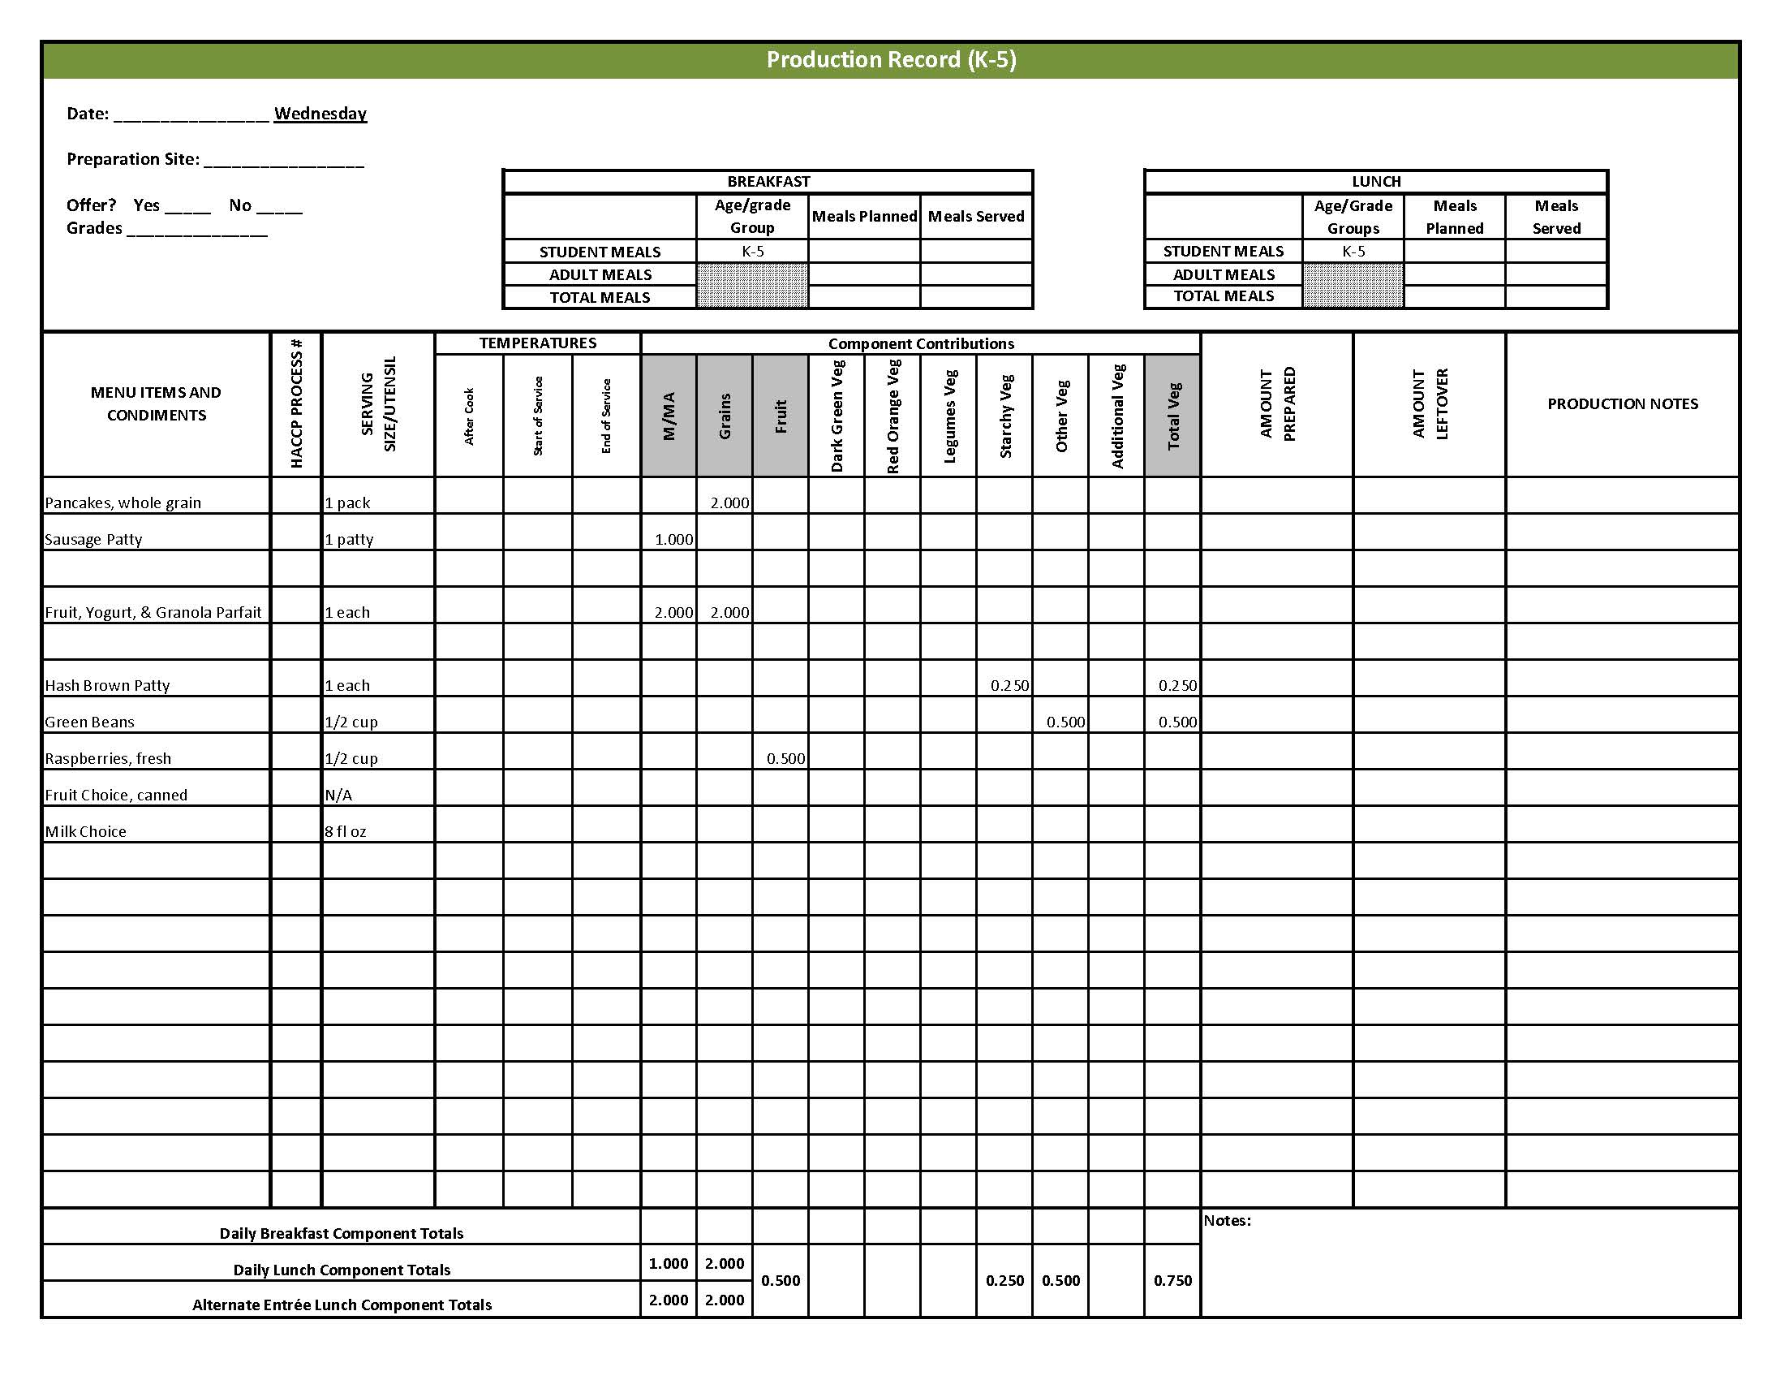

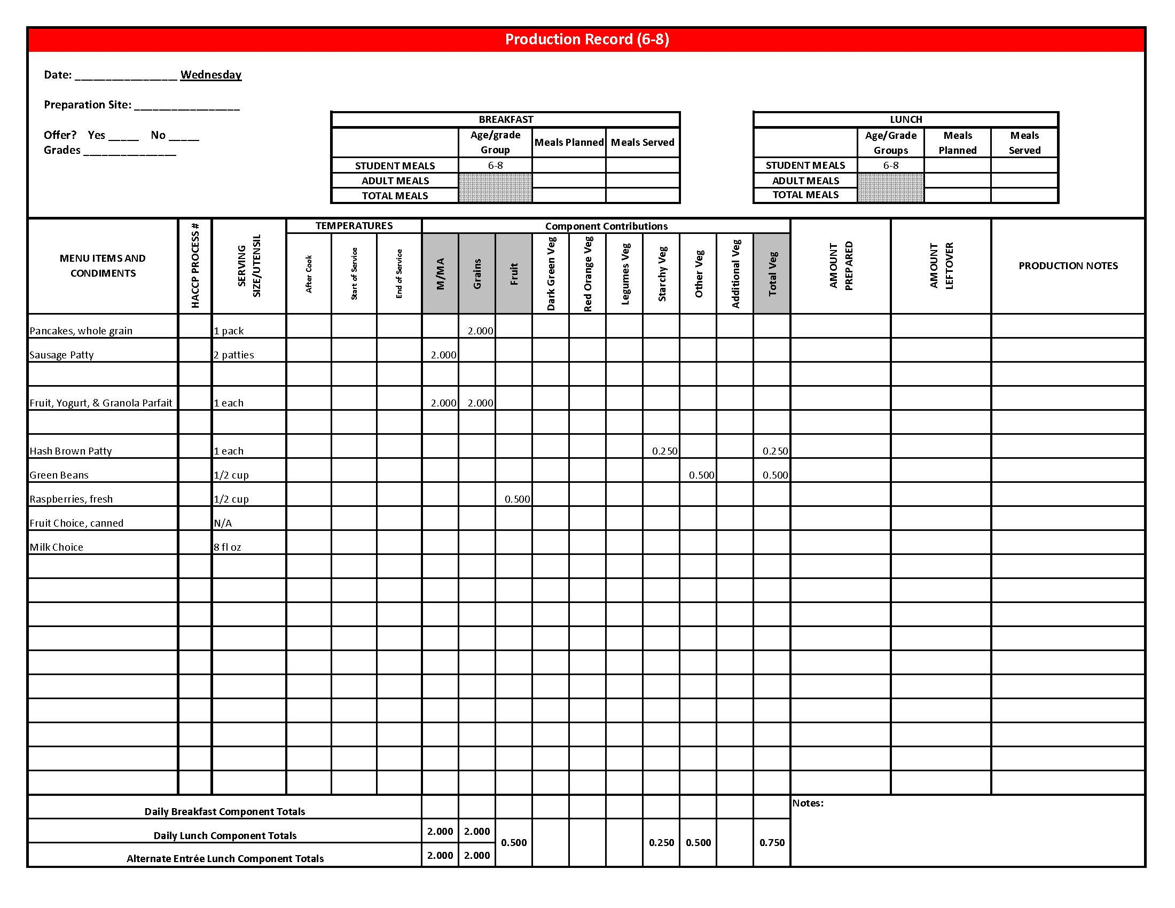

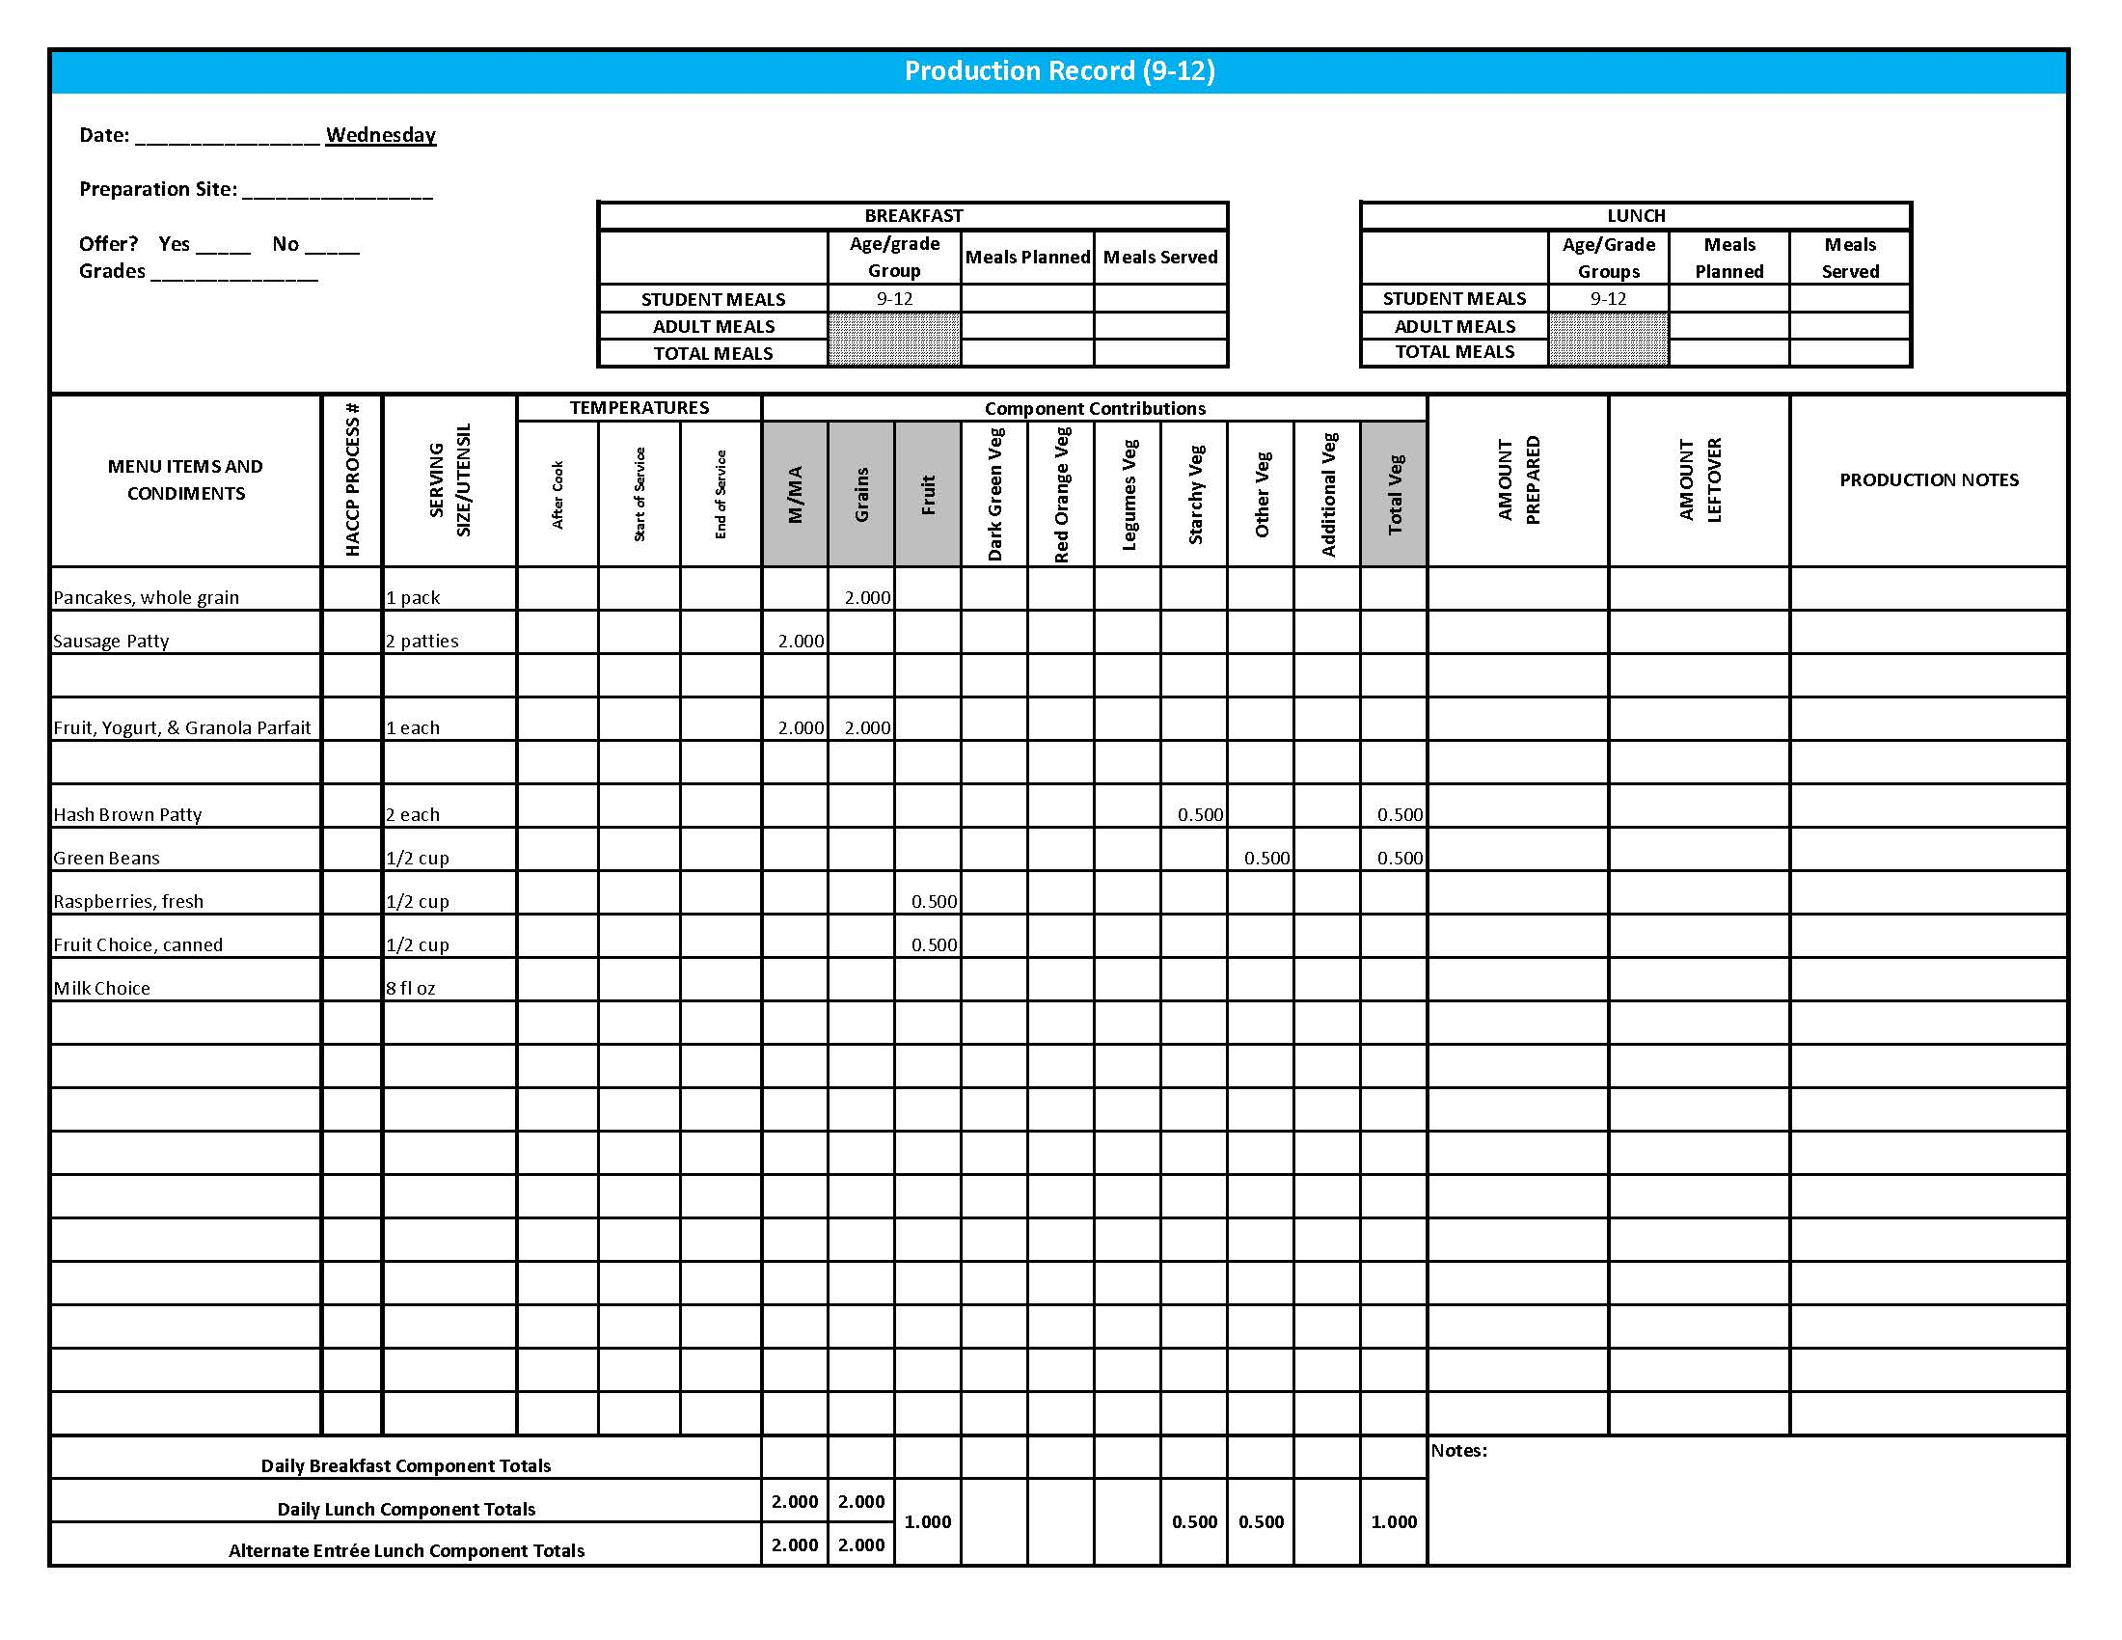

Purchasing, Preparation & Serving Instructions

Week 3 – Thursday

|  |  |  |
| --- | --- | --- |
| **Menu Item** | **Purchasing & Preparation** | **Serving** |
| Baked Chicken Drumstick | * Purchase raw, frozen chicken legs with skin that provide 1.5 oz equivalent M/MA per serving and prepare HKM Recipe 27, Baked Chicken Drumsticks. If product is not Child Nutrition (CN) labeled, obtain a Product Formulation Statement. * **OR** purchase a CN labeled (or one with a Product Formulation Statement), pre-cooked product that provides 1.5 oz equivalent M/MA per serving and prepare according to manufacturer’s instructions. * **CCP: Hold for hot service at 135°F or above.** | K-8: 1 drumstick  9-12: 2 drumsticks |
| Savory Rice | * Prepare HKM Recipe 17, Savory Rice. * Purchase Long Grain & Wild Mix rice with seasoning packets that have less than 600 mg sodium per 1 cup serving prepared. * Purchase chicken base with no more than 750 mg of sodium per cup prepared. * **CCP: Hold for hot service at 135°F or above.** | K-12: ½ cup |
| Oatmeal Roll | * Prepare HKM Recipe 14, Oatmeal Roll. | K-12: 1 each (1 oz) |
| **Alternate Entrée:**  Turkey & Cheese Sub | * Prepare HKM Recipe 144, Turkey & Cheese Sub. * Purchase lean, deli-sliced, turkey with no more than 500 mg of sodium per 2 oz serving. Product should be CN labeled or have a product formulation statement with crediting information. * Purchase a 2 oz whole wheat bun (first ingredient is whole wheat) or prepare HKM recipe 877, Whole Wheat Rolls, Bread Sticks, Buns. * **CCP: Refrigerate and hold at 41°F or below for cold service.** | K-12: 1 sandwich |
| Broccoli Florets | * Refer to *Fruit & Vegetable Order Guide* for amount needed. Purchase fresh broccoli florets, ready to serve. * Wash broccoli. * Cover and refrigerate until serving. * **CCP: Refrigerate and hold at 41°F or below for cold service.** | K-12: ½ cup |

*Continued on next page*

Purchasing, Preparation & Serving Instructions

**Week 3 – Thursday, continued**

|  |  |  |
| --- | --- | --- |
| **Menu Item** | **Purchasing & Preparation** | **Serving** |
| Cherry Tomatoes | * Refer to *Fruit & Vegetable Order Guide* for amount needed. * With gloved hands, wash and stem tomatoes. * **CCP: Refrigerate and hold at 41°F or below for cold service.** | K-12: 6 whole tomatoes (½ cup) |
| Grapes, fresh | * Refer to *Fruit & Vegetable Order Guide* for amount needed. * Wash grapes. Remove from stems or separate out into smaller clusters. * Cover and refrigerate until serving. * **CCP: Refrigerate and hold at 41°F or below for cold service.** | K-12: ½ cup |
| Fruit Choice, canned | Select an additional fruit choice to offer on the menu. The serving(s) offered must credit as ½ cup of fruit, to meet the minimum daily requirement, for grades 9-12.  *Note: The fruit choice is encouraged for grades K-5 and 6-8, but not required. The fruit choice is not included in the nutrient analysis for grades K-5 and 6-8. | K-8: N/A*  9-12: ½ cup |
| Milk | * Provide a variety of milk. May be 1% fat (unflavored) or skim (flavored or unflavored). * **CCP: Refrigerate and hold at 41°F or below for cold service.** | K-12: 8 fl oz |
| Ranch Dressing, Reduced Fat | * Purchase or prepare Ranch dressing containing no more than 6 gm of fat  per 1 fl oz. Purchase .8 gallons for every 100 1 fl oz portions. * **CCP: Refrigerate and serve at 41°F or below if school-prepared dressing is served.** | K-12: 1 fl oz **or** 2 Tbsp |
| Jelly | * Purchase .5 oz packets or purchase in bulk container. | K-12: ½ oz each **or**1 Tbsp |
| Mayo-type Salad Dressing, reduced fat | * Purchase mayo-type salad dressing containing no more than 6 gm of fat per 1 fl oz. Purchase 0.4 gallons per 100 servings | K-12: ½ oz or 1 Tbsp |

**Pre-preparation for Week 3 - Friday:** Thaw beef under refrigeration.

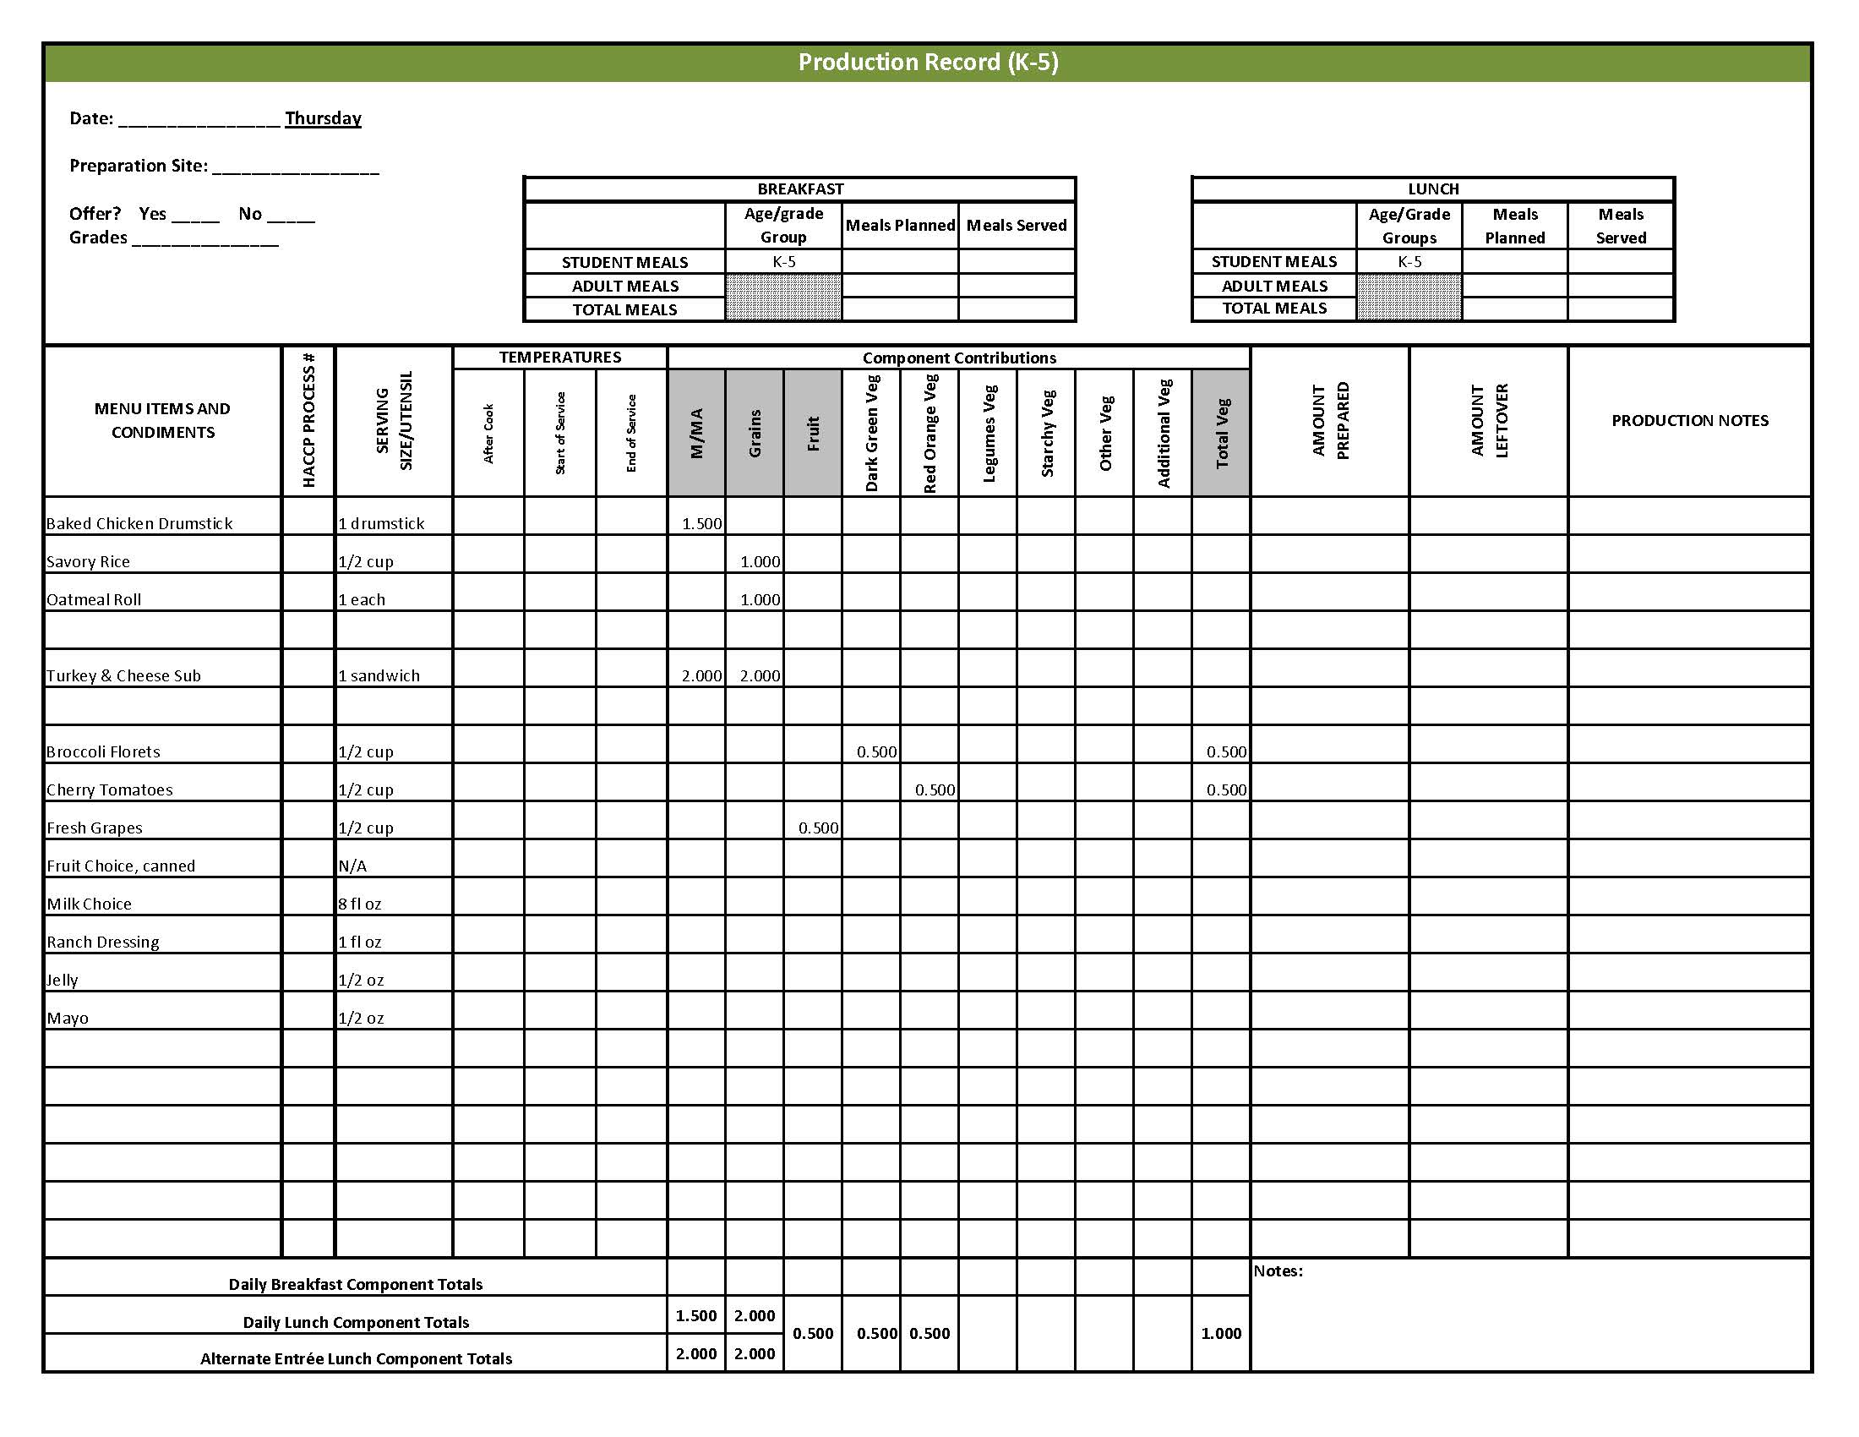

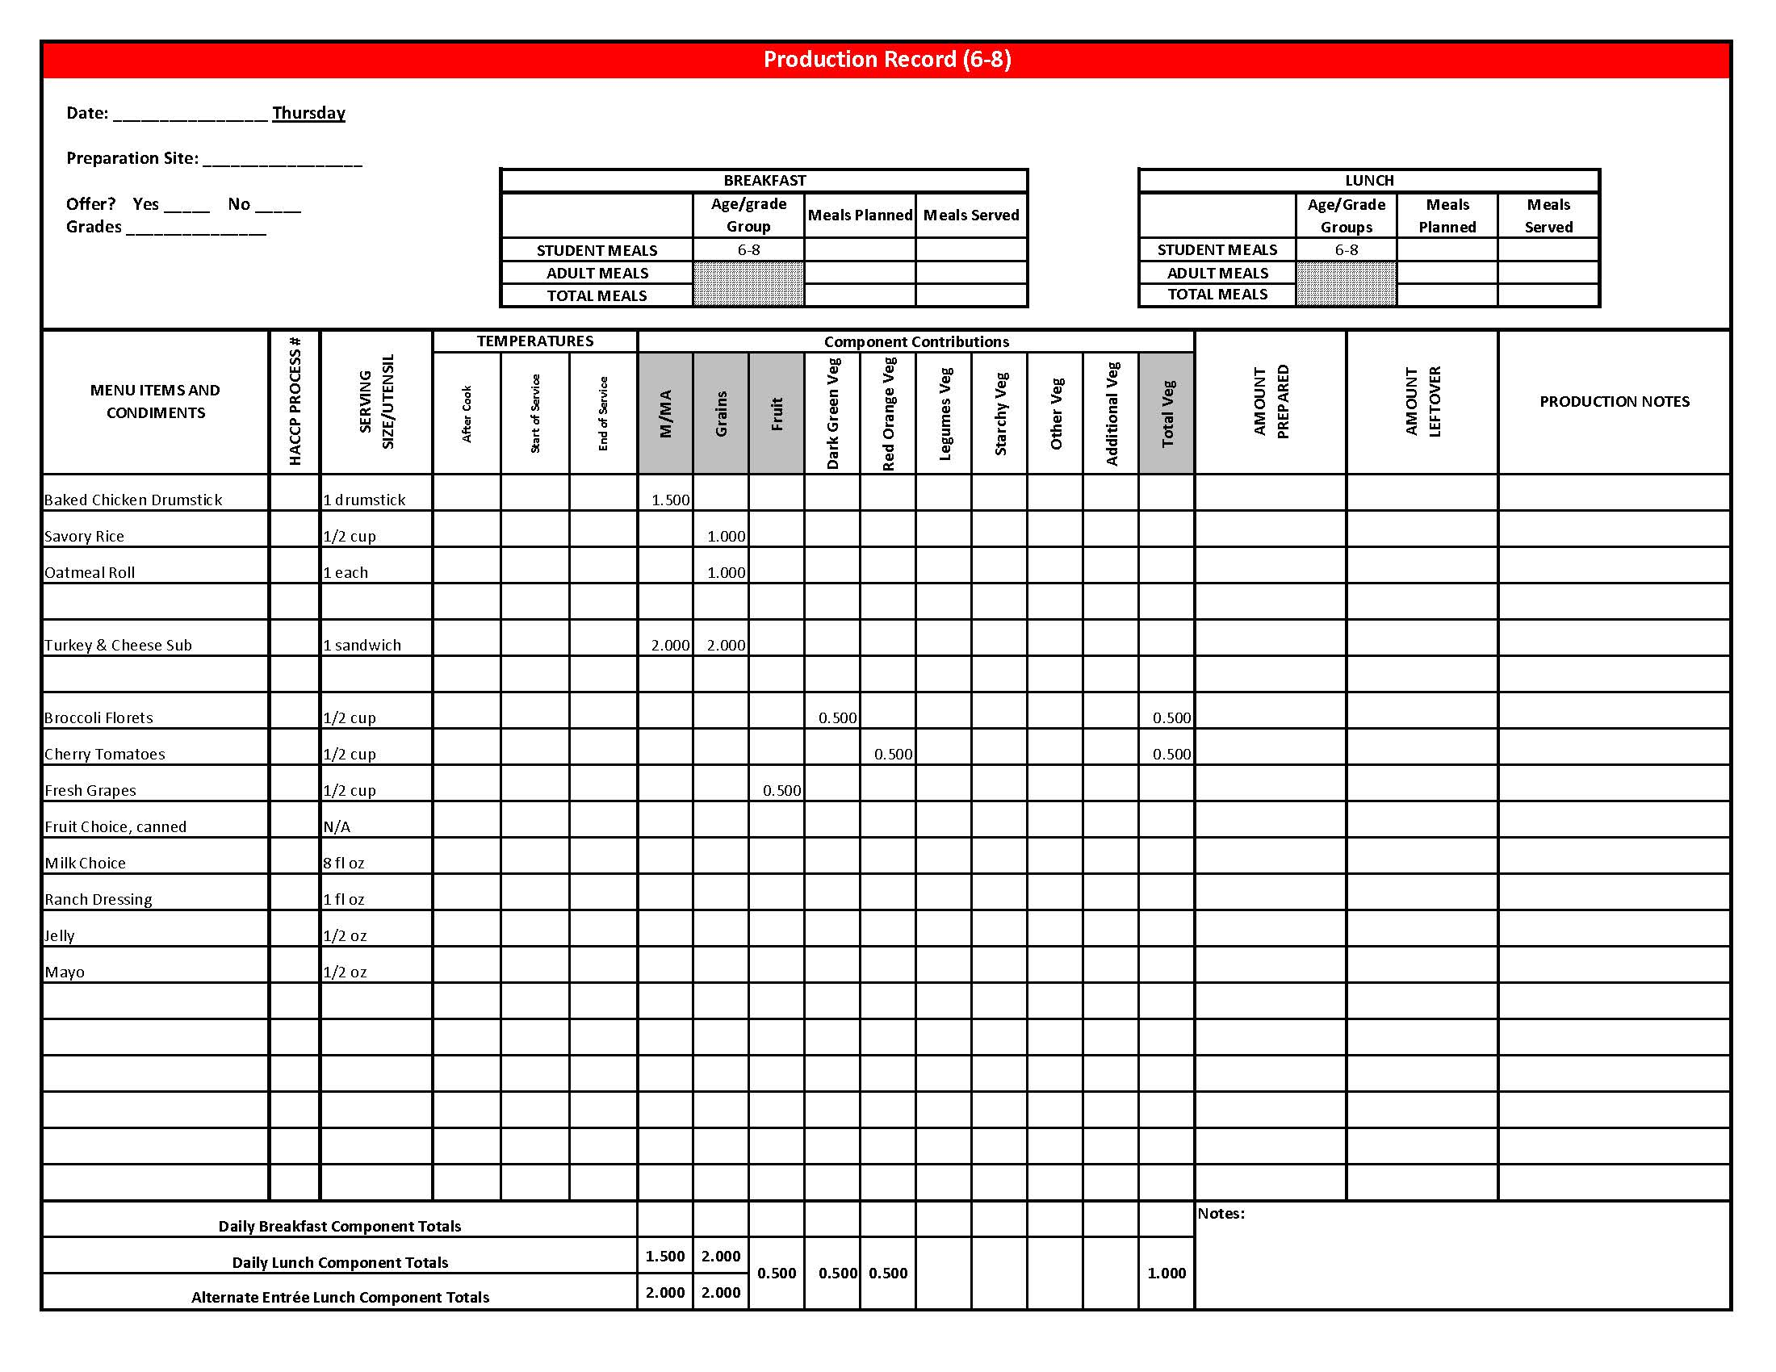

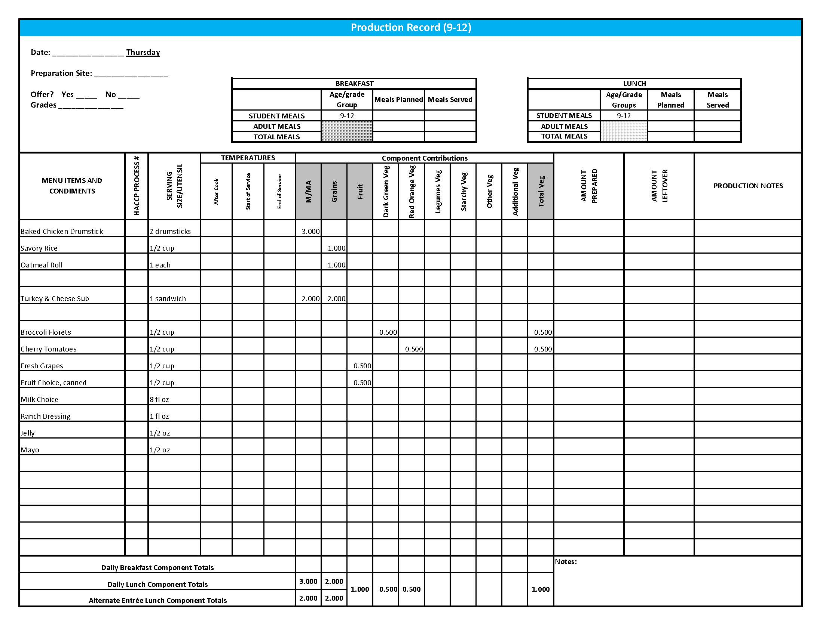

## Purchasing, Preparation & Serving Instructions

Week 3 – Friday

|  |  |  |
| --- | --- | --- |
| **Menu Item** | **Purchasing & Preparation** | **Serving** |
| Yummy Sloppy Joe on a Bun | * Prepare HKM Recipe 123, Yummy Sloppy Joe. * Purchase a 2 oz whole wheat bun (first ingredient is whole wheat) or prepare HKM Recipe 877, Whole Wheat Rolls, Bread Sticks, Buns. * Refer to *Fruit & Vegetable Order Guide* for amount needed. * **CCP: Hold for hot service at 135°F or above** | K-12: 1 sandwich |
| **Alternate Entrée:**  Peanut Butter & Jelly Sandwich Meal  (K-5) | * Purchase or prepare Peanut Butter & Jelly sandwich providing 1 oz equivalent M/MA and 1 oz equivalent Grain, no more than 17 gm of fat; and no more than 320 mg sodium per serving. If product is not Child Nutrition (CN) labeled, obtain a Product Formulation Statement. * Purchase whole grain-rich crackers and cheese sticks weighing 1 oz each. * **CCP: Refrigerate and hold at 41°F or below for cold service.** | K-5: 1 sandwich,  1 oz crackers,  1 oz cheese |
| **Alternate Entrée:**  Peanut Butter & Jelly Sandwich  (6-12) | * Purchase or prepare Peanut Butter & Jelly sandwich providing 2 oz equivalent M/MA and 2 oz equivalent Grains, no more than 33 gm of fat; and no more than 620 mg sodium per serving. If product is not Child Nutrition (CN) labeled, obtain a Product Formulation Statement. * **CCP: Refrigerate and hold at 41°F or below for cold service.** | 6-12: 1 sandwich  (or may choose to follow K-5 Peanut Butter & Jelly Sandwich Meal) |
| Roasted Red Potatoes | * Purchase ovenable, chopped roasted red potatoes that provide no more than 150 mg of sodium per ½ cup. * Follow manufacturer’s directions for baking and holding. * Batch cook. May add pepper or other non-sodium seasonings. * Weigh out each portion size indicated and use as a sample. * **CCP: Hold for hot service at 135°F or above.** | K-12: ½ cup |
| Edamame | * Refer to *Fruit & Vegetable Order Guide* for amount needed. * Batch cook by steaming or by cooking in stock pot with minimal liquid close to serving time. * **CCP: Hold for hot service at 135°F or above.** | K-12: ½ cup |

*Continued on next page*

## Purchasing, Preparation & Serving Instructions

Week 3 – Friday, continued

|  |  |  |
| --- | --- | --- |
| **Menu Item** | **Purchasing & Preparation** | **Serving** |
| Peach, fresh | * Refer to *Fruit & Vegetable Order Guide* for amount needed. * With gloved hands, wash peaches. * Cover and refrigerate or store at room temperature until serving. * **CCP: Refrigerate and hold at 41°F or below for cold service.** | K-12: 1 peach |
| Fruit Choice, canned | Select an additional fruit choice to offer on the menu. The serving(s) offered must credit as ½ cup of fruit, to meet the minimum daily requirement, for grades 9-12.  *Note: The fruit choice is encouraged for grades K-5 and 6-8, but not required. The fruit choice is not included in the nutrient analysis for grades K-5 and 6-8. | K-8: N/A*  9-12: ½ cup |
| Milk | * Provide a variety of milk. May be 1% fat (unflavored) or skim (flavored or unflavored). * **CCP: Refrigerate and hold at 41°F or below for cold service.** | K-12: 8 fl oz |

## **Pre-preparation for Week 4 - Monday:** None.

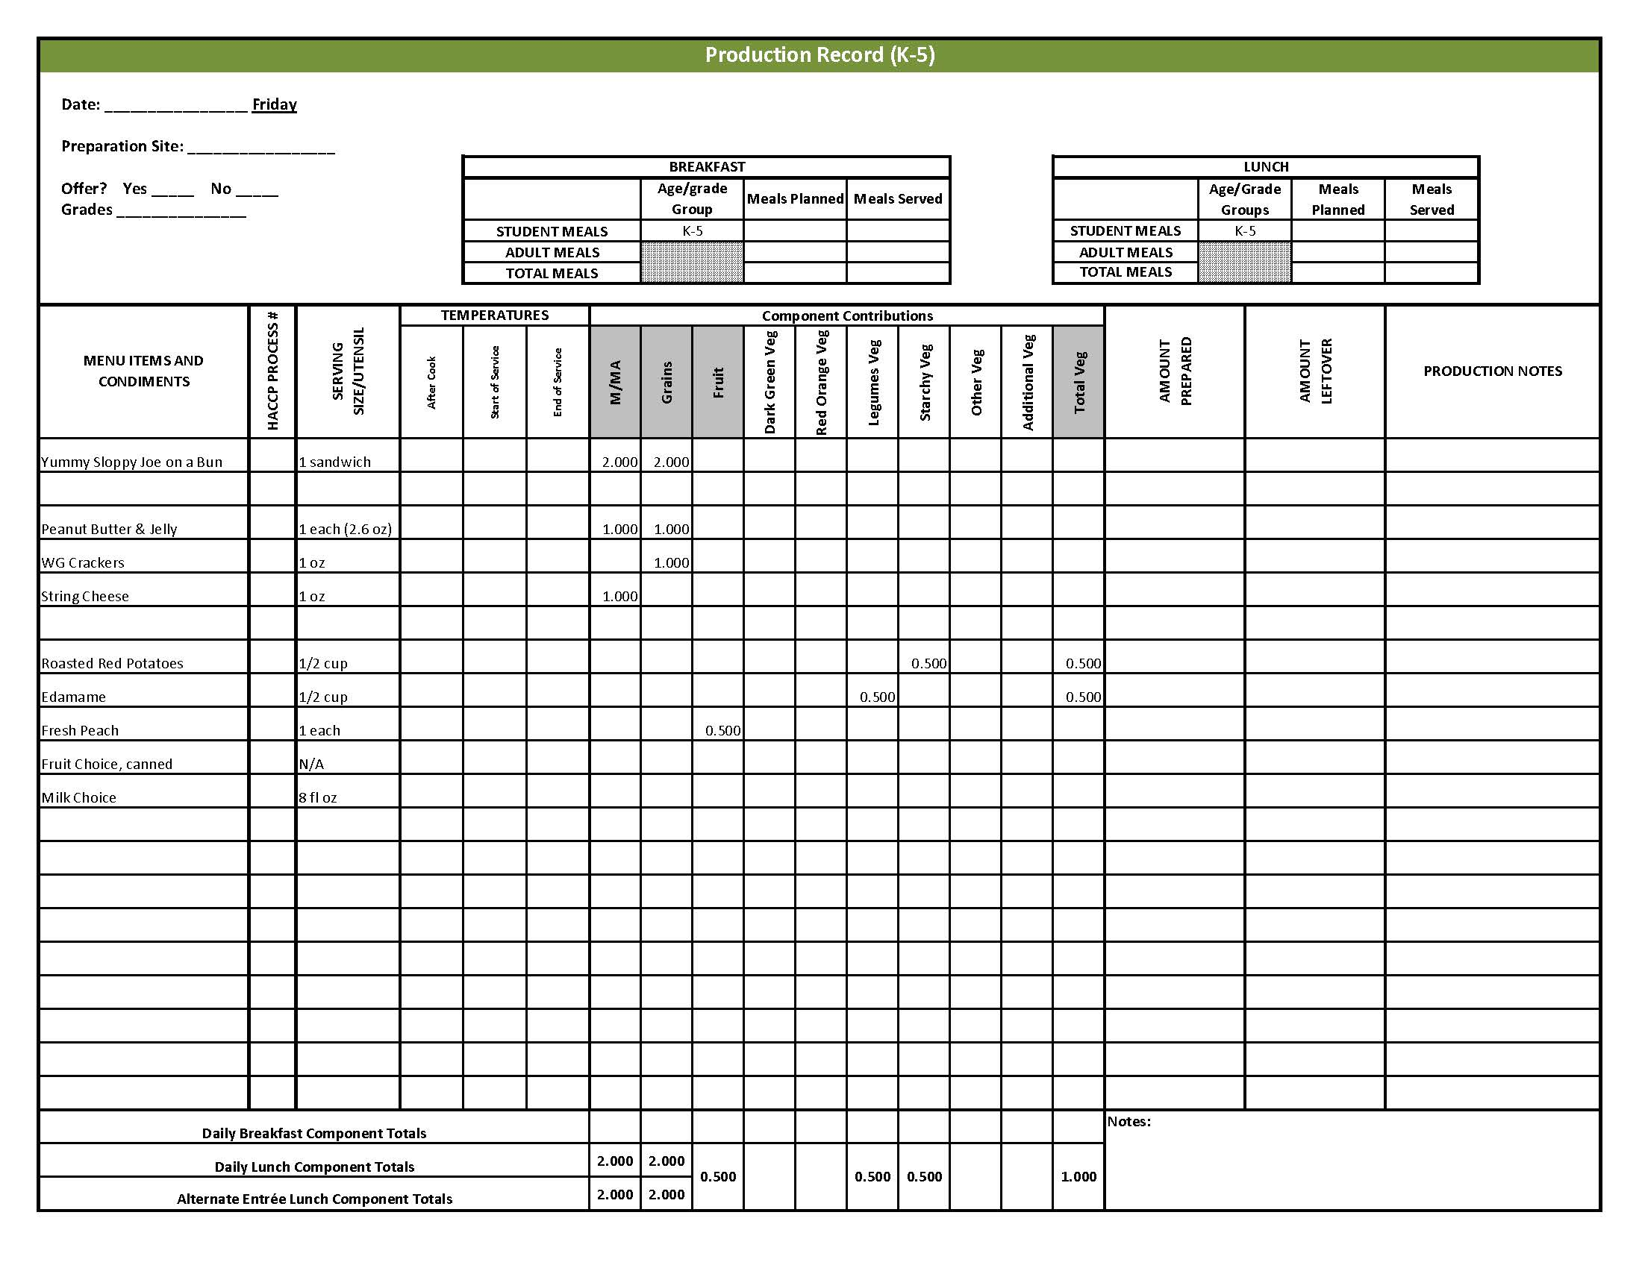

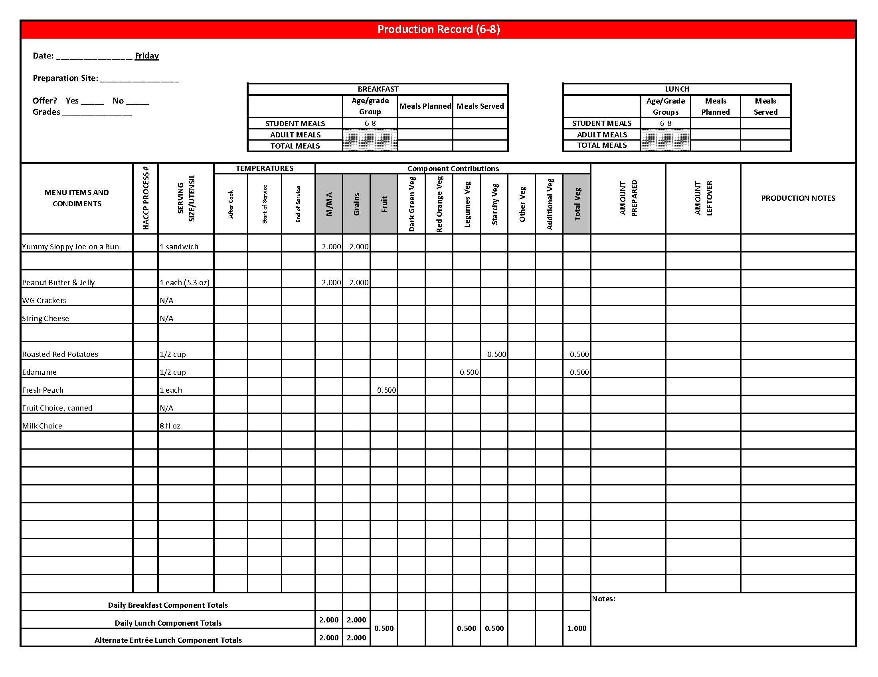

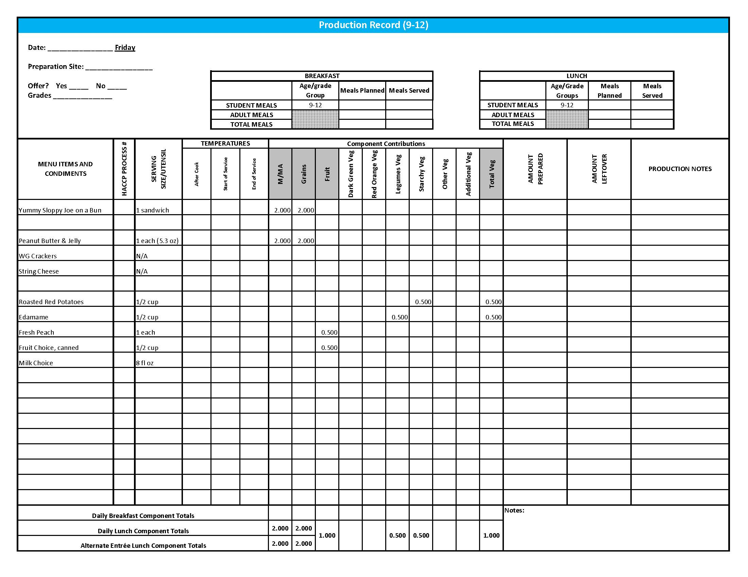

## Fruit & Vegetable Order Guide

**Week 3**

The chart below provides amounts to be ordered per 100 servings based on the serving sizes listed on Week 1 of *Healthier Kansas Menus Production Records* for students in grades groups K-5, 6-8, and 9-12. Amounts to order are based on standard yields and leveled serving utensils or weighed portions. Use the following procedures to determine the amounts to order:

1. **Forecast** the number of servings needed for each fruit and vegetable menu item for each grade group served.
2. **Divide** the number of servings needed by 100 for each portion size (K-5, 6-8 or 9-12).
3. **Multiply** the “Amount to order per 100 servings” by the factor determined in step 2 above for each portion size.
4. **Add** amounts needed for all serving sizes together to determine the amounts to order.

**Abbreviations Key: EP = Edible Portion AP = As Purchased lb = Pound oz = ounce # = Number**

|  |  |  |  |  |  |  |  |
| --- | --- | --- | --- | --- | --- | --- | --- |
| **Day** | **Fruit or Vegetable** | **K-5**  **Portion Size** | **K-5**  **Amount to Order per 100 Servings** | **6-8**  **Portion Size** | **6-8**  **Amount to Order**  **per 100 Servings** | **9-12 Portion Size** | **9-12 Amount to Order per 100 Servings** |
| Monday | Chicken Tetrazzini | ¾ cup |  | ¾ cup |  | 1 cup |  |
| Chilies, diced, canned |  | 1 lb 1 oz |  | 1 lb 1 oz |  | 1 lb 7 oz |
| Pimentos, canned | 11 oz | 11 oz | 15 oz |
| Tossed Salad | 1 cup |  | 1 cup |  | 1 cup |  |
| Spinach, fresh, trimmed, AP |  | 6 lb 8 oz |  | 6 lb 8 oz |  | 6 lb 8 oz |
| Romaine Lettuce, AP | 6 lb 8 oz | 6 lb 8 oz | 6 lb 8 oz |
| Cucumber, fresh, AP | ⅛ cup | 4 lb 1 oz | ⅛ cup | 4 lb 1 oz | ¼ cup | 8 lb 2 oz |
| Carrots, baby, fresh, EP | ⅛ cup | 3 lb 15 oz | ⅛ cup | 3 lb 15 oz | ¼ cup | 7 lb 13 oz |
| Apples, fresh, #125-138, AP | ½ apple | 13 lb 10 oz or 50 each | ½ apple | 13 lb 10 oz or 50 each | ½ apple | 13 lb 10 oz or 50 each |
| Tuesday | Lettuce, Dark Green Leafy, AP | ½ cup | 9 lb 7 oz | ½ cup | 9 lb 7 oz | ½ cup | 9 lb 7 oz |
| Tomato, large, fresh, AP | ¼” slice | 5 lb 12 oz | ¼” slice | 5 lb 12 oz | 2 - ¼” slices | 11 lb 8 oz |
| Potatoes, French Fries, frozen, straight cup | ½ cup | 14 lb 7 oz | ½ cup | 14 lb 7 oz | ½ cup | 14 lb 7 oz |
| Red Bell Pepper, AP | ½ cup | 13 lb 13 oz | ½ cup | 13 lb 13 oz | ½ cup | 13 lb 13 oz |
| Fruit Cocktail, canned in 100% juice or light syrup | ½ cup | 5.5 #10 cans | ½ cup | 5.5 #10 cans | ½ cup | 5.5 #10 cans |

Fruit & Vegetable Order Guide

**Week 3, continued**

|  |  |  |  |  |  |  |  |
| --- | --- | --- | --- | --- | --- | --- | --- |
| **Day** | **Fruit or Vegetable** | **K-5**  **Portion Size** | **K-5**  **Amount to Order per 100 Servings** | **6-8**  **Portion Size** | **6-8**  **Amount to Order**  **per 100 Servings** | **9-12 Portion Size** | **9-12 Amount to Order per 100 Servings** |
| Wednesday | Hash Brown Patties, frozen, 2.25 oz each | 1 each | 14 lb 1 oz or 100 each | 1 each | 14 lb 1 oz or 100 each | 2 each | 28 lb 2 oz or 200 each |
| Green Beans, canned | ½ cup | 4.6 #10 cans | ½ cup | 4.6 #10 cans | ½ cup | 4.6 #10 cans |
| Raspberries, fresh | ½ cup | 16 lb 10 oz | ½ cup | 16 lb 10 oz | ½ cup | 16 lb 10 oz |
| Thursday | Broccoli, florets, fresh, EP | ½ cup | 7 lb | ½ cup | 7 lb | ½ cup | 7 lb |
| Tomatoes, cherry, AP | 6 tomatoes | 16 lb 10 oz | 6 tomatoes | 16 lb 10 oz | 6 tomatoes | 16 lb 10 oz |
| Grapes, fresh, AP | ½ cup | 19 lb 4 oz | ½ cup | 19 lb 4 oz | ½ cup | 19 lb 4 oz |
| Friday | Yummy Sloppy Joes | ½ cup filling |  | ½ cup filling |  | ½ cup filling |  |
| Cabbage, shredded, ready to use |  | 2 lb 7 oz |  | 2 lb 7 oz |  | 2 lb 7 oz |
| Celery, AP | 1 lb 11 oz | 1 lb 11 oz | 1 lb 11 oz |
| Green Bell Pepper, AP | 1 lb 4 oz | 1 lb 4 oz | 1 lb 4 oz |
| Potatoes, frozen, red roasted, chopped | ½ cup | 19 lb | ½ cup | 19 lb | ½ cup | 19 lb |
| Peaches, fresh, 80 count, AP | 1 each | 22 lb 5 oz or 100 each | 1 each | 22 lb 5 oz or 100 each | 1 each | 22 lb 5 oz or 100 each |
| Edamame, shelled, EP | ½ cup | 18 lb 13 oz | ½ cup | 18 lb 13 oz | ½ cup | 18 lb 13 oz |