Healthier Kansas Menus

with Alternate Entrées

# C:\Documents and Settings\jmackey\My Documents\My Pictures\Microsoft Clip Organizer\j0349505.wmf

SPRING WEEK 2 – DAILY PRODUCTION RECORDS

Child Nutrition & Wellness, Kansas State Department of Education

Revised July 2019

This publication has been funded at least in part with Federal funds from the U.S. Department of Agriculture, Food and Nutrition Service. The contents of this publication do not necessarily reflect the views or policies of the Department, nor does mention of trade names, commercial products, or organizations imply endorsement by the U.S. Government.

**For further information about this publication, please contact:** Child Nutrition & Wellness, KSDE, Landon State Office Building, 900 SW Jackson Street, Suite #251, Avenue, Topeka, Kansas 66612, 785-296-2276, Fax: 785-296-0232,

[www.kn-eat.org](http://www.kn-eat.org/)

In accordance with Federal civil rights law and U.S. Department of Agriculture (USDA) civil rights regulations and policies, the USDA, its Agencies, offices, and employees, and institutions participating in or administering USDA programs are prohibited from discriminating based on race, color, national origin, sex, disability, age, or reprisal or retaliation for prior civil rights activity in any program or activity conducted or funded by USDA.  
  
Persons with disabilities who require alternative means of communication for program information (e.g. Braille, large print, audiotape, American Sign Language, etc.), should contact the Agency (State or local) where they applied for benefits. Individuals who are deaf, hard of hearing or have speech disabilities may contact USDA through the Federal Relay Service at (800) 877-8339. Additionally, program information may be made available in languages other than English.  
  
To file a program complaint of discrimination, complete the [USDA Program Discrimination Complaint Form](http://www.ocio.usda.gov/sites/default/files/docs/2012/Complain_combined_6_8_12.pdf), (AD-3027) found online at: [http://www.ascr.usda.gov/complaint_filing_cust.html](https://www.ascr.usda.gov/filing-discrimination-complaint-usda-customer), and at any USDA office, or write a letter addressed to USDA and provide in the letter all of the information requested in the form. To request a copy of the complaint form, call (866) 632-9992. Submit your completed form or letter to USDA by:  
  
(1)   Mail: U.S. Department of Agriculture  
Office of the Assistant Secretary for Civil Rights  
1400 Independence Avenue, SW  
Washington, D.C. 20250-9410;  
  
(2)   Fax: (202) 690-7442; or  
  
(3)   Email: [program.intake@usda.gov](mailto:program.intake@usda.gov).  
  
This institution is an equal opportunity provider.

The following person has been designated to handle inquiries regarding the non-discrimination policies at the Kansas State Department of Education: Office of General Counsel, Landon State Office Building, 900 SW Jackson St, Suite #102, Topeka, KS 66612, (785)296-3201.

Healthier Kansas Menus recipes were developed by Child Nutrition & Wellness, Kansas State Department of Education or adapted from the following sources:

* *Food for Fifty,* Ninth Edition (1989) Grace Shugart, Mary Molt*.*
* *Healthier Kansas Menus – Breakfast,* Child Nutrition & Wellness, Kansas State Department of Education
* *Iowa Gold Star Cycle Menus*, Iowa Department of Education
* *Menus that Move,* Ohio Department of Education.
* *Fruit and Veggie Quantity Cookbook,* New Hampshire Department of Health and Human Services.
* *Preparing Whole Grain Foods,* Child Nutrition & Wellness, Kansas State Department of Education
* *Singing the Praises of Beans & Legumes*, Child Nutrition & Wellness, Kansas State Department of Education
* *USDA Recipes for Schools,* U.S. Department of Agriculture, Food & Nutrition Service, Child Nutrition Programs, 2006.
* USD 225 Fowler
* USD 234 Fort Scott
* USD 267 Renwick
* USD 306 Southeast of Saline
* USD 308 Hutchinson
* USD 320 Wamego
* USD 349 Stafford
* USD 364 Marysville
* USD 503 Parsons
* USD 512 Shawnee Mission

Thank you to the following schools for assisting with menu development and recipe testing:

* Logan Elementary School – USD 345 Seaman
* St. Joseph Catholic School – Mt. Hope, KS
* Winfield Scott Elementary School – USD 234 Fort Scott

## Menus for the Week

**PLEASE NOTE:**

Milk choice includes a variety of non-fat or 1% (flavored or unflavored) milk. One milk choice must be unflavored.

Reduced fat dressing is served with salads and fresh vegetables.

Menus were planned using all whole grain-rich products. Beginning July 1, 2019, at least half of the weekly grains in the school lunch menu and the school breakfast menu must be whole grain-rich.

|  |  |  |  |  |  |  |  |  |
| --- | --- | --- | --- | --- | --- | --- | --- | --- |
| **MONDAY** | **TUESDAY** | **WEDNESDAY** | **THURSDAY** | **FRIDAY** | **Weekly Nutrient Averages** | | | |
|  | K-5 | 6-8 | 9-12 |
| Sweet and Sour Chicken Nuggets  Seasoned Brown Rice  **Or**  Yogurt & Blueberry Oat Muffin Plate  Asian Fresh Vegetables  Cherry Tomatoes  Fresh Pear  Canned Fruit Choice  Milk Choice | Super Nachos  **Or**  Chicken Crispito  Romaine Lettuce  Southwestern Lentils  Tomato Salsa  Fresh Plum  Canned Fruit Choice  Milk Choice | Cheese Breadsticks w/ Marinara Sauce  **Or**  Grilled Chicken Sandwich  Seasoned Corn  Tossed Salad  Fresh Watermelon  Canned Fruit Choice  Milk Choice | Pulled Pork Sandwich  **Or**  Hamburger on a Bun  Creamy Cole Slaw  Baked Beans  Applesauce  Fresh Fruit Choice  Milk Choice | Rock and Roll  Beef Wrap  **Or**  Cheese Pizza  Steamed Carrots  Broccoli Florets  Fresh Orange  **Cherry Crisp (6-12)**  Canned Fruit Choice  Milk Choice | **Calories**  **Sodium (mg)**  **% of Total Calories from Sat. Fat** | **627**  **706**  **8.8%** | **664**  **722**  **8.6%** | **790**  **772**  **8.8%** |

C:\Documents and Settings\jmackey\My Documents\My Pictures\Microsoft Clip Organizer\j0349505.wmf

## Recipes for the Week

|  |  |  |  |
| --- | --- | --- | --- |
| Day | Recipe Name | Recipe Number | HKM Recipe  Page Number |
| Monday | Sweet and Sour Chicken Nuggets  Seasoned Brown Rice  Asian Fresh Vegetables  Blueberry Oat Muffin | 143  142  141  28 | 36  80  49  64 |
| Tuesday | Super Nachos  Taco Meat  Cheese Sauce  Tomato Salsa  Southwestern Lentils | 140  76  139  129  138 | 35  39  9  61  58 |
| Wednesday | Cheese Breadstick  Tossed Salad | 125  74 | 8  62 |
| Thursday | Pulled Pork Sandwich  Whole Wheat Bun  Baked Beans  Creamy Cole Slaw | 136  877  188  20 | 29  91  46  52 |
| Friday | Rock and Roll Beef Wraps  Cherry Crisp, Whole Wheat | 133  82 | 30  65 |

## Abbreviations

|  |  |  |  |
| --- | --- | --- | --- |
| **Abbreviation** | **What it Means** | **Abbreviation** | **What it Means** |
| HKM | Healthier Kansas Menus | Tbsp | tablespoon |
| EP | edible portion | tsp | teaspoon |
| AP | as purchased | CCP | Critical Control Point |
| fl | fluid | PC | portion controlled * |
| oz | ounce | w/ | with |
| lb | pound | M/MA | meat/meat alternate |
| gm | gram |  |  |
| mg | milligram |  |  |

* For example, purchase pre-portioned servings of condiments.

## Portion Guide

|  |  |
| --- | --- |
| **Ladles & Spoodles** | **Scoops** |
| 1 fl oz = 2 Tbsp | #50 = 3 3/4 tsp |
| 2 fl oz = 1/4 cup | #40 = 1 2/3 Tbsp |
| 3 fl oz = 3/8 cup | #30 = 2 Tbsp |
| 4 fl oz = 1/2 cup | #20 = 3 1/3 Tbsp |
| 6 fl oz = 3/4 cup | #16 = 1/4 cup |
| 8 fl oz = 1 cup | #12 = 1/3 cup |
|  | #8 = 1/2 cup |
|  | #6 = 2/3 cup |

## Purchasing, Preparation & Serving Instructions

Week 2 – Monday

|  |  |  |
| --- | --- | --- |
| **Menu Item** | **Purchasing & Preparation** | **Serving** |
| Sweet and Sour Chicken Nuggets | * Prepare HKM Recipe 143, Sweet and Sour Chicken Nuggets. * Purchase whole grain rich, chicken nuggets that provide 2 oz equivalent M/MA and 1 oz equivalent Grains per serving. If product is not Child Nutrition (CN) labeled, obtain a Product Formulation Statement. * **CCP: Hold for hot service at 135°F or above.** | K-12: 5 nuggets (or number needed to meet 2 oz M/MA and 1 oz eq Grains) |
| Seasoned Brown Rice | * Prepare HKM Recipe 142, Seasoned Brown Rice. * **CCP: Hold for hot service at 135°F or above.** | K-12: ½ cup |
| **Alternate Entrée:**  Yogurt & Blueberry Oat Muffin Meal | * Prepare HKM Recipe 28, Blueberry Oat Muffin or purchase pre-prepared whole grain-rich muffins that provide 1 oz equivalent Grain. * Purchase low-fat, flavored yogurt in bulk and pre-portion 1 cup (8 oz) servings. * **CCP: Refrigerate and hold at 41o F or below for cold service.** | K-12: 8oz yogurt,  2 muffins each |
| Asian Fresh Vegetables | * Prepare HKM Recipe 141, Asian Fresh Vegetables. * **CCP: Hold for hot service at 135°F or above.** | K-12: ½ cup |
| Cherry Tomatoes | * Refer to *Fruit & Vegetable Order Guide* for amount needed. * With gloved hands, wash and stem tomatoes. * **CCP: Refrigerate and hold at 41°F or below for cold service.** | K-8: 3 whole tomatoes  (¼ cup)  9-12: 6 whole tomatoes  (½ cup) |
| Pear, fresh | * Refer to *Fruit & Vegetable Order Guide* for amount needed. * With gloved hands, wash pears. * Cover and refrigerate or store at room temperature until serving. * **CCP: Refrigerate and hold at 41°F or below for cold service.** | K-12: 1 each |
| Fruit Choice, canned | Select an additional fruit choice to offer on the menu. The serving(s) offered must credit as ½ cup of fruit, to meet the minimum daily requirement, for grades 9-12.  *Note: The fruit choice is encouraged for grades K-5 and 6-8, but not required. The fruit choice is not included in the nutrient analysis for grades K-5 and 6-8. | K-8: N/A*  9-12: ½ cup |

*Continued on next page*

## Purchasing, Preparation & Serving Instructions

Week 2 – Monday, continued

|  |  |  |  |
| --- | --- | --- | --- |
| **Menu Item** | **Purchasing & Preparation** | | **Serving** |
| Milk | * Provide a variety of milk. May be 1% fat (unflavored) or skim (flavored or unflavored). * **CCP: Refrigerate and hold at 41°F or below for cold service.** | | K-12: 8 fl oz |
| Ranch Dressing, Reduced Fat | | * Purchase or prepare Ranch dressing containing no more than 6 gm of fat  per 1 fl oz. Purchase .8 gallons for every 100 1 fl oz portions. * **CCP: Refrigerate and serve at 41°F or below if school-prepared dressing is served.** | K-12: 1 fl oz **or** 2 Tbsp |

**Pre-preparation for Week 2 – Tuesday:** Thaw ground beef under refrigeration.

## Mon K-5 PR

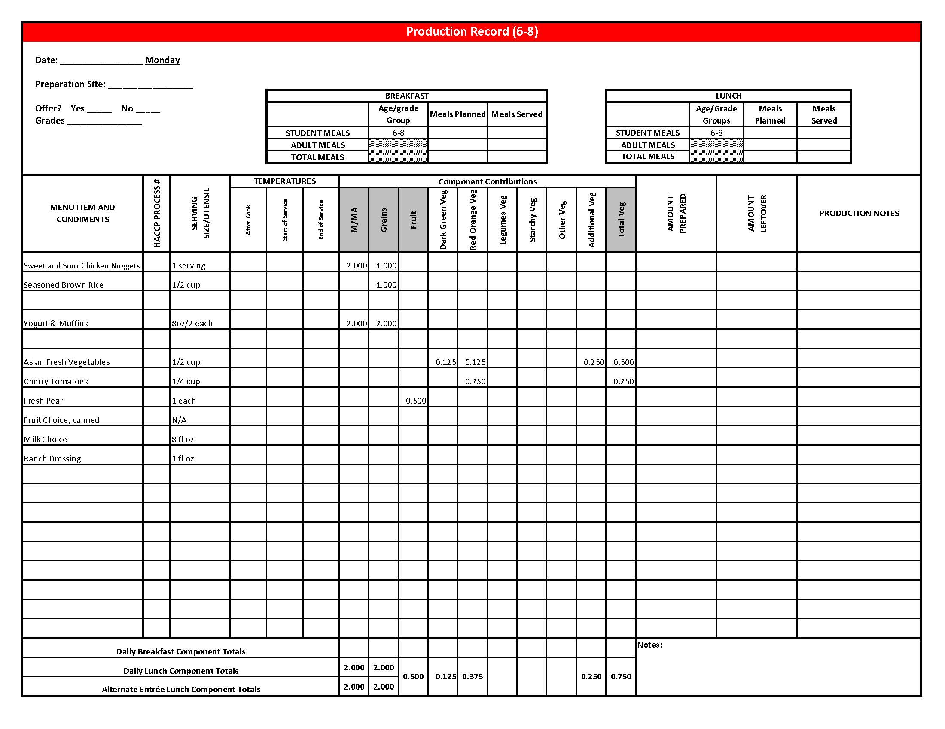

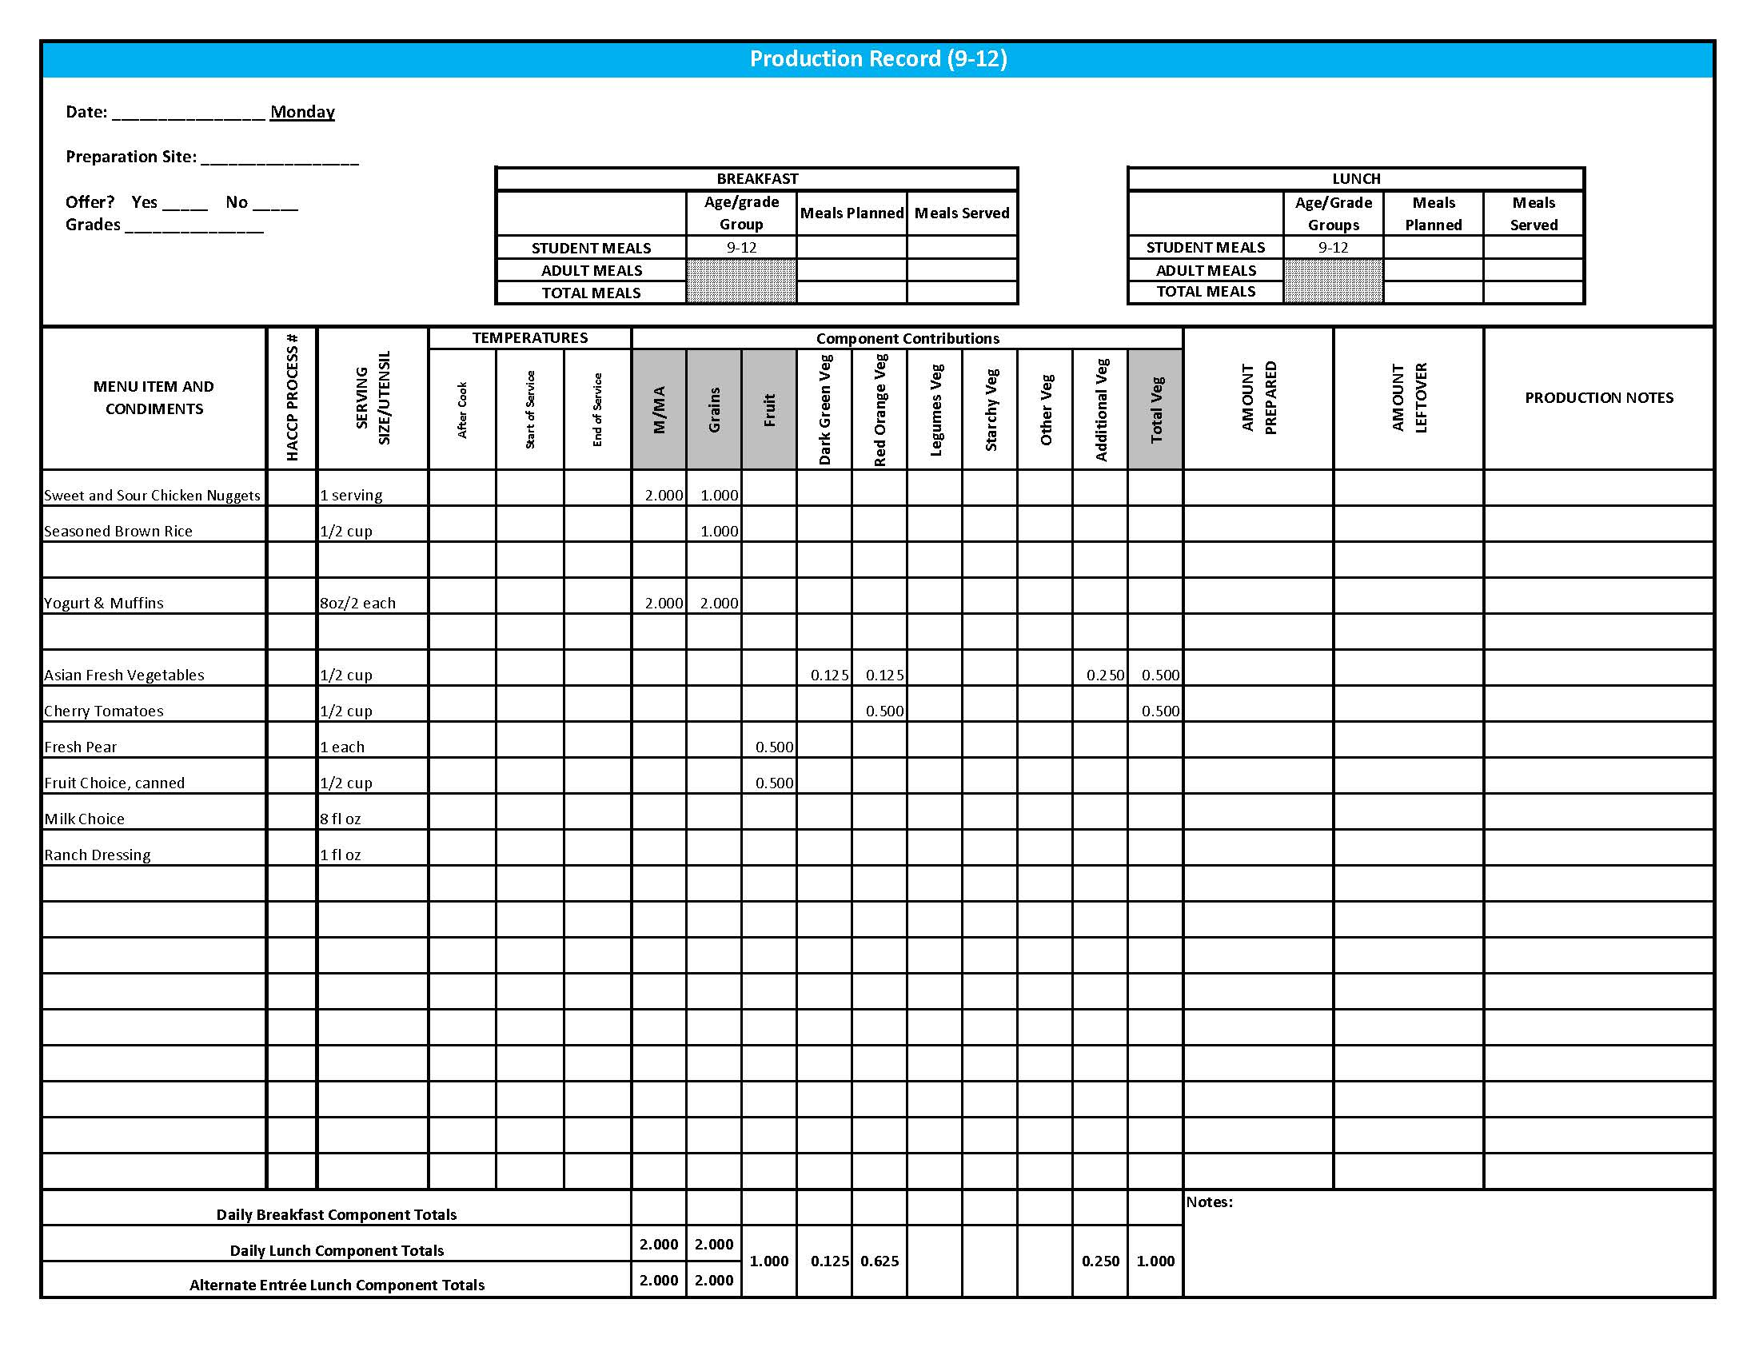

## Purchasing, Preparation & Serving Instructions

Week 2 – Tuesday

|  |  |  |
| --- | --- | --- |
| **Menu Item** | **Purchasing & Preparation** | **Serving** |
| Super Nachos | * Prepare HKM Recipe 140, Super Nachos (see following for information on sub-recipes used in Super Nachos recipe) * **CCP: Hold for hot service at 135°F or above.** | K-12: 1 plate |
| Taco Meat | * Prepare HKM Recipe 76, Taco Meat. * **CCP: Hold for hot service at 135°F or above.** | K-12: ¼ cup |
| Cheese Sauce | * Prepare HKM Recipe 139, Cheese Sauce. * **CCP: Hold for hot service at 135°F or above.** | K-8: 1/8 cup (#30 scoop)  9-12: ¼ cup (#16 scoop) |
| Tortilla Chips | * Purchase whole grain tortilla chips with no more than 50 mg sodium per oz. (Restaurant style usually has less sodium). * May be pre-portioned. Weigh a sample. Serve with gloved hands or tongs. | K-8: 1 oz  9-12: 2 oz |
| **Alternate Entrée:**  Crispito, chicken chili | * Purchase Crispito providing 1 oz equivalent M/MA and 1 oz equivalent Grain, no more than 14 gm of fat; and no more than 370 mg sodium per piece. If product is not Child Nutrition (CN) labeled, obtain a Product Formulation Statement. * Heat according to manufacturer’s instructions. * **CCP: Hold for hot service at 135°F or above.** | K-8: 1 each  9-12: 2 each |
| Romaine Lettuce | * Refer to *Fruit & Vegetable Order Guide* for amount needed. * Handle produce with gloved hands. May be pre-portioned. * **CCP: Refrigerate and hold at 41°F or below for cold service.** | K-12: ½ cup |
| Tomato Salsa | * Purchase salsa that is low in sodium or prepare HKM Recipe 129, Tomato Salsa. * Refer to *Fruit & Vegetable Order Guide* for amount needed. * May be served, self-serve or pre-portioned for service. * **CCP: Refrigerate and hold at 41°F or below for cold service.** | K-12: ¼ cup |

*Continued on next page*

## Purchasing, Preparation & Serving Instructions

Week 2 – Tuesday, continued

|  |  |  |
| --- | --- | --- |
| **Menu Item** | **Purchasing & Preparation** | **Serving** |
| Southwestern Lentils | * Prepare HKM Recipe 138, Southwestern Lentils. * Refer to *Fruit & Vegetable Order Guide* for amount needed. * **CCP: Hold for hot service at 135°F or above.** | K-8: ¼ cup  9-12: ½ cup |
| Plum, fresh | * Refer to *Fruit & Vegetable Order Guide* for amount needed. * With gloved hands, wash plums. * Cover and refrigerate or store at room temperature until serving. * **CCP: Refrigerate and hold at 41°F or below for cold service.** | K-12: 1 each |
| Fruit Choice, canned | Select an additional fruit choice to offer on the menu. The serving(s) offered must credit as ½ cup of fruit, to meet the minimum daily requirement, for grades 9-12.  *Note: The fruit choice is encouraged for grades K-5 and 6-8, but not required. The fruit choice is not included in the nutrient analysis for grades K-5 and 6-8. | K-8: N/A*  9-12: ½ cup |
| Milk | * Provide a variety of milk. May be 1% fat (unflavored) or skim (flavored or unflavored). * **CCP: Refrigerate and hold at 41°F or below for cold service.** | K-12: 8 fl oz |

**Pre-preparation for Week 2 - Wednesday:** Cut and chill watermelon.

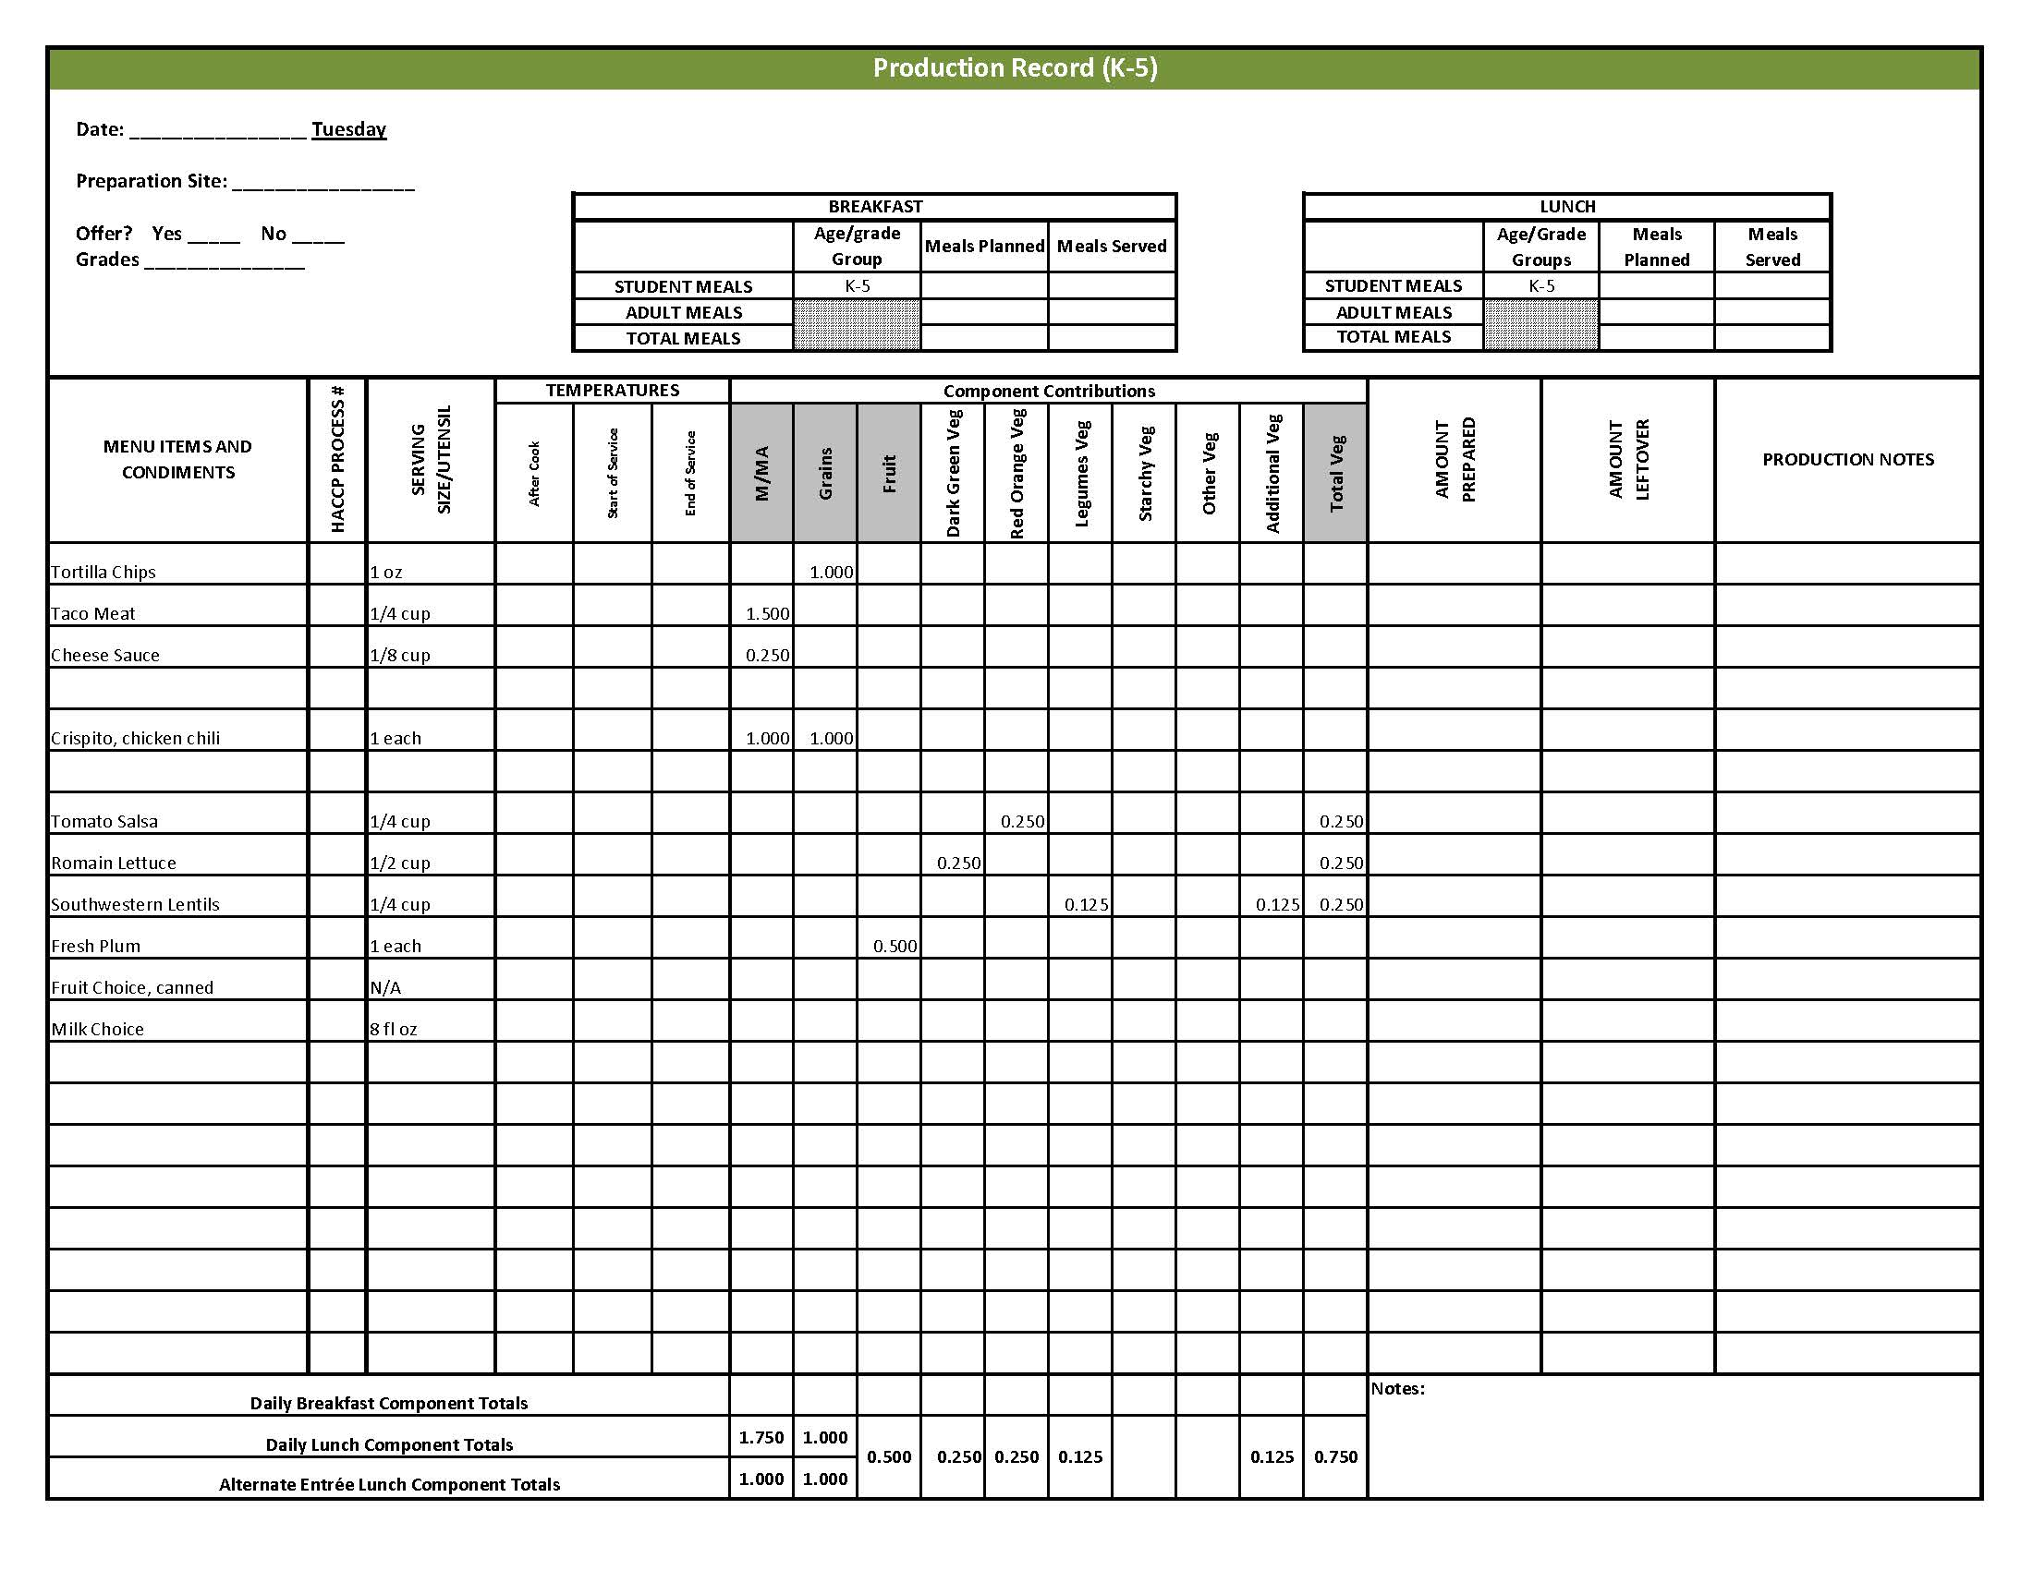

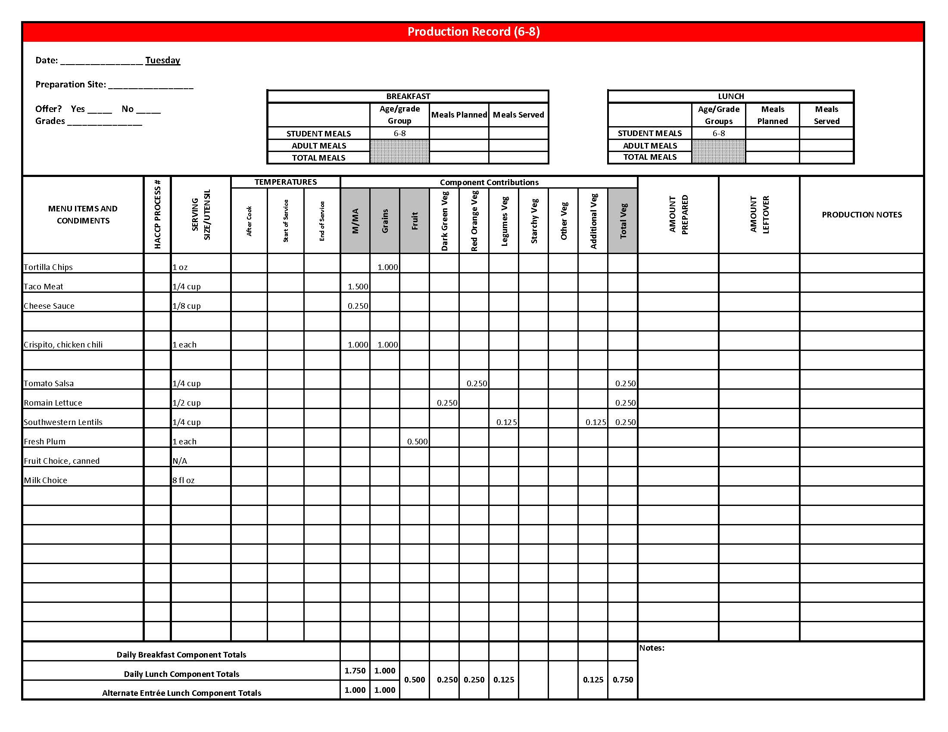

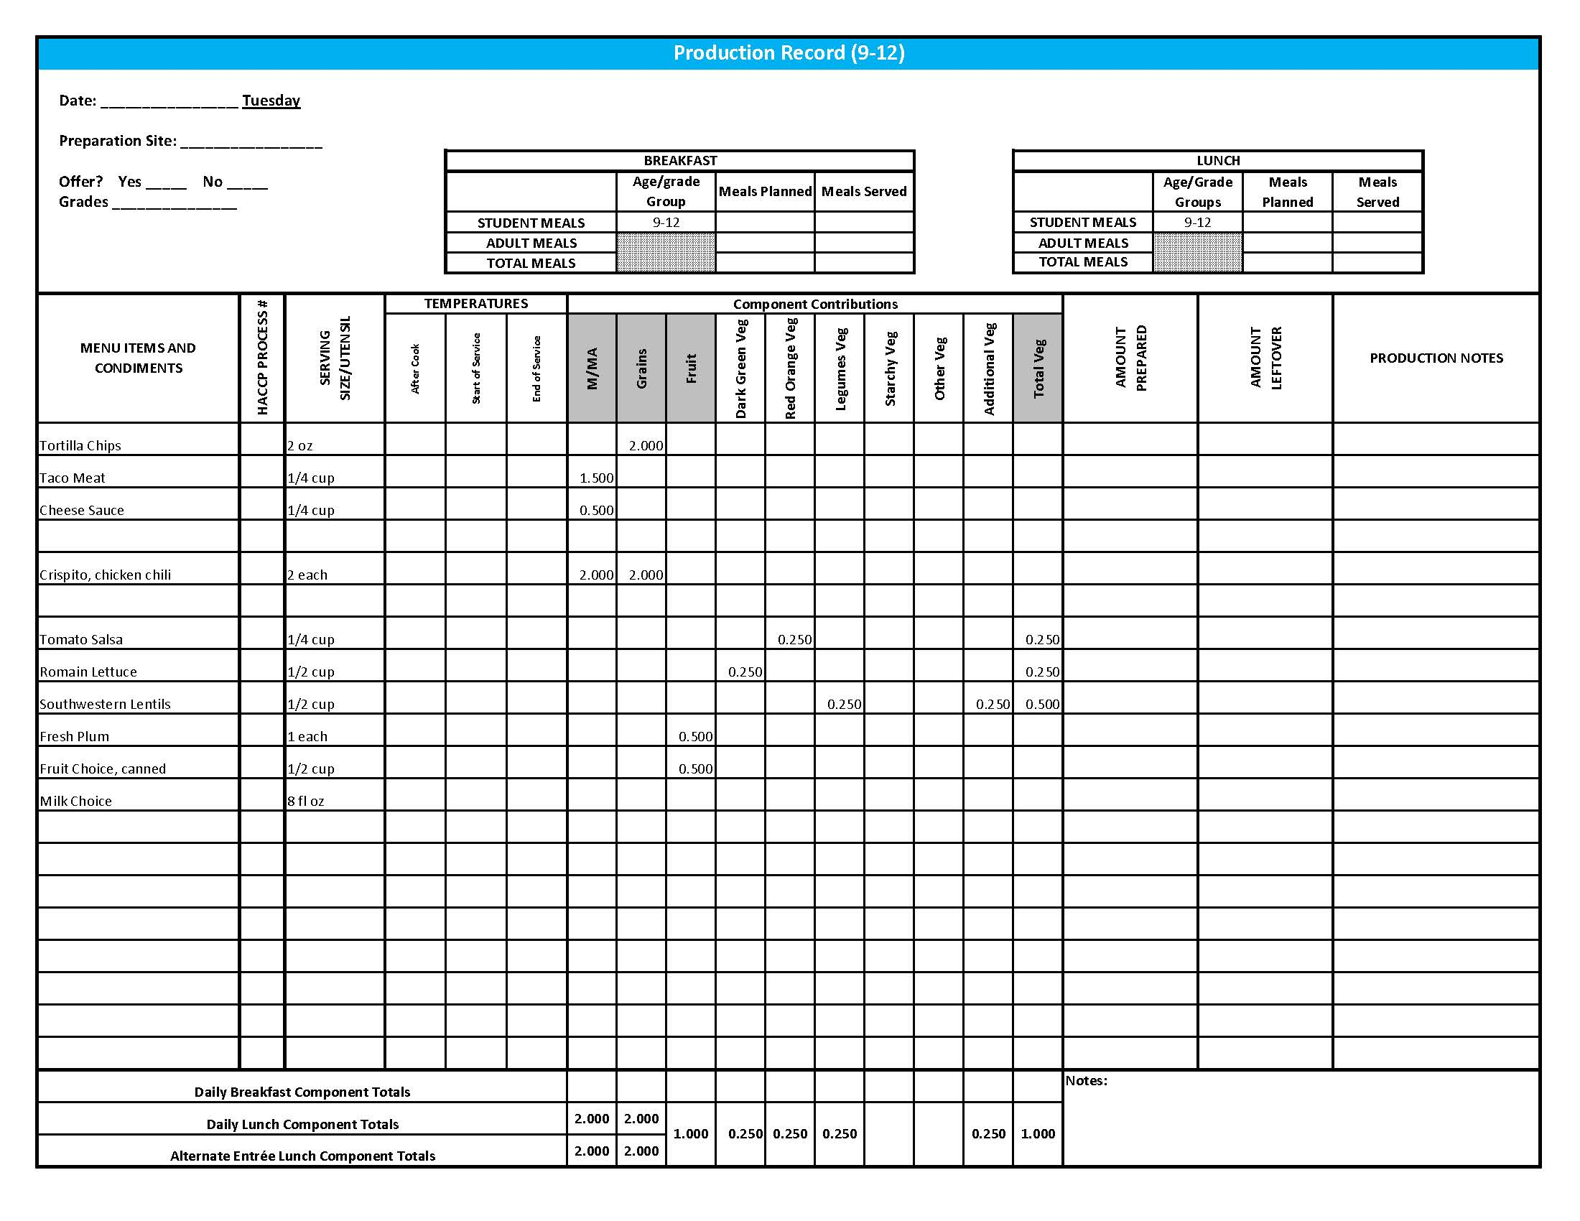

## Purchasing, Preparation & Serving Instructions

Week 2 – Wednesday

|  |  |  |  |  |  |
| --- | --- | --- | --- | --- | --- |
| **Menu Item** | | **Purchasing & Preparation** | | **Serving** | |
| Cheese Breadsticks | | * Prepare HKM Recipe 126, Cheese Breadsticks. * **CCP: Hold for hot service at 135°F or above.** | | K-12: 2 breadsticks | |
| Marinara Sauce | | * Purchase marinara sauce containing less than 300 mg sodium per ¼ cup serving. Refer to *Fruit & Vegetable Order Guide* for amount needed. * **CCP: Hold for hot service at 135°F or above.** | | K-12: ¼ cup | |
| **Alternate Entrée:**  Grilled Chicken Sandwich | | * Purchase pre-cooked, un-breaded chicken patties that provide 2 oz equivalent M/MA, no more than 3.5 gm of fat; and no more than 210 mg sodium per serving. If product is not Child Nutrition (CN) labeled, obtain a Product Formulation Statement. * Prepare according to manufacturer’s instructions. * Purchase a 2 oz whole wheat bun (first ingredient is whole wheat) or prepare following HKM Recipe 877, Whole Wheat Rolls, Bread Sticks, Buns, Hamburger Bun Variation. * **CCP: Hold for hot service at 135°F or above.** | | K-12: 1 each | |
| Corn, steamed | | * Purchase frozen or canned corn. Refer to *Fruit & Vegetable Order Guide* for amount needed. * If using canned corn, wipe tops of cans clean before opening. * Batch cook close to serving time by steaming or cooking in stock pot with minimal liquid. * **CCP: Hold for hot service at 135o F or above.** | | K-12: ½ cup | |
| Tossed Salad | | * Prepare HKM Recipe 74, Tossed Salad. * Refer to *Fruit & Vegetable Order Guide* for amount needed. * **CCP: Refrigerate and hold at 41°F or below for cold service.** | | K-12: 1 cup | |

*Continued on next page*

## Purchasing, Preparation & Serving Instructions

Week 2 – Wednesday, continued

|  |  |  |
| --- | --- | --- |
| **Menu Item** | **Purchasing & Preparation** | **Serving** |
| Watermelon, Fresh | * Refer to *Fruit &Vegetable Order Guide* for amount needed. * With gloved hands, wash outside of rind well to remove any surface dirt. Remove rind and cut into ½” cubes. * **CCP: Refrigerate and hold at 41°F or below for cold service.** | K-12: ½ cup |
| Fruit Choice, canned | Select an additional fruit choice to offer on the menu. The serving(s) offered must credit as ½ cup of fruit, to meet the minimum daily requirement, for grades 9-12.  *Note: The fruit choice is encouraged for grades K-5 and 6-8, but not required. The fruit choice is not included in the nutrient analysis for grades K-5 and 6-8. | K-8: N/A*  9-12: ½ cup |
| Milk | * Provide a variety of milk. May be 1% fat (unflavored) or skim (flavored or unflavored). * **CCP: Refrigerate and hold at 41°F or below for cold service.** | K-12: 8 fl oz |
| Ranch Dressing, Reduced Fat | * Purchase or prepare Ranch dressing containing no more than 6 gm of fat  per 1 fl oz. Purchase .8 gallons for every 100 1 fl oz portions. * **CCP: Refrigerate and serve at 41°F or below if school-prepared dressing is served.** | K-12: 1 fl oz **or** 2 Tbsp |
| Mayo-type Salad Dressing, reduced fat | * Purchase mayo-type salad dressing containing no more than 6 gm of fat per 1 fl oz. Purchase 0.4 gallons per 100 servings | K-12: ½ oz or 1 Tbsp |
| Mustard | * Purchase bulk or packets. If bulk, purchase 2 cups for every 100 1 tsp servings. | K-12: 1 tsp |

**Pre-preparation for Week 2 – Thursday:** Thaw pulled pork under refrigeration. Chill applesauce.

## Wed K-5 PR

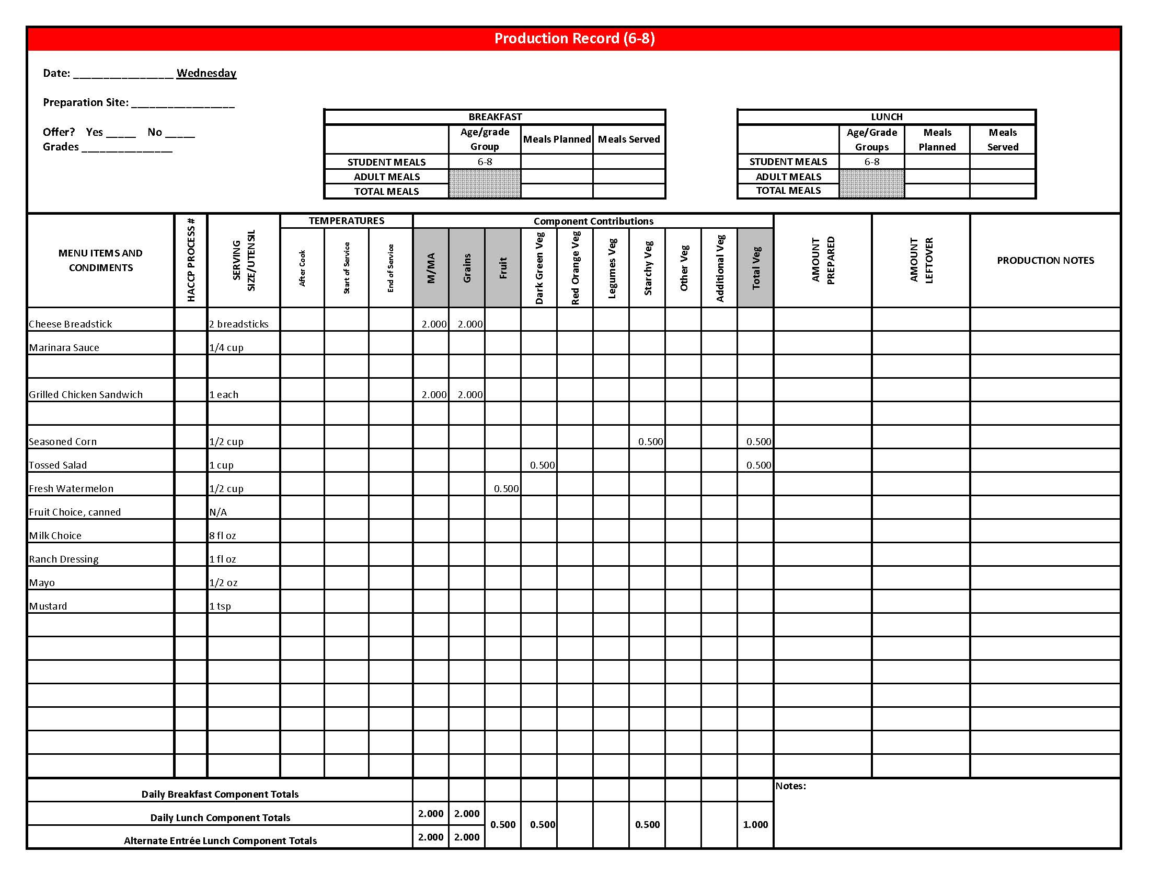

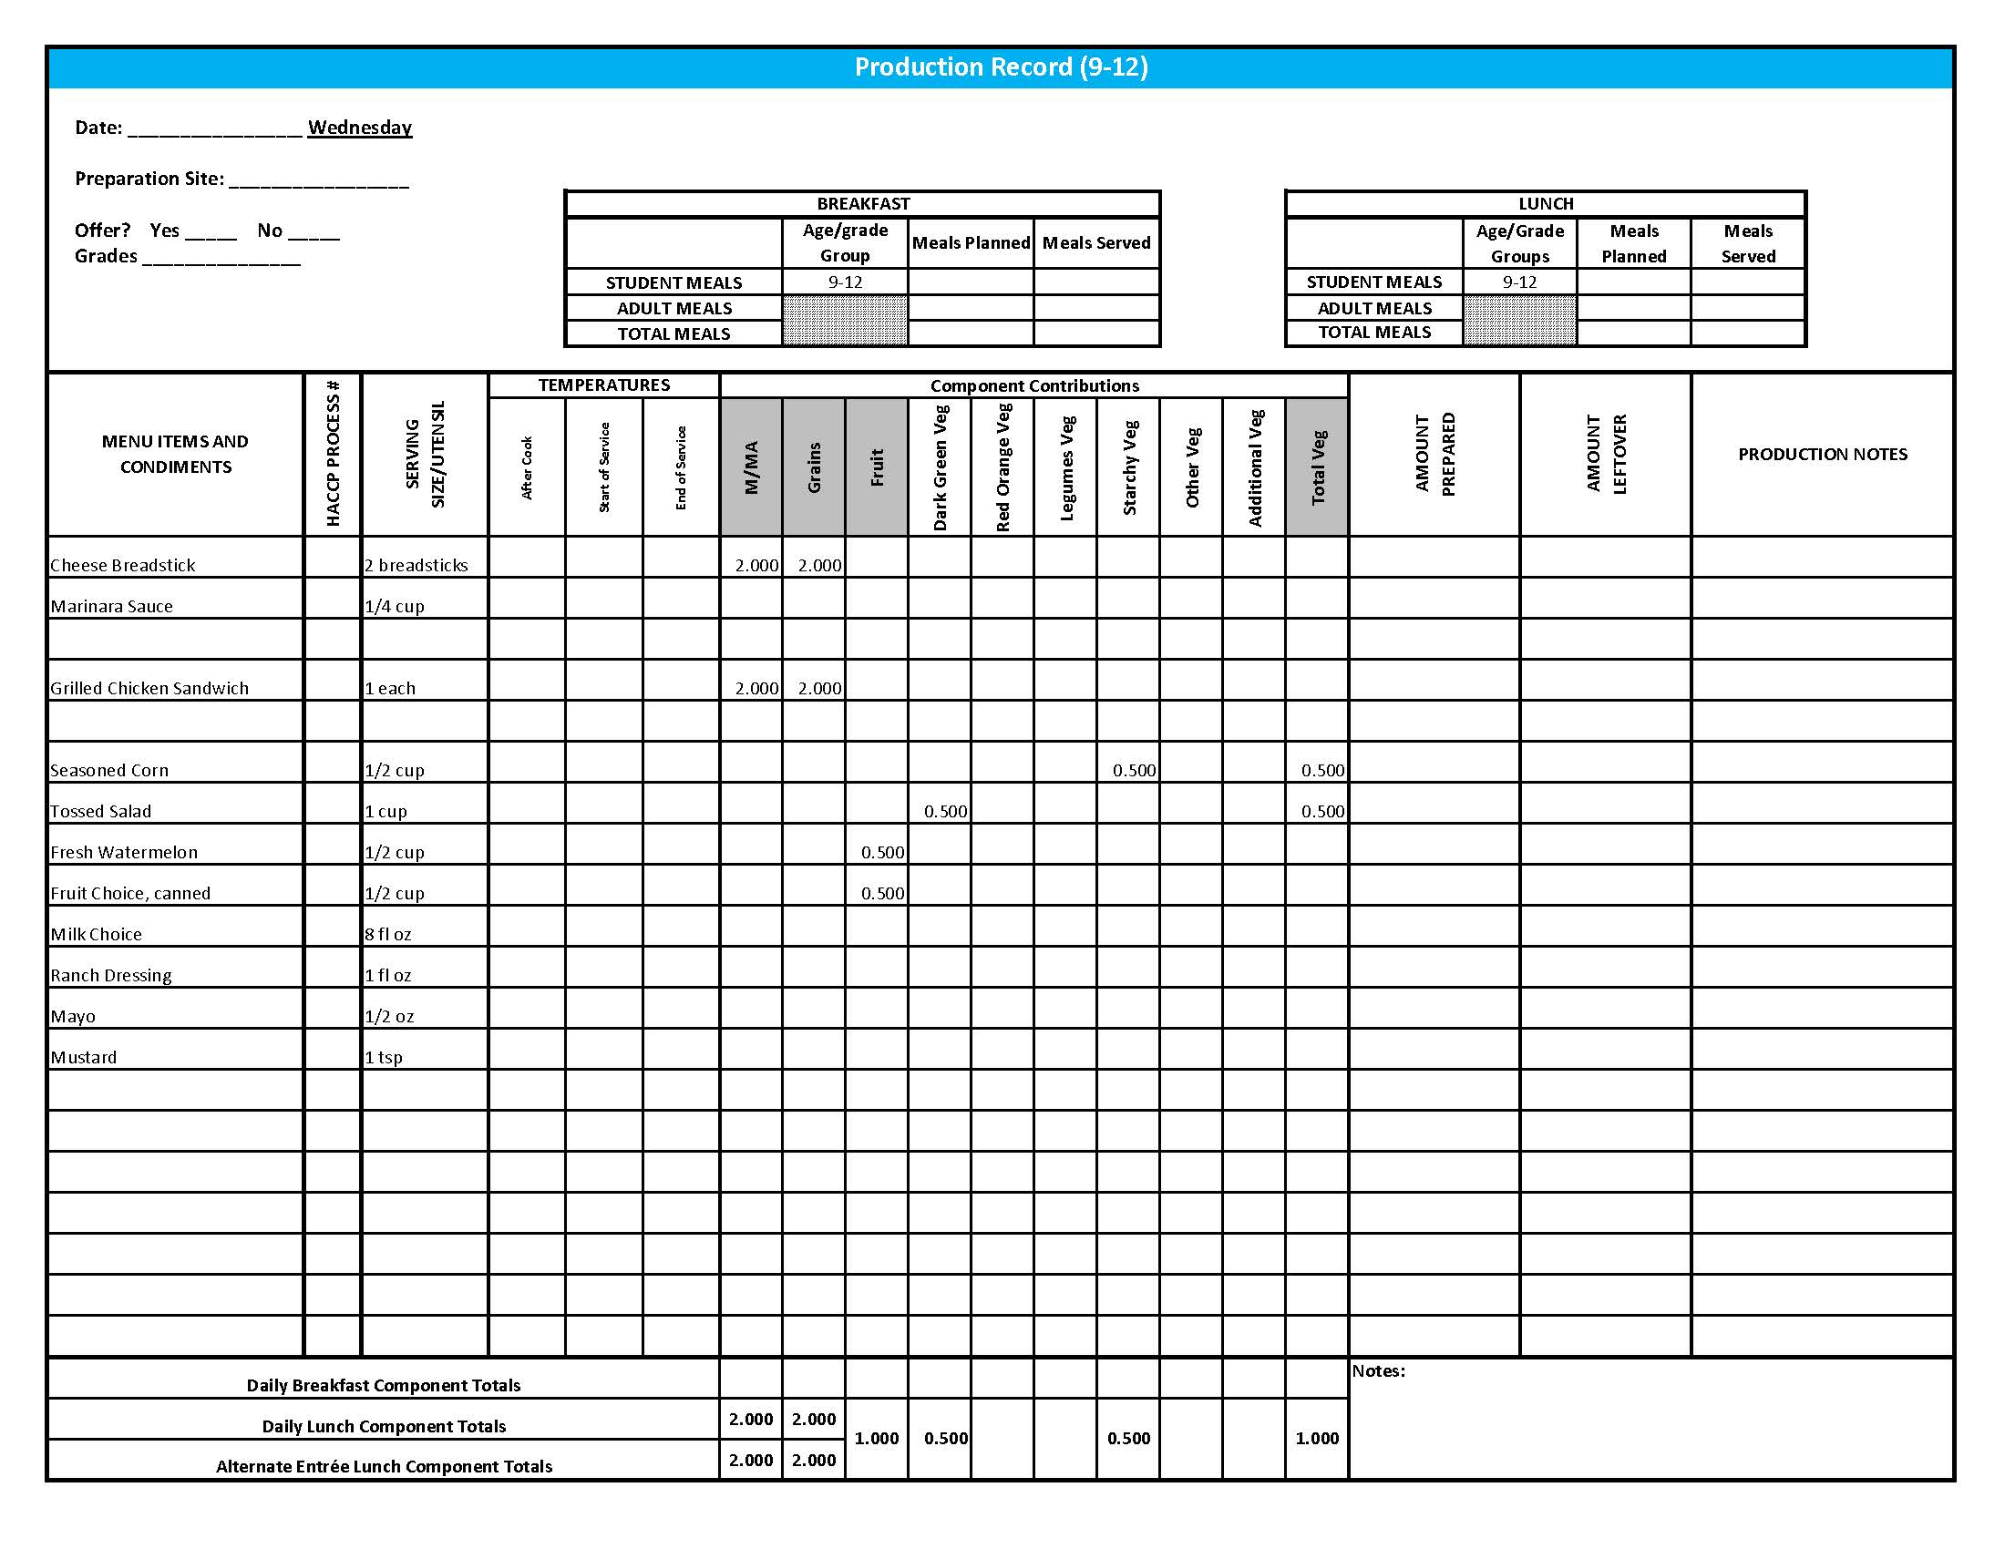

## Purchasing, Preparation & Serving Instructions

Week 2 – Thursday

|  |  |  |
| --- | --- | --- |
| **Menu Item** | **Purchasing & Preparation** | **Serving** |
| Pulled Pork Sandwich | * Prepare HKM Recipe 136, Pulled Pork Sandwich. * Purchase pre-prepared pulled pork that provides 2 oz equivalent M/MA, contains no more than 500 mg of sodium and no more than 13 g of fat. If product is not Child Nutrition (CN) labeled, obtain a Product Formulation Statement. * Purchase a 2 oz whole wheat bun (first ingredient is whole wheat) or prepare HKM Recipe 877, Whole Wheat Rolls, Bread Sticks, Buns. * **CCP: Hold for hot service at 135°F or above.** | K-12: 1 sandwich |
| **Alternate Entrée:**  Hamburger on a Bun | * Purchase pre-cooked, oven-ready hamburger patties that provides 2 oz equivalent M/MA; no more than 13 gm of fat; and no more than 300 mg sodium. If product is not Child Nutrition (CN) labeled, obtain a Product Formulation Statement. * Heat according to manufacturer’s instructions. * Purchase a 2 oz whole wheat bun (first ingredient is whole wheat) or prepare following HKM Recipe 877, Whole Wheat Rolls, Bread Sticks, Buns, Hamburger Bun Variation. * **CCP: Hold for hot service at 135°F or above.** | K-12: 1 each |
| Creamy Cole Slaw | * Prepare HKM Recipe 20, Creamy Cole Slaw. * Refer to *Fruit & Vegetable Order Guide* for amount needed. * Purchase pre-shredded green cabbage. * **CCP: Hold for cold service at 41°F or below.** | K-12: ½ cup |
| Baked Beans | * Prepare HKM Recipe 188, Baked Beans or purchase canned baked beans. * Refer to *Fruit & Vegetable Order Guide* for amount needed. * **CCP: Hold for hot service at 135°F or above.** | K-12: ½ cup |
| Applesauce, unsweetened | * Refer to *Fruit & Vegetable Order Guide* for amount needed. * Chill cans overnight. Wipe can tops clean before opening. * Cover and refrigerate until serving. * With gloved hands, wash strawberries. * **CCP: Refrigerate and hold at 41°F or below for cold service** | K-12: ½ cup |

*Continued on next page*

## Purchasing, Preparation & Serving Instructions

Week 2 – Thursday, continued

|  |  |  |
| --- | --- | --- |
| **Menu Item** | **Purchasing & Preparation** | **Serving** |
| Fruit Choice, fresh | Select an additional fruit choice to offer on the menu. The serving(s) offered must credit as ½ cup of fruit, to meet the minimum daily requirement, for grades 9-12.  *Note: The fruit choice is encouraged for grades K-5 and 6-8, but not required. The fruit choice is not included in the nutrient analysis for grades K-5 and 6-8. | K-8: N/A*  9-12: ½ cup |
| Milk | * Provide a variety of milk. May be 1% fat (unflavored) or skim (flavored or unflavored). * **CCP: Refrigerate and hold at 41°F or below for cold service.** | K-12: 8 fl oz |
| Ketchup | * Purchase in bulk or individual packets (9-gm or 12-gm). If bulk, purchase 1 #10 can or .8 gallon for every 100 1-fluid oz servings. | K-12: 1 fl oz **or** 2 Tbsp  **or** 2 PC |
| Mustard | * Purchase bulk or packets. If bulk, purchase 2 cups for every 100 1 tsp servings. | K-12: 1 tsp |

**Pre-preparation for Week 2 - Friday:** N/A

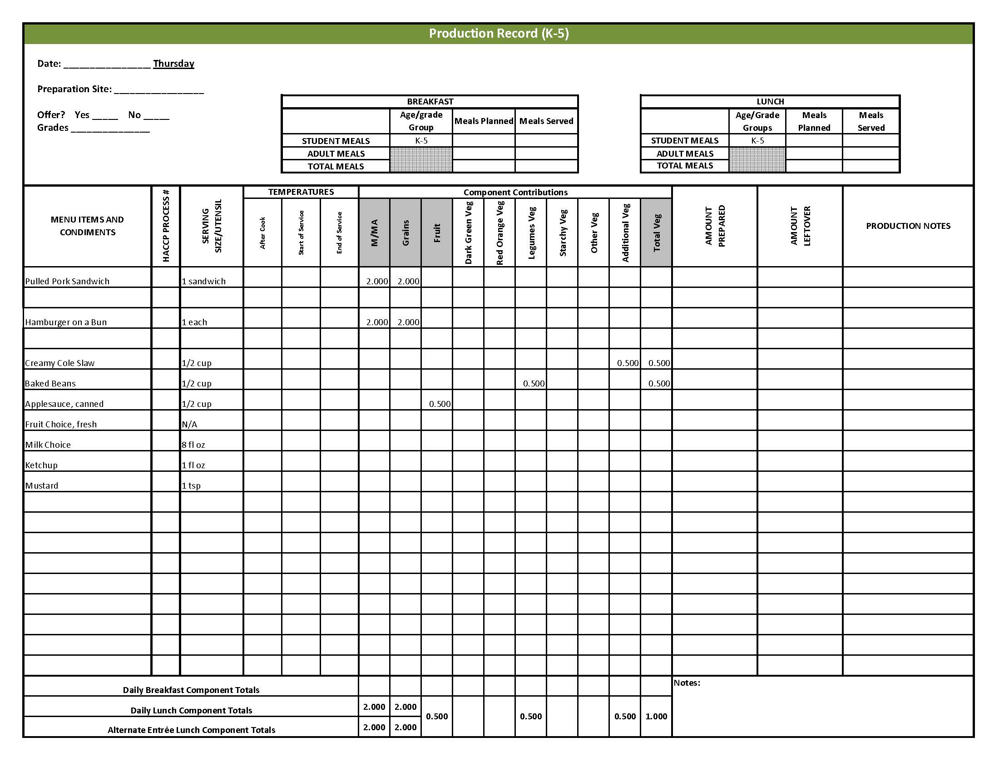

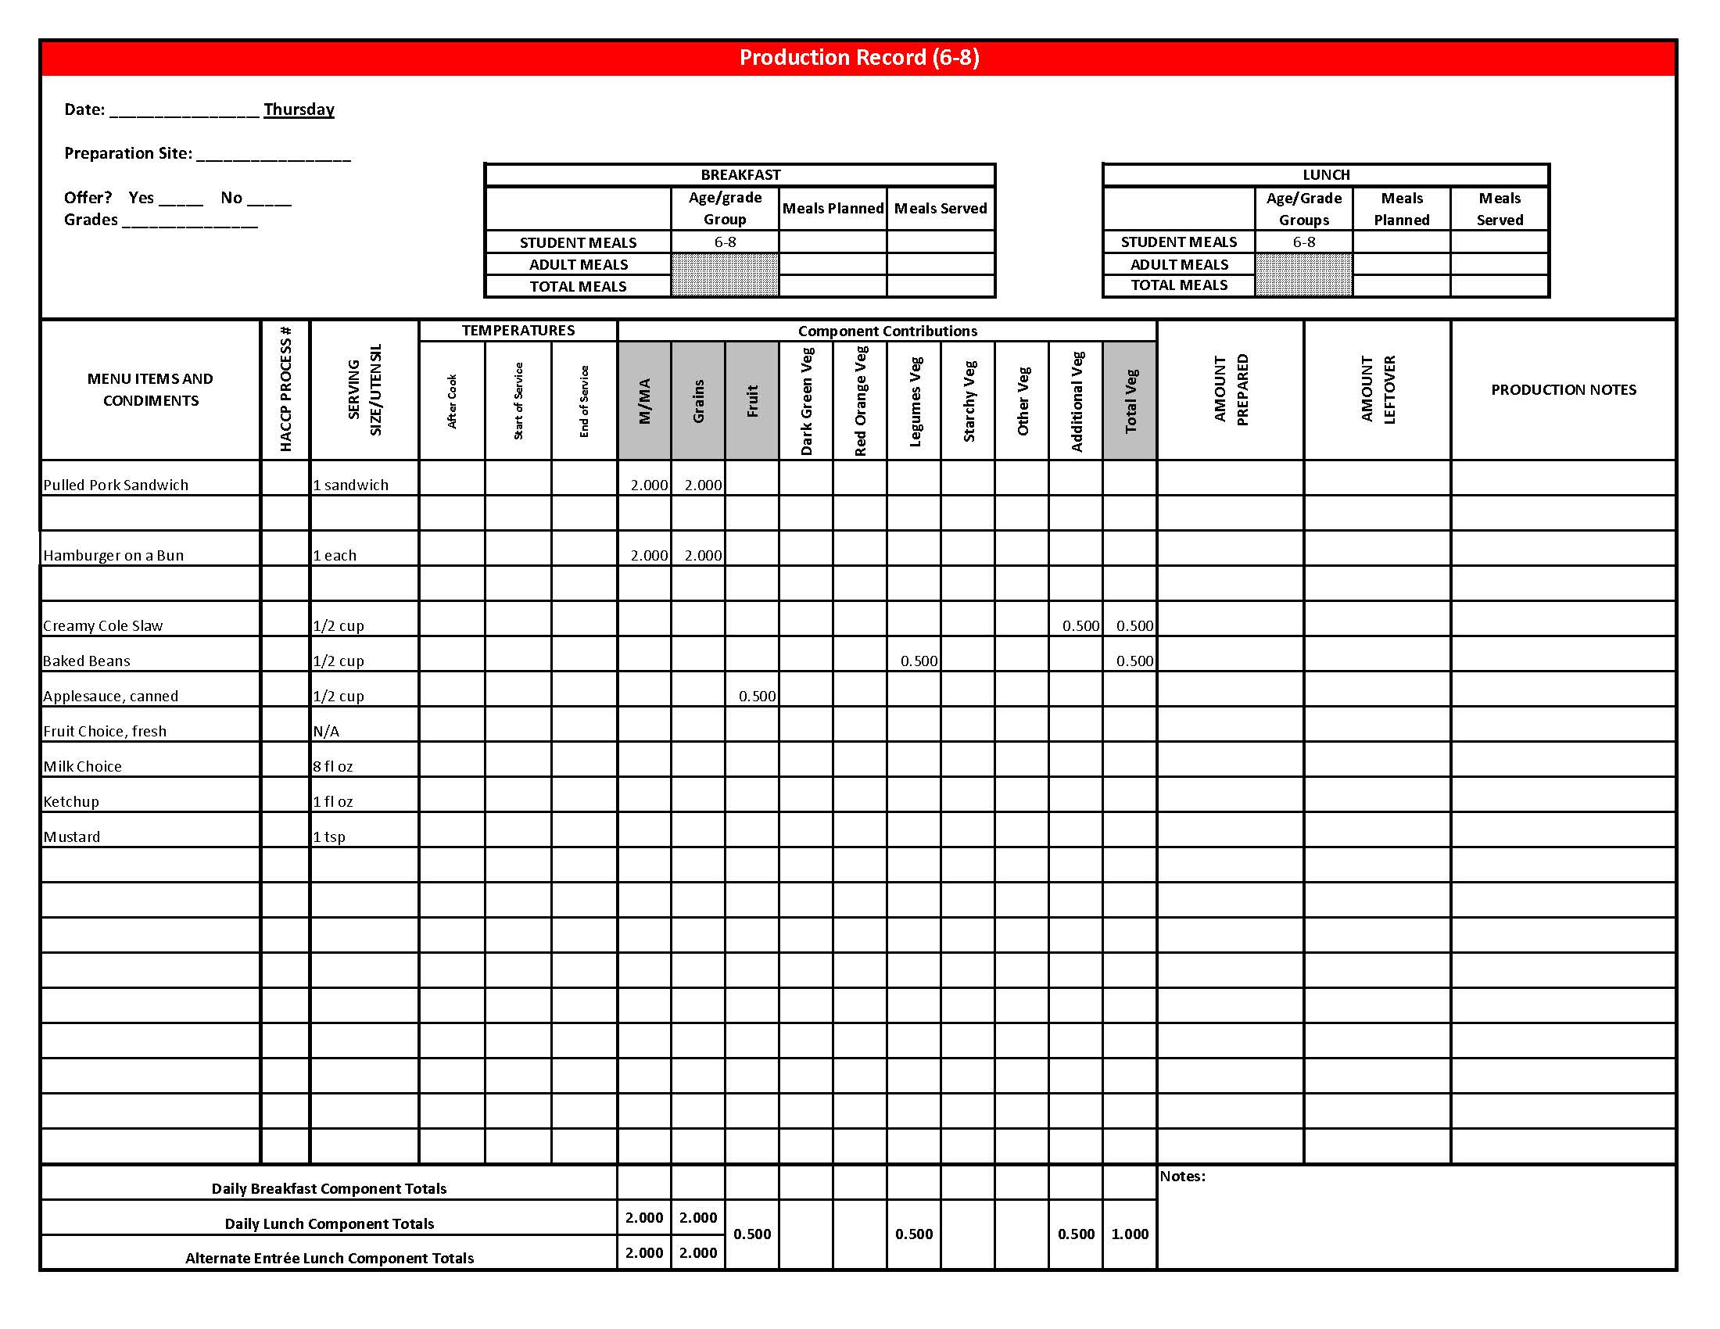

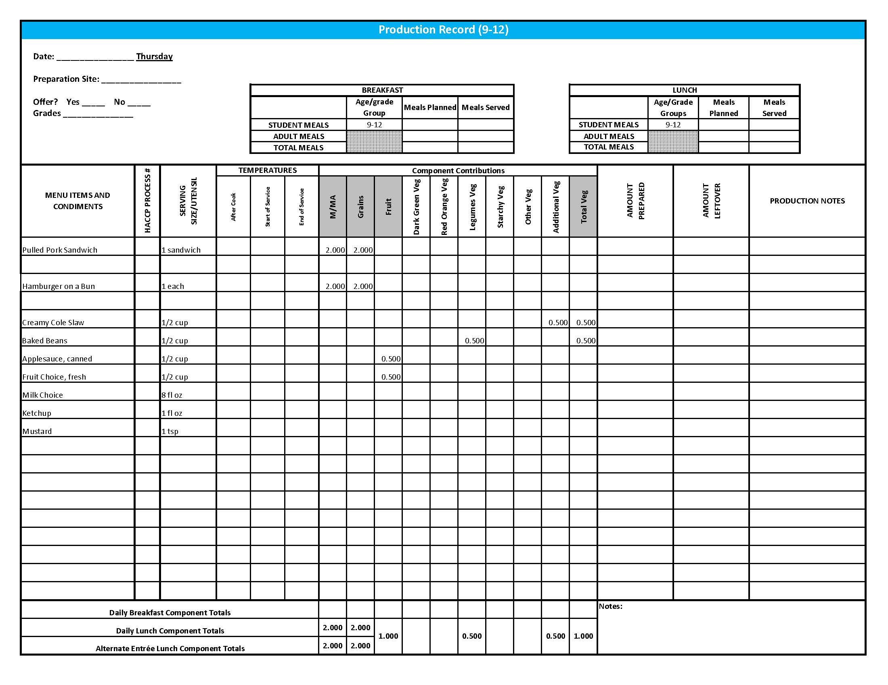

## Purchasing, Preparation & Serving Instructions

Week 2 – Friday

|  |  |  |
| --- | --- | --- |
| **Menu Item** | **Purchasing & Preparation** | **Serving** |
| Rock and Roll Beef Wraps | * Prepare HKM Recipe 133, Rock and Roll Beef Wraps. * Purchase 8” whole grain rich tortillas weighing 1.5 oz each. * **CCP: Hold for hot service at 135°F or above.** | K-12: 1 wrap |
| **Alternate Entrée:**  Cheese Pizza | * Purchase pre-prepared cheese pizza that provides 2 oz equivalent M/MA and 2 oz equivalent Grains; no more than 8 gm of fat; and no more than 600 mg sodium per serving. If product is not Child Nutrition (CN) labeled, obtain a Product Formulation Statement. * Heat in oven according to manufacturer’s instructions. * **CCP: Hold for hot service at 135°F or above.** | K-12: 1 piece |
| Carrots, Steamed | * Refer to *Fruit & Vegetable Order Guide* for amount needed. * Batch cook by steaming or by cooking in stock pot with minimal liquid close to serving time. * **CCP: Hold for hot service at 135°F or above.** | K-12: ½ cup |
| Broccoli Florets | * Refer to *Fruit & Vegetable Order Guide* for amount needed. Purchase fresh broccoli florets, ready to serve. * Wash broccoli. * Cover and refrigerate until serving. * **CCP: Refrigerate and hold at 41°F or below for cold service.** | K-8: ¼ cup  9-12: ½ cup |
| Orange Wedges, fresh | * Refer to *Fruit & Vegetable Order Guide* for amount needed. Purchase oranges, size #138. * Handle with gloved hands. Rinse peel. * Cut in fourths. For orange wedges cut in quarters lengthwise. For orange smiles trim ends, cut in two circles and then slice circles in half. * Cover and refrigerate. * **CCP: Hold for cold service at 41°F or below.** | K-12: 1 orange |

## Purchasing, Preparation & Serving Instructions

Week 2 – Friday, continued

|  |  |  |
| --- | --- | --- |
| **Menu Item** | **Purchasing & Preparation** | **Serving** |
| Fruit Choice, canned | Select an additional fruit choice to offer on the menu. The serving(s) offered must credit as ½ cup of fruit, to meet the minimum daily requirement, for grades 9-12.  *Note: The fruit choice is encouraged for grades K-5 and 6-8, but not required. The fruit choice is not included in the nutrient analysis for grades K-5 and 6-8. | K-8: N/A*  9-12: ½ cup |
| Cherry Crisp, Whole Wheat | * Prepare HKM Recipe 65 Cherry Crisp, Whole Wheat. * This menu item will count as a grain based dessert. | K-5: N/A  6-12: 1 piece |
| Milk | * Provide a variety of milk. May be 1% fat (unflavored) or skim (flavored or unflavored). * **CCP: Refrigerate and hold at 41°F or below for cold service.** | K-12: 8 fl oz |

**Pre-preparation for Week 3 - Monday:** Thaw chicken under refrigeration.

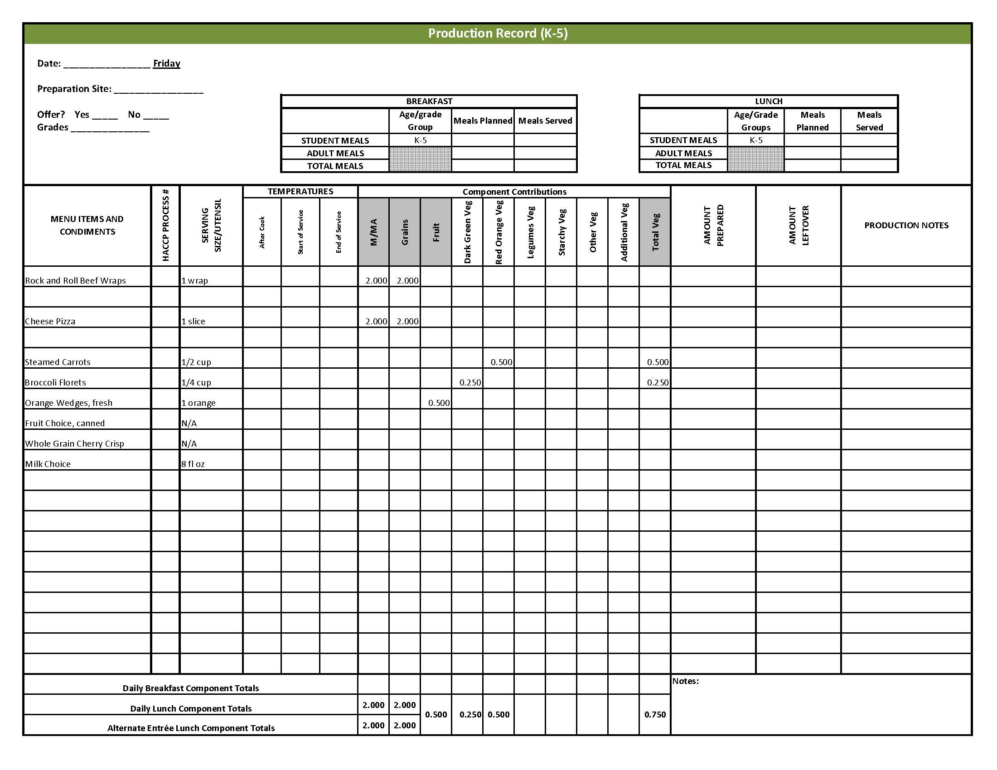

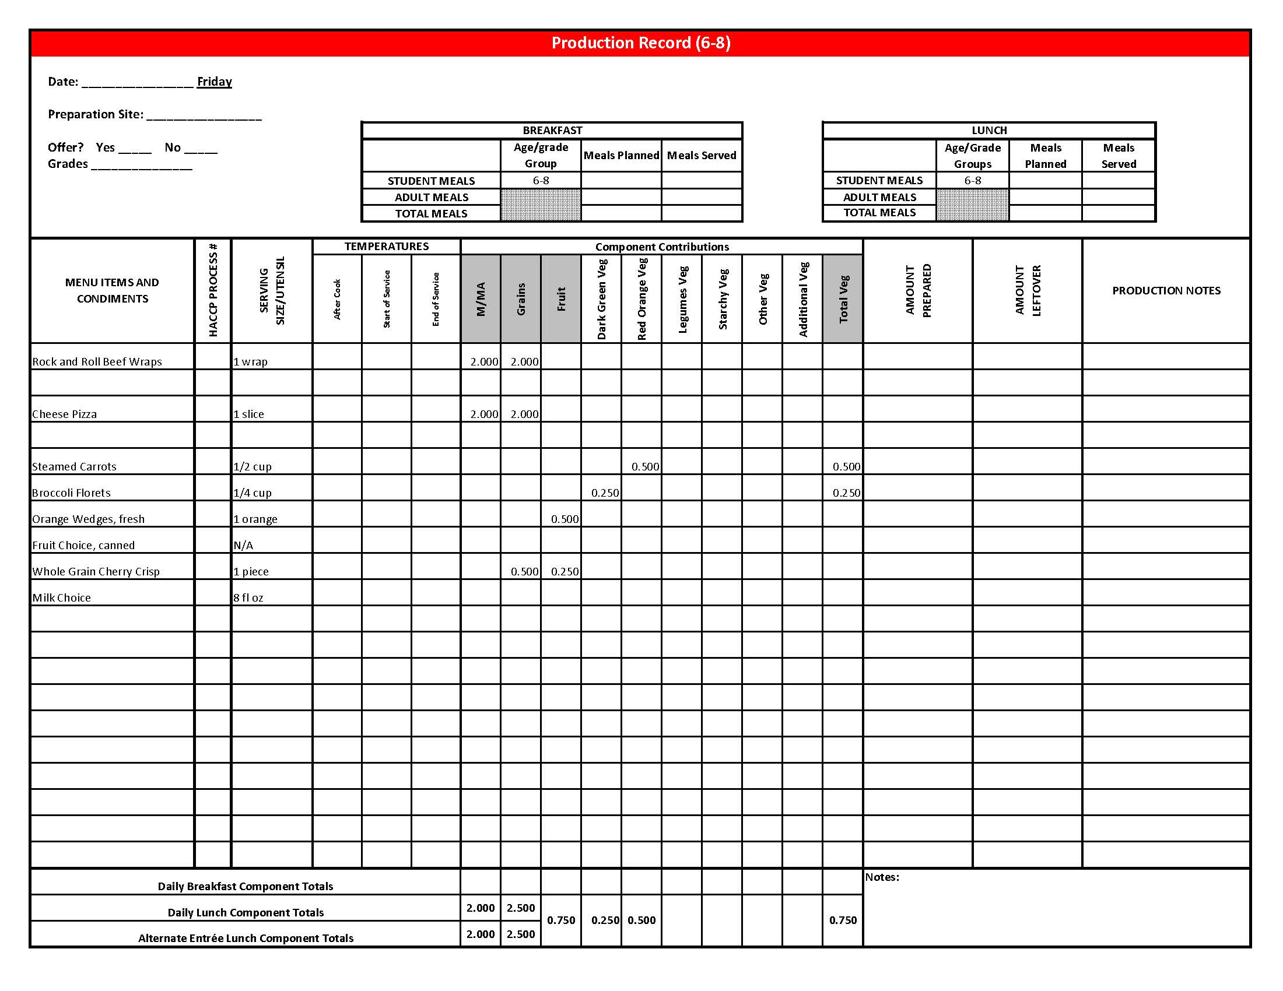

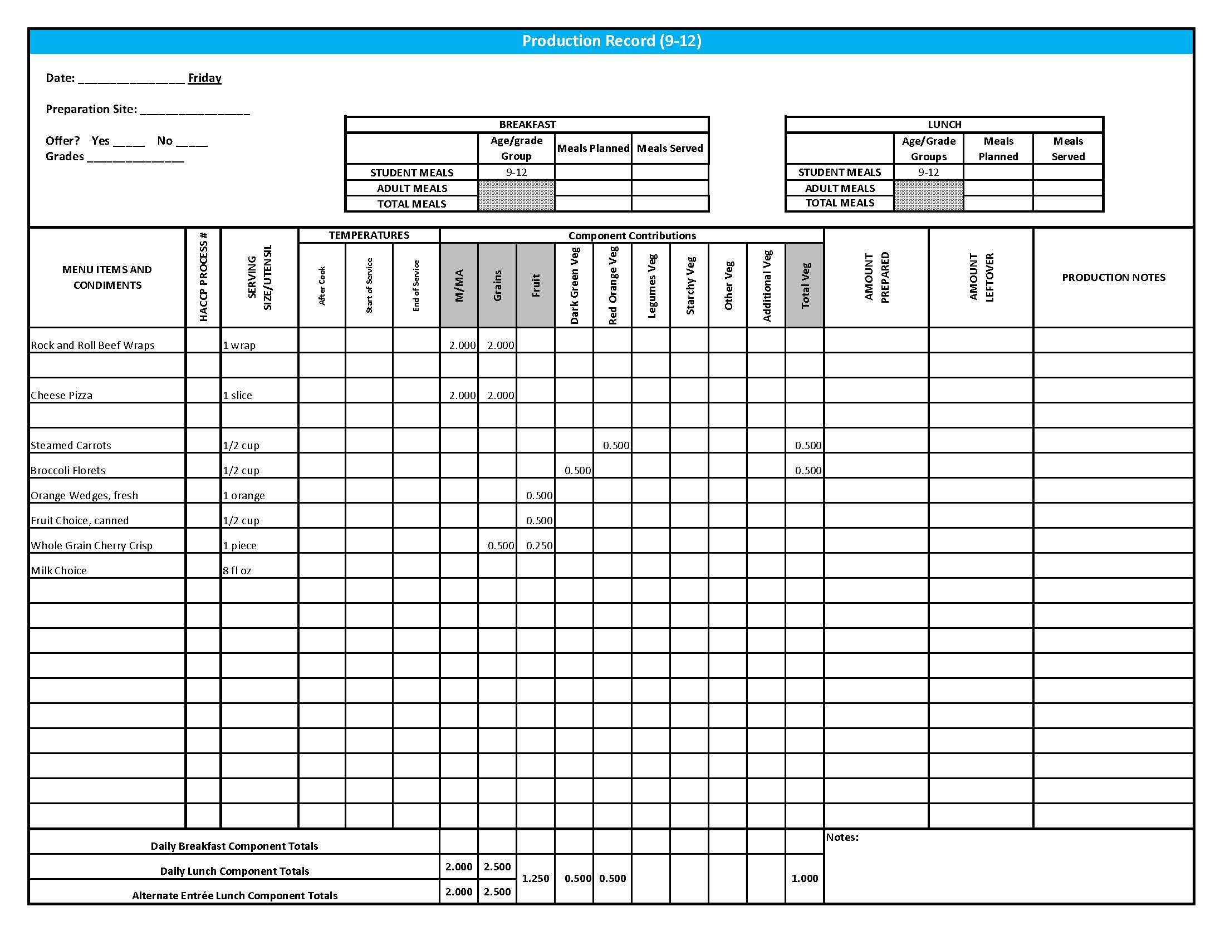

## Fruit & Vegetable Order Guide

## **Week 2**

The chart below provides amounts to be ordered per 100 servings based on the serving sizes listed on Week 1 of *Healthier Kansas Menus Production Records* for students in grades groups K-5, 6-8, and 9-12. Amounts to order are based on standard yields and leveled serving utensils or weighed portions. Use the following procedures to determine the amounts to order:

1. **Forecast** the number of servings needed for each fruit and vegetable menu item for each grade group served.
2. **Divide** the number of servings needed by 100 for each portion size (K-5, 6-8 or 9-12).
3. **Multiply** the “Amount to order per 100 servings” by the factor determined in step 2 above for each portion size.
4. **Add** amounts needed for all serving sizes together to determine the amounts to order.

**Abbreviations Key: EP = Edible Portion AP = As Purchased lb = Pound oz = ounce # = Number**

|  |  |  |  |  |  |  |  |
| --- | --- | --- | --- | --- | --- | --- | --- |
| **Day** | **Fruit or Vegetable** | **K-5**  **Portion Size** | **K-5**  **Amount to Order per 100 Servings** | **6-8**  **Portion Size** | **6-8**  **Amount to Order**  **per 100 Servings** | **9-12 Portion Size** | **9-12 Amount to Order per 100 Servings** |
| Monday | Sweet and Sour Chicken Nuggets (Sauce) | 5 nuggets |  | 5 nuggets |  | 5 nuggets |  |
| Juice, pineapple, 100% juice |  | 2 lb |  | 2 lb |  | 2 lb |
| Asian Fresh Vegetables | ½ cup |  | ½ cup |  | ½ cup |  |
| Cabbage, AP |  | 3 lb 10 oz |  | 3 lb 10 oz |  | 3 lb 10 oz |
| Peas, green, frozen | 2 lb 10 oz | 2 lb 10 oz | 2 lb 10 oz |
| Broccoli, florets, AP | 1 lb 12 oz | 1 lb 12 oz | 1 lb 12 oz |
| Carrots, sliced or crinkle, frozen | 5 lb 4 oz | 5 lb 4 oz | 5 lb 4 oz |
| Peppers, bell, green, AP | 2 lb 10 oz | 2 lb 10 oz | 2 lb 10 oz |
| Cherry Tomatoes, fresh, AP | 3 tomatoes | 8 lb 5 oz | 3 tomatoes | 8 lb 5 oz | 6 tomatoes | 16 lb 10 oz |
| Pear, fresh, 120 count, AP | 1 each | 25 lb 7 oz or 100 each | 1 each | 25 lb 7 oz or 100 each | 1 each | 25 lb 7 oz or 100 each |
| Blueberry Oat Muffin | 2 muffins |  | 2 muffins |  | 2 muffins |  |
| Applesauce, canned, unsweetened |  | 1 ½ #10 can |  | 1 ½ #10 can |  | 1 ½ #10 can |
| Blueberries, frozen, unsweetened |  | 5 lb |  | 5 lb |  | 5 lb |

Fruit & Vegetable Order Guide

**Week 2, continued**

|  |  |  |  |  |  |  |  |
| --- | --- | --- | --- | --- | --- | --- | --- |
| **Day** | **Fruit or Vegetable** | **K-5**  **Portion Size** | **K-5**  **Amount to Order per 100 Servings** | **6-8**  **Portion Size** | **6-8**  **Amount to Order**  **per 100 Servings** | **9-12 Portion Size** | **9-12 Amount to Order per 100 Servings** |
| Tuesday | Taco Meat | ¼ cup |  | ¼ cup |  | ¼ cup |  |
| Tomato Paste, canned |  | 3 cups |  | 3 cups |  | 3 cups |
| Picante Sauce **OR** | ¼ cup | 1 gal 9 cups | ¼ cup | 1 gal 9 cups | ¼ cup | 1 gal 9 cups |
| Tomato Salsa | ¼ cup |  | ¼ cup |  | ¼ cup |  |
| Tomatoes, crushed, salsa-ready, canned |  | 2 #10 cans |  | 2 #10 cans |  | 2 #10 cans |
| Peppers, jalapeno, canned | 4 oz | 4 oz | 4 oz |
| Lettuce, Romaine, AP | ½ cup | 6 lb 7 oz | ½ cup | 6 lb 7 oz | ½ cup | 6 lb 7 oz |
| Southwestern Lentils | ¼ cup |  | ¼ cup |  | ½ cup |  |
| Lentils, brown, AP |  | 2 lb 2 oz |  | 2 lb 2 oz |  | 4 lb 4 oz |
| Onions, AP | 2 lb 4 oz | 2 lb 4 oz | 4 lb 8 oz |
| Tomatoes, crushed, canned | 2 lb 8 oz | 2 lb 8 oz | 5 lb |
| Plum, fresh, 45-50 count, AP | 1 each | 20 lb 2 oz or 100 each | 1 each | 20 lb 2 oz or 100 each | 1 each | 20 lb 2 oz or 100 each |
| Wednesday | Marinara Sauce, canned | ¼ cup | 2.1 #10 cans | ¼ cup | 2.1 #10 cans | ¼ cup | 2.1 #10 cans |
| Watermelon, fresh, AP | ½ cup | 32 lb 13 oz | ½ cup | 32 lb 13 oz | ½ cup | 32 lb 13 oz |
| Tossed Salad | 1 cup |  | 1 cup |  | 1 cup |  |
| Spinach, fresh, trimmed, AP |  | 7 lb |  | 7 lb |  | 7 lb |
| Romaine Lettuce, AP | 7 lb | 7 lb | 7 lb |
| Corn, frozen OR | ½ cup | 18 lb 4 oz | ½ cup | 18 lb 4 oz | ½ cup | 18 lb 4 oz |
| Corn, canned |  | 5.2 #10 cans |  | 5.2 #10 cans |  | 5.2 #10 cans |

Fruit & Vegetable Order Guide

**Week 2, continued**

|  |  |  |  |  |  |  |  |
| --- | --- | --- | --- | --- | --- | --- | --- |
| **Day** | **Fruit or Vegetable** | **K-5**  **Portion Size** | **K-5**  **Amount to Order per 100 Servings** | **6-8**  **Portion Size** | **6-8**  **Amount to Order**  **per 100 Servings** | **9-12 Portion Size** | **9-12 Amount to Order per 100 Servings** |
| Thursday | Creamy Cole Slaw | ½ cup |  | ½ cup |  | ½ cup |  |
| Cabbage, fresh, green, shredded ready to use |  | 12 lb |  | 12 lb |  | 12 lb |
| Carrots, fresh, AP |  | 1 lb 8 oz |  | 1 lb 8 oz |  | 1 lb 8 oz |
| Baked Beans | ½ cup |  | ½ cup |  | ½ cup |  |
| Beans, baked, canned, vegetarian |  | 4.25 #10 cans |  | 4.25 #10 cans |  | 4.25 #10 cans |
| Tomato Sauce, canned | 6 cups | 6 cups | 6 cups |
| Applesauce, canned, unsweetened | ½ cup | 4.4 #10 cans | ½ cup | 4.4 #10 cans | ½ cup | 4.4 #10 cans |
| Friday | Rock and Roll Beef Wraps | 1 wrap |  | 1 wrap |  | 1 wrap |  |
| Broccoli Slaw, AP |  | 9 lb 13 oz |  | 9 lb 13 oz |  | 9 lb 13 oz |
| Broccoli, florets, fresh, EP | ¼ cup | 3 lb 8 oz | ¼ cup | 3 lb 8 oz | ½ cup | 7 lb |
| Carrots, frozen, sliced | ½ cup | 20 lb 7 oz | ½ cup | 20 lb 7 oz | ½ cup | 20 lb 7 oz |
| Oranges, fresh, whole, #138 | 1 orange | 29 lb 8 oz or 100 each | 1 orange | 29 lb 8 oz or 100 each | 1 orange | 29 lb 8 oz or 100 each |
| Cherry Crisp, Whole Wheat | N/A |  | 1 piece |  | 1 piece |  |
| Cherries, canned, packed in water |  | N/A |  | 3 #10 cans |  | 3 #10 cans |
| Orange Juice, Frozen, unsweetened |  | N/A |  | ½ cup |  | ½ cup |