He**althier Kansas Menus**

with Alternate Entrées

# C:\Documents and Settings\jmackey\My Documents\My Pictures\Microsoft Clip Organizer\j0349505.wmf

SPRING WEEK 1 – DAILY PRODUCTION RECORDS

Child Nutrition & Wellness, Kansas State Department of Education

Revised July 2019

This publication has been funded at least in part with Federal funds from the U.S. Department of Agriculture, Food and Nutrition Service. The contents of this publication do not necessarily reflect the views or policies of the Department, nor does mention of trade names, commercial products, or organizations imply endorsement by the U.S. Government.

**For further information about this publication, please contact:** Child Nutrition & Wellness, KSDE, Landon State Office Building, 900 SW Jackson Street, Suite #251, Avenue, Topeka, Kansas 66612, 785-296-2276, Fax: 785-296-0232,

[www.kn-eat.org](http://www.kn-eat.org/)

In accordance with Federal civil rights law and U.S. Department of Agriculture (USDA) civil rights regulations and policies, the USDA, its Agencies, offices, and employees, and institutions participating in or administering USDA programs are prohibited from discriminating based on race, color, national origin, sex, disability, age, or reprisal or retaliation for prior civil rights activity in any program or activity conducted or funded by USDA.  
  
Persons with disabilities who require alternative means of communication for program information (e.g. Braille, large print, audiotape, American Sign Language, etc.), should contact the Agency (State or local) where they applied for benefits. Individuals who are deaf, hard of hearing or have speech disabilities may contact USDA through the Federal Relay Service at (800) 877-8339. Additionally, program information may be made available in languages other than English.  
  
To file a program complaint of discrimination, complete the [USDA Program Discrimination Complaint Form](http://www.ocio.usda.gov/sites/default/files/docs/2012/Complain_combined_6_8_12.pdf), (AD-3027) found online at: [http://www.ascr.usda.gov/complaint_filing_cust.html](https://www.ascr.usda.gov/filing-discrimination-complaint-usda-customer), and at any USDA office, or write a letter addressed to USDA and provide in the letter all of the information requested in the form. To request a copy of the complaint form, call (866) 632-9992. Submit your completed form or letter to USDA by:  
  
(1)   Mail: U.S. Department of Agriculture  
Office of the Assistant Secretary for Civil Rights  
1400 Independence Avenue, SW  
Washington, D.C. 20250-9410;  
  
(2)   Fax: (202) 690-7442; or  
  
(3)   Email: [program.intake@usda.gov](mailto:program.intake@usda.gov).  
  
This institution is an equal opportunity provider.

The following person has been designated to handle inquiries regarding the non-discrimination policies at the Kansas State Department of Education: Office of General Counsel, Landon State Office Building, 900 SW Jackson St, Suite #102, Topeka, KS 66612, (785)296-3201.

Healthier Kansas Menus recipes were developed by Child Nutrition & Wellness, Kansas State Department of Education or adapted from the following sources:

* *Food for Fifty,* Ninth Edition (1989) Grace Shugart, Mary Molt*.*
* *Healthier Kansas Menus – Breakfast,* Child Nutrition & Wellness, Kansas State Department of Education
* *Iowa Gold Star Cycle Menus*, Iowa Department of Education
* *Menus that Move,* Ohio Department of Education.
* *Fruit and Veggie Quantity Cookbook,* New Hampshire Department of Health and Human Services.
* *Preparing Whole Grain Foods,* Child Nutrition & Wellness, Kansas State Department of Education
* *Singing the Praises of Beans & Legumes*, Child Nutrition & Wellness, Kansas State Department of Education
* *USDA Recipes for Schools,* U.S. Department of Agriculture, Food & Nutrition Service, Child Nutrition Programs, 2006.
* USD 225 Fowler
* USD 234 Fort Scott
* USD 267 Renwick
* USD 306 Southeast of Saline
* USD 308 Hutchinson
* USD 320 Wamego
* USD 349 Stafford
* USD 364 Marysville
* USD 503 Parsons
* USD 512 Shawnee Mission

Thank you to the following schools for assisting with menu development and recipe testing:

* Logan Elementary School – USD 345 Seaman
* St. Joseph Catholic School – Mt. Hope, KS
* Winfield Scott Elementary School – USD 234 Fort Scott

## Menus for the Week

**PLEASE NOTE:**

Milk choice includes a variety of non-fat or 1% (flavored or unflavored) milk. One milk choice must be unflavored.

Reduced fat dressing is served with salads and fresh vegetables.

Menus were planned using all whole grain-rich products. Beginning July 1, 2019, at least half of the weekly grains in the school lunch menu and the school breakfast menu must be whole grain-rich.

|  |  |  |  |  |  |  |  |  |
| --- | --- | --- | --- | --- | --- | --- | --- | --- |
| **MONDAY** | **TUESDAY** | **WEDNESDAY** | **THURSDAY** | **FRIDAY** | **Weekly Nutrient Averages** | | | |
|  | K-5 | 6-8 | 9-12 |
| Hot Ham & Cheese  on a Bun  **Or**  Pork Rib on a Bun  Potato Wedges  Red Bell Pepper Strips  Fresh Apple  Canned Fruit Choice  Milk Choice | Pepperoni Pizza  **Or**  Popcorn Chicken  **Whole Wheat Roll (9-12)**  Broccoli Florets  Cherry Tomatoes  Fruit Cocktail  Fresh Fruit Choice  Milk Choice | Taco Burger  on a Bun  **Tortilla Chips (6-12)**  **Or**  Fruit, Yogurt & Granola Parfait  **Tortilla Chips (6-12)**  Tomato Salsa  Dark Green Leaf Lettuce  Refried Beans  Fresh Raspberries  Canned Fruit Choice  Milk Choice | Lasagna  Garlic Bread Stick  w/ Marinara Sauce  **Or**  Turkey & Cheese Sub Sandwich  Garden Salad  Fresh Baby Carrots  Fresh Grapes  Chocolate Chip Cookie  Canned Fruit Choice  Milk Choice | Chicken Patty  Whole Wheat Roll  **Or**  Peanut Butter & Jelly Sandwich  Mashed Potatoes  & Gravy  Steamed Asparagus  Fresh Peach  Canned Fruit Choice  Milk Choice | **Calories**  **Sodium (mg)**  **% of Total Calories from Sat. Fat** | **649**  **890**  **8.5%** | **683**  **858**  **8.4%** | **759**  **910**  **7.6%** |

C:\Documents and Settings\jmackey\My Documents\My Pictures\Microsoft Clip Organizer\j0349505.wmf

## Recipes for the Week

|  |  |  |  |
| --- | --- | --- | --- |
| Day | Recipe Name | Recipe Number | HKM Recipe  Page Number |
| Monday | Hot Ham & Cheese on a Bun  Whole Wheat Bun | 48  877 | 20  91 |
| Tuesday | Whole Wheat Roll | 877 | 91 |
| Wednesday | Taco Burger on a Bun  Whole Wheat Bun  Tomato Salsa | 77  877  129 | 37  91  61 |
| Thursday | Lasagna  Whole Wheat Bread Stick: Garlic Variation  Garden Salad  Chocolate Chip Cookie | 40  877  164  1079 | 21  91  55  67 |
| Friday | Whole Wheat Roll | 877 | 91 |

## Abbreviations

|  |  |  |  |
| --- | --- | --- | --- |
| **Abbreviation** | **What it Means** | **Abbreviation** | **What it Means** |
| HKM | Healthier Kansas Menus | Tbsp | tablespoon |
| EP | edible portion | tsp | teaspoon |
| AP | as purchased | CCP | Critical Control Point |
| fl | fluid | PC | portion controlled * |
| oz | ounce | w/ | with |
| lb | pound | M/MA | meat/meat alternate |
| gm | gram |  |  |
| mg | milligram |  |  |

* For example, purchase pre-portioned servings of condiments.

## Portion Guide

|  |  |
| --- | --- |
| **Ladles & Spoodles** | **Scoops** |
| 1 fl oz = 2 Tbsp | #50 = 3 3/4 tsp |
| 2 fl oz = 1/4 cup | #40 = 1 2/3 Tbsp |
| 3 fl oz = 3/8 cup | #30 = 2 Tbsp |
| 4 fl oz = 1/2 cup | #20 = 3 1/3 Tbsp |
| 6 fl oz = 3/4 cup | #16 = 1/4 cup |
| 8 fl oz = 1 cup | #12 = 1/3 cup |
|  | #8 = 1/2 cup |
|  | #6 = 2/3 cup |

## Purchasing, Preparation & Serving Instructions

Week 1 – Monday

|  |  |  |
| --- | --- | --- |
| **Menu Item** | **Purchasing & Preparation** | **Serving** |
| Hot Ham & Cheese on a Bun | * Purchase pre-cooked “Ham, water added”. * Prepare HKM Recipe 48, Hot Ham & Cheese on Whole Wheat Bun. Batch cook as necessary. * Purchase a 2 oz whole wheat bun (first ingredient is whole wheat) or prepare HKM Recipe 877, Whole Wheat Rolls, Bread Sticks, Buns. * **CCP: Hold for hot service at 135°F or above.** | K-12: 1 sandwich |
| **Alternate Entrée:**  Pork Rib on a Bun | * Purchase a pre-cooked rib patty that provides 2 oz equivalent M/MA; no more than 10 gm of fat; and no more than 400 mg of sodium per serving. If product is not Child Nutrition (CN) labeled, obtain a Product Formulation Statement. * Heat according to manufacturer’s instructions. * Purchase a 2 oz whole wheat bun (first ingredient is whole wheat) or prepare HKM Recipe 877, Whole Wheat Rolls, Bread Sticks, Buns, hamburger bun variation. * **CCP: Hold for hot service at 135°F or above.** | K-12: 1 sandwich |
| Potato Wedges | * Refer to *Fruit & Vegetable Order Guide* for amount needed. Purchase frozen, ovenable, unseasoned potato wedges. Choose skin-on wedges for additional fiber. * Follow manufacturer’s directions for baking and holding. * Batch cook. May add pepper or other non-sodium seasonings. * May estimate serving sizes using measure portions as samples. * **CCP: Hold for hot service at 135°F or above.** | K-12: ½ cup |
| Red Bell Pepper Strips | * Refer to *Fruit & Vegetable Order Guide* for amount needed. * With gloved hands, core and slice bell peppers into strips. * Cover and refrigerate until serving. * **CCP: Refrigerate and hold at 41°F or below for cold service.** | K-12: ½ cup |
| Apple Slices, Fresh | * Refer to *Fruit & Vegetable Order Guide* for amount needed. Purchase apples, size #125-138. * Handle with gloved hands. Rinse and remove core. Cut in 4ths or 8ths. * Dip in lemon, orange, pineapple juice or antioxidant solution to preserve color. * Cover and refrigerate until serving. * **CCP: Refrigerate and hold at 41°F or below for cold service.** | K-12: ½ apple |

*Continued on next page*

## Purchasing, Preparation & Serving Instructions

Week 1 – Monday, continued

|  |  |  |
| --- | --- | --- |
| **Menu Item** | **Purchasing & Preparation** | **Serving** |
| Fruit Choice, canned | Select an additional fruit choice to offer on the menu. The serving(s) offered must credit as ½ cup of fruit, to meet the minimum daily requirement, for grades 9-12.  *Note: The fruit choice is encouraged for grades K-5 and 6-8, but not required. The fruit choice is not included in the nutrient analysis for grades K-5 and 6-8. | K-8: N/A*  9-12: ½ cup |
| Milk | * Provide a variety of milk. May be 1% fat (unflavored) or skim (flavored or unflavored). * **CCP: Refrigerate and hold at 41°F or below for cold service.** | K-12: 8 fl oz |
| Ranch Dressing, Reduced Fat | * Purchase or prepare Ranch dressing containing no more than 6 gm of fat  per 1 fl oz. Purchase .8 gallons for every 100 1 fl oz portions. * **CCP: Refrigerate and serve at 41°F or below if school-prepared dressing is served.** | K-12: 1 fl oz **or** 2 Tbsp |
| Ketchup | * Purchase in bulk or individual packets (9-gm or 12-gm). If bulk, purchase 1 #10 can or .8 gallon for every 100 1-fluid oz servings. | K-12: 1 fl oz  **or** 2 Tbsp **or** 2 PC |

**Pre-preparation for Week 1 – Tuesday:** None

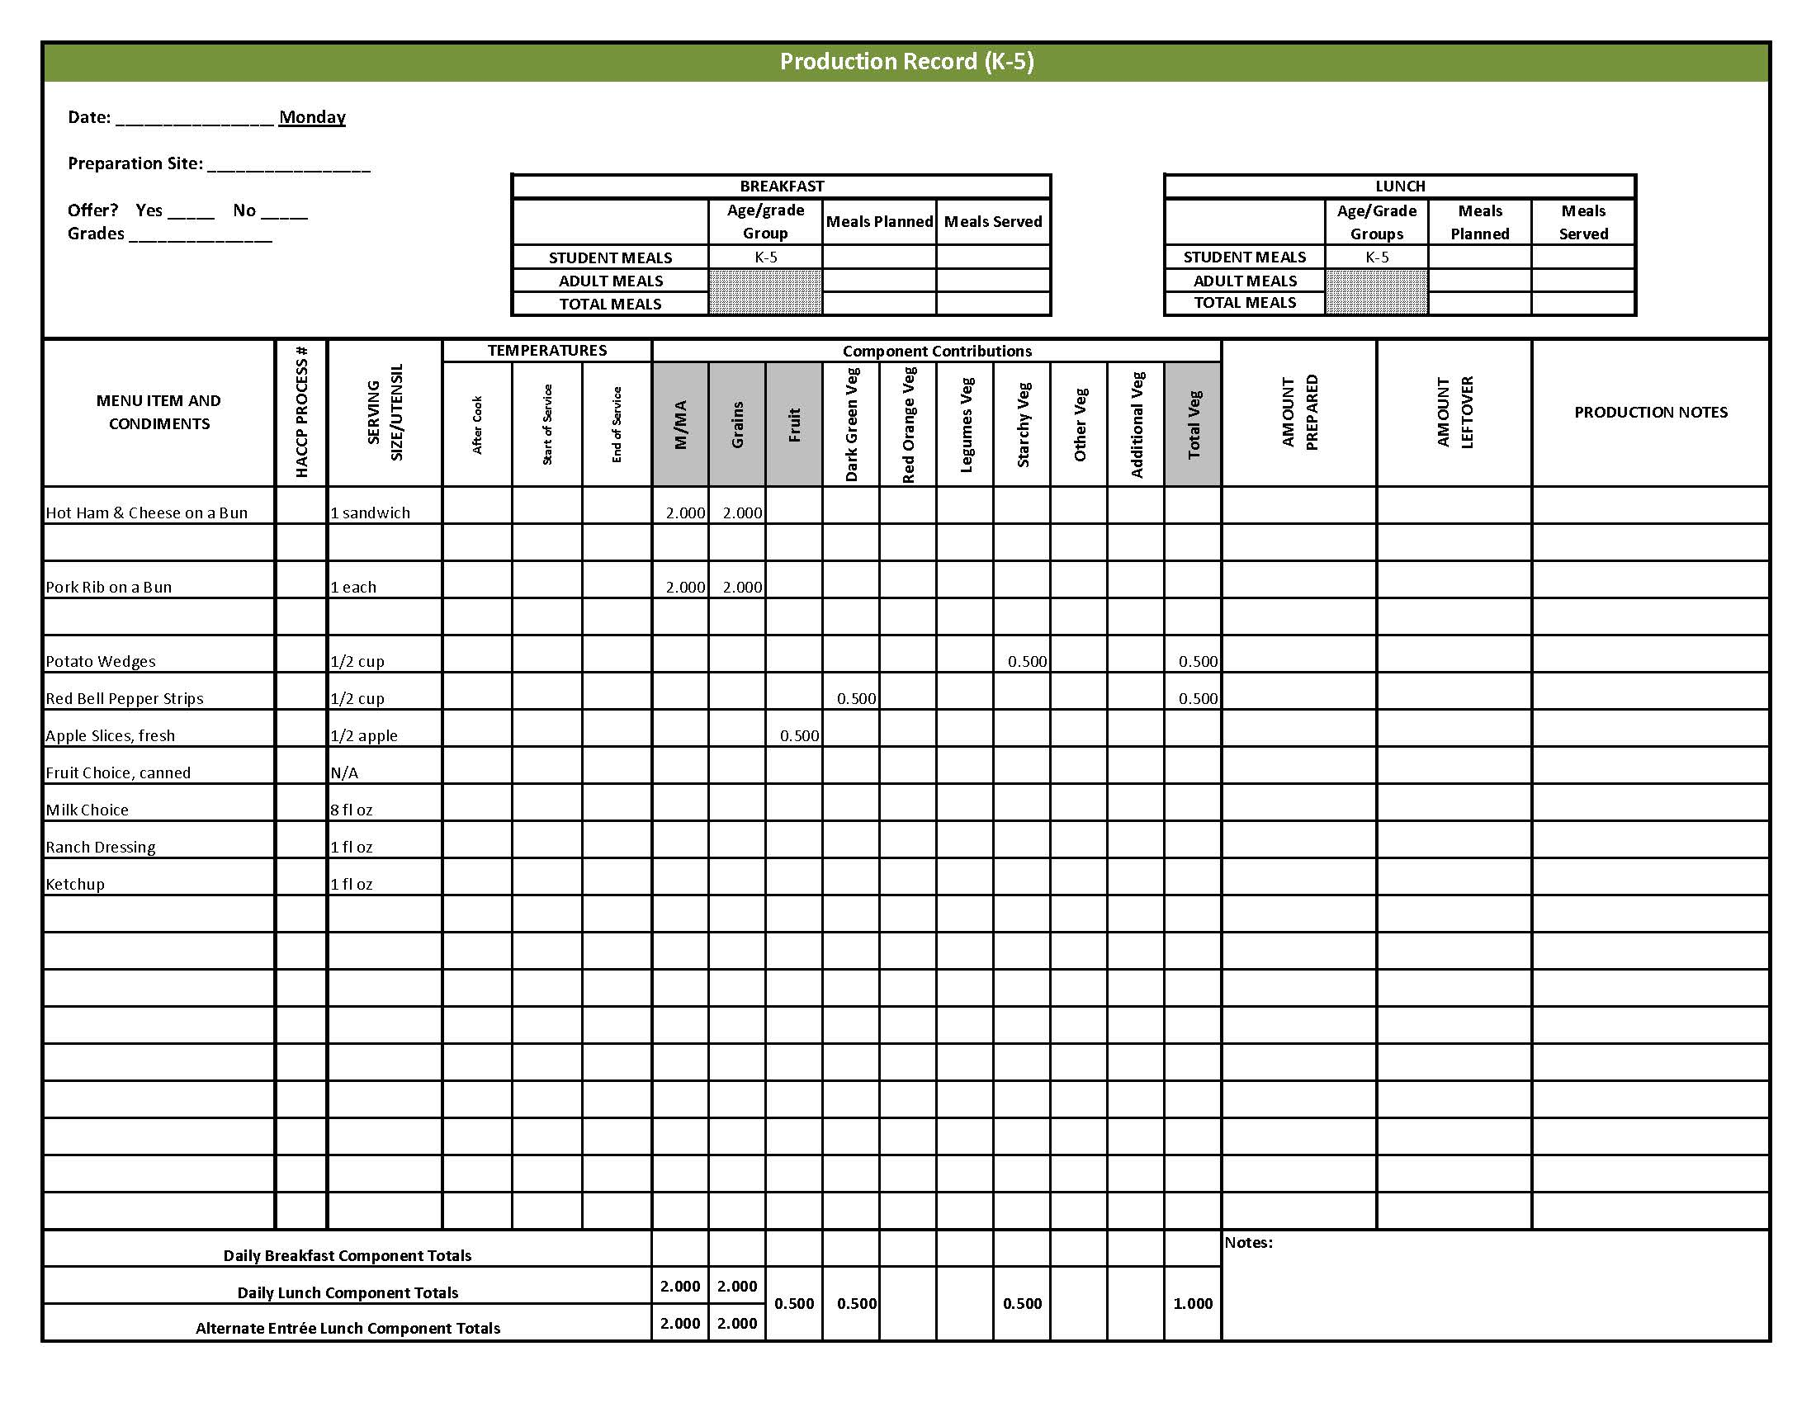

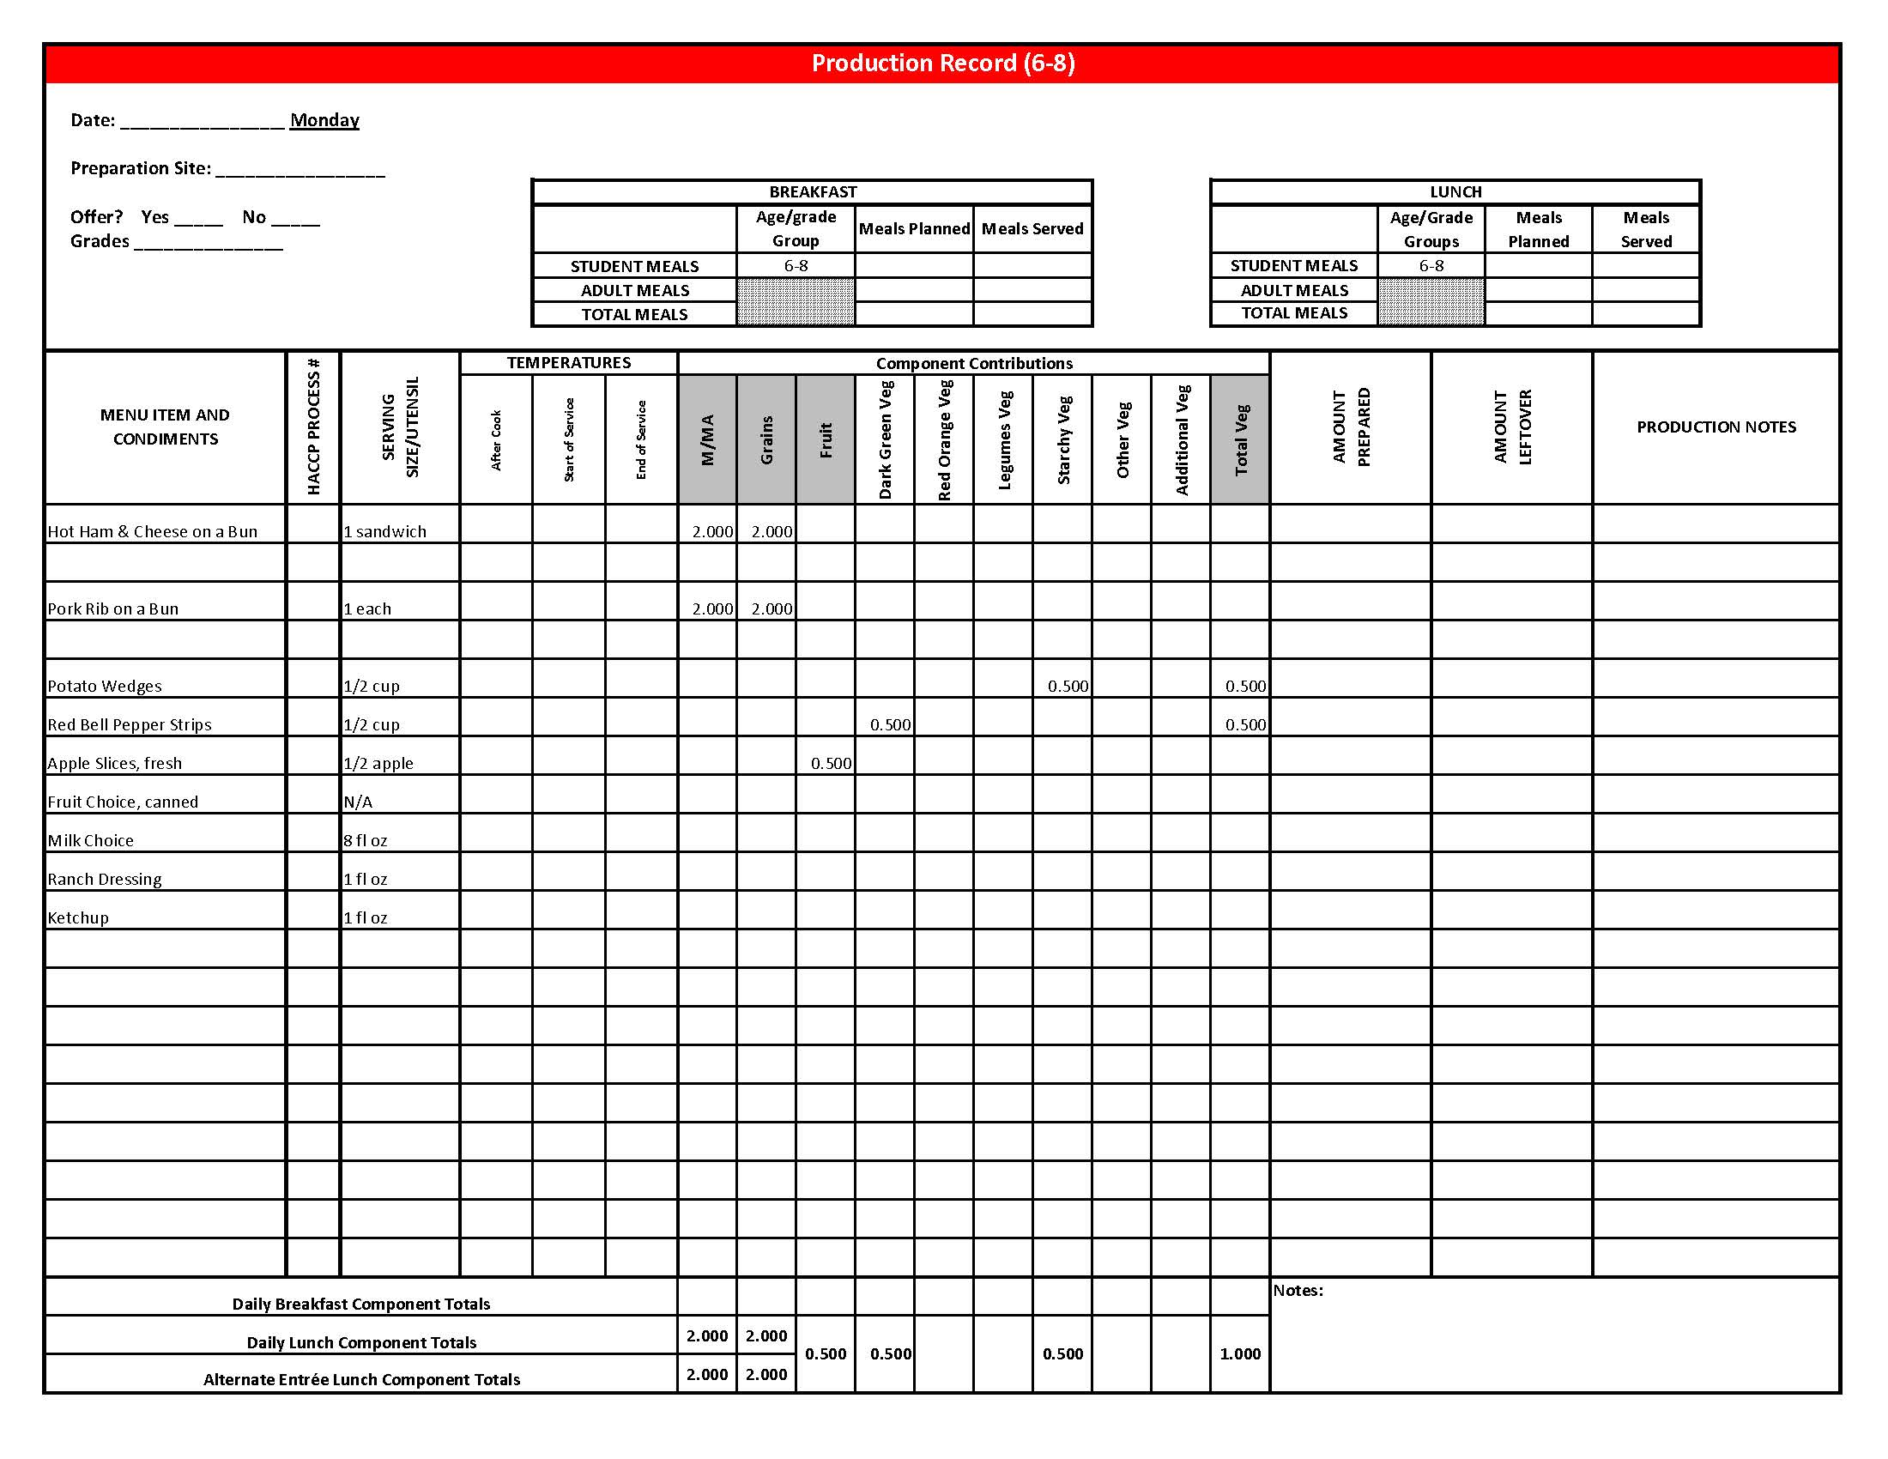

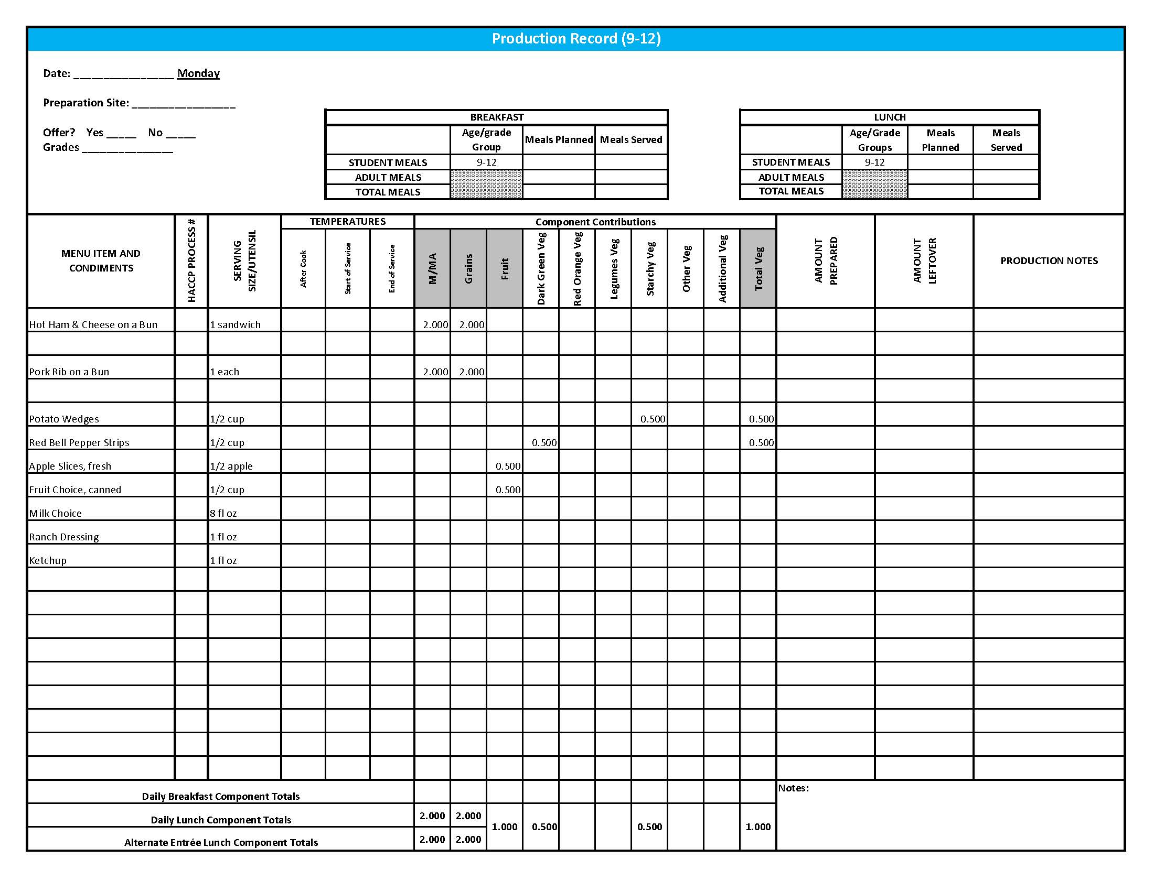

## Purchasing, Preparation & Serving Instructions

Week 1 – Tuesday

|  |  |  |
| --- | --- | --- |
| **Menu Item** | **Purchasing & Preparation** | **Serving** |
| Pepperoni Pizza | * Purchase pre-prepared pepperoni pizza that provides 2 oz equivalent M/MA, 2 oz equivalent Grains, and 0.125 cup vegetables, RO; no more than 9 gm of fat; and no more than 600 mg sodium per serving. If product is not Child Nutrition (CN) labeled, obtain a Product Formulation Statement. * Heat in oven according to manufacturer’s instructions. * **CCP: Hold for hot service at 135°F or above.** | K-12: 1 piece |
| **Alternate Entrée:**  Chicken, popcorn | * Purchase pre-cooked, oven-ready popcorn chicken that provides 2 oz equivalent M/MA and 1 oz equivalent Grain, no more than 18 gm of fat; and no more than 290 mg sodium per serving. If product is not Child Nutrition (CN) labeled, obtain a Product Formulation Statement. * Heat according to manufacturer’s instructions. * **CCP: Hold for hot service at 135°F or above.** | K-12: 15 pieces (or number needed to provide 2 oz equivalent M/MA & 1 oz equivalent Grain) |
| **Alternate Entrée:**  Whole Wheat Roll | * Prepare HKM Recipe 877, Whole Wheat Rolls, Bread Sticks and Buns. | K-8: N/A  9-12: 1 each (1 oz) |
| Broccoli Florets, fresh | * Refer to *Fruit & Vegetable Order Guide* for amount needed. Purchase fresh broccoli florets, ready to serve. * Wash broccoli. * Cover and refrigerate until serving. * **CCP: Refrigerate and hold at 41°F or below for cold service.** | K-8: ¼ cup  9-12: ½ cup |
| Cherry Tomatoes | * Refer to *Fruit & Vegetable Order Guide* for amount needed. * With gloved hands, wash and stem tomatoes. * **CCP: Refrigerate and hold at 41°F or below for cold service.** | K-12: 6 tomatoes  (½ cup) |

*Continued on next page*

## Purchasing, Preparation & Serving Instructions

**Week 1 – Tuesday, continued**

|  |  |  |
| --- | --- | --- |
| **Menu Item** | **Purchasing & Preparation** | **Serving** |
| Fruit Cocktail, canned | * Refer to *Fruit & Vegetable Order Guide* for amount needed. * Purchase a canned product that includes peaches, pears, pineapple, grapes, and cherries packed in 100% juice or light syrup. * Chill cans overnight. Wipe tops of cans clean before opening. * Cover, drain, and refrigerate until serving. Serve with slotted utensil. * **CCP: Refrigerate and hold at 41°F or below for cold service.** | K-12: ½ cup |
| Fruit Choice, fresh | Select an additional fruit choice to offer on the menu. The serving(s) offered must credit as ½ cup of fruit, to meet the minimum daily requirement, for grades 9-12.  *Note: The fruit choice is encouraged for grades K-5 and 6-8, but not required. The fruit choice is not included in the nutrient analysis for grades K-5 and 6-8. | K-8: N/A*  9-12: ½ cup |
| Milk | * Provide a variety of milk. May be 1% fat (unflavored) or skim (flavored or unflavored). * **CCP: Refrigerate and hold at 41°F or below for cold service.** | K-12: 8 fl oz |
| Ranch Dressing, Reduced Fat | * Purchase or prepare Ranch dressing containing no more than 6 gm of fat  per 1 fl oz. Purchase .8 gallons for every 100 1 fl oz portions. * **CCP: Refrigerate and serve at 41°F or below if school-prepared dressing is served.** | K-12: 1 fl oz **or** 2 Tbsp |
| Ketchup | * Purchase in bulk or individual packets (9 gm or 12 gm). If bulk, purchase 1 #10 can or 0.8 gallon for every 100 1-fluid oz servings. | K-12: 1 fl oz **or** 2 Tbsp  **or** 2 PC |

**Pre-preparation for Week 1 - Wednesday:** Thaw ground beef under refrigeration.

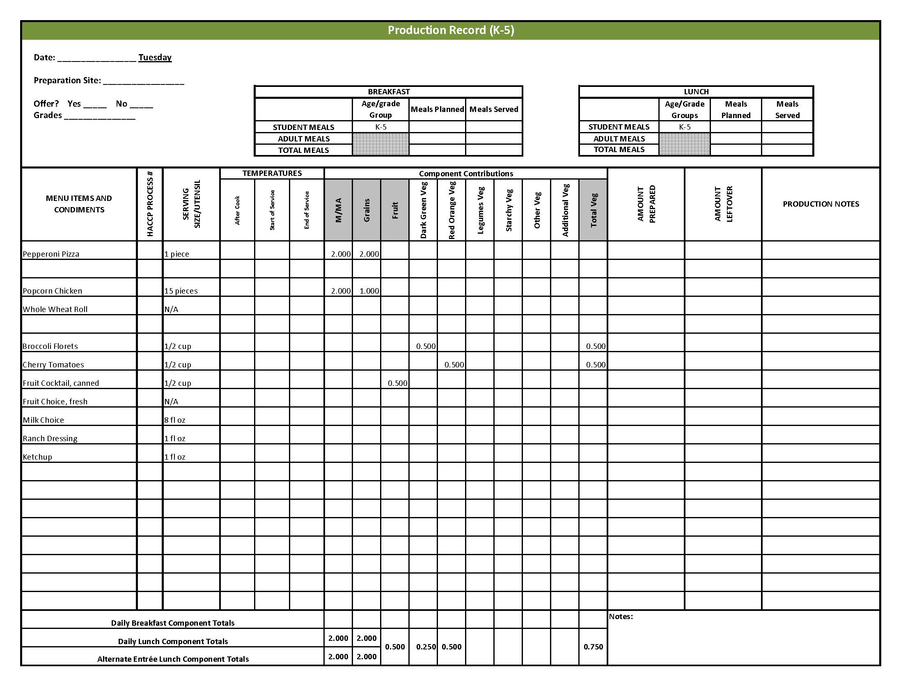

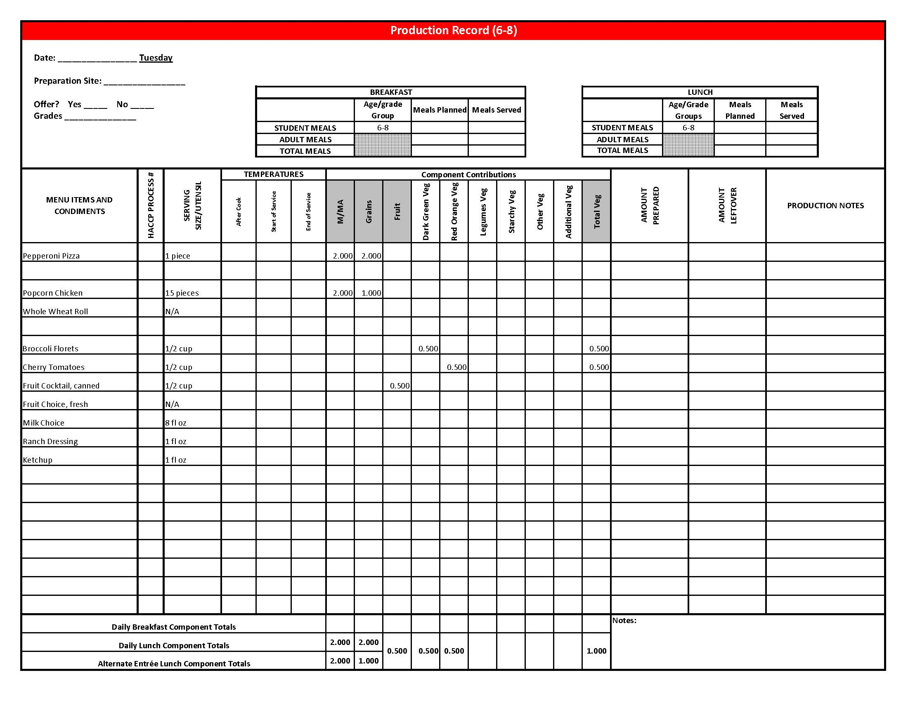

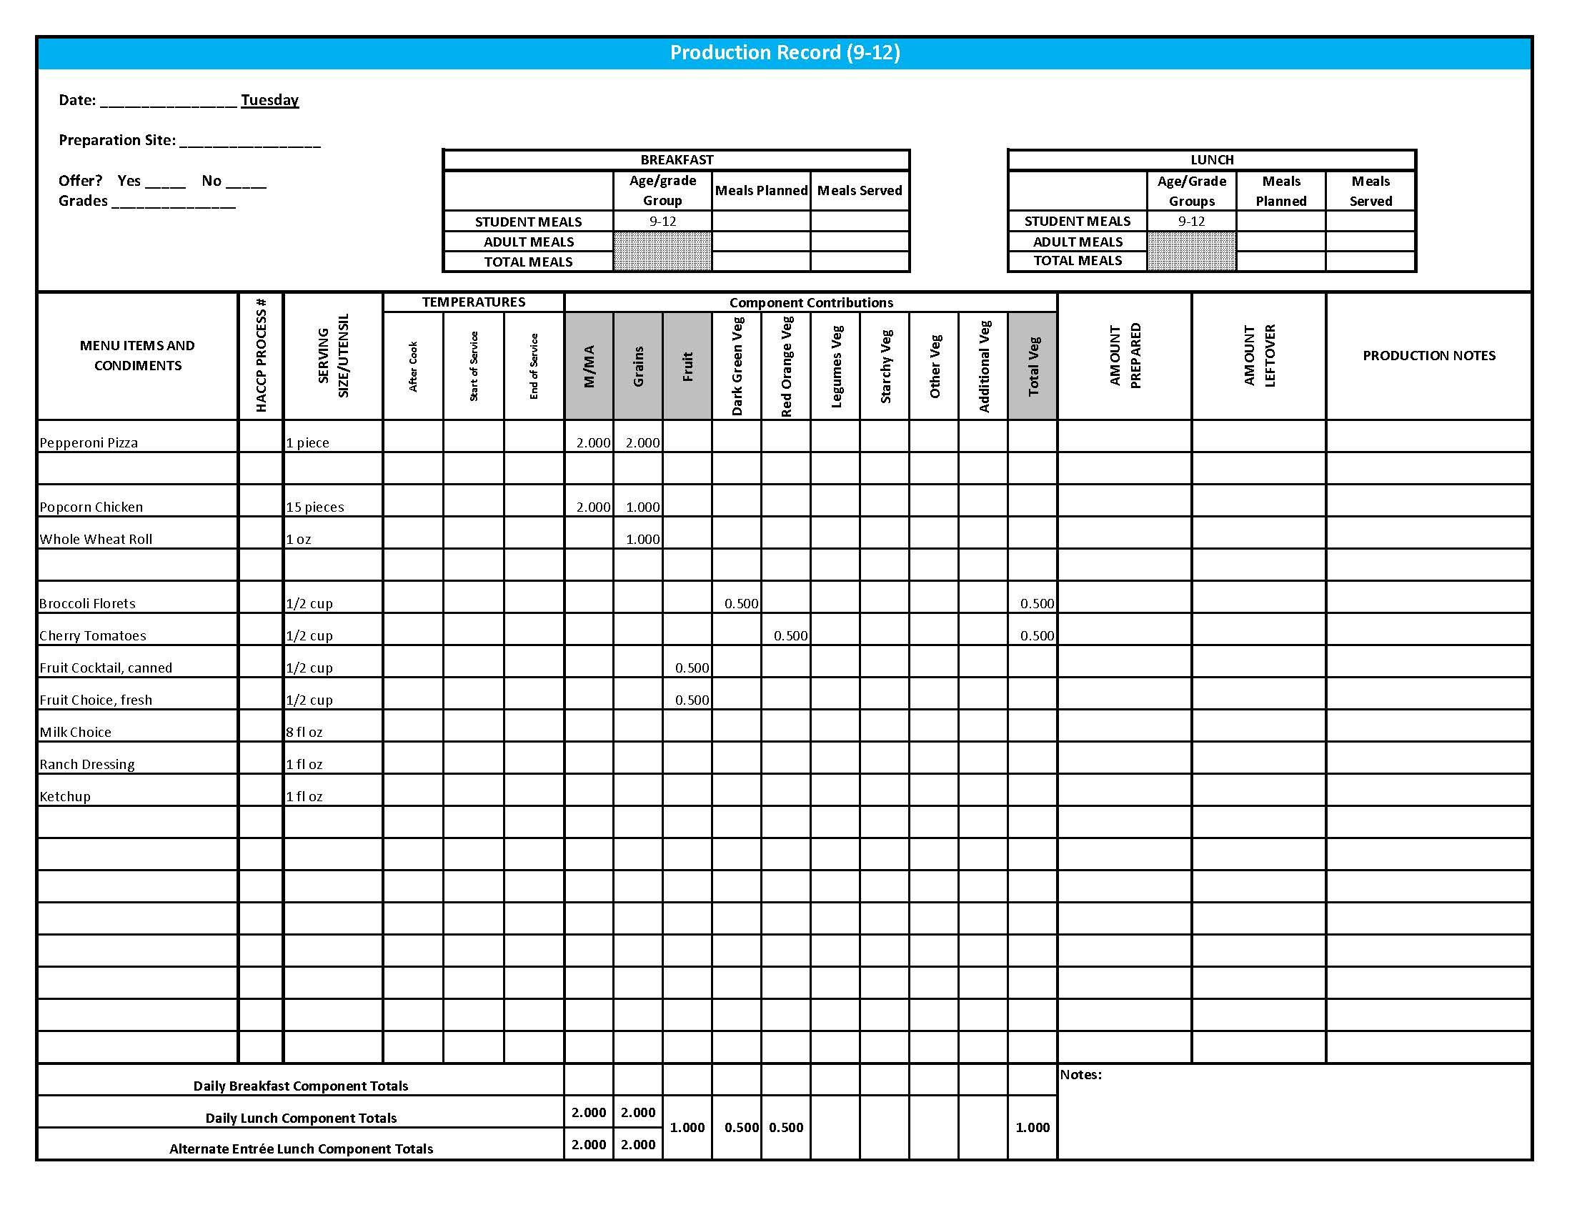

## Purchasing, Preparation & Serving Instructions

Week 1 – Wednesday

|  |  |  |  |  |  |
| --- | --- | --- | --- | --- | --- |
| **Menu Item** | | **Purchasing & Preparation** | | **Serving** | |
| Taco Burger on a Bun | | * Prepare HKM Recipe 77, Taco Burger. * Purchase a 2 oz whole wheat bun (first ingredient is whole wheat) or prepare HKM Recipe 877, Whole Wheat Rolls, Bread Sticks, Buns. * **CCP: Hold for hot service at 135°F or above.** | | K-12: 1 sandwich | |
| **Alternate Entrée:**  Fruit, Yogurt & Granola Parfait | | * Purchase a fresh, frozen or canned fruit packed in light syrup or 100% juice. Refer to *Fruit & Vegetable Order Guide* for amount needed. * Purchase low-fat, flavored bulk yogurt and portion 1 cup (8 oz) for each serving. * Purchase pre-prepared granola that provides 2 oz Grains per ½ cup serving; no more than 7 gm of fat; and no more than 180 mg of sodium per serving. * Assemble parfait with fruit and yogurt in one cup and granola in different cup. Recommend layering ½ cup yogurt, ¼ cup fruit, ½ cup yogurt and ¼ cup fruit. Portioning granola separately will help to keep granola fresh and crunchy. * **CCP: Refrigerate and hold at 41o F or below for cold service.** | | K-12: ½ cup fruit, 8 oz yogurt,  ½ cup granola | |
| Tortilla Chips | | * Purchase whole grain tortilla chips with no more than 50 mg sodium per oz. (Restaurant style usually has less sodium). * May be pre-portioned. Weigh a sample. Serve with gloved hands or tongs. | | K-5: N/A  6-12: 1 oz | |
| Dark Green Leaf Lettuce | | * Refer to *Fruit & Vegetable Order Guide* for amount needed. * Handle produce with gloved hands. May be pre-portioned. * **CCP: Refrigerate and hold at 41°F or below for cold service.** | | K-12: ½ cup | |
| Refried Beans | | * Refer to *Fruit & Vegetable Order Guide* for amount needed. Purchase canned or dried refried beans with no more than 600 mg of sodium per ½ cup prepared. * For dried beans, prepare according to manufacturer directions. * For canned beans, wipe top of cans before opening. * **CCP: Hold for hot service at 135°F or above.** | | K-12: ½ cup | |

*Continued on next page*

## Purchasing, Preparation & Serving Instructions

Week 1 – Wednesday, continued

|  |  |  |
| --- | --- | --- |
| **Menu Item** | **Purchasing & Preparation** | **Serving** |
| Tomato Salsa | * Purchase salsa that is low in sodium or prepare HKM Recipe 129, Tomato Salsa. * Refer to *Fruit & Vegetable Order Guide* for amount needed. * May be served, self-serve or pre-portioned for service. * **CCP: Refrigerate and hold at 41°F or below for cold service.** | K-12: ¼ cup |
| Raspberries, fresh | * Refer to *Fruit & Vegetable Order Guide* for amount needed. * With gloved hands, wash raspberries. * **CCP: Refrigerate and hold at 41°F or below for cold service.** | K-12: ½ cup |
| Fruit Choice, canned | Select an additional fruit choice to offer on the menu. The serving(s) offered must credit as ½ cup of fruit, to meet the minimum daily requirement, for grades 9-12.  *Note: The fruit choice is encouraged for grades K-5 and 6-8, but not required. The fruit choice is not included in the nutrient analysis for grades K-5 and 6-8. | K-8: N/A*  9-12: ½ cup |
| Milk | * Provide a variety of milk. May be 1% fat (unflavored) or skim (flavored or unflavored). * **CCP: Refrigerate and hold at 41°F or below for cold service.** | K-12: 8 fl oz |

**Pre-preparation for Week 1 – Thursday:** Thaw ground beef under refrigeration. Chill grapes.

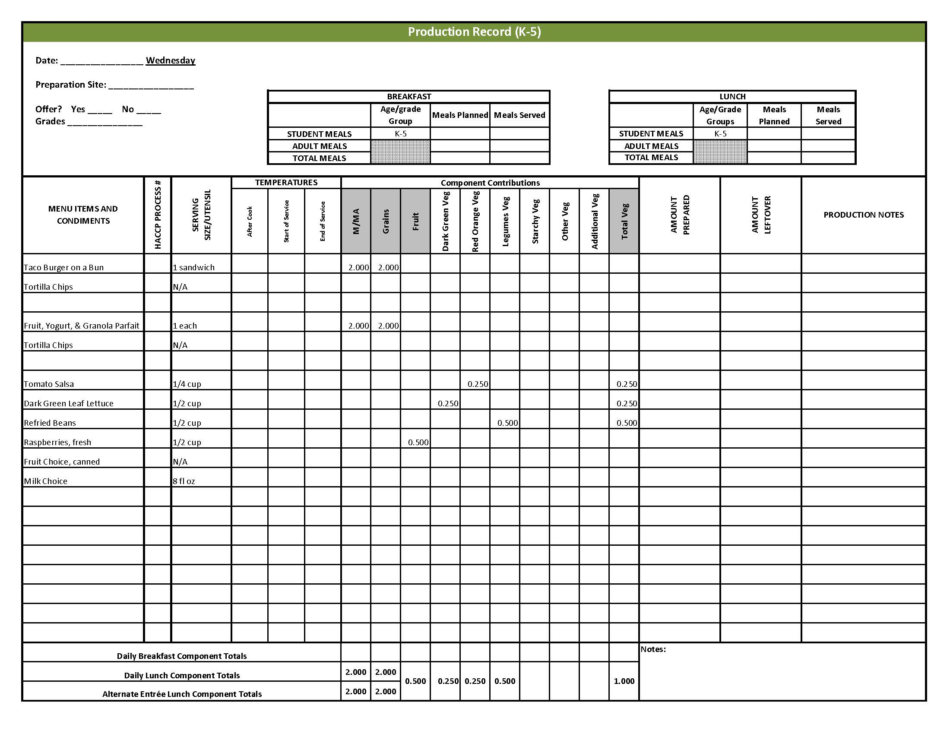

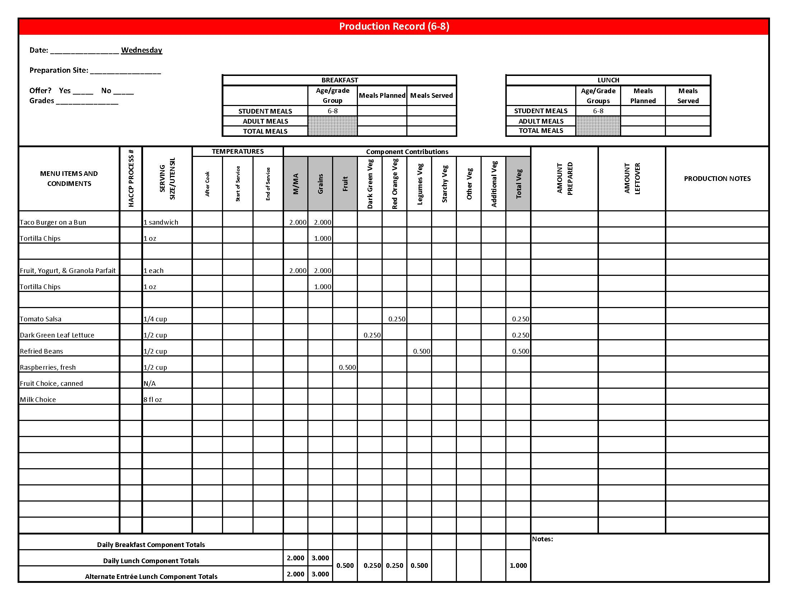

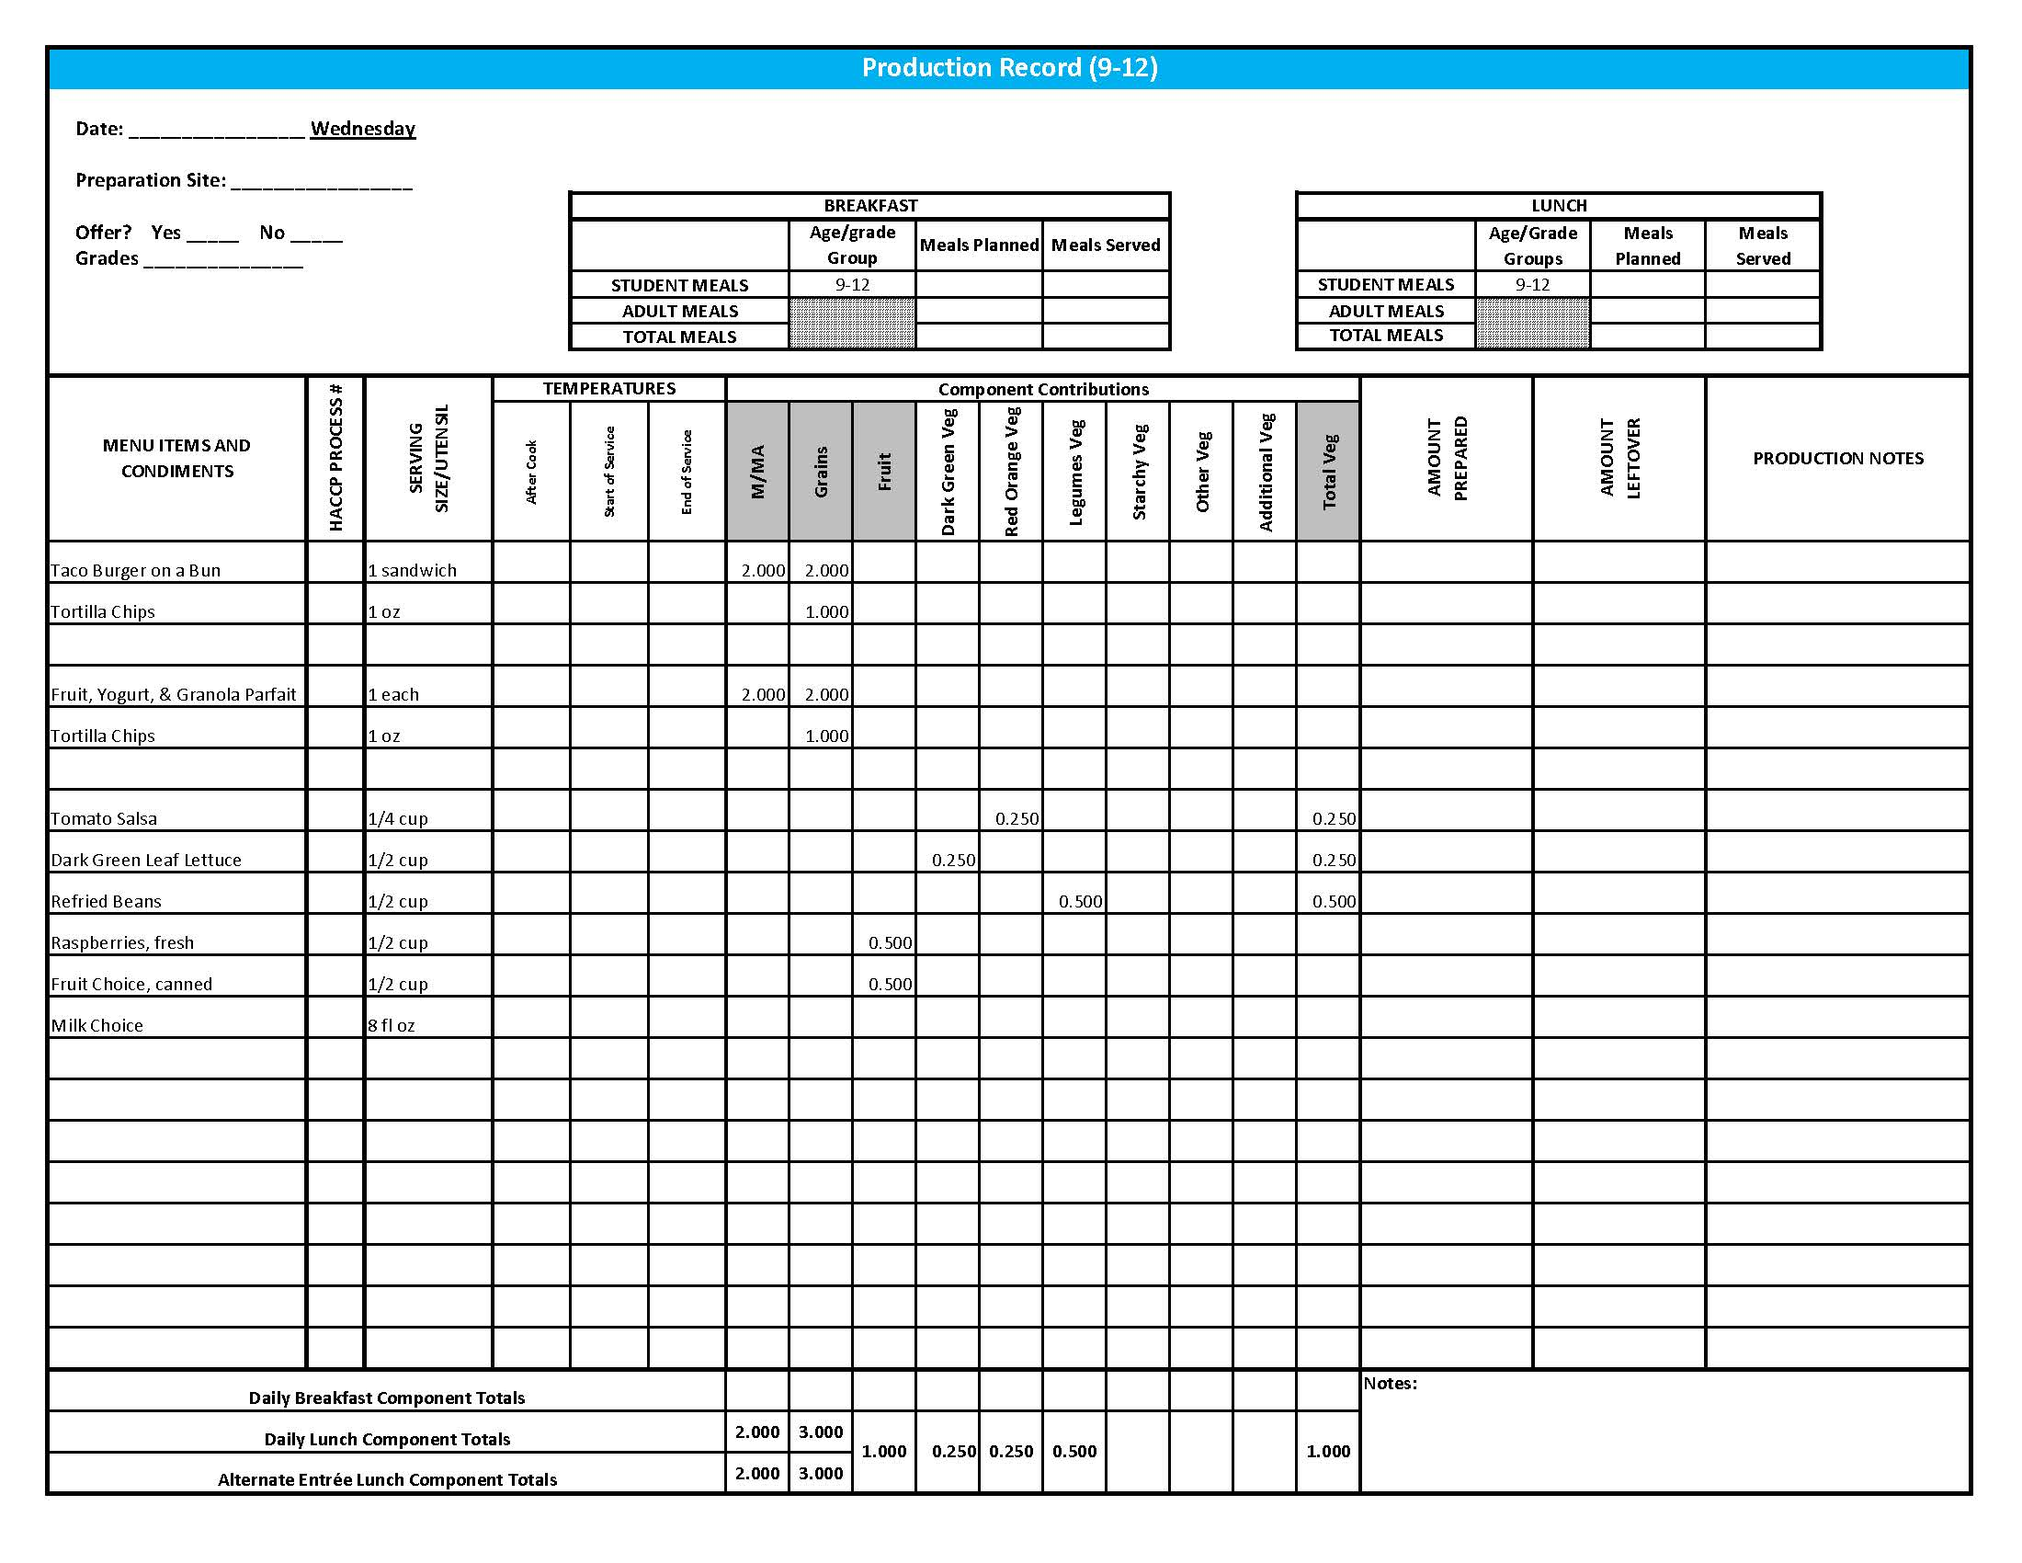

Purchasing, Preparation & Serving Instructions

Week 1 – Thursday

|  |  |  |
| --- | --- | --- |
| **Menu Item** | **Purchasing & Preparation** | **Serving** |
| Lasagna | * Prepare HKM Recipe 40, Lasagna. * **CCP: Hold for hot service at 135°F or above.** | K-12: 1 piece (4 x 6 cut) |
| Garlic Bread Stick | * Prepare HKM Recipe 877, Whole Wheat Rolls, Bread Sticks, Buns: Garlic Bread Stick Variation. | K-12: 1 each |
| Marinara Sauce | * Purchase marinara sauce containing less than 300 mg sodium per ¼ cup serving. Refer to *Fruit & Vegetable Order Guide* for amount needed. * **CCP: Hold for hot service at 135°F or above.** | K-12: ¼ cup |
| **Alternate Entrée:**  Turkey & Cheese Sub | * Prepare HKM Recipe 144, Turkey & Cheese Sub. * Purchase lean, deli-sliced, turkey with no more than 500 mg of sodium per 2 oz serving. Product should be CN labeled or have a product formulation statement with crediting information. * Purchase a 2 oz whole wheat bun (first ingredient is whole wheat) or prepare HKM recipe 877, Whole Wheat Rolls, Bread Sticks, Buns. * **CCP: Refrigerate and hold at 41°F or below for cold service.** | K-12: 1 sandwich |
| Garden Salad | * Prepare HKM Recipe 164, Garden Salad. Refer to *Fruit & Vegetable Order Guide* for amounts of individual ingredients needed. * Handle salad with gloved hands, tongs or serving utensils. * May estimate serving sizes using measured portions as samples. * **CCP: Refrigerate and hold at 41°F or below for cold service.** | K-12: 1 cup |
| Carrots, baby, fresh | * Refer to *Fruit & Vegetable Order Guide* for amount needed. * Handle with gloved hands or serving utensils. Cover and refrigerate until serving. * Weigh or count number needed per portion. * **CCP: Refrigerate and hold at 41°F or below for cold service.** | K-8: ¼ cup  9-12: ½ cup |
| Grapes, fresh | * Refer to *Fruit & Vegetable Order Guide* for amount needed. * Wash grapes. Remove from stems or separate out into smaller clusters. * Cover and refrigerate until serving. * **CCP: Refrigerate and hold at 41°F or below for cold service.** | K-12: ½ cup |

*Continued on next page*

Purchasing, Preparation & Serving Instructions

Week 1 – Thursday, continued

|  |  |  |
| --- | --- | --- |
| **Menu Item** | **Purchasing & Preparation** | **Serving** |
| Chocolate Chip Cookie | * Prepare HKM Recipe1079, Chocolate Chip Cookie, Whole Grain. * This menu item will count as a grain based dessert. | K-12: 1 each |
| Milk | * Provide a variety of milk. May be 1% fat (unflavored) or skim (flavored or unflavored). * **CCP: Refrigerate and hold at 41°F or below for cold service.** | K-12: 8 fl oz |
| Ranch Dressing, Reduced Fat | * Purchase or prepare Ranch dressing containing no more than 6 gm of fat  per 1 fl oz. Purchase .8 gallons for every 100 1 fl oz portions. * **CCP: Refrigerate and serve at 41°F or below if school-prepared dressing is served.** | K-12: 1 fl oz **or** 2 Tbsp |
| Mayo-type Salad Dressing, reduced fat | * Purchase mayo-type salad dressing containing no more than 6 gm of fat per 1 fl oz. Purchase 0.4 gallons per 100 servings | K-12: ½ oz or 1 Tbsp |
| Mustard | * Purchase bulk or packets. If bulk, purchase 2 cups for every 100 1 tsp servings. | K-12: 1 tsp |

## 

**Pre-preparation for Week 1 - Friday:** N/A

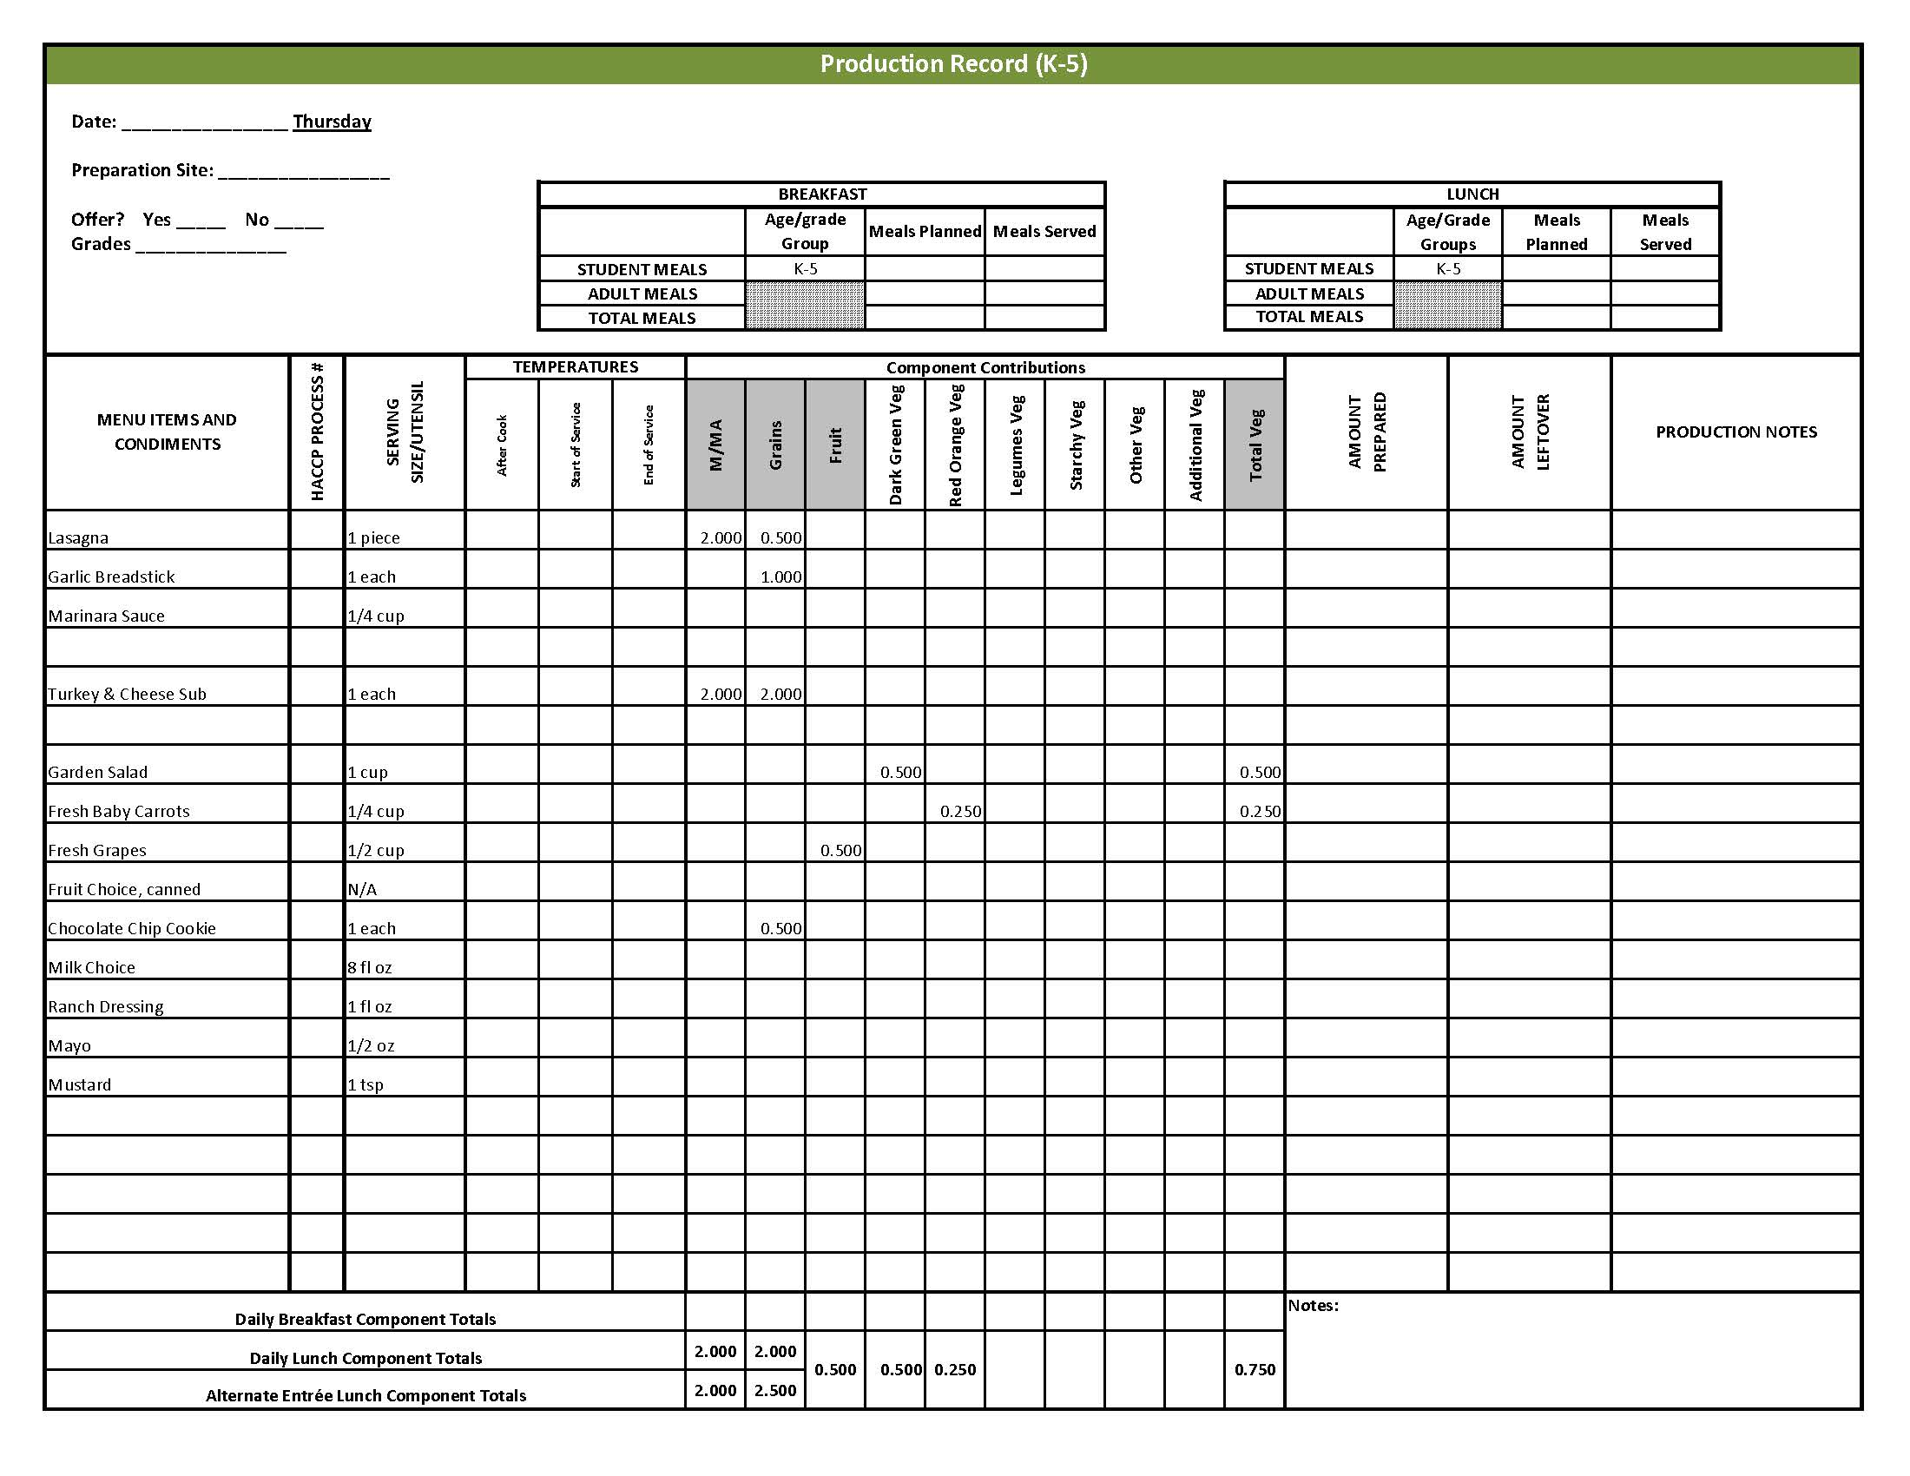

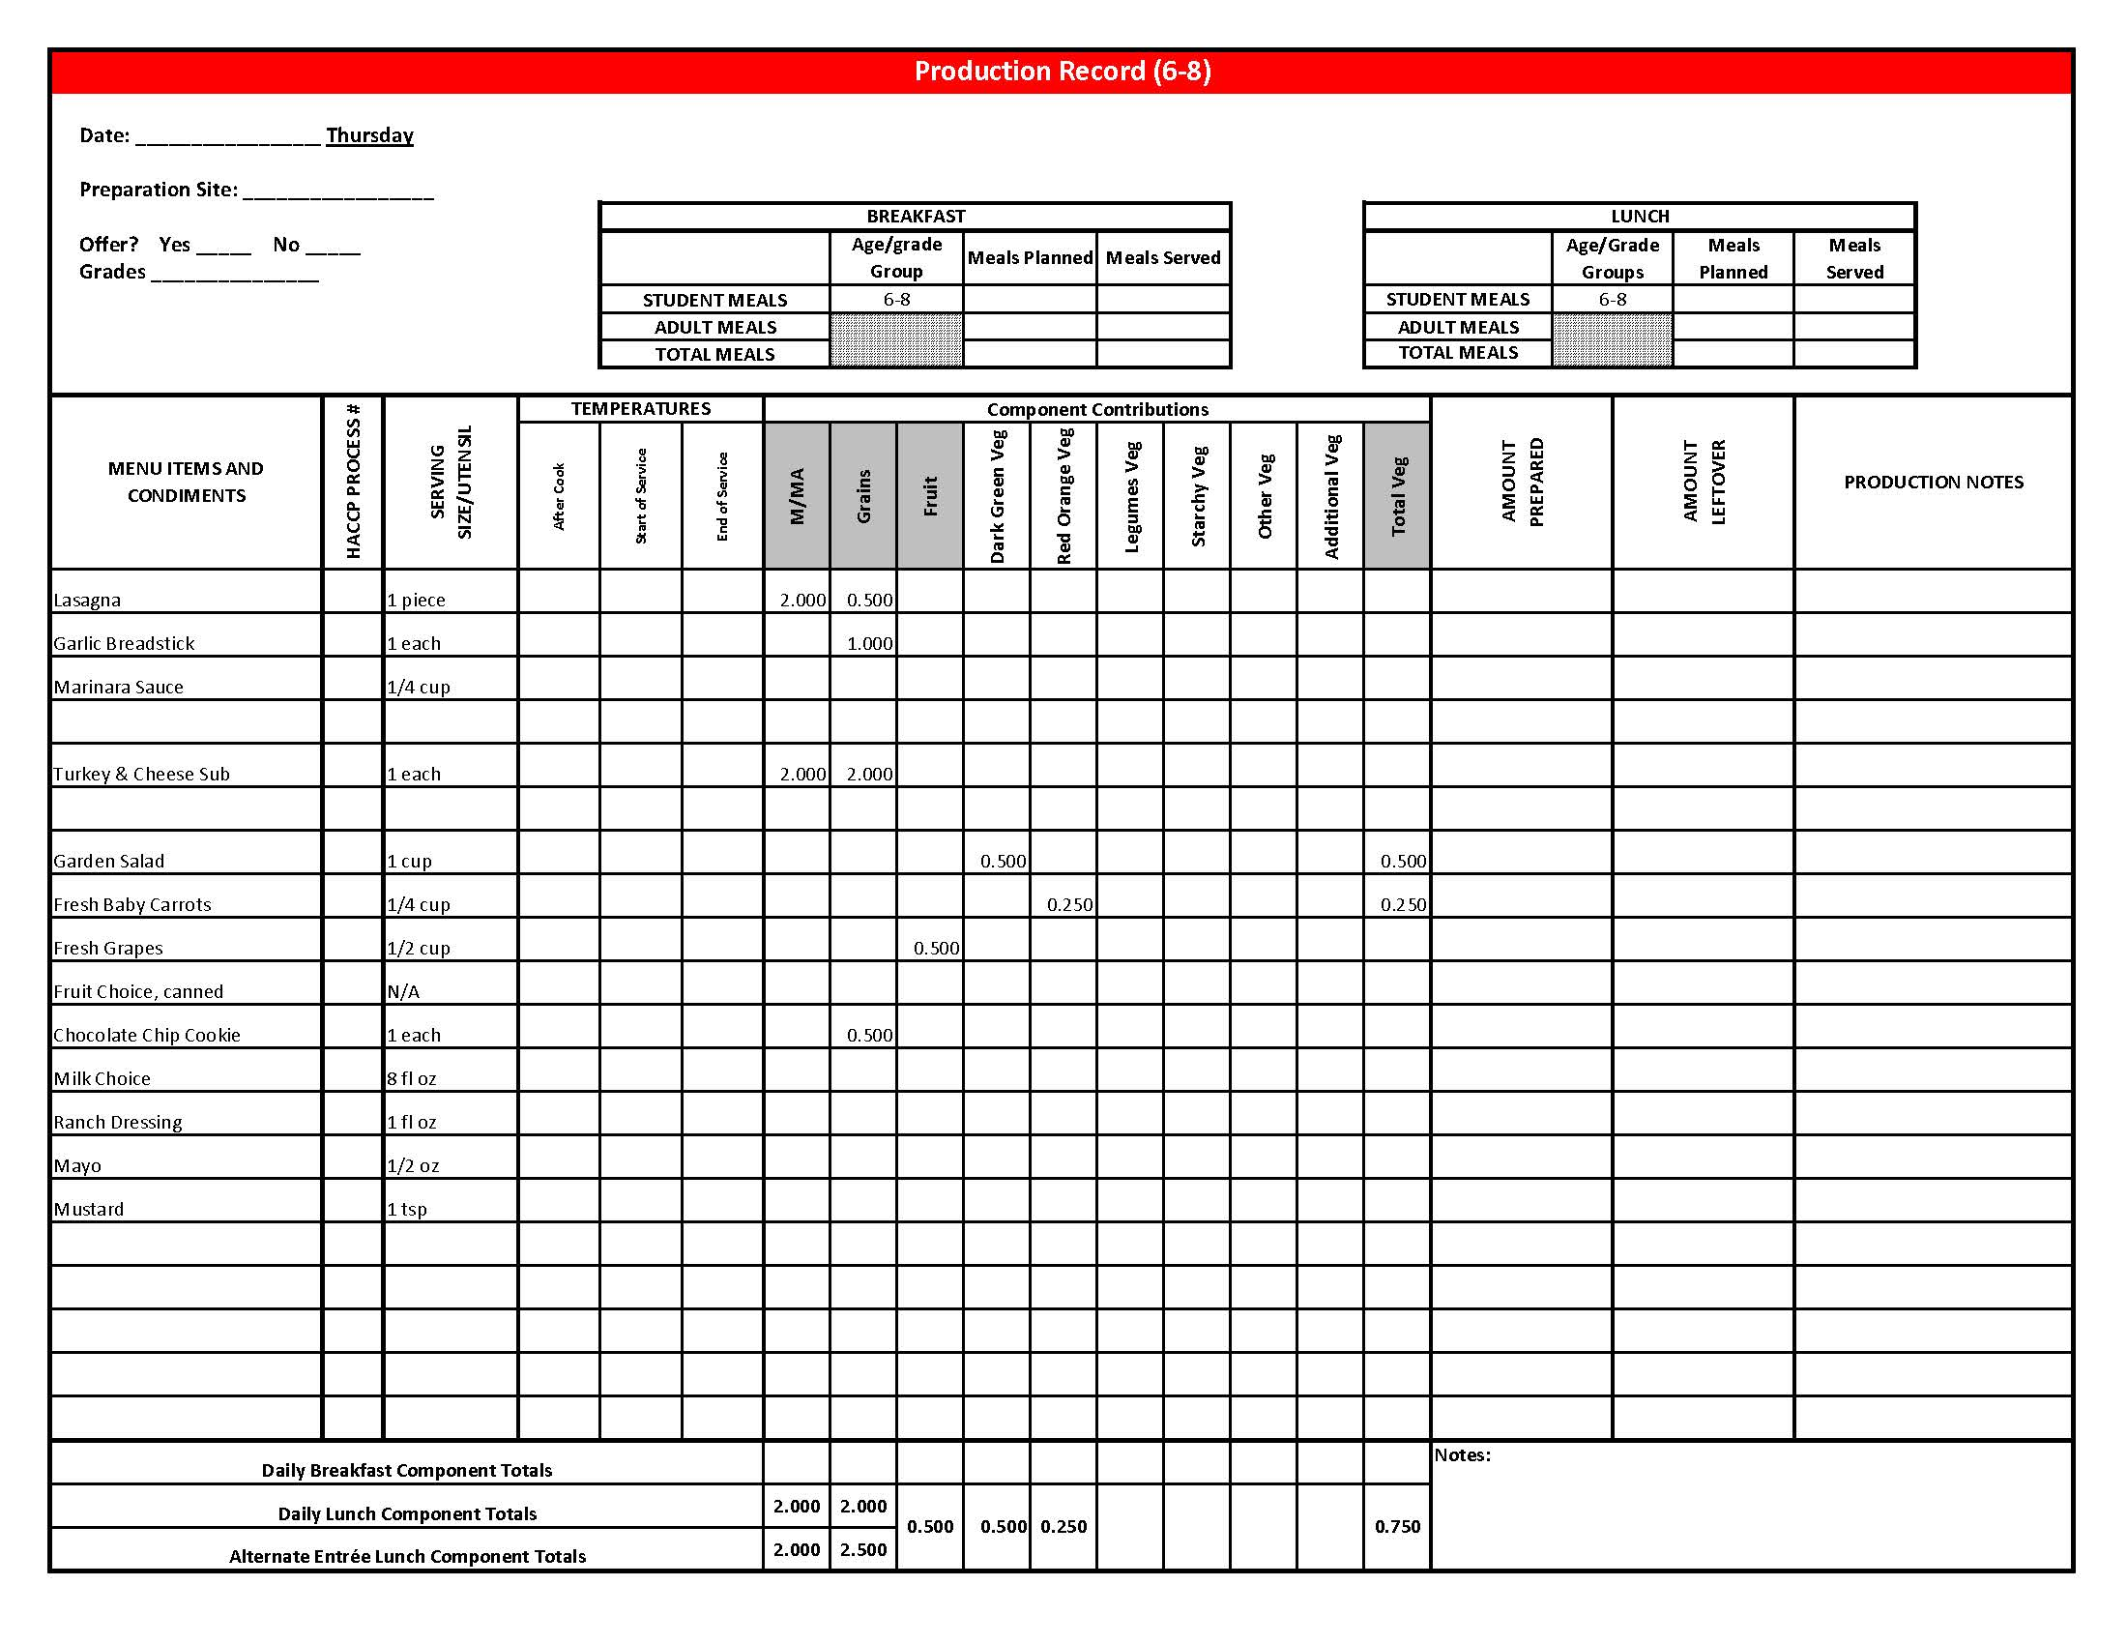

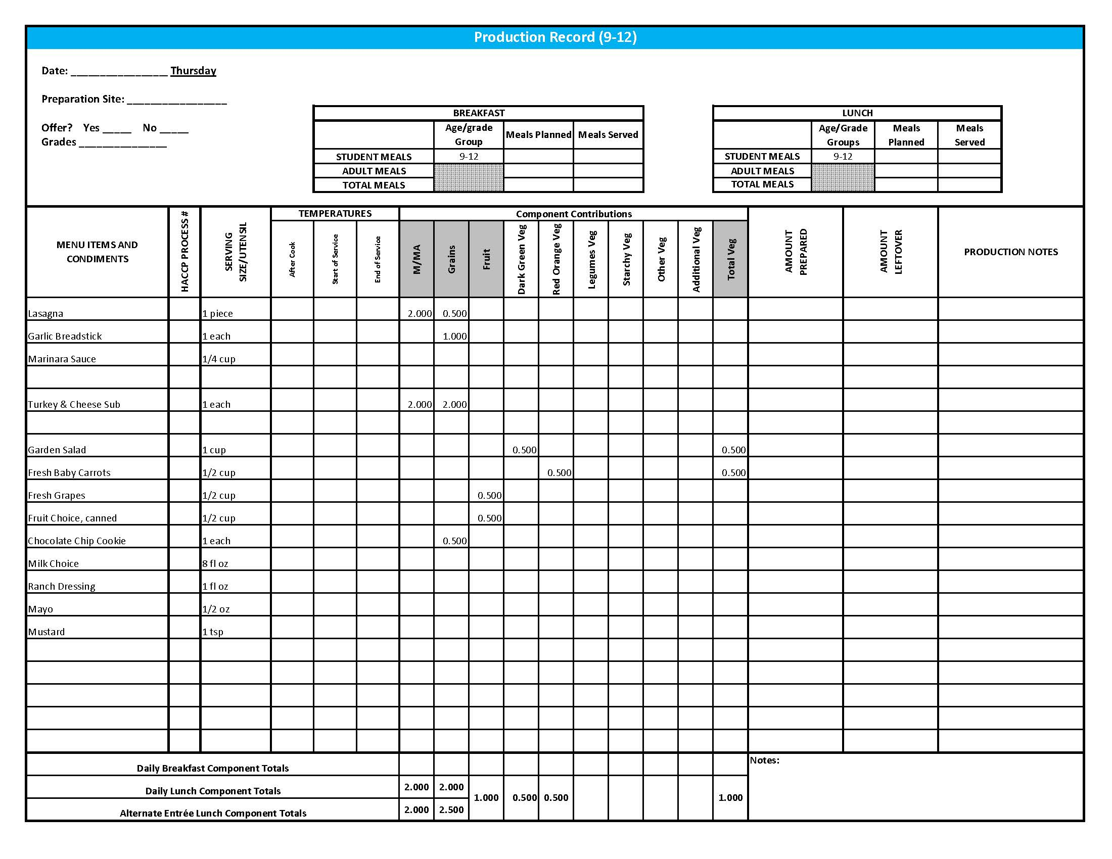

## Purchasing, Preparation & Serving Instructions

Week 1 – Friday

|  |  |  |
| --- | --- | --- |
| **Menu Item** | **Purchasing & Preparation** | **Serving** |
| Chicken Patty | * Purchase pre-cooked chicken patties that provide 2 oz equivalent M/MA, 1 oz equivalent Grains; no more than 16 gm of fat; and no more than 500 mg sodium per serving. If product is not Child Nutrition (CN) labeled, obtain a Product Formulation Statement. * Prepare according to manufacturer’s instructions. * **CCP: Hold for hot service at 135°F or above.** | K-12: 1 each |
| Whole Wheat Roll | * Prepare HKM Recipe 877, Whole Wheat Rolls, Bread Sticks and Buns. | K-12: 1 each  (1 oz) |
| **Alternate Entrée:**  Peanut Butter & Jelly Sandwich Meal  (K-5) | * Purchase or prepare Peanut Butter & Jelly sandwich providing 1 oz equivalent M/MA and 1 oz equivalent Grain, no more than 17 gm of fat; and no more than 320 mg sodium per serving. If product is not Child Nutrition (CN) labeled, obtain a Product Formulation Statement. * Purchase whole grain-rich crackers and cheese sticks weighing 1 oz each. * **CCP: Refrigerate and hold at 41°F or below for cold service.** | K-5: 1 sandwich,  1 oz crackers,  1 oz cheese |
| **Alternate Entrée:**  Peanut Butter & Jelly Sandwich  (6-12) | * Purchase or prepare Peanut Butter & Jelly sandwich providing 2 oz equivalent M/MA and 2 oz equivalent Grains, no more than 33 gm of fat; and no more than 620 mg sodium per serving. If product is not Child Nutrition (CN) labeled, obtain a Product Formulation Statement. * **CCP: Refrigerate and hold at 41°F or below for cold service.** | 6-12: 1 sandwich  (or may choose to follow K-5 Peanut Butter & Jelly Sandwich Meal) |
| Mashed Potatoes | * Refer to *Fruit & Vegetable Order Guide* for amount needed. Purchase dehydrated mashed potatoes. * Do not add margarine. Add salt only if the product has less than 50 mg of sodium per ½ cup prepared. Add no more than 2 tablespoons of salt per 70 cups prepared potatoes. * **CCP: Hold for hot service at 135°F or above.** | K-12: ½ cup |
| Gravy | * Purchase a gravy mix with no more than 1 gm of fat per fl oz and prepare according to package directions. * **CCP: Hold for hot service at 135°F or above.** | K-12: 1 fl oz |

*Continued on next page*

## Purchasing, Preparation & Serving Instructions

Week 1 – Friday, continued

|  |  |  |
| --- | --- | --- |
| **Menu Item** | **Purchasing & Preparation** | **Serving** |
| Asparagus, steamed | * Purchase fresh asparagus or frozen spears. * If fresh, with gloved hands, wash and remove ends. * Batch cook by steaming or cooking in stock pot with minimal liquid close to serving time. * **CCP: Hold for hot service at 135°F or above.** | K-12: ½ cup |
| Peach, fresh | * Refer to *Fruit & Vegetable Order Guide* for amount needed. * With gloved hands, wash peaches. * Cover and refrigerate or store at room temperature until serving. * **CCP: Refrigerate and hold at 41°F or below for cold service.** | K-12: 1 peach |
| Fruit Choice, canned | Select an additional fruit choice to offer on the menu. The serving(s) offered must credit as ½ cup of fruit, to meet the minimum daily requirement, for grades 9-12.  *Note: The fruit choice is encouraged for grades K-5 and 6-8, but not required. The fruit choice is not included in the nutrient analysis for grades K-5 and 6-8. | K-8: N/A*  9-12: ½ cup |
| Milk | * Provide a variety of milk. May be 1% fat (unflavored) or skim (flavored or unflavored). * **CCP: Refrigerate and hold at 41°F or below for cold service.** | K-12: 8 fl oz |
| Honey | * Purchase .5 oz packets or purchase in bulk container. If bulk, purchase 6.25 cups per 100 1 Tbsp servings. | K-12: 1 PC each  **or** 1 Tbsp |

**Pre-preparation for Week 2 - Monday:** Chill canned pears.

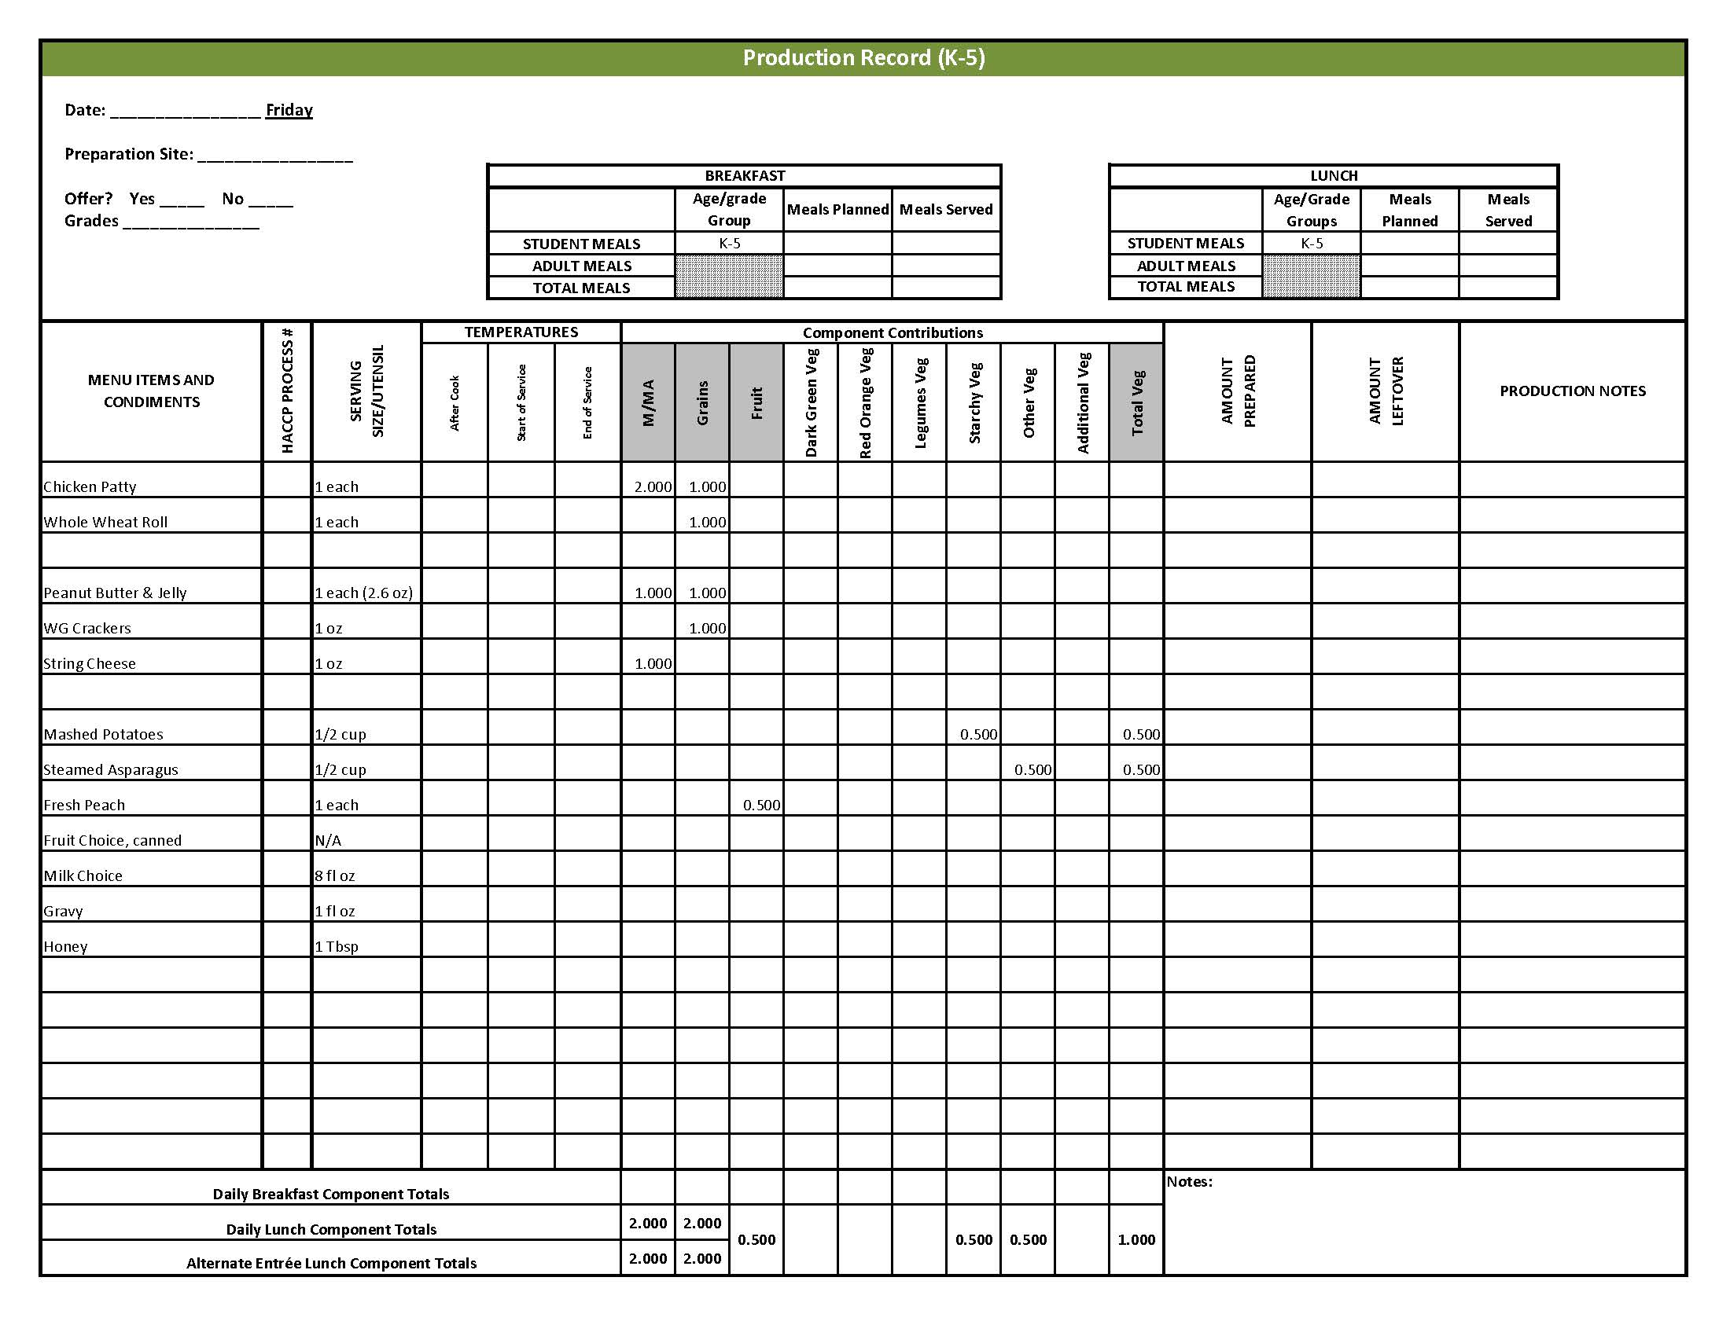

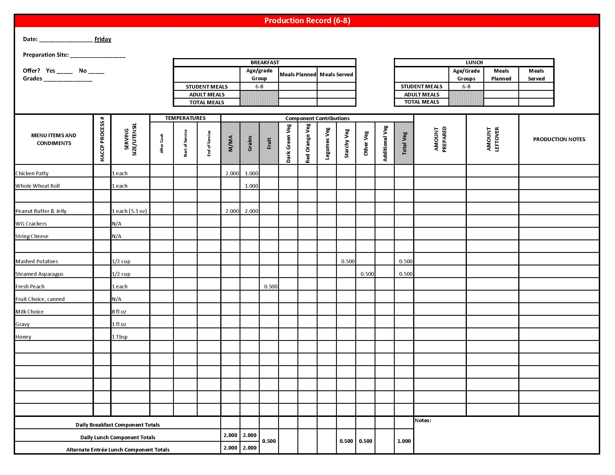

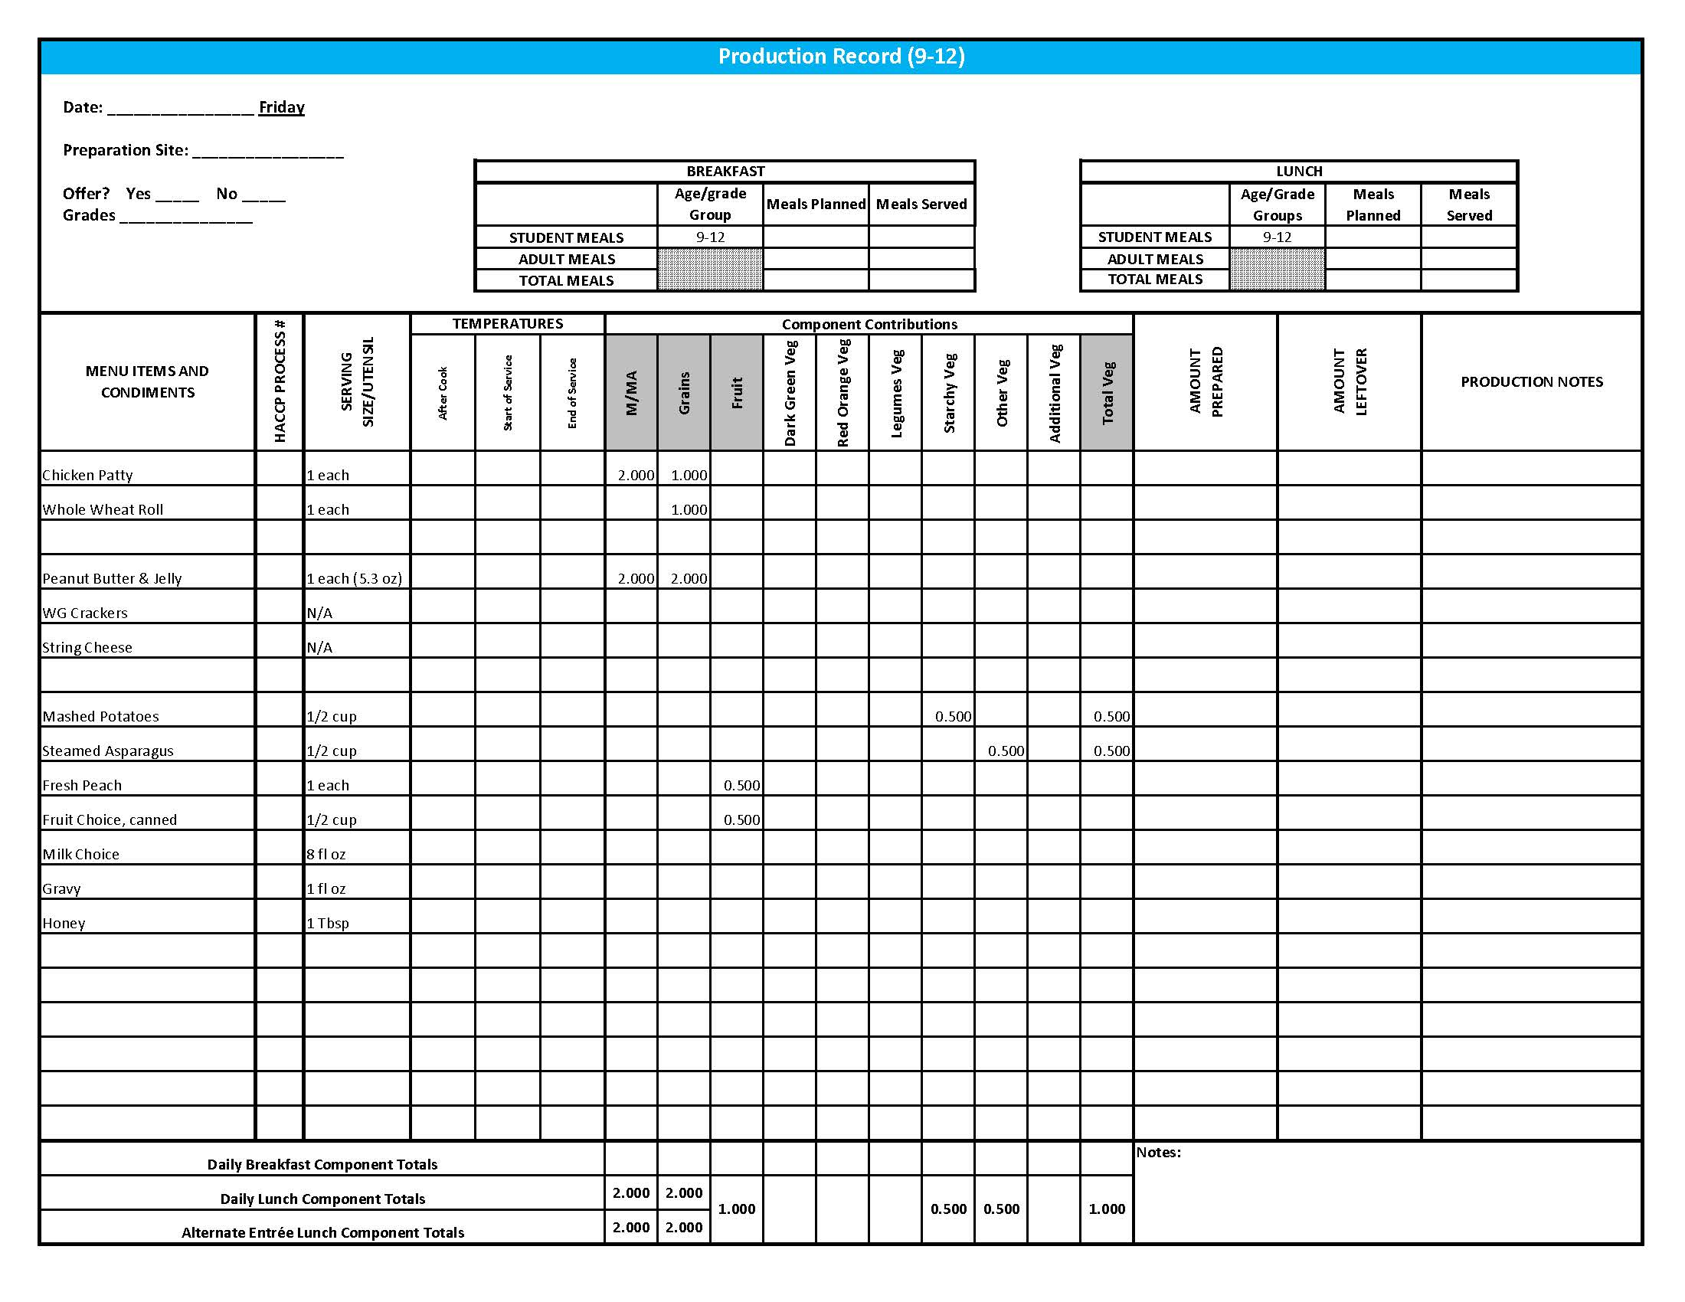

Fruit & Vegetable Order Guide

## **Week 1**

The chart below provides amounts to be ordered per 100 servings based on the serving sizes listed on Week 1 of *Healthier Kansas Menus Production Records* for students in grades groups K-5, 6-8, and 9-12. Amounts to order are based on standard yields and leveled serving utensils or weighed portions. Use the following procedures to determine the amounts to order:

1. **Forecast** the number of servings needed for each fruit and vegetable menu item for each grade group served.
2. **Divide** the number of servings needed by 100 for each portion size (K-5, 6-8 or 9-12).
3. **Multiply** the “Amount to order per 100 servings” by the factor determined in step 2 above for each portion size.
4. **Add** amounts needed for all serving sizes together to determine the amounts to order.

**Abbreviations Key: EP = Edible Portion AP = As Purchased lb = Pound oz = ounce # = Number**

|  |  |  |  |  |  |  |  |
| --- | --- | --- | --- | --- | --- | --- | --- |
| **Day** | **Fruit or Vegetable** | **K-5**  **Portion Size** | **K-5**  **Amount to Order per 100 Servings** | **6-8**  **Portion Size** | **6-8**  **Amount to Order**  **per 100 Servings** | **9-12 Portion Size** | **9-12 Amount to Order per 100 Servings** |
| Monday | Potato Wedges, frozen, ovenable, unseasoned | ½ cup | 19 lb | ½ cup | 19 lb | ½ cup | 19 lb |
| Red Bell Pepper, AP | ½ cup | 13 lb 13 oz | ½ cup | 13 lb 13 oz | ½ cup | 13 lb 13 oz |
| Apples, fresh, #125-138, AP | ½ apple | 13 lb 10 oz or 50 each | ½ apple | 13 lb 10 oz or 50 each | ½ apple | 13 lb 10 oz or 50 each |
| Tuesday | Broccoli, florets, fresh, EP | ½ cup | 7 lb | ½ cup | 7 lb | ½ cup | 7 lb |
| Tomatoes, cherry, AP | 6 tomatoes | 16 lb 10 oz | 6 tomatoes | 16 lb 10 oz | 6 tomatoes | 16 lb 10 oz |
| Fruit Cocktail, canned in 100% juice or light syrup | ½ cup | 5.5 #10 cans | ½ cup | 5.5 #10 cans | ½ cup | 5.5 #10 cans |

Fruit & Vegetable Order Guide

**Week 1,** continued

|  |  |  |  |  |  |  |  |
| --- | --- | --- | --- | --- | --- | --- | --- |
| **Day** | **Fruit or Vegetable** | **K-5**  **Portion Size** | **K-5**  **Amount to Order per 100 Servings** | **6-8**  **Portion Size** | **6-8**  **Amount to Order**  **per 100 Servings** | **9-12 Portion Size** | **9-12 Amount to Order per 100 Servings** |
| Wednesday | Taco Meat | ¼ cup |  | ¼ cup |  | ¼ cup |  |
| Tomato Paste, canned |  | 3 cups |  | 3 cups |  | 3 cups |
| Lettuce, Dark Green Leafy, AP | ½ cup | 9 lb 7 oz | ½ cup | 9 lb 7 oz | ½ cup | 9 lb 7 oz |
| Refried Beans, canned **OR** | ½ cup | 4.2 #10 cans | ½ cup | 4.2 #10 cans | ½ cup | 4.2 #10 cans |
| Refried Beans, dried |  | 9 lb 13 oz |  | 9 lb 13 oz |  | 9 lb 13 oz |
| Picante Sauce **OR** | ¼ cup | 1.6 gallons | ¼ cup | 1.6 gallons | ¼ cup | 1.6 gallons |
| Tomato, crushed, salsa- ready, canned (for Tomato Salsa) |  | 2 #10 can |  | 2 #10 can |  | 2 #10 can |
| Jalapeno Peppers, canned (for Tomato Salsa) | 4 oz | |  | 4 oz |  | 4 oz |
| Raspberries, fresh | ½ cup | 16 lb 10 oz | ½ cup | 16 lb 10 oz | ½ cup | 16 lb 10 oz |
| Thursday | Lasagna | 1 piece |  | 1 piece |  | 1 piece |  |
| Spaghetti Sauce, canned |  | 1.5 #10 cans |  | 1.5 #10 cans |  | 1.5 #10 cans |
| Tomatoes, diced, canned | 1 #10 can | 1 #10 can | 1 #10 can |
| Marinara Sauce, canned | ¼ cup | 2.1 #10 cans | ¼ cup | 2.1 #10 cans | ¼ cup | 2.1 #10 cans |
| Grapes, fresh, AP | ½ cup | 19 lb 4 oz | ½ cup | 19 lb 4 oz | ½ cup | 19 lb 4 oz |
| Carrots, baby, fresh, EP | ¼ cup | 7 lb 13 oz | ¼ cup | 7 lb 13 oz | ½ cup | 15 lb 10 oz |
| Garden Salad: | 1 cup |  | 1 cup |  | 1 cup |  |
| Lettuce, Romaine, AP |  | 6 lb 8 oz |  | 6 lb 8 oz |  | 6 lb 8 oz |
| Spinach, fresh, trimmed, AP |  | 6 lb 8 oz |  | 6 lb 8 oz |  | 6 lb 8 oz |
| Tomato, fresh, AP | 1 lb 5 oz | 1 lb 5 oz | 1 lb 5 oz |
| Carrots, fresh, AP | 15 oz | 15 oz | 15 oz |
| Cucumber, fresh, AP | 14 oz | 14 oz | 14 oz |

Fruit & Vegetable Order Guide

**Week 1, continued**

|  |  |  |  |  |  |  |  |
| --- | --- | --- | --- | --- | --- | --- | --- |
| **Day** | **Fruit or Vegetable** | **K-5**  **Portion Size** | **K-5**  **Amount to Order per 100 Servings** | **6-8**  **Portion Size** | **6-8**  **Amount to Order**  **per 100 Servings** | **9-12 Portion Size** | **9-12 Amount to Order per 100 Servings** |
| Friday | Potatoes, dehydrated, flakes | ½ cup prepared | 4 lb | ½ cup prepared | 4 lb | ½ cup prepared | 4 lb |
| Asparagus, fresh | ½ cup | 41 lb 13 oz | ½ cup | 41 lb 13 oz | ½ cup | 41 lb 13 oz |
| Peaches, fresh, 80 count, AP | 1 each | 22 lb 5 oz or 100 each | 1 each | 22 lb 5 oz or 100 each | 1 each | 22 lb 5 oz or 100 each |