Healthier Kansas Menus

with Alternate Entrées

# C:\Documents and Settings\jmackey\My Documents\My Pictures\Microsoft Clip Organizer\j0349505.wmf

FALL WEEK 4 – DAILY PRODUCTION RECORDS

Child Nutrition & Wellness, Kansas State Department of Education

Revised July 2019

This publication has been funded at least in part with Federal funds from the U.S. Department of Agriculture, Food and Nutrition Service. The contents of this publication do not necessarily reflect the views or policies of the Department, nor does mention of trade names, commercial products, or organizations imply endorsement by the U.S. Government.

**For further information about this publication, please contact:** Child Nutrition & Wellness, KSDE, Landon State Office Building, 900 SW Jackson Street, Suite #251, Avenue, Topeka, Kansas 66612, 785-296-2276, Fax: 785-296-0232,

[www.kn-eat.org](http://www.kn-eat.org/)

In accordance with Federal civil rights law and U.S. Department of Agriculture (USDA) civil rights regulations and policies, the USDA, its Agencies, offices, and employees, and institutions participating in or administering USDA programs are prohibited from discriminating based on race, color, national origin, sex, disability, age, or reprisal or retaliation for prior civil rights activity in any program or activity conducted or funded by USDA.  
  
Persons with disabilities who require alternative means of communication for program information (e.g. Braille, large print, audiotape, American Sign Language, etc.), should contact the Agency (State or local) where they applied for benefits. Individuals who are deaf, hard of hearing or have speech disabilities may contact USDA through the Federal Relay Service at (800) 877-8339. Additionally, program information may be made available in languages other than English.  
  
To file a program complaint of discrimination, complete the [USDA Program Discrimination Complaint Form](http://www.ocio.usda.gov/sites/default/files/docs/2012/Complain_combined_6_8_12.pdf), (AD-3027) found online at: [http://www.ascr.usda.gov/complaint_filing_cust.html](https://www.ascr.usda.gov/filing-discrimination-complaint-usda-customer), and at any USDA office, or write a letter addressed to USDA and provide in the letter all of the information requested in the form. To request a copy of the complaint form, call (866) 632-9992. Submit your completed form or letter to USDA by:  
  
(1)   Mail: U.S. Department of Agriculture  
Office of the Assistant Secretary for Civil Rights  
1400 Independence Avenue, SW  
Washington, D.C. 20250-9410;  
  
(2)   Fax: (202) 690-7442; or  
  
(3)   Email: [program.intake@usda.gov](mailto:program.intake@usda.gov).  
  
This institution is an equal opportunity provider.

The following person has been designated to handle inquiries regarding the non-discrimination policies at the Kansas State Department of Education: Office of General Counsel, Landon State Office Building, 900 SW Jackson St, Suite #102, Topeka, KS 66612, (785)296-3201.

Healthier Kansas Menus recipes were developed by Child Nutrition & Wellness, Kansas State Department of Education or adapted from the following sources:

* *Food for Fifty,* Ninth Edition (1989) Grace Shugart, Mary Molt*.*
* *Healthier Kansas Menus – Breakfast,* Child Nutrition & Wellness, Kansas State Department of Education
* *Iowa Gold Star Cycle Menus*, Iowa Department of Education
* *Menus that Move,* Ohio Department of Education.
* *Fruit and Veggie Quantity Cookbook,* New Hampshire Department of Health and Human Services.
* *Preparing Whole Grain Foods,* Child Nutrition & Wellness, Kansas State Department of Education
* *Singing the Praises of Beans & Legumes*, Child Nutrition & Wellness, Kansas State Department of Education
* *USDA Recipes for Schools,* U.S. Department of Agriculture, Food & Nutrition Service, Child Nutrition Programs, 2006.
* USD 225 Fowler
* USD 234 Fort Scott
* USD 267 Renwick
* USD 306 Southeast of Saline
* USD 308 Hutchinson
* USD 320 Wamego
* USD 349 Stafford
* USD 364 Marysville
* USD 503 Parsons
* USD 512 Shawnee Mission

Thank you to the following schools for assisting with menu development and recipe testing:

* Logan Elementary School – USD 345 Seaman
* St. Joseph Catholic School – Mt. Hope, KS
* Winfield Scott Elementary School – USD 234 Fort Scott

## Menus for the Week

**PLEASE NOTE:**

Milk choice includes a variety of non-fat or 1% (flavored or unflavored) milk. One milk choice must be unflavored.

Reduced fat dressing is served with salads and fresh vegetables.

Menus were planned using all whole grain-rich products. Beginning July 1, 2019, at least half of the weekly grains in the school lunch menu and the school breakfast menu must be whole grain-rich.

|  |  |  |  |  |  |  |  |  |
| --- | --- | --- | --- | --- | --- | --- | --- | --- |
| **MONDAY** | **TUESDAY** | **WEDNESDAY** | **THURSDAY** | **FRIDAY** | **Weekly Nutrient Averages** | | | |
|  | K-5 | 6-8 | 9-12 |
| Hamburger on a Bun  **Or**  Fruit, Yogurt & Granola Parfait  Dark Green Leaf Lettuce  Tomato Slice  Oven Fries  Fresh Apple  Canned Fruit Choice  Milk Choice | Chili  **Tortilla Chips (9-12)**  **Or**  Popcorn Chicken  **Tortilla Chips (9-12)**  Red Bell Pepper Strips  Sliced Cucumber  Fresh Nectarine  Cinnamon Roll  Canned Fruit Choice  Milk Choice | Chicken Nuggets  Whole Wheat Roll  **Or**  Rock and Roll  Beef Wrap  Mashed Potatoes  & Gravy  Tossed Salad  Fresh Blueberries  Canned Fruit Choice  Milk Choice | Baked Ham  Angel Biscuit & Jelly  **Or**  Grilled Chicken Sandwich  Apple Glazed Sweet Potatoes  Green Beans  Diced Peaches  **Honey Apple Crisp (9-12)**  Fresh Fruit Choice  Milk Choice | Macaroni & Cheese  Meatballs  **Whole Wheat Bread & Jelly (6-12)**  **Or**  Pepperoni Pizza  Baked Beans  Fresh Baby Carrots  Fresh Strawberries  Canned Fruit Choice  Milk Choice | **Calories**  **Sodium (mg)**  **% of Total Calories from Sat. Fat** | **637**  **880**  **8.9%** | **655**  **899**  **8.7%** | **813**  **957**  **7.9%** |

C:\Documents and Settings\jmackey\My Documents\My Pictures\Microsoft Clip Organizer\j0349505.wmf

## Recipes for the Week

|  |  |  |  |
| --- | --- | --- | --- |
| Day | Recipe Name | Recipe Number | HKM Recipe  Page Number |
| Monday | Whole Grain Bun | 877 | 91 |
| Tuesday | Chili  Whole Wheat Cinnamon Roll | 218  167 | 17  87 |
| Wednesday | Whole Grain Roll  Tossed Salad  Rock & Roll Beef Wrap | 877  74  133 | 91  62  30 |
| Thursday | Apple Glazed Sweet Potatoes  Angel Biscuit, Whole Wheat  Honey Apple Crisp (9-12 only) | 122  120  39 | 47  63  71 |
| Friday | Macaroni & Cheese  Whole Wheat Bread  Baked Beans | 184  107  188 | 23  83  50 |

## Abbreviations

|  |  |  |  |
| --- | --- | --- | --- |
| **Abbreviation** | **What it Means** | **Abbreviation** | **What it Means** |
| HKM | Healthier Kansas Menus | Tbsp | tablespoon |
| EP | edible portion | tsp | teaspoon |
| AP | as purchased | CCP | Critical Control Point |
| fl | fluid | PC | portion controlled * |
| oz | ounce | w/ | with |
| lb | pound | M/MA | meat/meat alternate |
| gm | gram |  |  |
| mg | milligram |  |  |

* For example, purchase pre-portioned servings of condiments.

## Portion Guide

|  |  |
| --- | --- |
| **Ladles & Spoodles** | **Scoops** |
| 1 fl oz = 2 Tbsp | #50 = 3 3/4 tsp |
| 2 fl oz = 1/4 cup | #40 = 1 2/3 Tbsp |
| 3 fl oz = 3/8 cup | #30 = 2 Tbsp |
| 4 fl oz = 1/2 cup | #20 = 3 1/3 Tbsp |
| 6 fl oz = 3/4 cup | #16 = 1/4 cup |
| 8 fl oz = 1 cup | #12 = 1/3 cup |
|  | #8 = 1/2 cup |
|  | #6 = 2/3 cup |

## Purchasing, Preparation & Serving Instructions

Week 4 – Monday

|  |  |  |
| --- | --- | --- |
| **Menu Item** | **Purchasing & Preparation** | **Serving** |
| Hamburger on a Bun | * Purchase pre-cooked, oven-ready hamburger patties that provides 2 oz equivalent M/MA; no more than 13 gm of fat; and no more than 300 mg sodium. If product is not Child Nutrition (CN) labeled, obtain a Product Formulation Statement. * Heat according to manufacturer’s instructions. * Purchase a 2 oz whole wheat bun (first ingredient is whole wheat) or prepare following HKM Recipe 877, Whole Wheat Rolls, Bread Sticks, Buns, Hamburger Bun Variation. * **CCP: Hold for hot service at 135°F or above.** | K-12: 1 each |
| **Alternate Entrée:**  Fruit, Yogurt & Granola Parfait | * Purchase a fresh, frozen or canned fruit packed in light syrup or 100% juice. Refer to *Fruit & Vegetable Order Guide* for amount needed. * Purchase low-fat, flavored bulk yogurt and portion 1 cup (8 oz) for each serving. * Purchase pre-prepared granola that provides 2 oz Grains per ½ cup serving; no more than 7 gm of fat; and no more than 180 mg of sodium per serving. * Assemble parfait with fruit and yogurt in one cup and granola in different cup. Recommend layering ½ cup yogurt, ¼ cup fruit, ½ cup yogurt and ¼ cup fruit. Portioning granola separately will help to keep granola fresh and crunchy. * **CCP: Refrigerate and hold at 41o F or below for cold service.** | K-12: ½ cup fruit, 8 oz yogurt, ½ cup granola |
| Dark Green Leaf Lettuce | * Refer to *Fruit & Vegetable Order Guide* for amount needed. * Handle produce with gloved hands. May be pre-portioned. * **CCP: Refrigerate and hold at 41°F or below for cold service.** | K-12: ½ cup |
| Tomato Slice | * Refer to *Fruit & Vegetable Order Guide* for amount needed. * Handle produce with gloved hands. * Slice ¼” thick. * **CCP: Refrigerate and hold at 41°F or below for cold service.** | K-12: 2 slices |
| Oven Fries | * Refer to *Fruit & Vegetable Order Guide* for amount needed. Purchase ovenable straight cut fries. * Heat in oven according to manufacturer’s instructions. * **CCP: Hold for hot service at 135°F or above.** | K-12: ½ cup |

*Continued on next page*

## Purchasing, Preparation & Serving Instructions

Week 4 – Monday, continued

|  |  |  |
| --- | --- | --- |
| **Menu Item** | **Purchasing & Preparation** | **Serving** |
| Apple Slices, Fresh | * Refer to *Fruit & Vegetable Order Guide* for amount needed. Purchase apples, size #125-138. * Handle with gloved hands. Rinse and remove core. Cut in 4ths or 8ths. * Dip in lemon, orange, pineapple juice, or antioxidant solution to preserve color. * Cover and refrigerate or store at room temperature until serving. * **CCP: Refrigerate and hold at 41⁰ F or below for cold service** | K-12: ½ apple |
| Fruit Choice, canned | Select an additional fruit choice to offer on the menu. The serving(s) offered must credit as ½ cup of fruit, to meet the minimum daily requirement, for grades 9-12.  *Note: The fruit choice is encouraged for grades K-5 and 6-8, but not required. The fruit choice is not included in the nutrient analysis for grades K-5 and 6-8. | K-8: N/A*  9-12: ½ cup |
| Milk | * Provide a variety of milk. May be 1% fat (unflavored) or skim (flavored or unflavored). * **CCP: Refrigerate and hold at 41°F or below for cold service.** | K-12: 8 fl oz |
| Ketchup | * Purchase in bulk or individual packets (9-gm or 12-gm). If bulk, purchase 1 #10 can or .8 gallon for every 100 1-fluid oz servings. | K-12: 1 fl oz  **or** 2 Tbsp **or** 2 PC |
| Mustard | * Purchase bulk or packets. If bulk, purchase 2 cups for every 100 1 tsp servings. | K-12: 1 tsp |

**Pre-preparation for Week 4 - Tuesday:** Thaw ground beef under refrigeration.

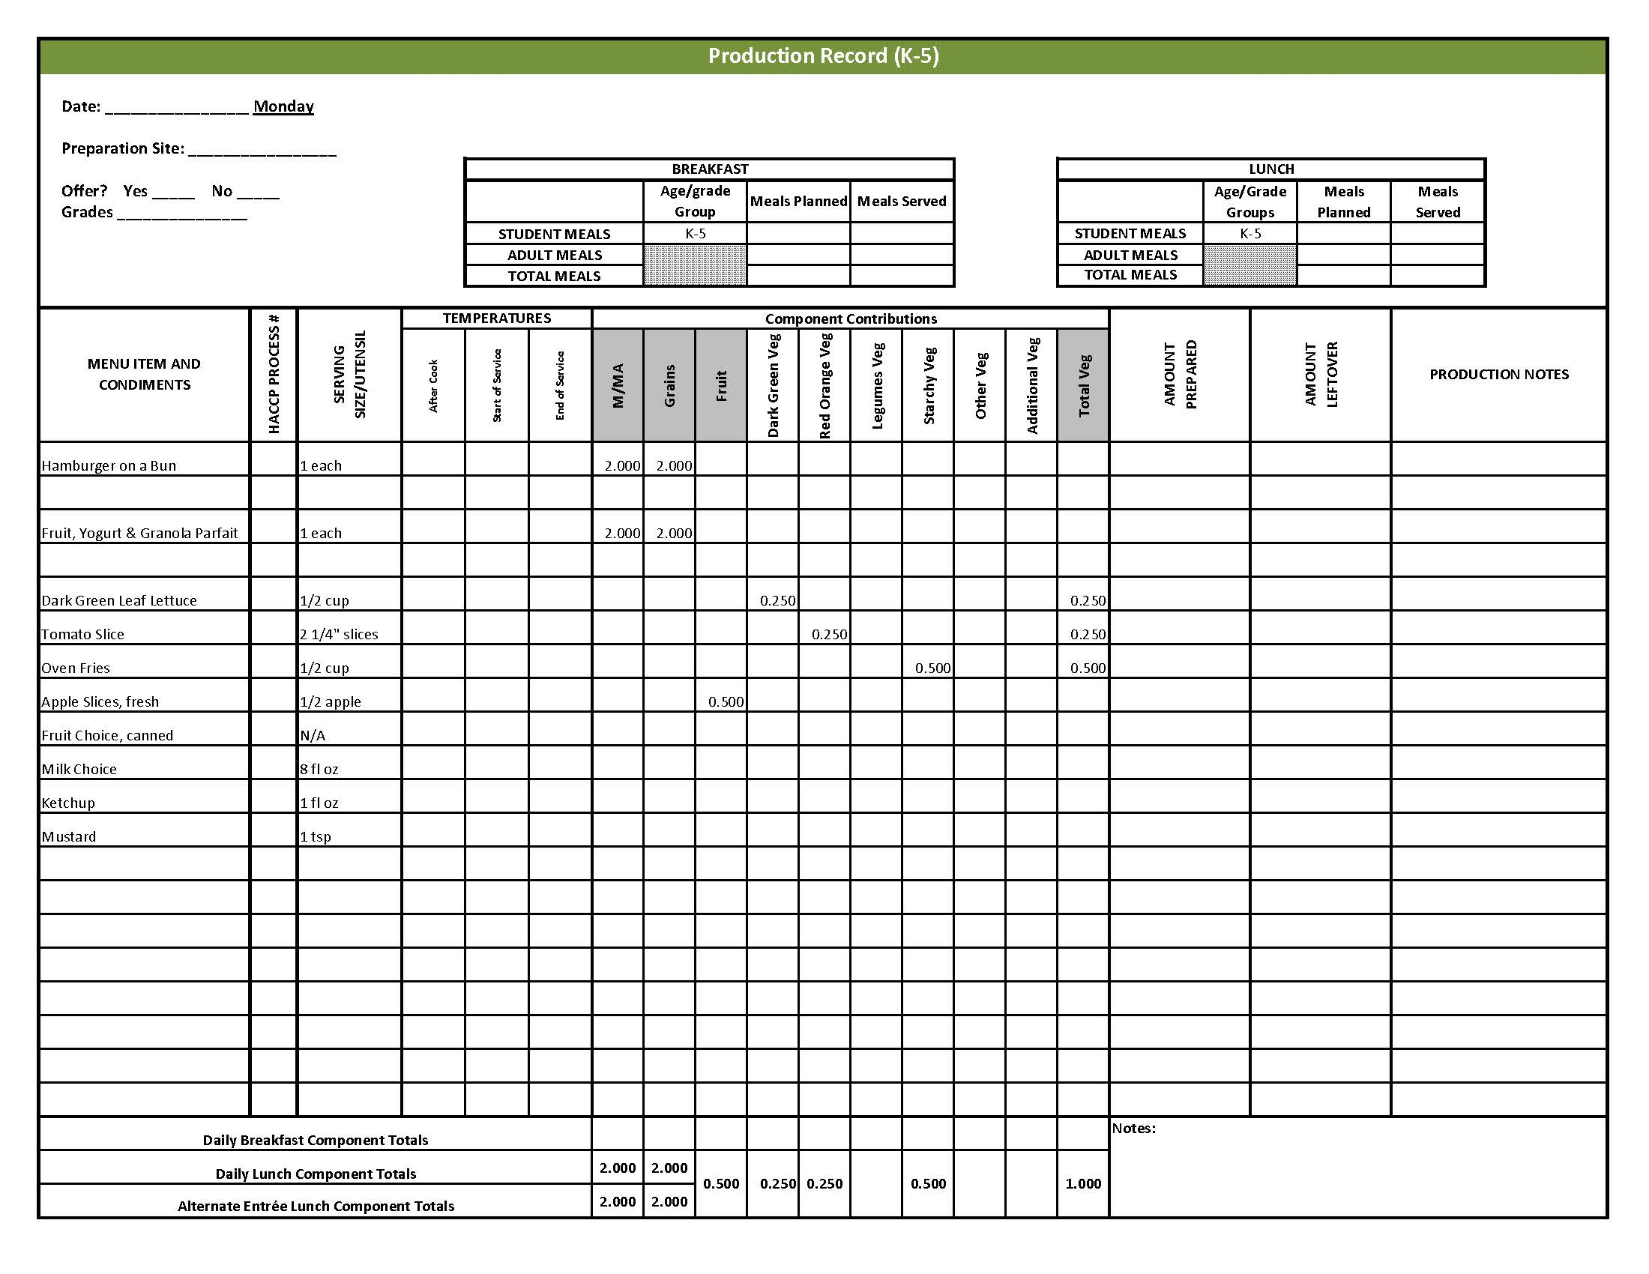

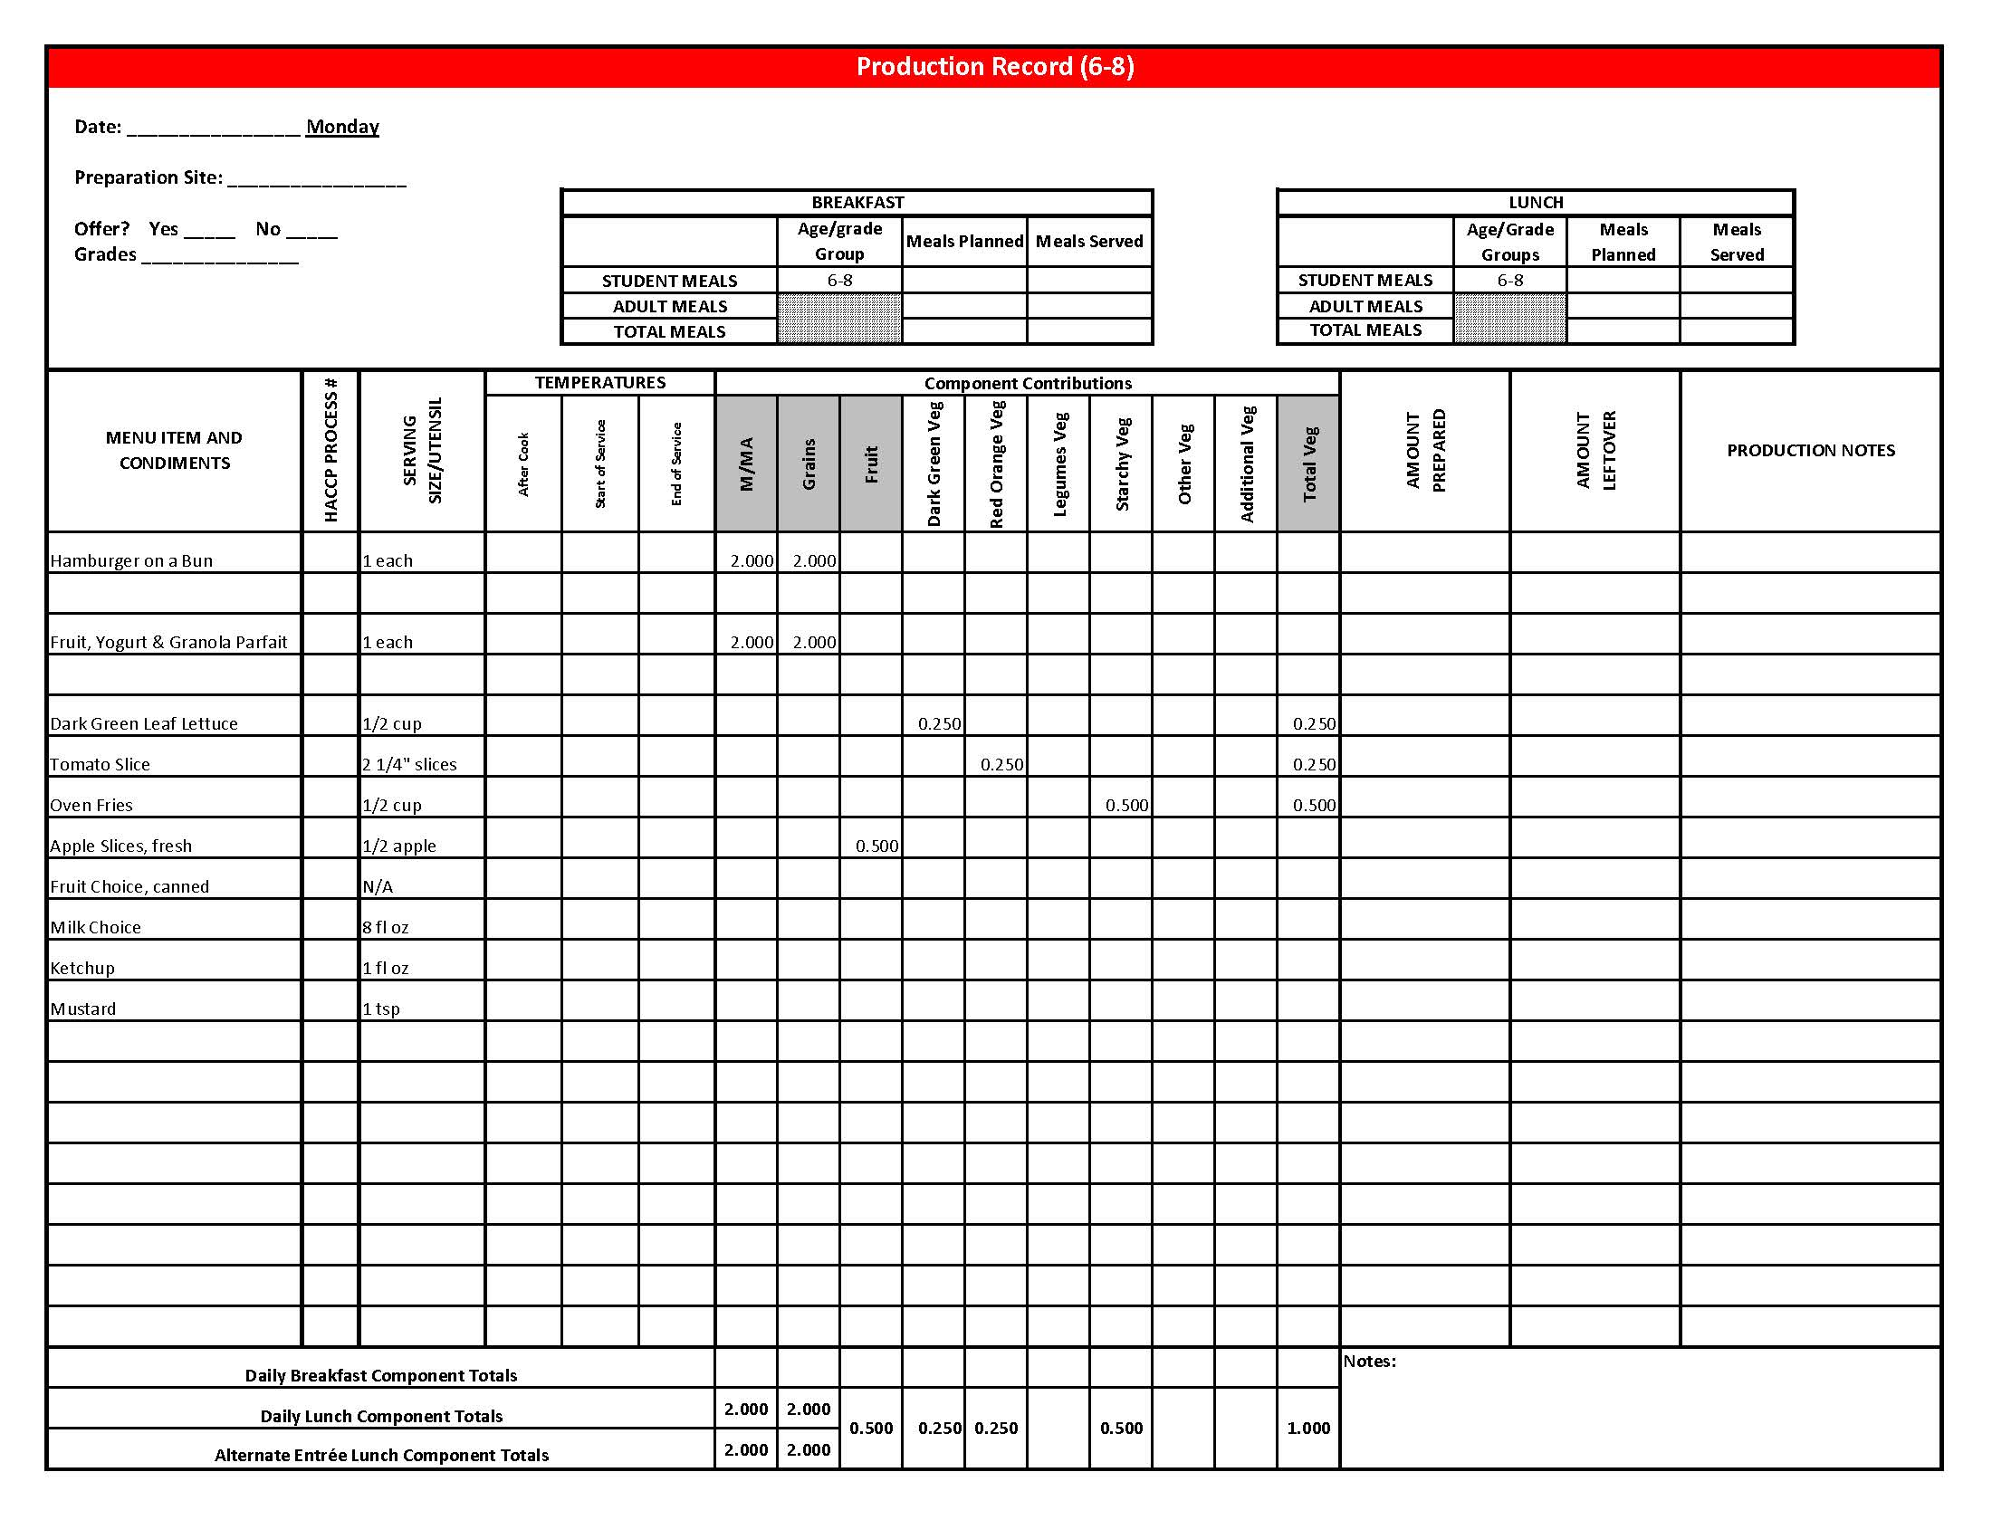

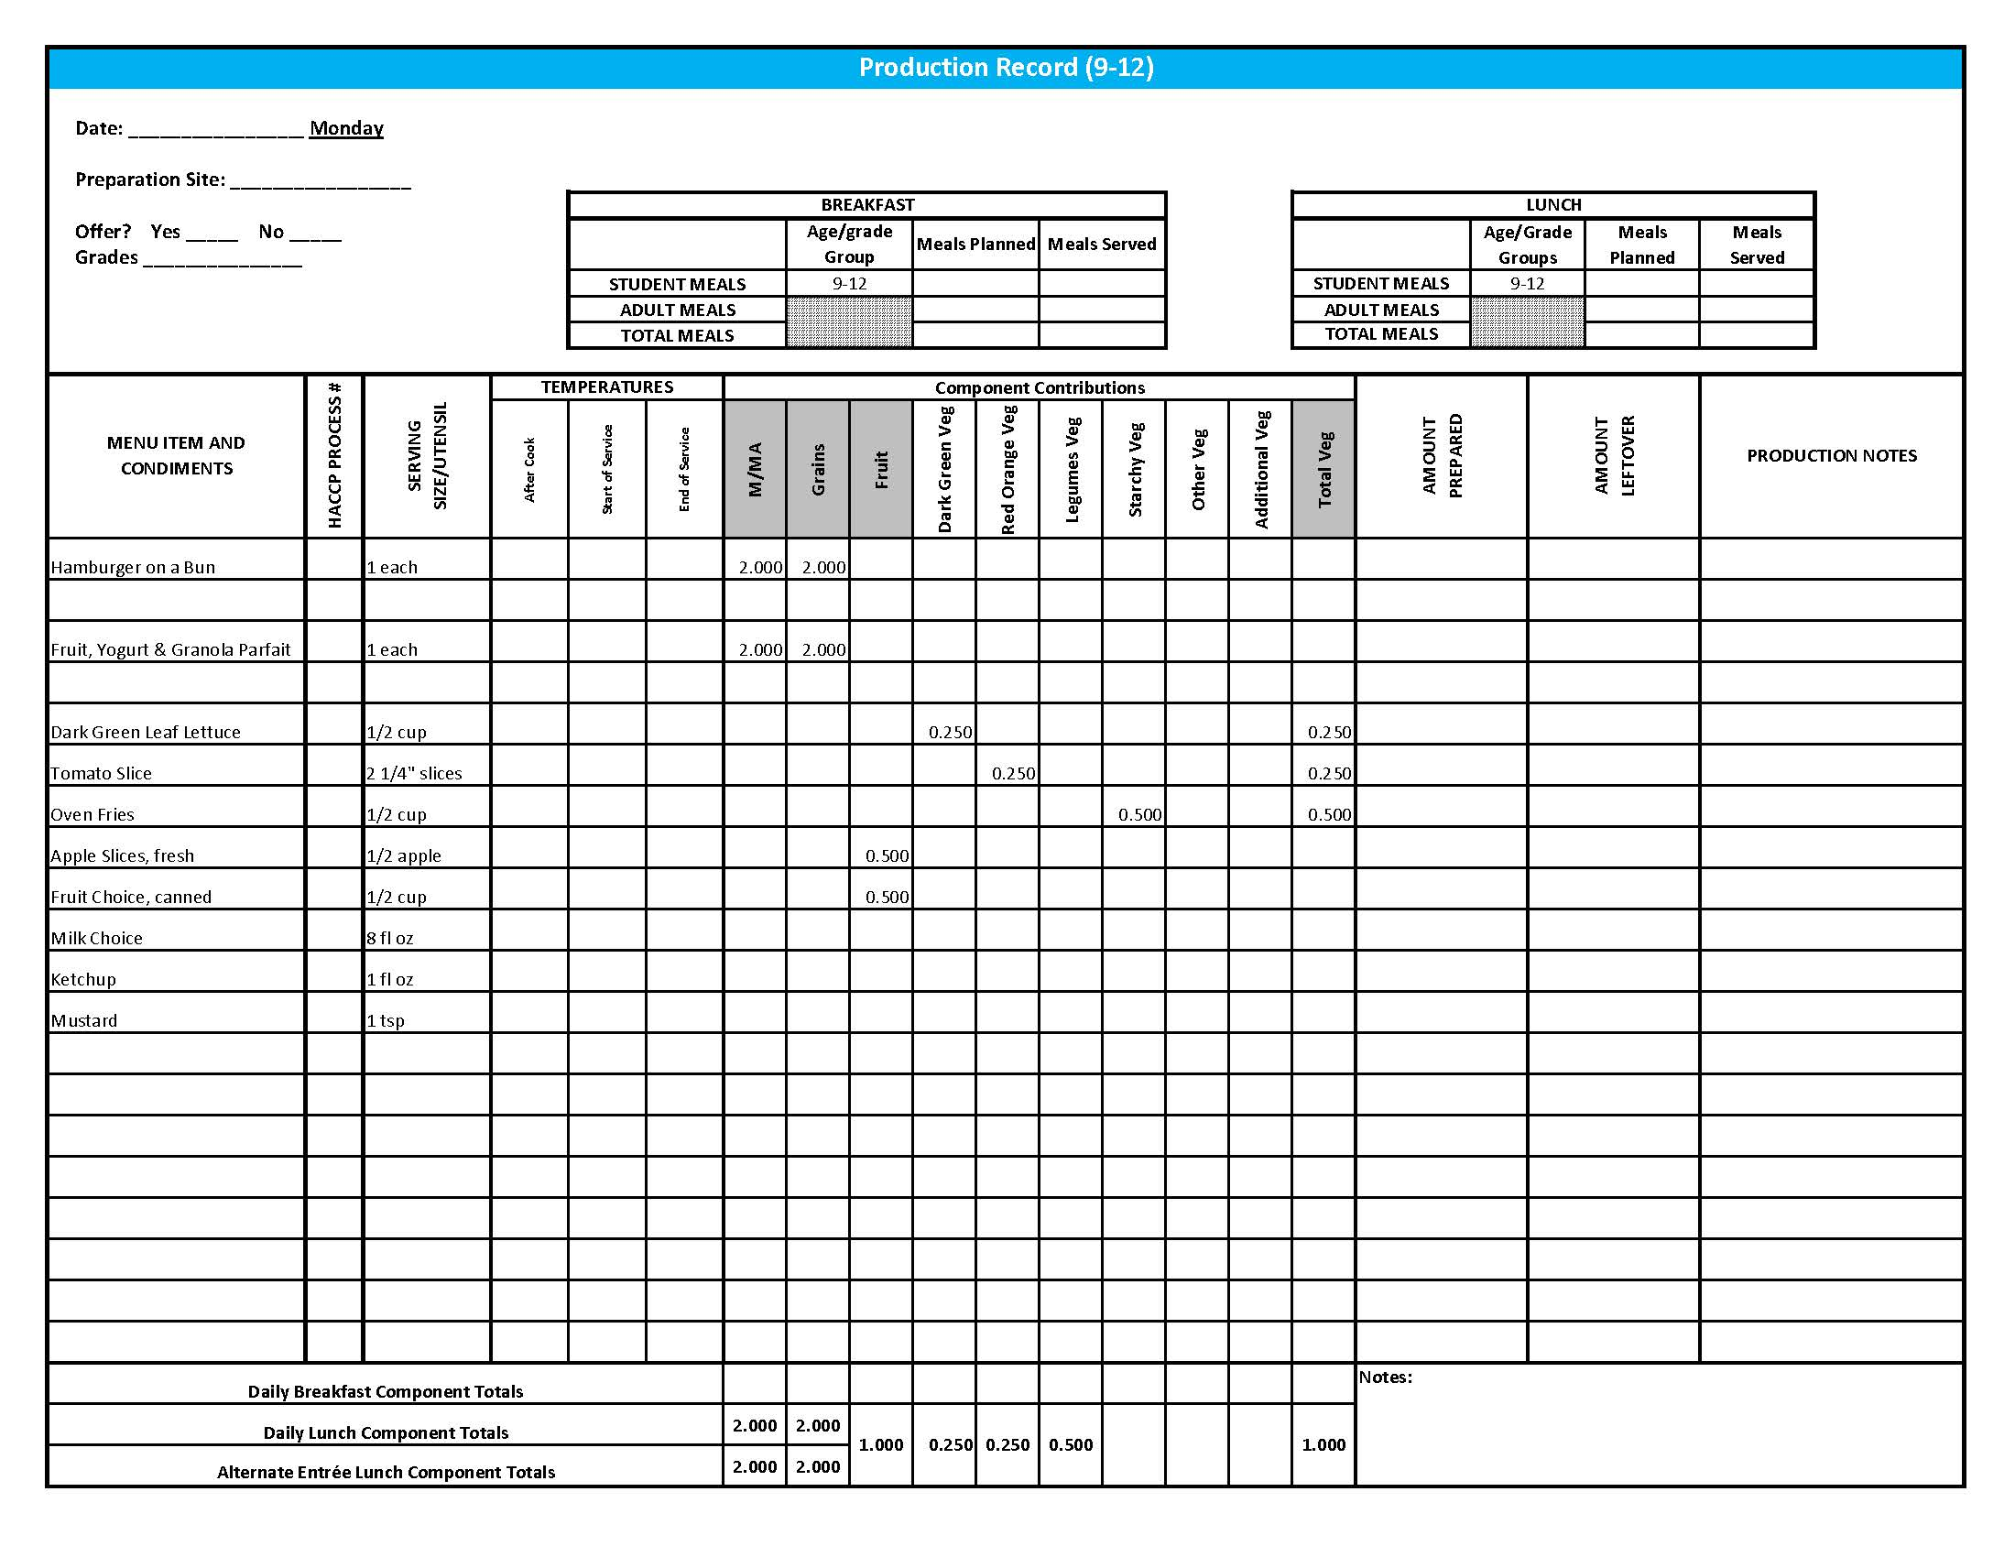

Purchasing, Preparation & Serving Instructions

Week 4 – Tuesday

|  |  |  |
| --- | --- | --- |
| **Menu Item** | **Purchasing & Preparation** | **Serving** |
| Chili | * Purchase 80/20 ground beef. Prepare HKM Recipe 218, Chili. * **CCP: Hold for hot service at 135°F or above.** | K-8: ¾ cup  9-12: 1 cup |
| **Alternate Entrée:**  Chicken, popcorn | * Purchase pre-cooked, oven-ready popcorn chicken that provides 2 oz equivalent M/MA and 1 oz equivalent Grain, no more than 18 gm of fat; and no more than 290 mg sodium per serving. If product is not Child Nutrition (CN) labeled, obtain a Product Formulation Statement. * Heat according to manufacturer’s instructions. * **CCP: Hold for hot service at 135°F or above.** | K-12: 15 pieces  (or number needed to provide 2 oz equivalent M/MA & 1 oz equivalent Grain) |
| Tortilla Chips | * Purchase whole grain tortilla chips with no more than 50 mg sodium per oz. (Restaurant style usually has less sodium). * May be pre-portioned. Weigh a sample. Serve with gloved hands or tongs. | K-8: N/A  9-12: 1 oz |
| Red Bell Pepper Strips | * Refer to *Fruit & Vegetable Order Guide* for amount needed. * With gloved hands, core and slice bell peppers into strips. * **CCP: Refrigerate and hold at 41°F or below for cold service.** | K-12: ½ cup |
| Cucumber Slices | * Refer to *Fruit & Vegetable Order Guide* for amount needed. * With gloved hands, wash and slice cucumbers. * **CCP: Refrigerate and hold at 41°F or below for cold service.** | K-8: ¼ cup  9-12: ½ cup |
| Nectarines, fresh | * Refer to *Fruit & Vegetable Order Guide* for amount needed. * With gloved hands, wash nectarines. * Cover and refrigerate or store at room temperature until serving. * **CCP: Refrigerate and hold at 41⁰ F or below for cold service.** | K-12: 1 each |

*Continued on next page*

Purchasing, Preparation & Serving Instructions

Week 4 – Tuesday, continued

|  |  |  |
| --- | --- | --- |
| **Menu Item** | **Purchasing & Preparation** | **Serving** |
| Fruit Choice, canned | Select an additional fruit choice to offer on the menu.  The serving(s) offered must credit as ½ cup of fruit, to meet the minimum daily requirement, for grades 9-12.  *Note: The fruit choice is encouraged for grades K-5 and 6-8, but not required.  The fruit choice is not included in the nutrient analysis for grades K-5 and 6-8. | K-8: N/A*  9-12: ½ cup |
| Whole Wheat Cinnamon Roll | * Prepare HKM Recipe 167, Whole Wheat Cinnamon Roll. * This menu item will count as a grain based dessert. | K-12: 1 each |
| Milk | * Provide a variety of milk. May be 1% fat (unflavored) or skim (flavored or unflavored). * **CCP: Refrigerate and hold at 41°F or below for cold service.** | K-12: 8 fl oz |
| Ranch Dressing, Reduced Fat | * Purchase or prepare Ranch dressing containing no more than 6 gm of fat  per 1 fl oz. Purchase .8 gallons for every 100 1 fl oz portions. * **CCP: Refrigerate and serve at 41°F or below if school-prepared dressing is served.** | K-12: 1 fl oz **or** 2 Tbsp |

**Pre-preparation for Week 4 - Wednesday:** None

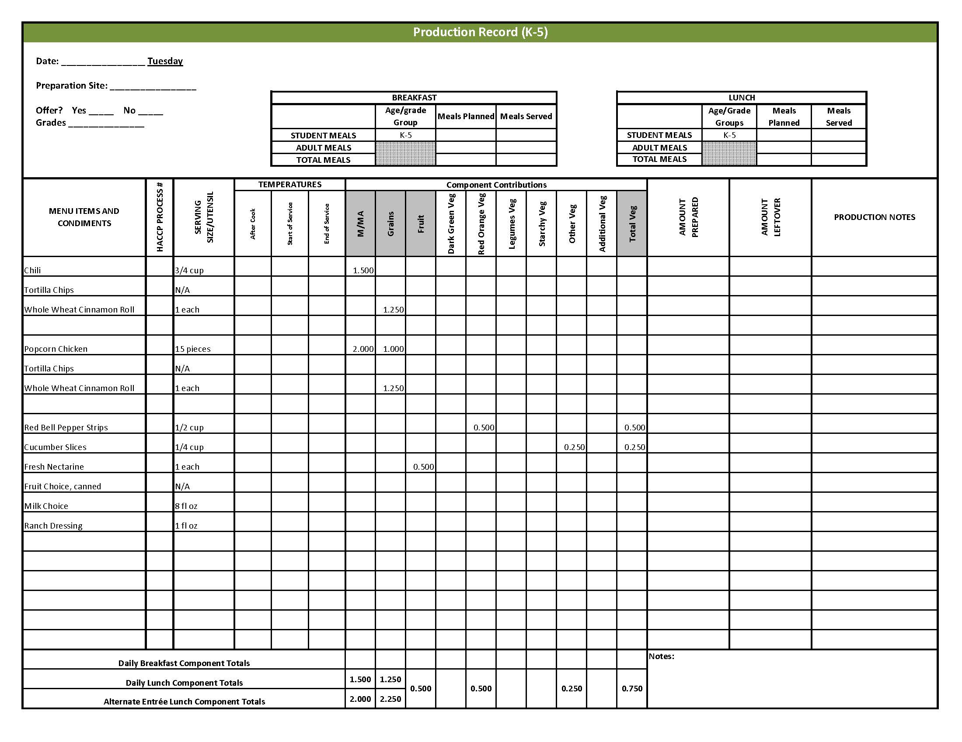

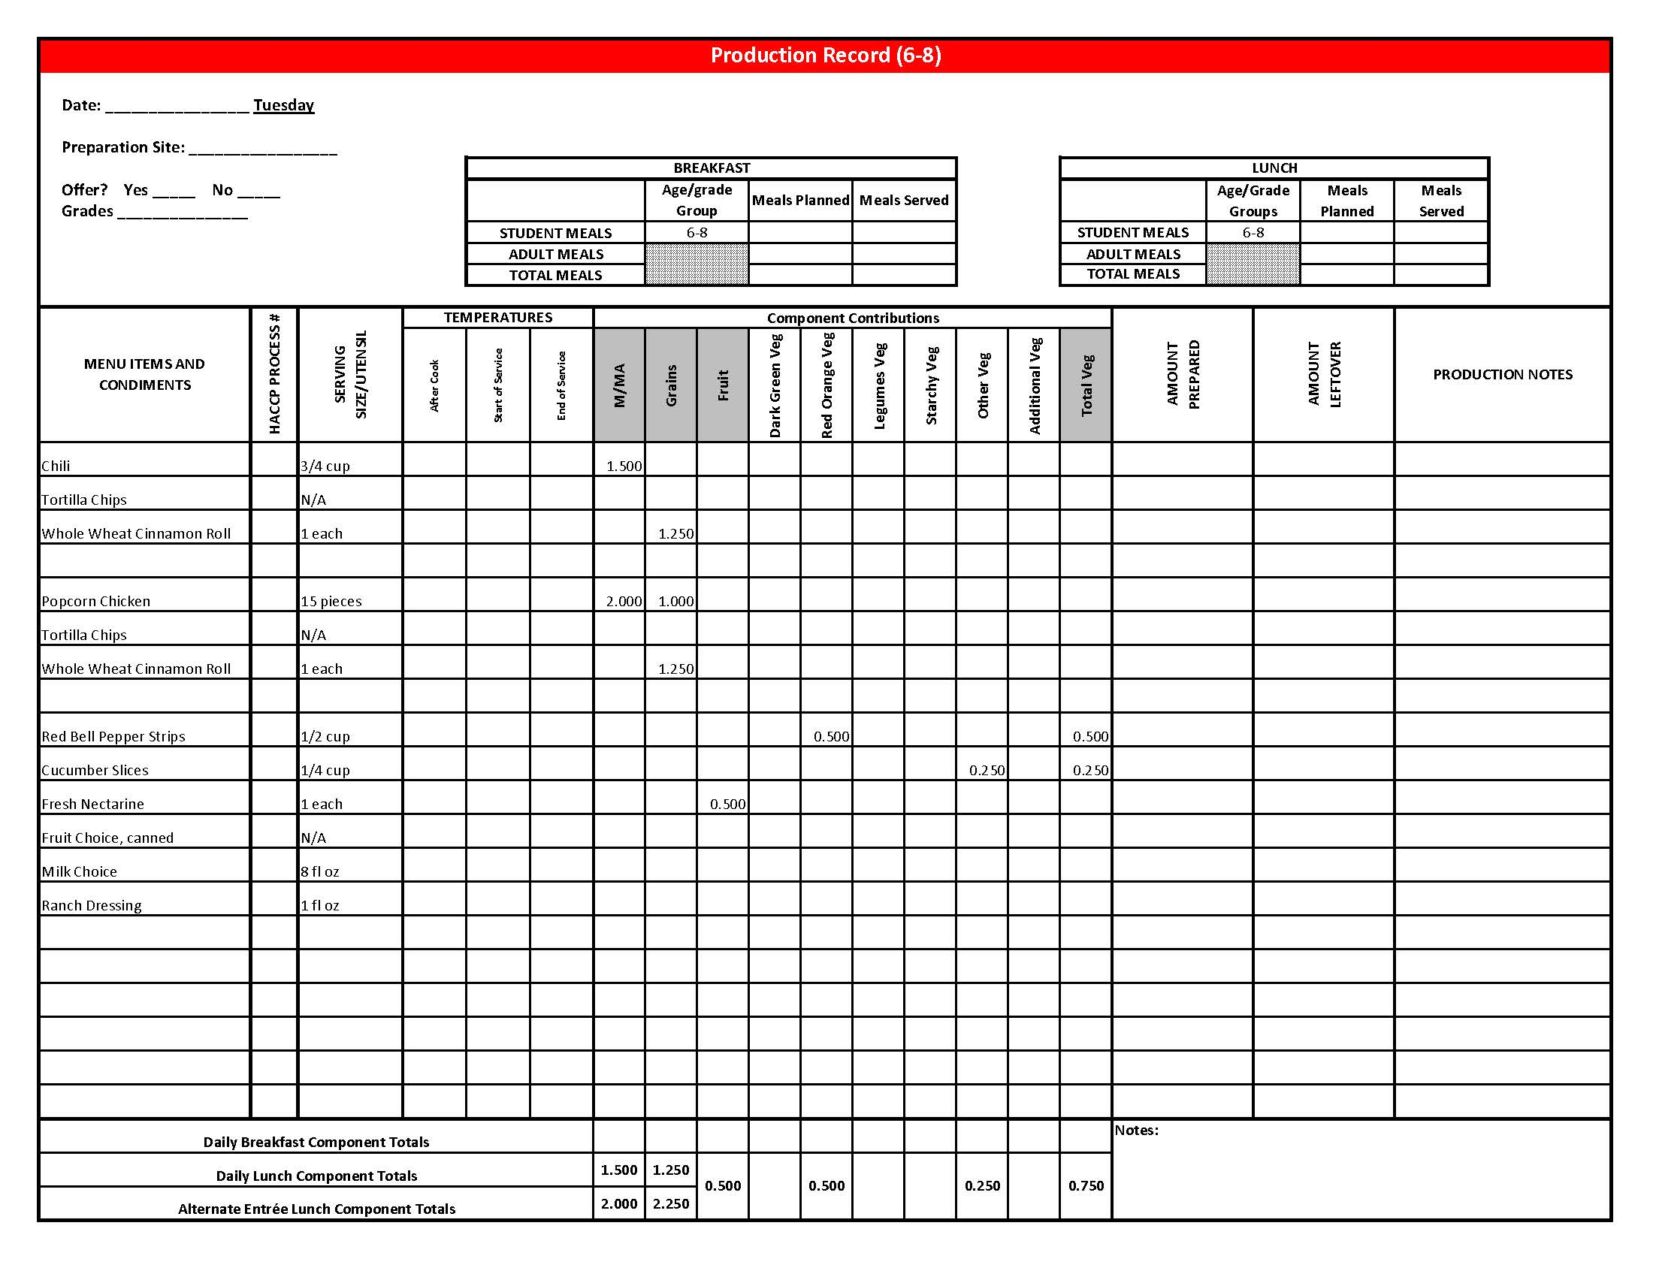

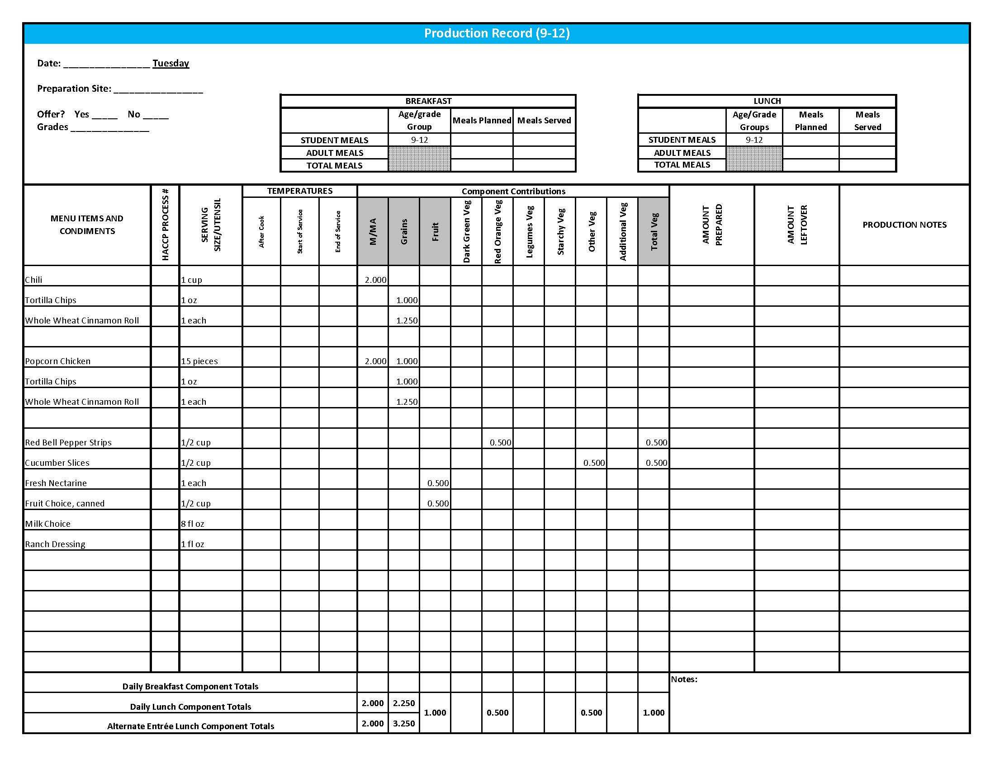

## Purchasing, Preparation & Serving Instructions

Week 4 – Wednesday

|  |  |  |
| --- | --- | --- |
| **Menu Item** | **Purchasing & Preparation** | **Serving** |
| Chicken Nuggets | * Purchase pre-cooked nuggets providing 2 oz equivalent M/MA and 1 oz equivalent Grains; no more than 15 gm of fat; and no more than 450 mg sodium per serving. If product is not Child Nutrition (CN) labeled, obtain a Product Formulation Statement. * Heat in oven according to manufacturer’s instructions. * **CCP: Hold for hot service at 135°F or above.** | K-12: 1 serving  (providing 2 oz M/MA and 1 oz equivalent Grains) |
| Whole Wheat Roll | * Prepare HKM Recipe 877, Whole Wheat Rolls, Bread Sticks and Buns. | K-12: 1 each (1 oz) |
| **Alternate Entrée:**  Rock and Roll Beef Wraps | * Prepare HKM Recipe 133, Rock and Roll Beef Wraps. * Purchase 8” whole grain rich tortillas weighing 1.5 oz each. * **CCP: Hold for hot service at 135°F or above.** | K-12: 1 wrap |
| Mashed Potatoes | * Refer to *Fruit & Vegetable Order Guide* for amount needed. Purchase dehydrated mashed potatoes. * Do not add margarine. Add salt only if the product has less than 50 mg of sodium per ½ cup prepared. Add no more than 2 tablespoons of salt per 70 cups prepared potatoes. * **CCP: Hold for hot service at 135°F or above.** | K-12: ½ cup |
| Tossed Salad | * Prepare HKM Recipe 74, Tossed Salad. * Refer to *Fruit & Vegetable Order Guide* for amount needed. * **CCP: Refrigerate and hold at 41°F or below for cold service.** | K-12: 1 cup |
| Blueberries, Fresh | * Refer to *Fruit & Vegetable Order Guide* for amount needed. * With gloved hands, wash blueberries. * **CCP: Refrigerate and hold at 41⁰ F or below for cold service.** | K-12: ½ cup |

*Continued on next page*

Purchasing, Preparation & Serving Instructions

Week 4 – Wednesday, continued

|  |  |  |
| --- | --- | --- |
| **Menu Item** | **Purchasing & Preparation** | **Serving** |
| Fruit Choice, canned | Select an additional fruit choice to offer on the menu. The serving(s) offered must credit as ½ cup of fruit, to meet the minimum daily requirement, for grades 9-12.  *Note: The fruit choice is encouraged for grades K-5 and 6-8, but not required. The fruit choice is not included in the nutrient analysis for grades K-5 and 6-8. | K-8: N/A*  9-12: ½ cup |
| Milk | * Provide a variety of milk. May be 1% fat (unflavored) or skim (flavored or unflavored). * **CCP: Refrigerate and hold at 41°F or below for cold service.** | K-12: 8 fl oz |
| Gravy | * Purchase a gravy mix with no more than 1 gm of fat per fl oz and prepare according to package directions. * **CCP: Hold for hot service at 135°F or above.** | K-12: 1 fl oz |
| Ranch Dressing, Reduced Fat | * Purchase or prepare Ranch dressing containing no more than 6 gm of fat  per 1 fl oz. Purchase .8 gallons for every 100 1 fl oz portions. * **CCP: Refrigerate and serve at 41°F or below if school-prepared dressing is served.** | K-12: 1 fl oz **or** 2 Tbsp |
| Jelly | * Purchase .5 oz packets or purchase in bulk container. | K-12: ½ oz each  **or**1 Tbsp |

**Pre-preparation for Week 4 - Thursday:** Chill peaches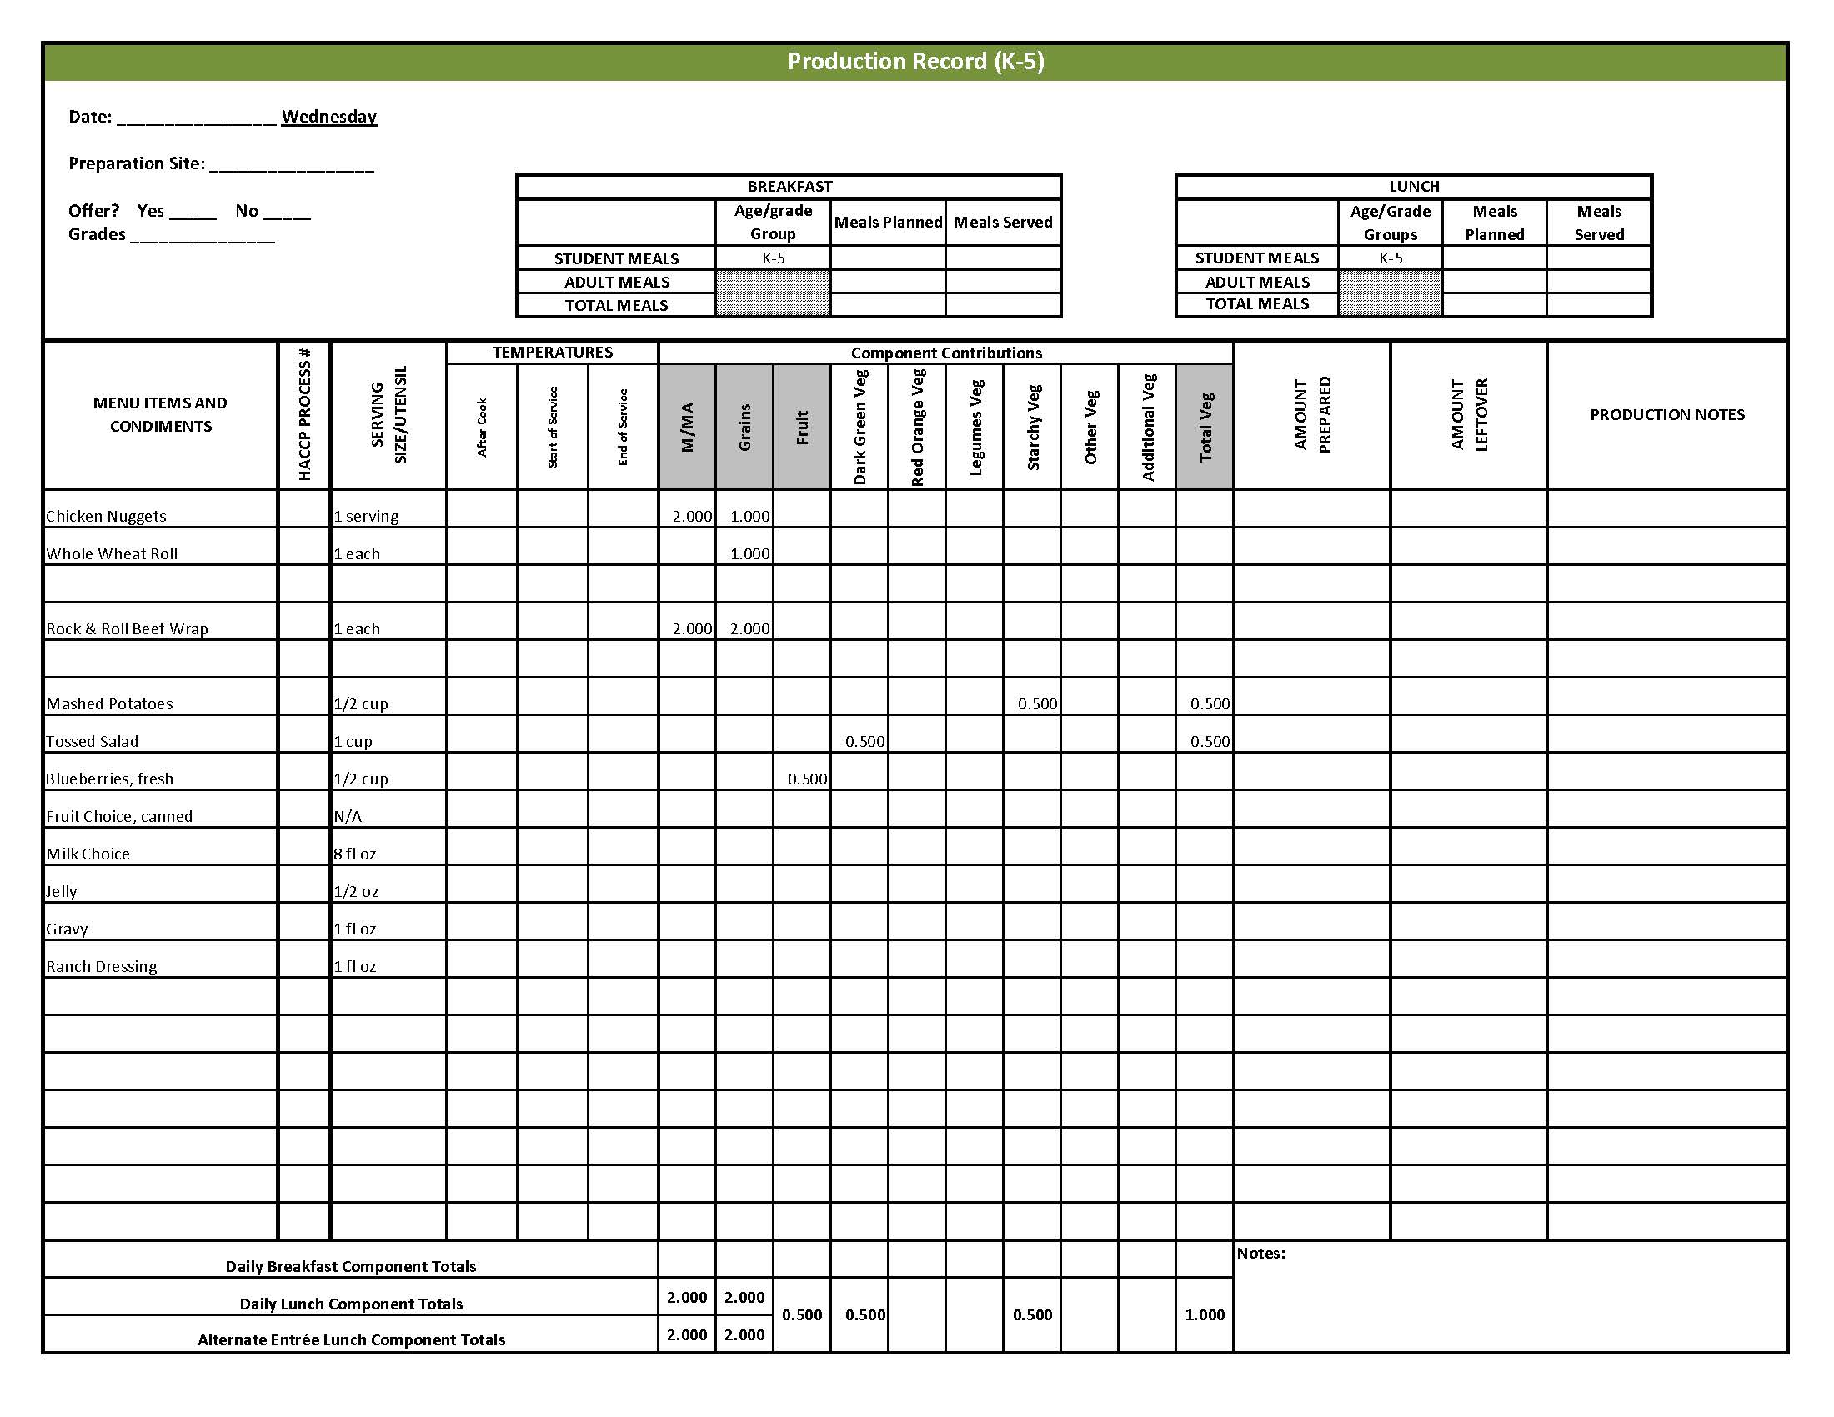

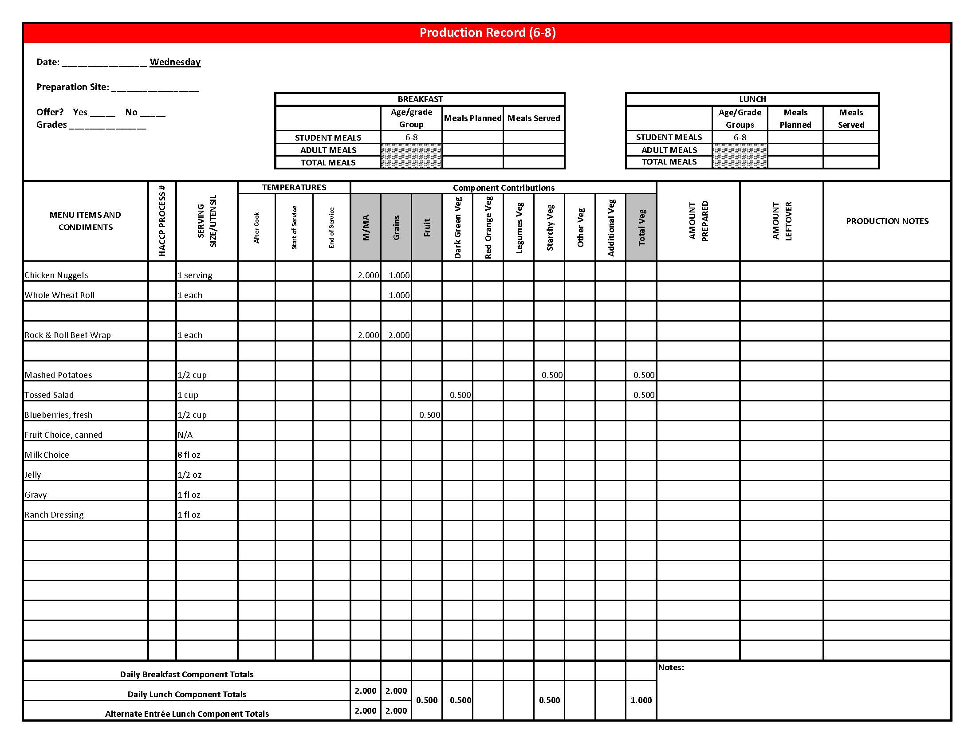

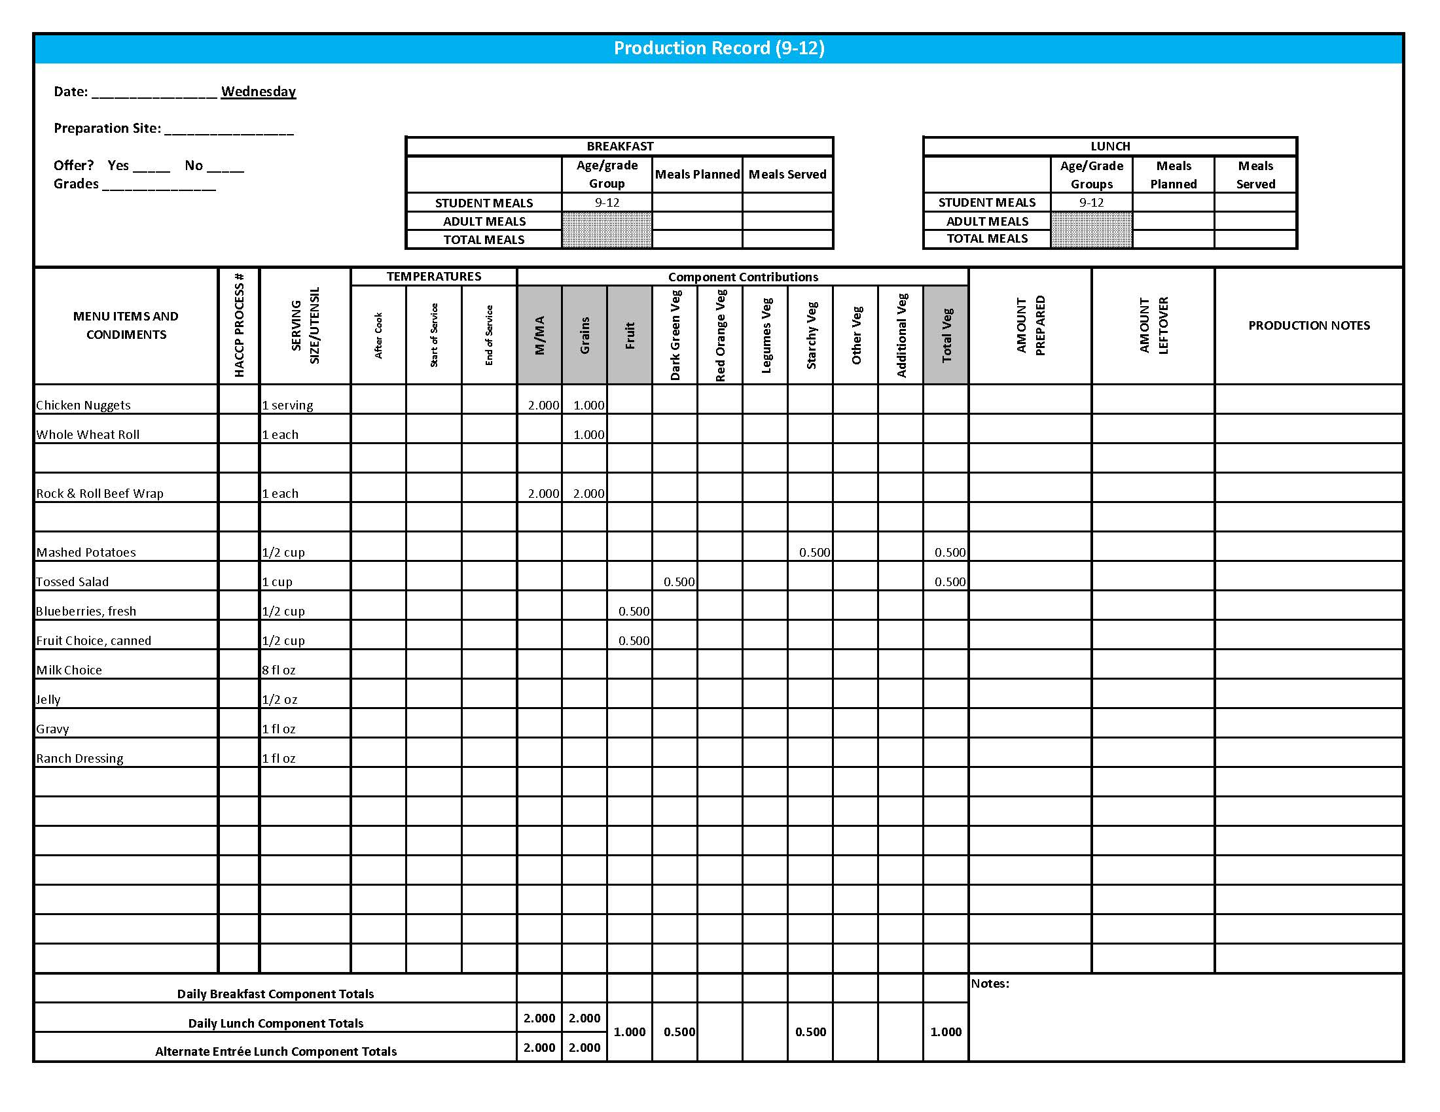

Purchasing, Preparation & Serving Instructions

Week 4 – Thursday

|  |  |  |
| --- | --- | --- |
| **Menu Item** | **Purchasing & Preparation** | **Serving** |
| Baked Ham | * Purchase pre-cooked ham with no more than 650 mg sodium per serving and no more than 3 gm of fat per serving. * Slice prior to heating. Each slice before heating should weigh 2.5 oz. Prepare according to manufacturer’s instructions. * **CCP: Hold for hot service at 135°F or above.** | K-12: 2.5 oz slice |
| Angel Biscuit | * Prepare HKM Recipe 120, Angel Biscuits, Whole Wheat. | K-12: 1 each |
| **Alternate Entrée:**  Grilled Chicken Sandwich | * Purchase pre-cooked, un-breaded chicken patties that provide 2 oz equivalent M/MA, no more than 3.5 gm of fat; and no more than 210 mg sodium per serving. If product is not Child Nutrition (CN) labeled, obtain a Product Formulation Statement. * Prepare according to manufacturer’s instructions. * Purchase a 2 oz whole wheat bun (first ingredient is whole wheat) or prepare following HKM Recipe 877, Whole Wheat Rolls, Bread Sticks, Buns, Hamburger Bun Variation. * **CCP: Hold for hot service at 135°F or above.** | K-12: 1 each |
| Apple Glazed Sweet Potatoes | * Prepare HKM Recipe 122, Apple Glazed Sweet Potatoes. * Refer to *Fruit & Vegetable Order Guide* for amount needed. * **CCP: Hold for hot service at 135°F or above.** | K-8: ¼ cup (2 wedges)  9-12: ½ cup (4 wedges) |
| Green Beans | * Refer to *Fruit & Vegetable Order Guide* for amount needed. * Wipe can tops clean before opening. * Batch cook by steaming or by stock pot with minimal liquid close to serving time. * **CCP: Hold for hot service at 135°F or above.** | K-12: ½ cup |
| Peaches, canned, sliced | * Purchase slices peaches packed in light syrup. Refer to *Fruit & Vegetable Order Guide* for amount needed. * Chill cans overnight. Wipe can tops clean before opening. Drain, cover, and refrigerate until serving. * Serve with slotted utensil. Level utensil when serving. * **CCP: Refrigerate and hold at 41⁰ F or below for cold service.** | K-12: ½ cup |

*Continued on next page*

Purchasing, Preparation & Serving Instructions

Week 4 – Thursday, continued

|  |  |  |
| --- | --- | --- |
| Fruit Choice, fresh | Select an additional fruit choice to offer on the menu.  The serving(s) offered must credit as ½ cup of fruit, to meet the minimum daily requirement, for grades 9-12.  *Note: The fruit choice is encouraged for grades K-5 and 6-8, but not required.  The fruit choice is not included in the nutrient analysis for grades K-5 and 6-8. | K-8: N/A*  9-12: ½ cup |
| Honey Apple Crisp, Whole Wheat | * Prepare Honey Apple Crisp, Whole Wheat HKM Recipe 39. * This menu item will count as a grain based dessert. | K-8: N/A  9-12: 1 piece |
| Milk | * Provide a variety of milk. May be 1% fat (unflavored) or skim (flavored or unflavored). * **CCP: Refrigerate and hold at 41°F or below for cold service.** | K-12: 8 fl oz |
| Ketchup | * Purchase in bulk or individual packets (9-gm or 12-gm). If bulk, purchase 1 #10 can or .8 gallon for every 100 1-fluid oz servings. | K-12: 1 fl oz  **or** 2 Tbsp **or** 2 PC |
| Mustard | * Purchase bulk or packets. If bulk, purchase 2 cups for every 100 1 tsp servings. | K-12: 1 tsp |
| Jelly | * Purchase .5 oz packets or purchase in bulk container. | K-12: ½ oz each **or** 1 Tbsp |

**Pre-preparation for Week 4 - Friday:** N/A

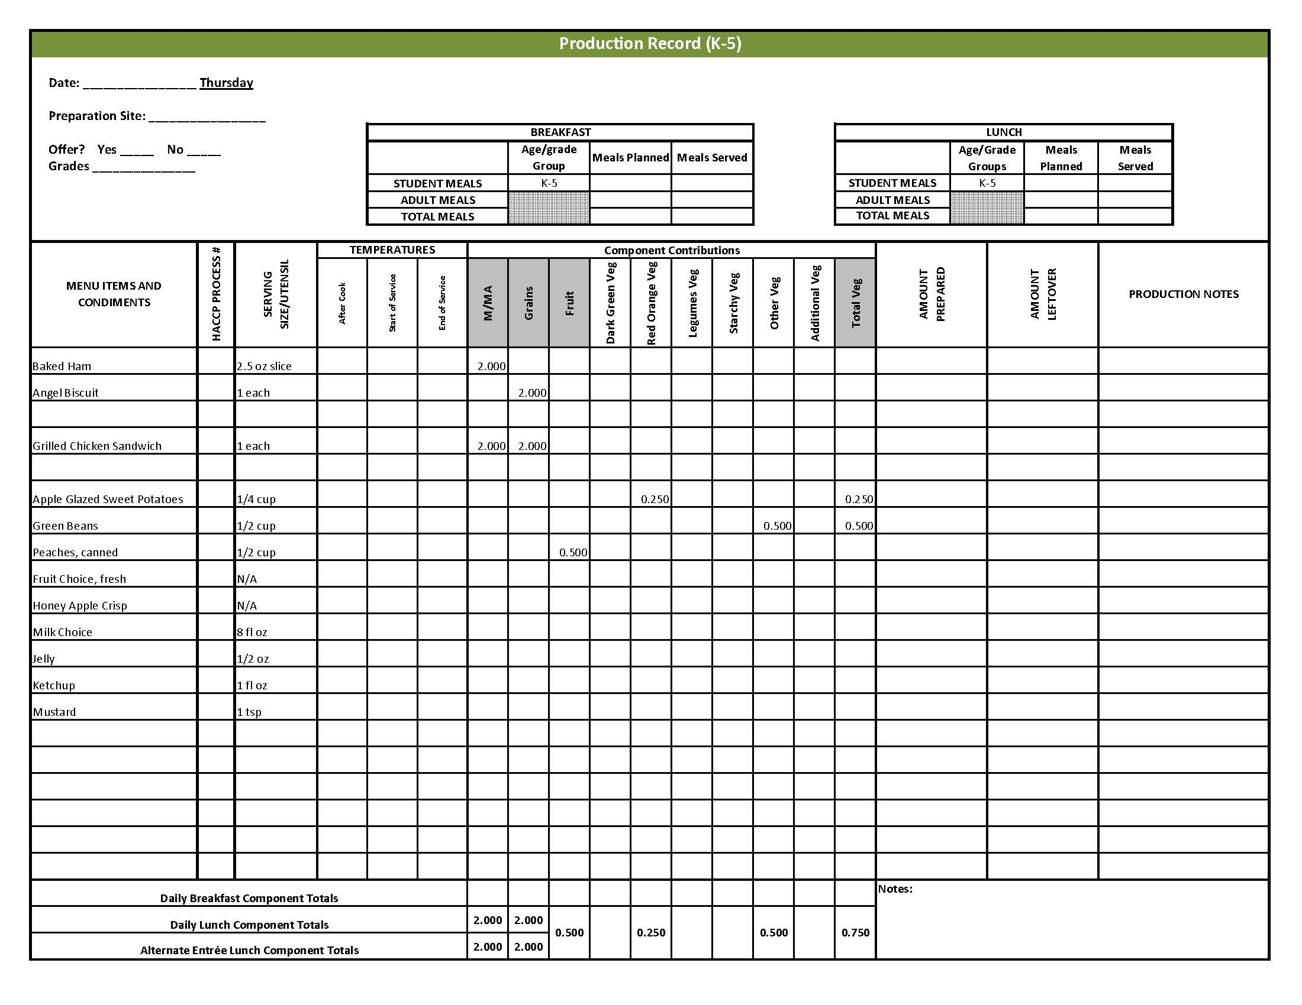

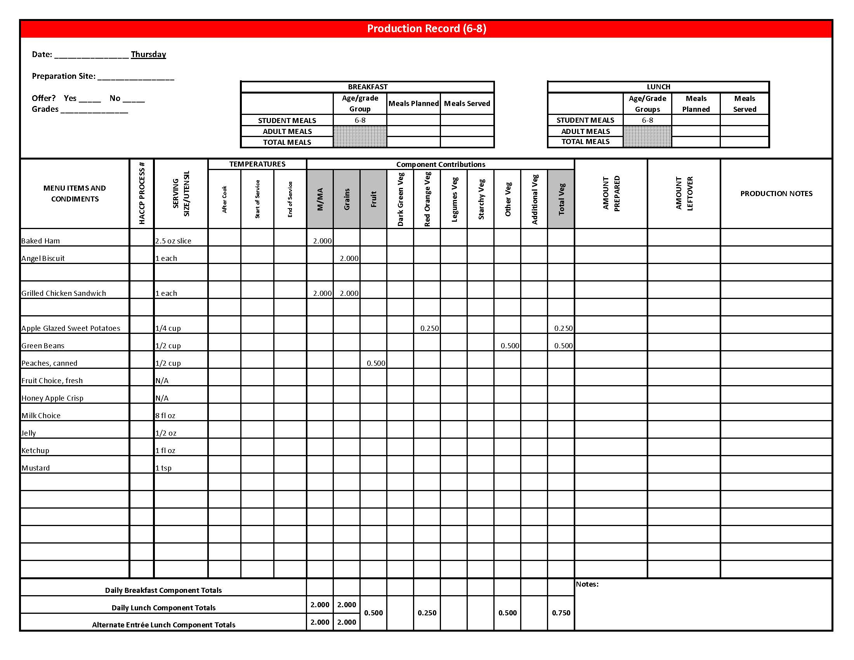

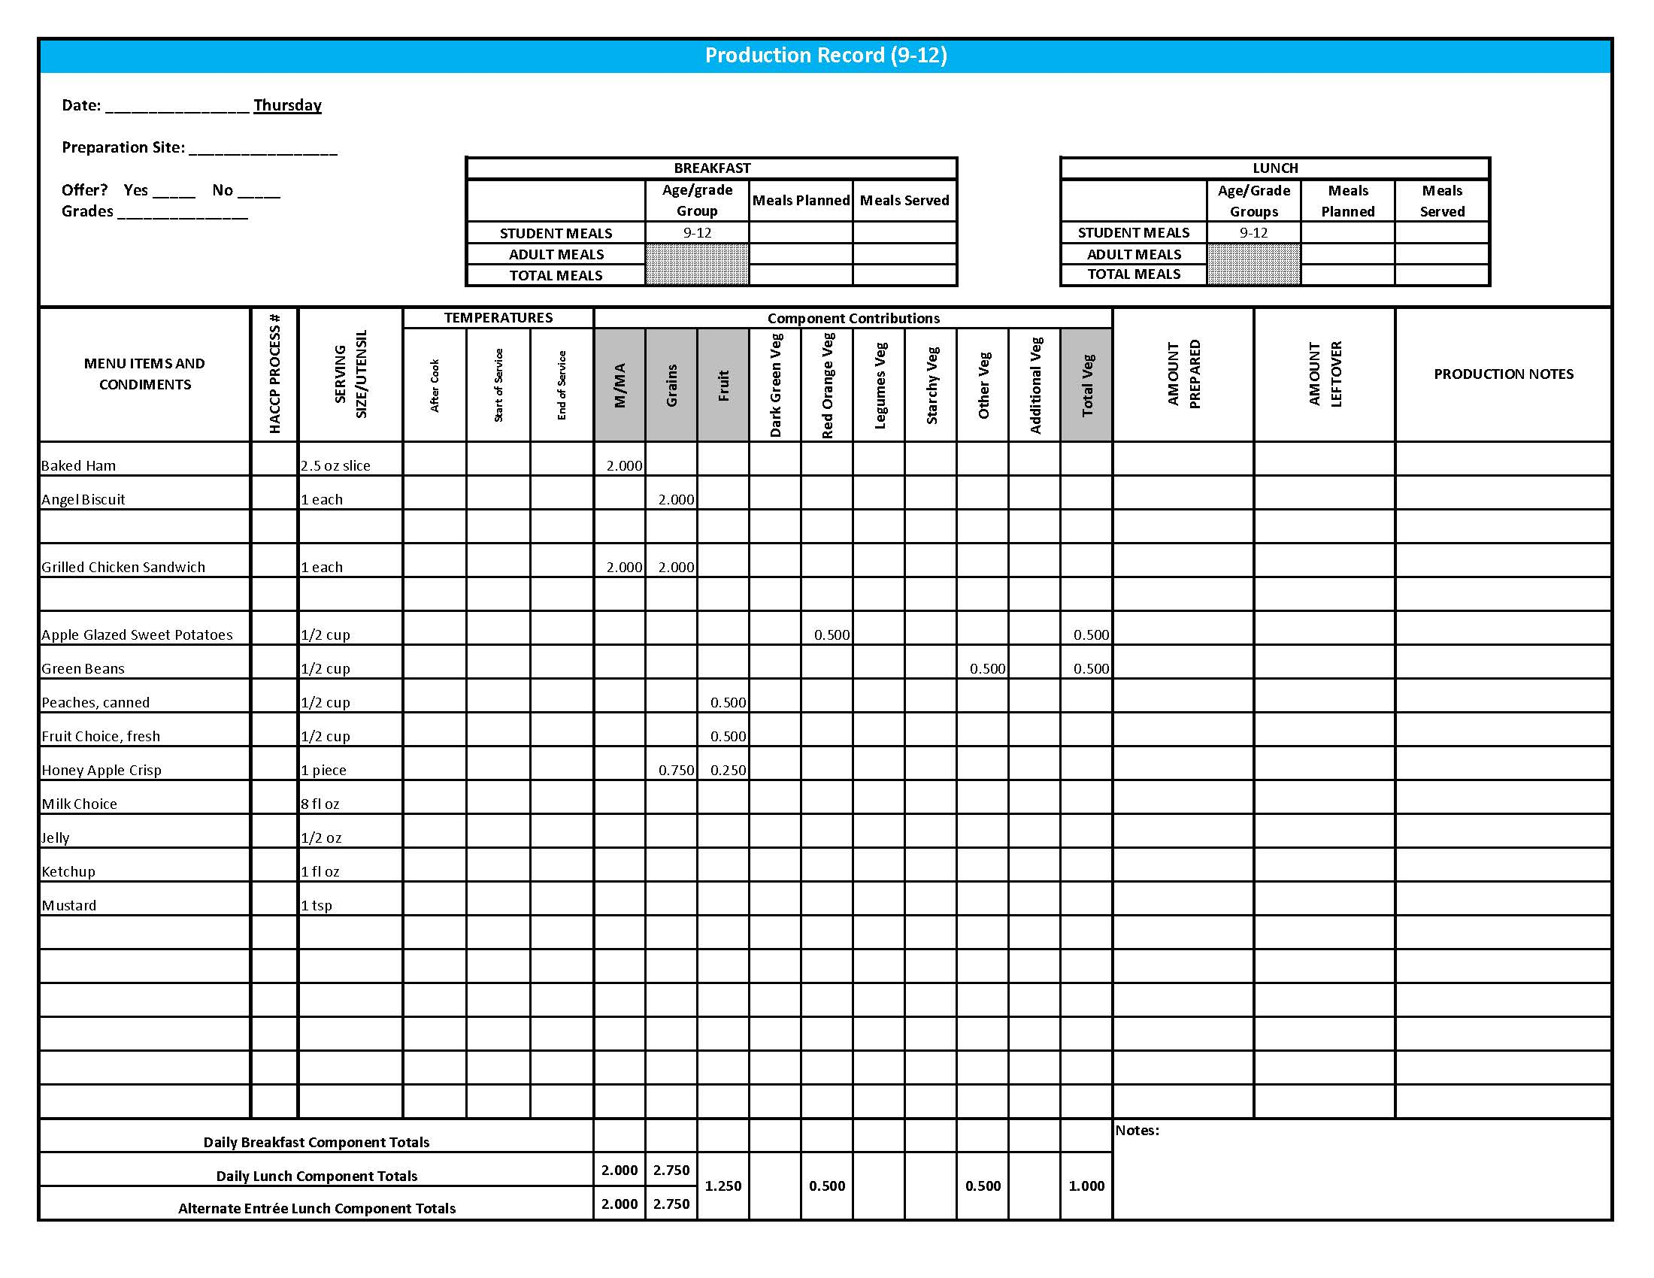

Purchasing, Preparation & Serving Instructions

Week 4 – Friday

|  |  |  |
| --- | --- | --- |
| **Menu Item** | **Purchasing & Preparation** | **Serving** |
| Macaroni & Cheese | * Prepare HKM Recipe 184, Macaroni & Cheese. * **CCP: Hold for hot service at 135°F or above.** | K-12: ½ cup |
| Meatballs, beef | * Purchase pre-cooked beef meatballs that provide 2 oz equivalent M/MA; no more than 10 gm of fat; and no more than 300 mg of sodium per serving. If product is not Child Nutrition (CN) labeled, obtain a Product Formulation Statement. * Heat according to manufacturer’s instructions. * **CCP: Hold for hot service at 135°F or above.** | K-12: 3 each  (or number needed to provide 1 oz equivalent M/MA) |
| Sliced Whole Wheat Bread | * Purchase sliced, whole wheat bread; 1 oz per slice (first ingredient listed is whole wheat flour) or prepare HKM Recipe 107, Whole Wheat Bread. | K-5: N/A  6-12: 1 slice |
| **Alternate Entrée:**  Pepperoni Pizza | * Purchase pre-prepared pepperoni pizza that provides 2 oz equivalent M/MA and 2 oz equivalent Grains; no more than 9 gm of fat; and no more than 600 mg sodium per serving. If product is not Child Nutrition (CN) labeled, obtain a Product Formulation Statement. * Heat in oven according to manufacturer’s instructions. * **CCP: Hold for hot service at 135°F or above.** | K-12: 1 piece |
| Baked Beans | * Prepare HKM Recipe 188, Baked Beans or purchase canned baked beans. * Refer to *Fruit & Vegetable Order Guide* for amount needed. * **CCP: Hold for hot service at 135°F or above.** | K-12: ½ cup |
| Carrots, baby, fresh | * Refer to *Fruit & Vegetable Order Guide* for amount needed. * Handle with gloved hands or serving utensils. Cover and refrigerate until serving. * Weigh or count number needed per portion. * **CCP: Refrigerate and hold at 41°F or below for cold service.** | K-12: ½ cup |

## *Continued on next page*

Purchasing, Preparation & Serving Instructions

Week 4 – Friday, continued

|  |  |  |
| --- | --- | --- |
| **Menu Item** | **Purchasing & Preparation** | **Serving** |
| Strawberries, fresh | * Refer to *Fruit & Vegetable Order Guide* for amount needed. * With gloved hands, wash strawberries. * **CCP: Refrigerate and hold at 41⁰ F or below for cold service** | K-12: ½ cup |
| Fruit Choice, canned | Select an additional fruit choice to offer on the menu.  The serving(s) offered must credit as ½ cup of fruit, to meet the minimum daily requirement, for grades 9-12.  *Note: The fruit choice is encouraged for grades K-5 and 6-8, but not required.  The fruit choice is not included in the nutrient analysis for grades K-5 and 6-8. | K-8: N/A*  9-12: ½ cup |
| Milk | * Provide a variety of milk. May be 1% fat (unflavored) or skim (flavored or unflavored). * **CCP: Refrigerate and hold at 41°F or below for cold service.** | K-12: 8 fl oz |
| Jelly | * Purchase .5 oz packets or purchase in bulk container. If bulk, purchase 6.25 cups per 100 1 Tbsp servings. | K-5: N/A  6-12: ½ oz each **or** 1 Tbsp |
| Ranch Dressing, Reduced Fat | * Purchase or prepare Ranch dressing containing no more than 6 gm of fat  per 1 fl oz. Purchase .8 gallons for every 100 1 fl oz portions. * **CCP: Refrigerate and serve at 41°F or below if school-prepared dressing is served.** | K-12: 1 fl oz **or** 2 Tbsp |

**Pre-preparation for Week 1 - Monday:** None

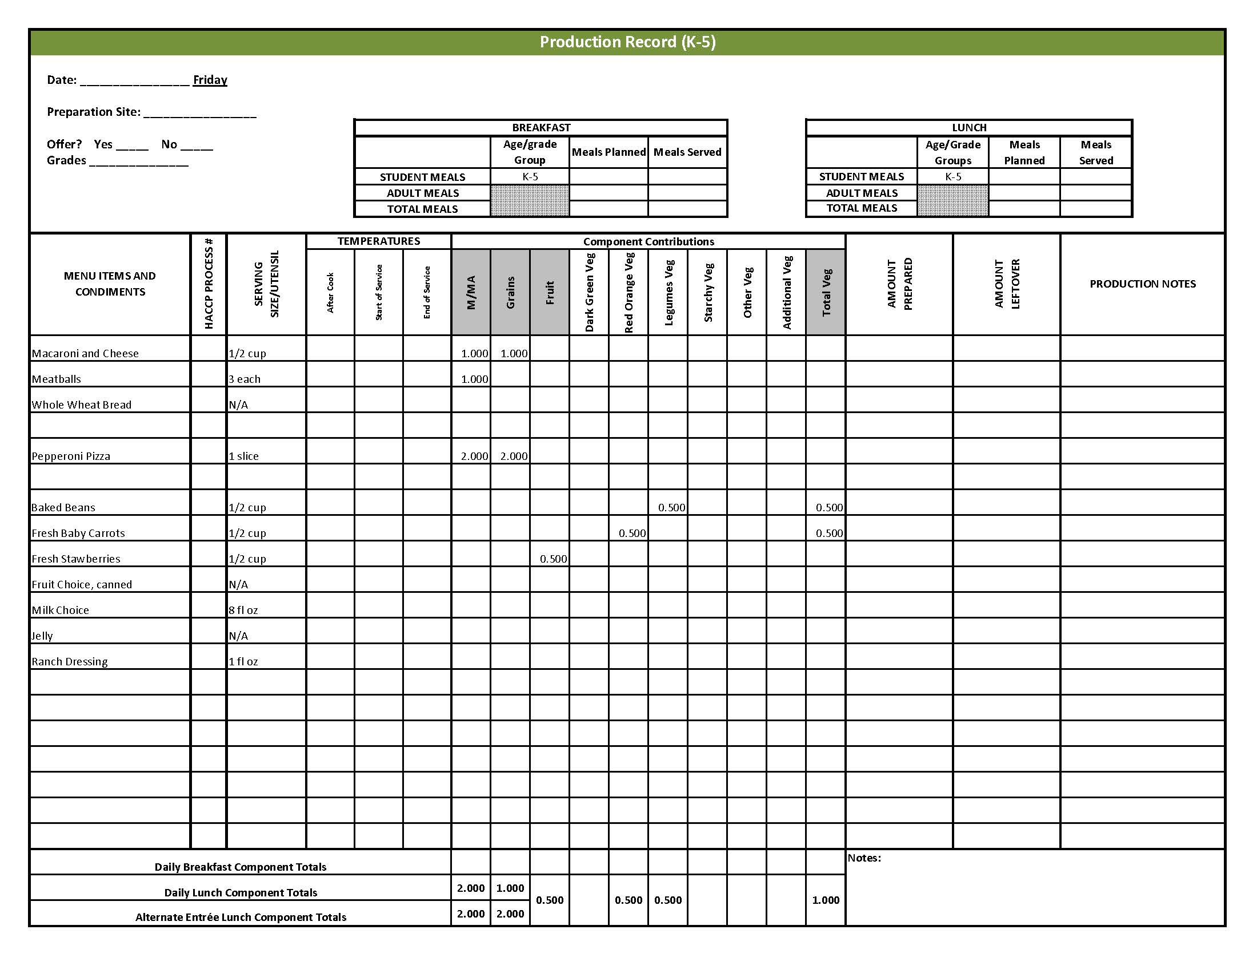

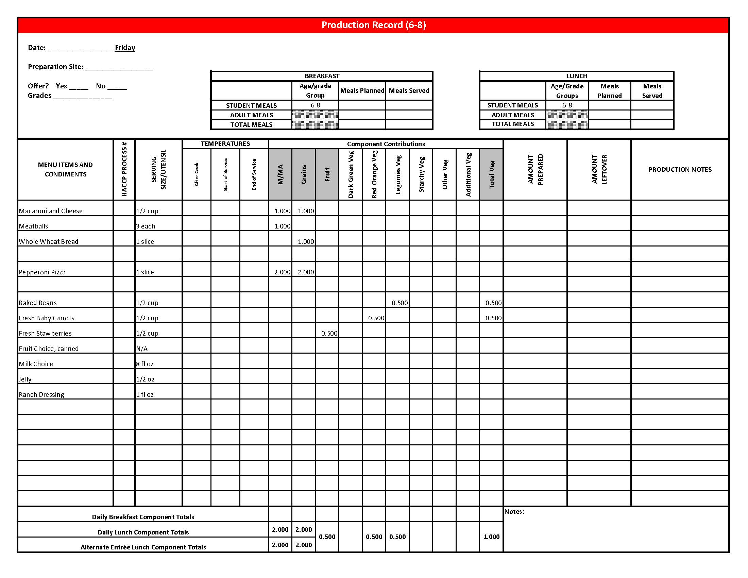

## Fri 9-12 PR

## Fruit & Vegetable Order Guide

## **Week 4**

The chart below provides amounts to be ordered per 100 servings based on the serving sizes listed on Week 1 of *Healthier Kansas Menus Production Records* for students in grades groups K-5, 6-8, and 9-12. Amounts to order are based on standard yields and leveled serving utensils or weighed portions. Use the following procedures to determine the amounts to order:

1. **Forecast** the number of servings needed for each fruit and vegetable menu item for each grade group served.
2. **Divide** the number of servings needed by 100 for each portion size (K-5, 6-8 or 9-12).
3. **Multiply** the “Amount to order per 100 servings” by the factor determined in step 2 above for each portion size.
4. **Add** amounts needed for all serving sizes together to determine the amounts to order.

**Abbreviations Key: EP = Edible Portion AP = As Purchased lb = Pound oz = ounce # = Number**

|  |  |  |  |  |  |  |  |
| --- | --- | --- | --- | --- | --- | --- | --- |
| **Day** | **Fruit or Vegetable** | **K-5**  **Portion Size** | **K-5**  **Amount to Order per 100 Servings** | **6-8**  **Portion Size** | **6-8**  **Amount to Order**  **per 100 Servings** | **9-12 Portion Size** | **9-12 Amount to Order per 100 Servings** |
| Monday | Lettuce, Dark Green Leafy, AP | ½ cup | 9 lb 7 oz | ½ cup | 9 lb 7 oz | ½ cup | 9 lb 7 oz |
| Tomato, large, fresh, AP | 2 - ¼” slices | 11 lb 8 oz | 2 - ¼” slices | 11 lb 8 oz | 2 - ¼” slices | 11 lb 8 oz |
| Potatoes, French Fries, frozen, straight cup | ½ cup | 14 lb 7 oz | ½ cup | 14 lb 7 oz | ½ cup | 14 lb 7 oz |
| Apples, fresh, #125-138, AP | ½ apple | 13 lb 10 oz  or 50 each | ½ apple | 13 lb 10 oz  or 50 each | ½ apple | 13 lb 10 oz  or 50 each |
| Tuesday | Chili | ¾ cup |  | ¾ cup |  | 1 cup |  |
| Tomato Juice |  | 6 lb 8 oz |  | 6 lb 8 oz |  | 8 lb 11 oz |
| Pinto Beans, canned |  | 5.5 #10 cans |  | 5.5 #10 cans |  | 7.33 #10 cans |
| Tomato, canned, Puree | 0.5 #10 can | 0.5 #10 can | 0.66 #10 can |
| Cucumber, fresh, AP | ¼ cup | 8 lb 2 oz | ¼ cup | 8 lb 2 oz | ½ cup | 16 lb 4 oz |
| Peppers, bell, fresh, red | ½ cup | 13 lb 13 oz | ½ cup | 13 lb 13 oz | ½ cup | 13 lb 13 oz |
| Nectarines, fresh | 1 nectarine | 45 lb 10 oz | 1 nectarine | 45 lb 10 oz | 1 nectarine | 45 lb 10 oz |

Fruit & Vegetable Order Guide

**Week 4, continued**

|  |  |  |  |  |  |  |  |
| --- | --- | --- | --- | --- | --- | --- | --- |
| **Day** | **Fruit or Vegetable** | **K-5**  **Portion Size** | **K-5**  **Amount to Order per 100 Servings** | **6-8**  **Portion Size** | **6-8**  **Amount to Order**  **per 100 Servings** | **9-12 Portion Size** | **9-12 Amount to Order per 100 Servings** |
| Wednesday | Potatoes, dehydrated, flakes | ½ cup prepared | 4 lb | ½ cup prepared | 4 lb | ½ cup prepared | 4 lb |
| Tossed Salad | 1 cup |  | 1 cup |  | 1 cup |  |
| Spinach, fresh, trimmed, AP | 7 lb | 7 lb | 7 lb |
| Romaine Lettuce, AP | 7 lb | 7 lb | 7 lb |
| Blueberries, fresh | ½ cup | 23 lb 13 oz | ½ cup | 23 lb 13 oz | ½ cup | 23 lb 13 oz |
| Thursday | Apple Glazed Sweet Potatoes | 2 wedges  (1/4 cup) |  | 2 wedges  (1/4 cup) |  | 4 wedges  (1/2 cup) |  |
| Sweet Potatoes, whole, AP |  | 15 lb 8 oz |  | 15 lb 8 oz |  | 31 lb |
| Juice, Apple, 100% |  | ½ gal |  | ½ gal |  | 1 gal |
| Green Beans, canned | ½ cup | 4.6 #10 cans | ½ cup | 4.6 #10 cans | ½ cup | 4.6 #10 cans |
| Peaches, cling, sliced, canned in 100% juice or light syrup | ½ cup | 5.6 #10 cans | ½ cup | 5.6 #10 cans | ½ cup | 5.6 #10 cans |
| Honey Apple Crisp, Whole Wheat | N/A |  | N/A |  | 1 piece |  |
| Apples, sliced, canned in water |  | N/A |  | N/A |  | 2 #10 cans |
| Friday | Baked Beans | ½ cup |  | ½ cup |  | ½ cup |  |
| Beans, baked, canned, vegetarian |  | 4.25 #10 cans |  | 4.25 #10 cans |  | 4.25 #10 cans |
| Tomato Sauce, canned |  | 6 cups |  | 6 cups |  | 6 cups |
| Carrots, baby, fresh, EP | ½ cup | 15 lb 10 oz | ½ cup | 15 lb 10 oz | ½ cup | 15 lb 10 oz |
| Strawberries, fresh, whole, AP | ½ cup | 19 lb 4 oz | ½ cup | 19 lb 4 oz | ½ cup | 19 lb 4 oz |