Healthier Kansas Menus

with Alternate Entrées

# C:\Documents and Settings\jmackey\My Documents\My Pictures\Microsoft Clip Organizer\j0349505.wmf

FALL WEEK 3 – DAILY PRODUCTION RECORDS

Child Nutrition & Wellness, Kansas State Department of Education

Revised July 2019

This publication has been funded at least in part with Federal funds from the U.S. Department of Agriculture, Food and Nutrition Service. The contents of this publication do not necessarily reflect the views or policies of the Department, nor does mention of trade names, commercial products, or organizations imply endorsement by the U.S. Government.

**For further information about this publication, please contact:** Child Nutrition & Wellness, KSDE, Landon State Office Building, 900 SW Jackson Street, Suite #251, Avenue, Topeka, Kansas 66612, 785-296-2276, Fax: 785-296-0232,

[www.kn-eat.org](http://www.kn-eat.org/)

In accordance with Federal civil rights law and U.S. Department of Agriculture (USDA) civil rights regulations and policies, the USDA, its Agencies, offices, and employees, and institutions participating in or administering USDA programs are prohibited from discriminating based on race, color, national origin, sex, disability, age, or reprisal or retaliation for prior civil rights activity in any program or activity conducted or funded by USDA.  
  
Persons with disabilities who require alternative means of communication for program information (e.g. Braille, large print, audiotape, American Sign Language, etc.), should contact the Agency (State or local) where they applied for benefits. Individuals who are deaf, hard of hearing or have speech disabilities may contact USDA through the Federal Relay Service at (800) 877-8339. Additionally, program information may be made available in languages other than English.  
  
To file a program complaint of discrimination, complete the [USDA Program Discrimination Complaint Form](http://www.ocio.usda.gov/sites/default/files/docs/2012/Complain_combined_6_8_12.pdf), (AD-3027) found online at: [http://www.ascr.usda.gov/complaint_filing_cust.html](https://www.ascr.usda.gov/filing-discrimination-complaint-usda-customer), and at any USDA office, or write a letter addressed to USDA and provide in the letter all of the information requested in the form. To request a copy of the complaint form, call (866) 632-9992. Submit your completed form or letter to USDA by:  
  
(1)   Mail: U.S. Department of Agriculture  
Office of the Assistant Secretary for Civil Rights  
1400 Independence Avenue, SW  
Washington, D.C. 20250-9410;  
  
(2)   Fax: (202) 690-7442; or  
  
(3)   Email: [program.intake@usda.gov](mailto:program.intake@usda.gov).  
  
This institution is an equal opportunity provider.

The following person has been designated to handle inquiries regarding the non-discrimination policies at the Kansas State Department of Education: Office of General Counsel, Landon State Office Building, 900 SW Jackson St, Suite #102, Topeka, KS 66612, (785)296-3201.

Healthier Kansas Menus recipes were developed by Child Nutrition & Wellness, Kansas State Department of Education or adapted from the following sources:

* *Food for Fifty,* Ninth Edition (1989) Grace Shugart, Mary Molt*.*
* *Healthier Kansas Menus – Breakfast,* Child Nutrition & Wellness, Kansas State Department of Education
* *Iowa Gold Star Cycle Menus*, Iowa Department of Education
* *Menus that Move,* Ohio Department of Education.
* *Fruit and Veggie Quantity Cookbook,* New Hampshire Department of Health and Human Services.
* *Preparing Whole Grain Foods,* Child Nutrition & Wellness, Kansas State Department of Education
* *Singing the Praises of Beans & Legumes*, Child Nutrition & Wellness, Kansas State Department of Education
* *USDA Recipes for Schools,* U.S. Department of Agriculture, Food & Nutrition Service, Child Nutrition Programs, 2006.
* USD 225 Fowler
* USD 234 Fort Scott
* USD 267 Renwick
* USD 306 Southeast of Saline
* USD 308 Hutchinson
* USD 320 Wamego
* USD 349 Stafford
* USD 364 Marysville
* USD 503 Parsons
* USD 512 Shawnee Mission

Thank you to the following schools for assisting with menu development and recipe testing:

* Logan Elementary School – USD 345 Seaman
* St. Joseph Catholic School – Mt. Hope, KS
* Winfield Scott Elementary School – USD 234 Fort Scott

## Menus for the Week

**PLEASE NOTE:**

Milk choice includes a variety of non-fat or 1% (flavored or unflavored) milk. One milk choice must be unflavored.

Reduced fat dressing is served with salads and fresh vegetables.

Menus were planned using all whole grain-rich products. Beginning July 1, 2019, at least half of the weekly grains in the school lunch menu and the school breakfast menu must be whole grain-rich.

|  |  |  |  |  |  |  |  |  |
| --- | --- | --- | --- | --- | --- | --- | --- | --- |
| **MONDAY** | **TUESDAY** | **WEDNESDAY** | **THURSDAY** | **FRIDAY** | **Weekly Nutrient Averages** | | | |
|  | K-5 | 6-8 | 9-12 |
| Pork Rib on a Bun  **Or**  Peanut Butter & Jelly Sandwich  Dark Green Leaf Lettuce  & Tomato Slice  Sweet Potato Puffs  Fresh Cantaloupe  Canned Fruit Choice  Milk Choice | Taco Soup  & Tortilla Chips  **Or**  Chicken Crispito  & Tortilla Chips  Tomato Salsa  Refried Beans  Sliced Pears  Fresh Fruit Choice  Milk Choice | Corn Dog  **Or**  Hamburger on a Bun  Green Beans  Tater Tots  Honeydew Melon  Snickerdoodle  Canned Fruit Choice  Milk Choice | Chicken Quesadilla  **Tortilla Chips (9-12)**  **Or**  Yogurt & Blueberry Oat Muffin Plate  **Tortilla Chips (9-12)**  **Black Bean & Corn Salsa (9-12)**  Broccoli Florets  Fresh Baby Carrots  Apple Salad  Canned Fruit Choice  Milk Choice | Cowboy Cavatini  Whole Wheat Roll  **Or**  Turkey & Cheese Sub Sandwich  Seasoned Corn  Garden Salad  Fresh Grapes  Canned Fruit Choice  Milk Choice | **Calories**  **Sodium (mg)**  **% of Total Calories from Sat. Fat** | **655**  **856**  **7.7%** | **661**  **858**  **7.5%** | **823**  **922**  **6.9%** |

C:\Documents and Settings\jmackey\My Documents\My Pictures\Microsoft Clip Organizer\j0349505.wmf

## Recipes for the Week

|  |  |  |  |
| --- | --- | --- | --- |
| Day | Recipe Name | Recipe Number | HKM Recipe  Page Number |
| Monday | Whole Wheat Bun | 877 | 91 |
| Tuesday | Taco Soup  Tomato Salsa | 20  129 | 41  61 |
| Wednesday | Snickerdoodle | 19 | 81 |
| Thursday | Chicken Quesadilla  Black Bean & Corn Salsa (9-12 only)  Blueberry Oat Muffin | 29  81  28 | 13  51  64 |
| Friday | Cowboy Cavatini  Turkey & Cheese Sub  Whole Wheat Roll  Garden Salad | 32  144  877  164 | 19  42  91  55 |

## Abbreviations

|  |  |  |  |
| --- | --- | --- | --- |
| **Abbreviation** | **What it Means** | **Abbreviation** | **What it Means** |
| HKM | Healthier Kansas Menus | Tbsp | tablespoon |
| EP | edible portion | tsp | teaspoon |
| AP | as purchased | CCP | Critical Control Point |
| fl | fluid | PC | portion controlled * |
| oz | ounce | w/ | with |
| lb | pound | M/MA | meat/meat alternate |
| gm | gram |  |  |
| mg | milligram |  |  |

* For example, purchase pre-portioned servings of condiments.

## Portion Guide

|  |  |
| --- | --- |
| **Ladles & Spoodles** | **Scoops** |
| 1 fl oz = 2 Tbsp | #50 = 3 3/4 tsp |
| 2 fl oz = 1/4 cup | #40 = 1 2/3 Tbsp |
| 3 fl oz = 3/8 cup | #30 = 2 Tbsp |
| 4 fl oz = 1/2 cup | #20 = 3 1/3 Tbsp |
| 6 fl oz = 3/4 cup | #16 = 1/4 cup |
| 8 fl oz = 1 cup | #12 = 1/3 cup |
|  | #8 = 1/2 cup |
|  | #6 = 2/3 cup |

## Purchasing, Preparation & Serving Instructions

Week 3 – Monday

|  |  |  |
| --- | --- | --- |
| **Menu Item** | **Purchasing & Preparation** | **Serving** |
| Pork Rib on a Bun | * Purchase a pre-cooked rib patty that provides 2 oz equivalent M/MA; no more than 10 gm of fat; and no more than 400 mg of sodium per serving. If product is not Child Nutrition (CN) labeled, obtain a Product Formulation Statement. * Heat according to manufacturer’s instructions. * Purchase a 2 oz whole wheat bun (first ingredient is whole wheat) or prepare HKM Recipe 877, Whole Wheat Rolls, Bread Sticks, Buns, hamburger bun variation. * **CCP: Hold for hot service at 135°F or above.** | K-12: 1 sandwich |
| **Alternate Entrée:**  Peanut Butter & Jelly Sandwich Meal  (K-5) | * Purchase or prepare Peanut Butter & Jelly sandwich providing 1 oz equivalent M/MA and 1 oz equivalent Grain, no more than 17 gm of fat; and no more than 320 mg sodium per serving. If product is not Child Nutrition (CN) labeled, obtain a Product Formulation Statement. * Purchase whole grain-rich crackers and cheese sticks weighing 1 oz each. * **CCP: Refrigerate and hold at 41⁰ F or below for cold service.** | K-5: 1 sandwich,  1 oz crackers, 1 oz cheese |
| **Alternate Entrée:**  Peanut Butter & Jelly Sandwich  (6-12) | * Purchase or prepare Peanut Butter & Jelly sandwich providing 2 oz equivalent M/MA and 2 oz equivalent Grains, no more than 33 gm of fat; and no more than 620 mg sodium per serving. If product is not Child Nutrition (CN) labeled, obtain a Product Formulation Statement. * **CCP: Refrigerate and hold at 41⁰ F or below for cold service.** | 6-12: 1 sandwich  (or may choose to follow K-5 Peanut Butter & Jelly Sandwich Meal) |
| Dark Green Leaf Lettuce | * Refer to *Fruit & Vegetable Order Guide* for amount needed. * Handle produce with gloved hands. May be pre-portioned. * **CCP: Refrigerate and hold at 41⁰ F or below for cold service.** | K-12: ½ cup |
| Tomato Slice | * Refer to *Fruit & Vegetable Order Guide* for amount needed. * Handle produce with gloved hands. * Slice ¼” thick. * **CCP: Refrigerate and hold at 41⁰ F or below for cold service.** | K-8: 1 slice  9-12: 2 slices |
| Sweet Potato Puffs | * Purchase ovenable sweet potato puffs. * Refer to *Fruit & Vegetable Order Guide* for amount needed. Heat in oven according to manufacturer’s instructions. * **CCP: Hold for hot service at 135°F or above.** | K-12: ½ cup |

*Continued on next page*

## Purchasing, Preparation & Serving Instructions

**Week 3 – Monday, continued**

|  |  |  |
| --- | --- | --- |
| **Menu Item** | **Purchasing & Preparation** | **Serving** |
| Cantaloupe, Fresh | * Refer to *Fruit & Vegetable Order Guide* for amount needed. * With gloved hands, wash outside of rind well to remove any surface dirt. Remove rind and inside seeds. * **CCP: Refrigerate and hold at 41⁰ F or below for cold service.** | K-12: ½ cup |
| Fruit Choice, canned | Select an additional fruit choice to offer on the menu. The serving(s) offered must credit as ½ cup of fruit, to meet the minimum daily requirement, for grades 9-12.  *Note: The fruit choice is encouraged for grades K-5 and 6-8, but not required. The fruit choice is not included in the nutrient analysis for grades K-5 and 6-8. | K-8: N/A*  9-12: ½ cup |
| Milk | * Provide a variety of milk. May be 1% fat (unflavored) or skim (flavored or unflavored). * **CCP: Refrigerate and hold at 41⁰ F or below for cold service.** | K-12: 8 fl oz |
| Ketchup | * Purchase in bulk or individual packets (9-gm or 12-gm). If bulk, purchase 1 #10 can or .8 gallon for every 100 1-fluid oz servings. | K-12: 1 fl oz **or** 2 Tbsp **or** 2 PC |

**Pre-preparation for Week 3 – Tuesday:** Prepare Tomato Salsa. Thaw ground beef under refrigeration.

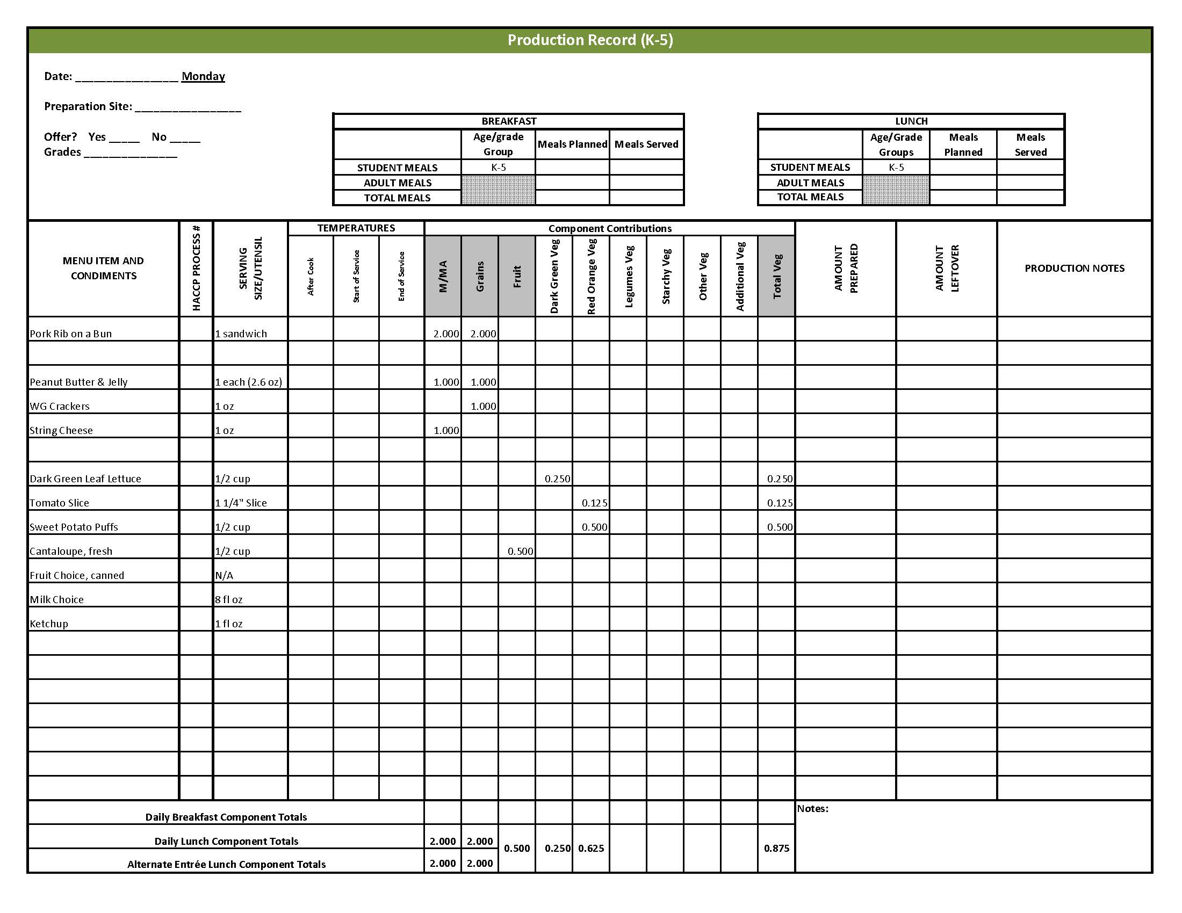

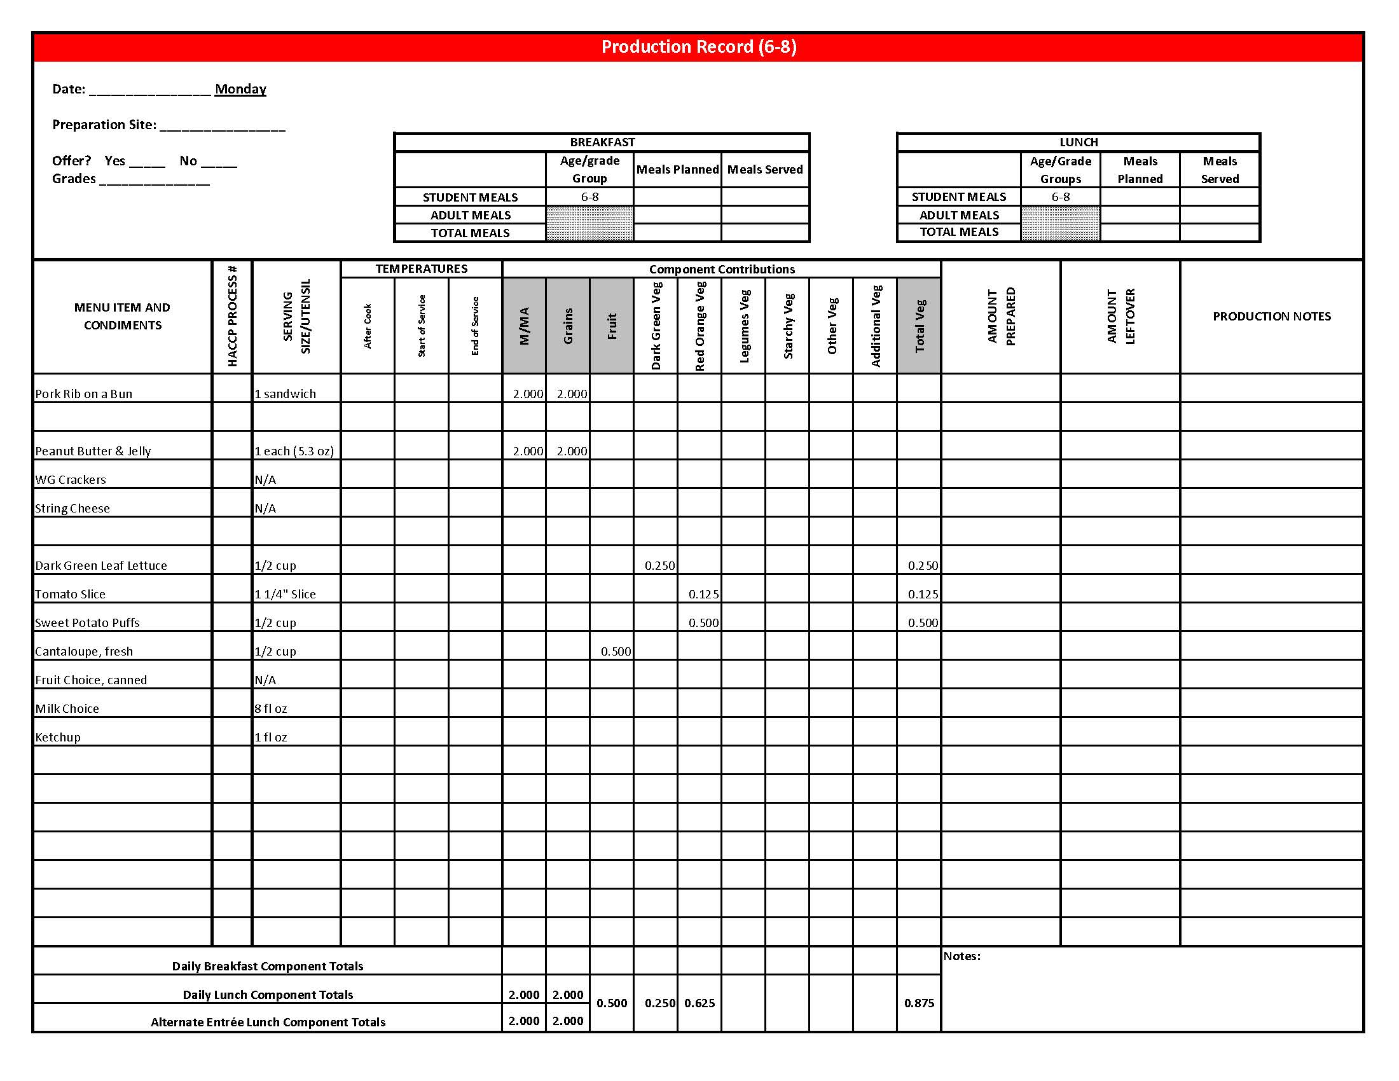

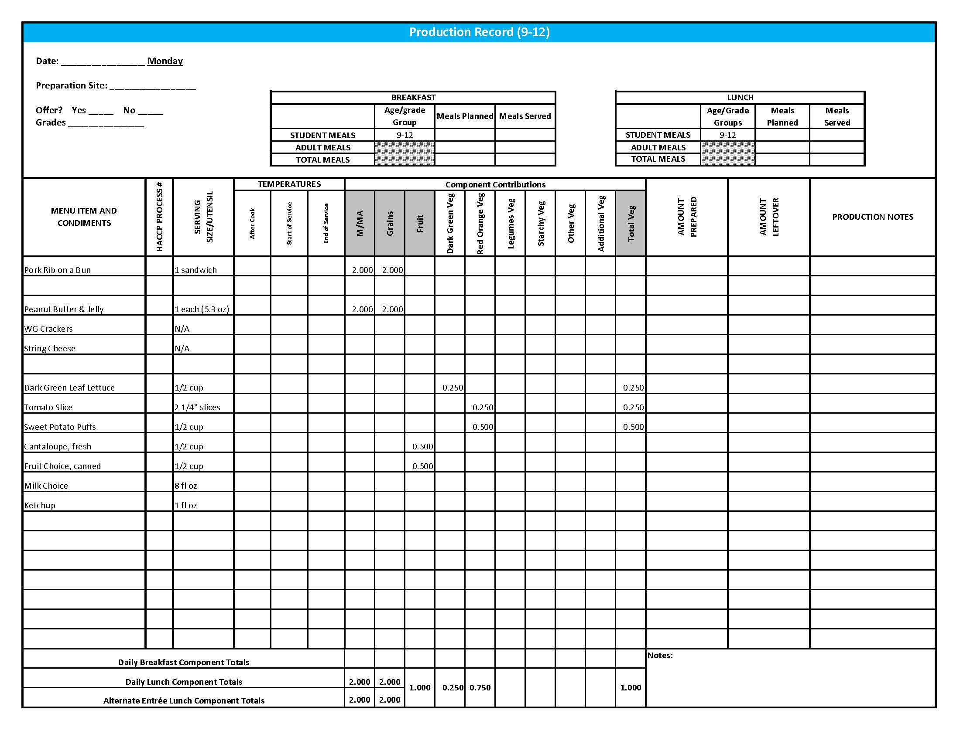

# Purchasing, Preparation & Serving Instructions

Week 3 – Tuesday

|  |  |  |
| --- | --- | --- |
| **Menu Item** | **Purchasing & Preparation** | **Serving** |
| Taco Soup | * Prepare HKM Recipe 20, Taco Soup. * Purchase 80/20 ground beef. * **CCP: Hold for hot service at 135°F or above.** | K-12: 1 cup |
| **Alternate Entrée:**  Crispito, chicken chili | * Purchase Crispito providing 1 oz equivalent M/MA and 1 oz equivalent Grain, no more than 14 gm of fat; and no more than 370 mg sodium per piece. If product is not Child Nutrition (CN) labeled, obtain a Product Formulation Statement. * Heat according to manufacturer’s instructions. * **CCP: Hold for hot service at 135°F or above.** | K-8: 1 each  9-12: 2 each |
| Tortilla Chips | * Purchase whole grain tortilla chips with no more than 50 mg sodium per oz. (Restaurant style usually has less sodium). * May be pre-portioned. Weigh a sample. Serve with gloved hands or tongs. | K-8: 1 oz  9-12: 2 oz |
| Tomato Salsa | * Purchase salsa that is low in sodium or prepare HKM Recipe 129, Tomato Salsa. * Refer to *Fruit & Vegetable Order Guide* for amount needed. * May be served, self-serve or pre-portioned for service. * **CCP: Refrigerate and hold at 41⁰ F or below for cold service.** | K-8: ¼ cup  9-12: ½ cup |
| Refried Beans | * Refer to *Fruit & Vegetable Order Guide* for amount needed. Purchase canned or dried refried beans with no more than 600 mg of sodium per ½ cup prepared. * For dried beans, prepare according to manufacturer directions. * For canned beans, wipe top of cans before opening. * **CCP: Hold for hot service at 135°F or above.** | K-12: ½ cup |
| Pears, canned, sliced | * Refer to *Fruit & Vegetable Order Guide* for amount needed. Purchase sliced pears packed in light syrup or juice. * Chill cans overnight. Wipe tops clean before opening. Drain, cover, and refrigerate until servings. * Serve with slotted utensil. Level utensil when serving. * **CCP: Refrigerate and hold at 41⁰ F or below for cold service.** | K-12: ½ cup |

*Continued on next page*

## Purchasing, Preparation & Serving Instructions

Week 3 – Tuesday, continued

|  |  |  |
| --- | --- | --- |
| **Menu Item** | **Purchasing & Preparation** | **Serving** |
| Fruit Choice, fresh | Select an additional fruit choice to offer on the menu. The serving(s) offered must credit as ½ cup of fruit, to meet the minimum daily requirement, for grades 9-12.  *Note: The fruit choice is encouraged for grades K-5 and 6-8, but not required. The fruit choice is not included in the nutrient analysis for grades K-5 and 6-8. | K-8: N/A*  9-12: ½ cup |
| Milk | * Provide a variety of milk. May be 1% fat (unflavored) or skim (flavored or unflavored). * **CCP: Refrigerate and hold at 41⁰ F or below for cold service.** | K-12: 8 fl oz |

**Pre-preparation for Week 3 - Wednesday:** Cut and chill honeydew melon.

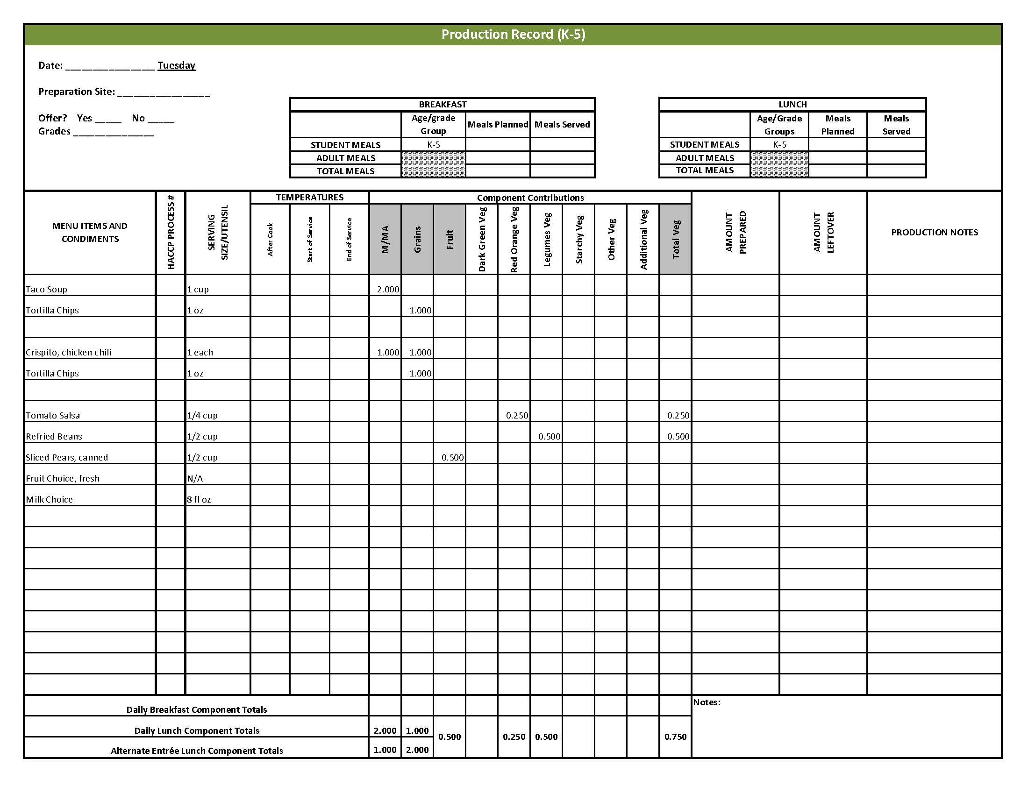

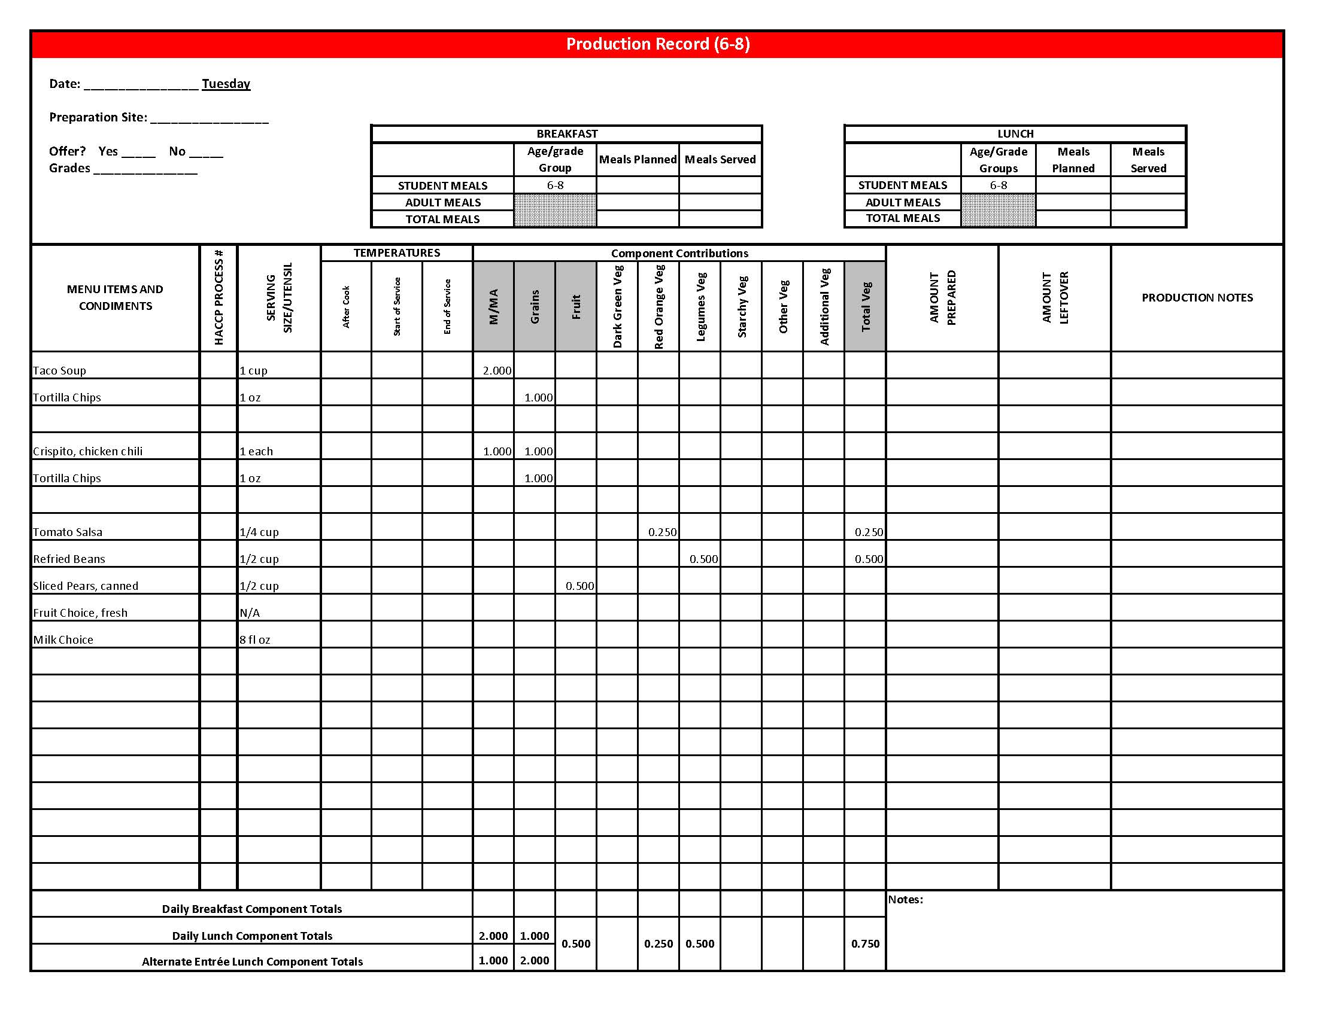

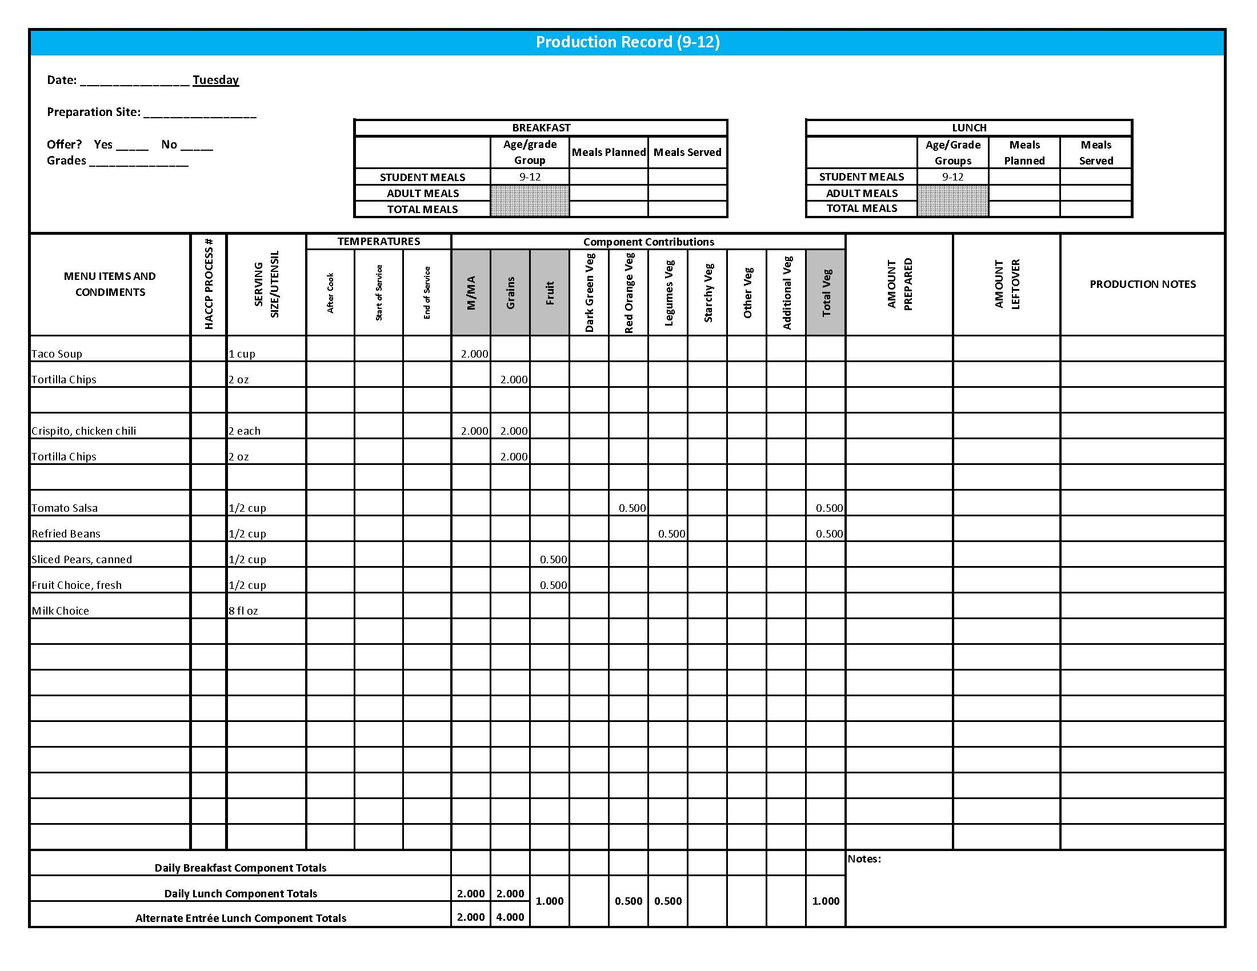

## Purchasing, Preparation & Serving Instructions

Week 3 – Wednesday

|  |  |  |  |
| --- | --- | --- | --- |
| **Menu Item** | **Purchasing & Preparation** | **Serving** | |
| Corn Dog | | * Purchase a whole grain-rich, pre-cooked product that provides 2 oz equivalent M/MA and 2 oz equivalent Grains; no more than 8 gm of fat; and no more than 600 mg of sodium per serving. If product is not Child Nutrition (CN) labeled, obtain a Product Formulation Statement. * Heat according to manufacturer’s instructions. * **CCP: Hold for hot service at 135°F or above.** | K-12: 1 each |
| **Alternate Entrée:**  Hamburger on a Bun | | * Purchase pre-cooked, oven-ready hamburger patties that provides 2 oz equivalent M/MA; no more than 13 gm of fat; and no more than 300 mg sodium. If product is not Child Nutrition (CN) labeled, obtain a Product Formulation Statement. * Heat according to manufacturer’s instructions. * Purchase a 2 oz whole wheat bun (first ingredient is whole wheat) or prepare following HKM Recipe 877, Whole Wheat Rolls, Bread Sticks, Buns, Hamburger Bun Variation. * **CCP: Hold for hot service at 135°F or above.** | K-12: 1 each |
| Green Beans | | * Refer to *Fruit & Vegetable Order Guide* for amount needed. * Wipe can tops clean before opening. * Batch cook by steaming or by stock pot with minimal liquid close to serving time. * **CCP: Hold for hot service at 135°F or above.** | K-12: ½ cup |
| Tater Tots | | * Refer to *Fruit & Vegetable Order Guide* for amount needed. * Purchase frozen, ovenable, tater tots. * Follow manufacturer’s directions for baking and holding. Batch cook. May add pepper or other non-sodium seasonings. * **CCP: Hold for hot service at 135°F or above.** | K-12: ½ cup |
| Snickerdoodle | | * Prepare HKM Recipe 19, Snickerdoodle. * This menu item will count as a grain based dessert. | K-12: 1 each |

*Continued on next page*

## Purchasing, Preparation & Serving Instructions

Week 3 – Wednesday, continued

|  |  |  |
| --- | --- | --- |
| **Menu Item** | **Purchasing & Preparation** | **Serving** |
| Honeydew Melon, fresh | * Refer to *Fruit & Vegetable Order Guide* for amount needed. * With gloved hands, wash outside of rind well to remove any surface dirt. Remove rind and inside seeds. * **CCP: Refrigerate and hold at 41⁰ F or below for cold service.** | K-12: ½ cup |
| Fruit Choice, canned | Select an additional fruit choice to offer on the menu. The serving(s) offered must credit as ½ cup of fruit, to meet the minimum daily requirement, for grades 9-12.  *Note: The fruit choice is encouraged for grades K-5 and 6-8, but not required. The fruit choice is not included in the nutrient analysis for grades K-5 and 6-8. | K-8: N/A*  9-12: ½ cup |
| Milk | * Provide a variety of milk. May be 1% fat (unflavored) or skim (flavored or unflavored). * **CCP: Refrigerate and hold at 41⁰ F or below for cold service.** | K-12: 8 fl oz |
| Ketchup | * Purchase in bulk or individual packets (9-gm or 12-gm). If bulk, purchase 1 #10 can or .8 gallon for every 100 1-fluid oz servings. | K-12: 1 fl oz  **or** 2 Tbsp **or** 2 PC |
| Mustard | * Purchase bulk or packets. If bulk, purchase 2 cups for every 100 1 tsp servings. | K-12: 1 tsp |

**Pre-preparation for Week 3 – Thursday**: Thaw chicken under refrigeration. Prepare and chill apple salad.

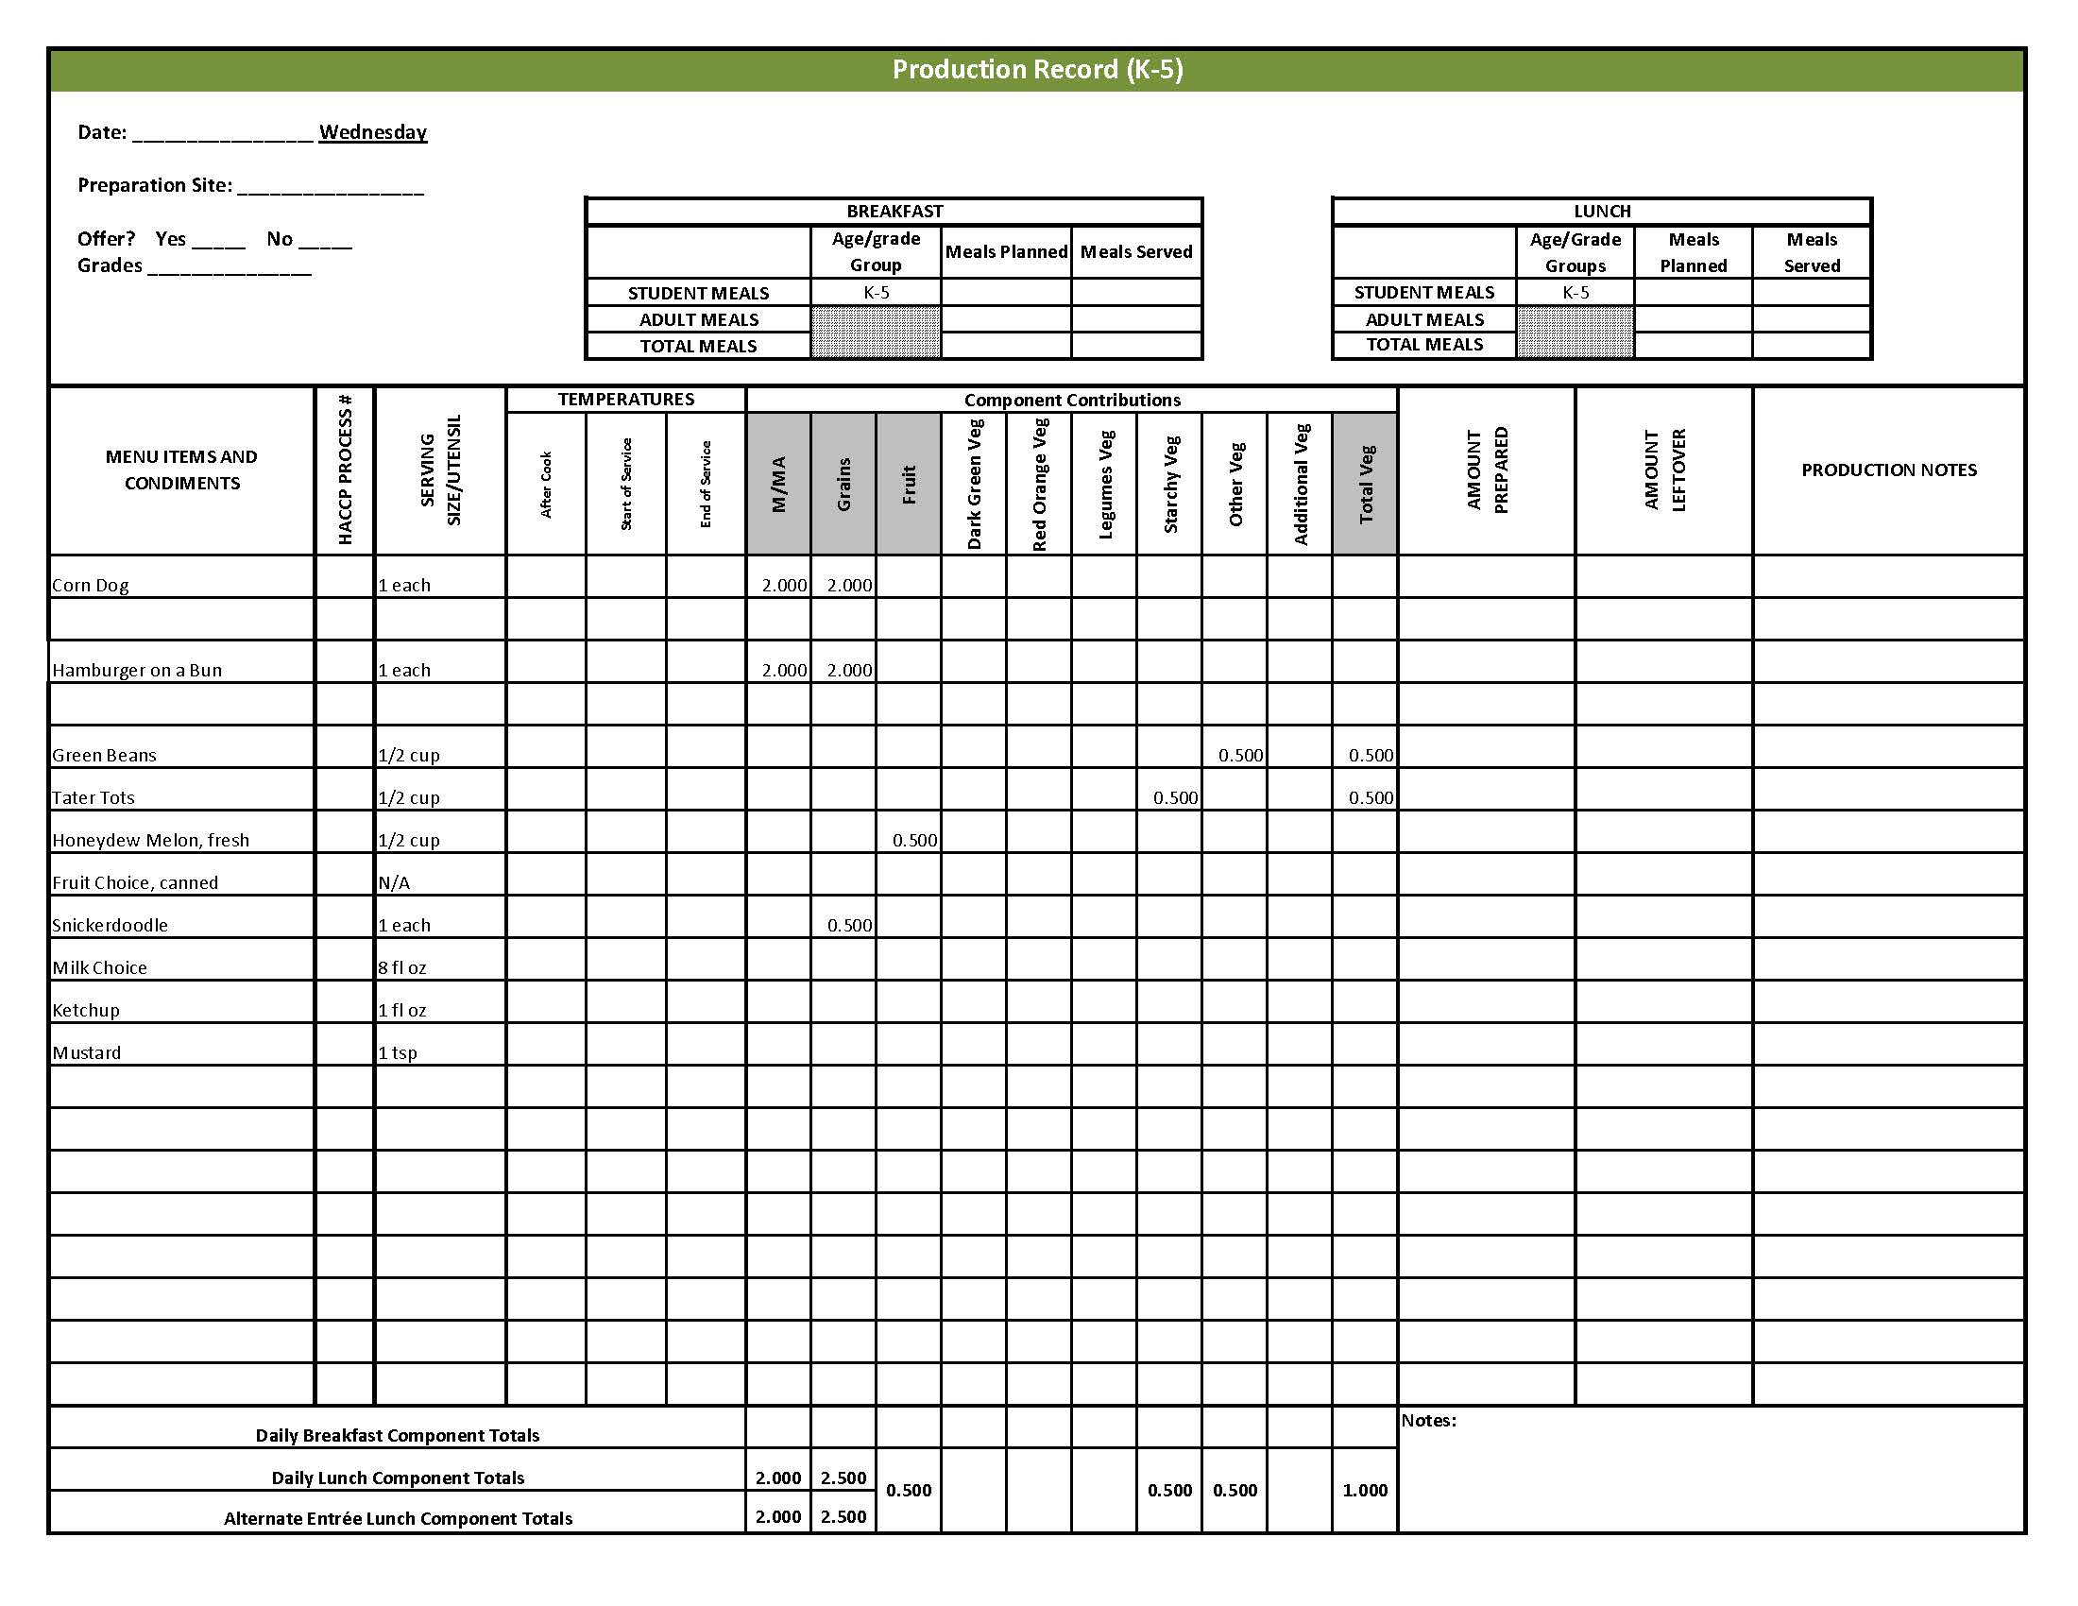

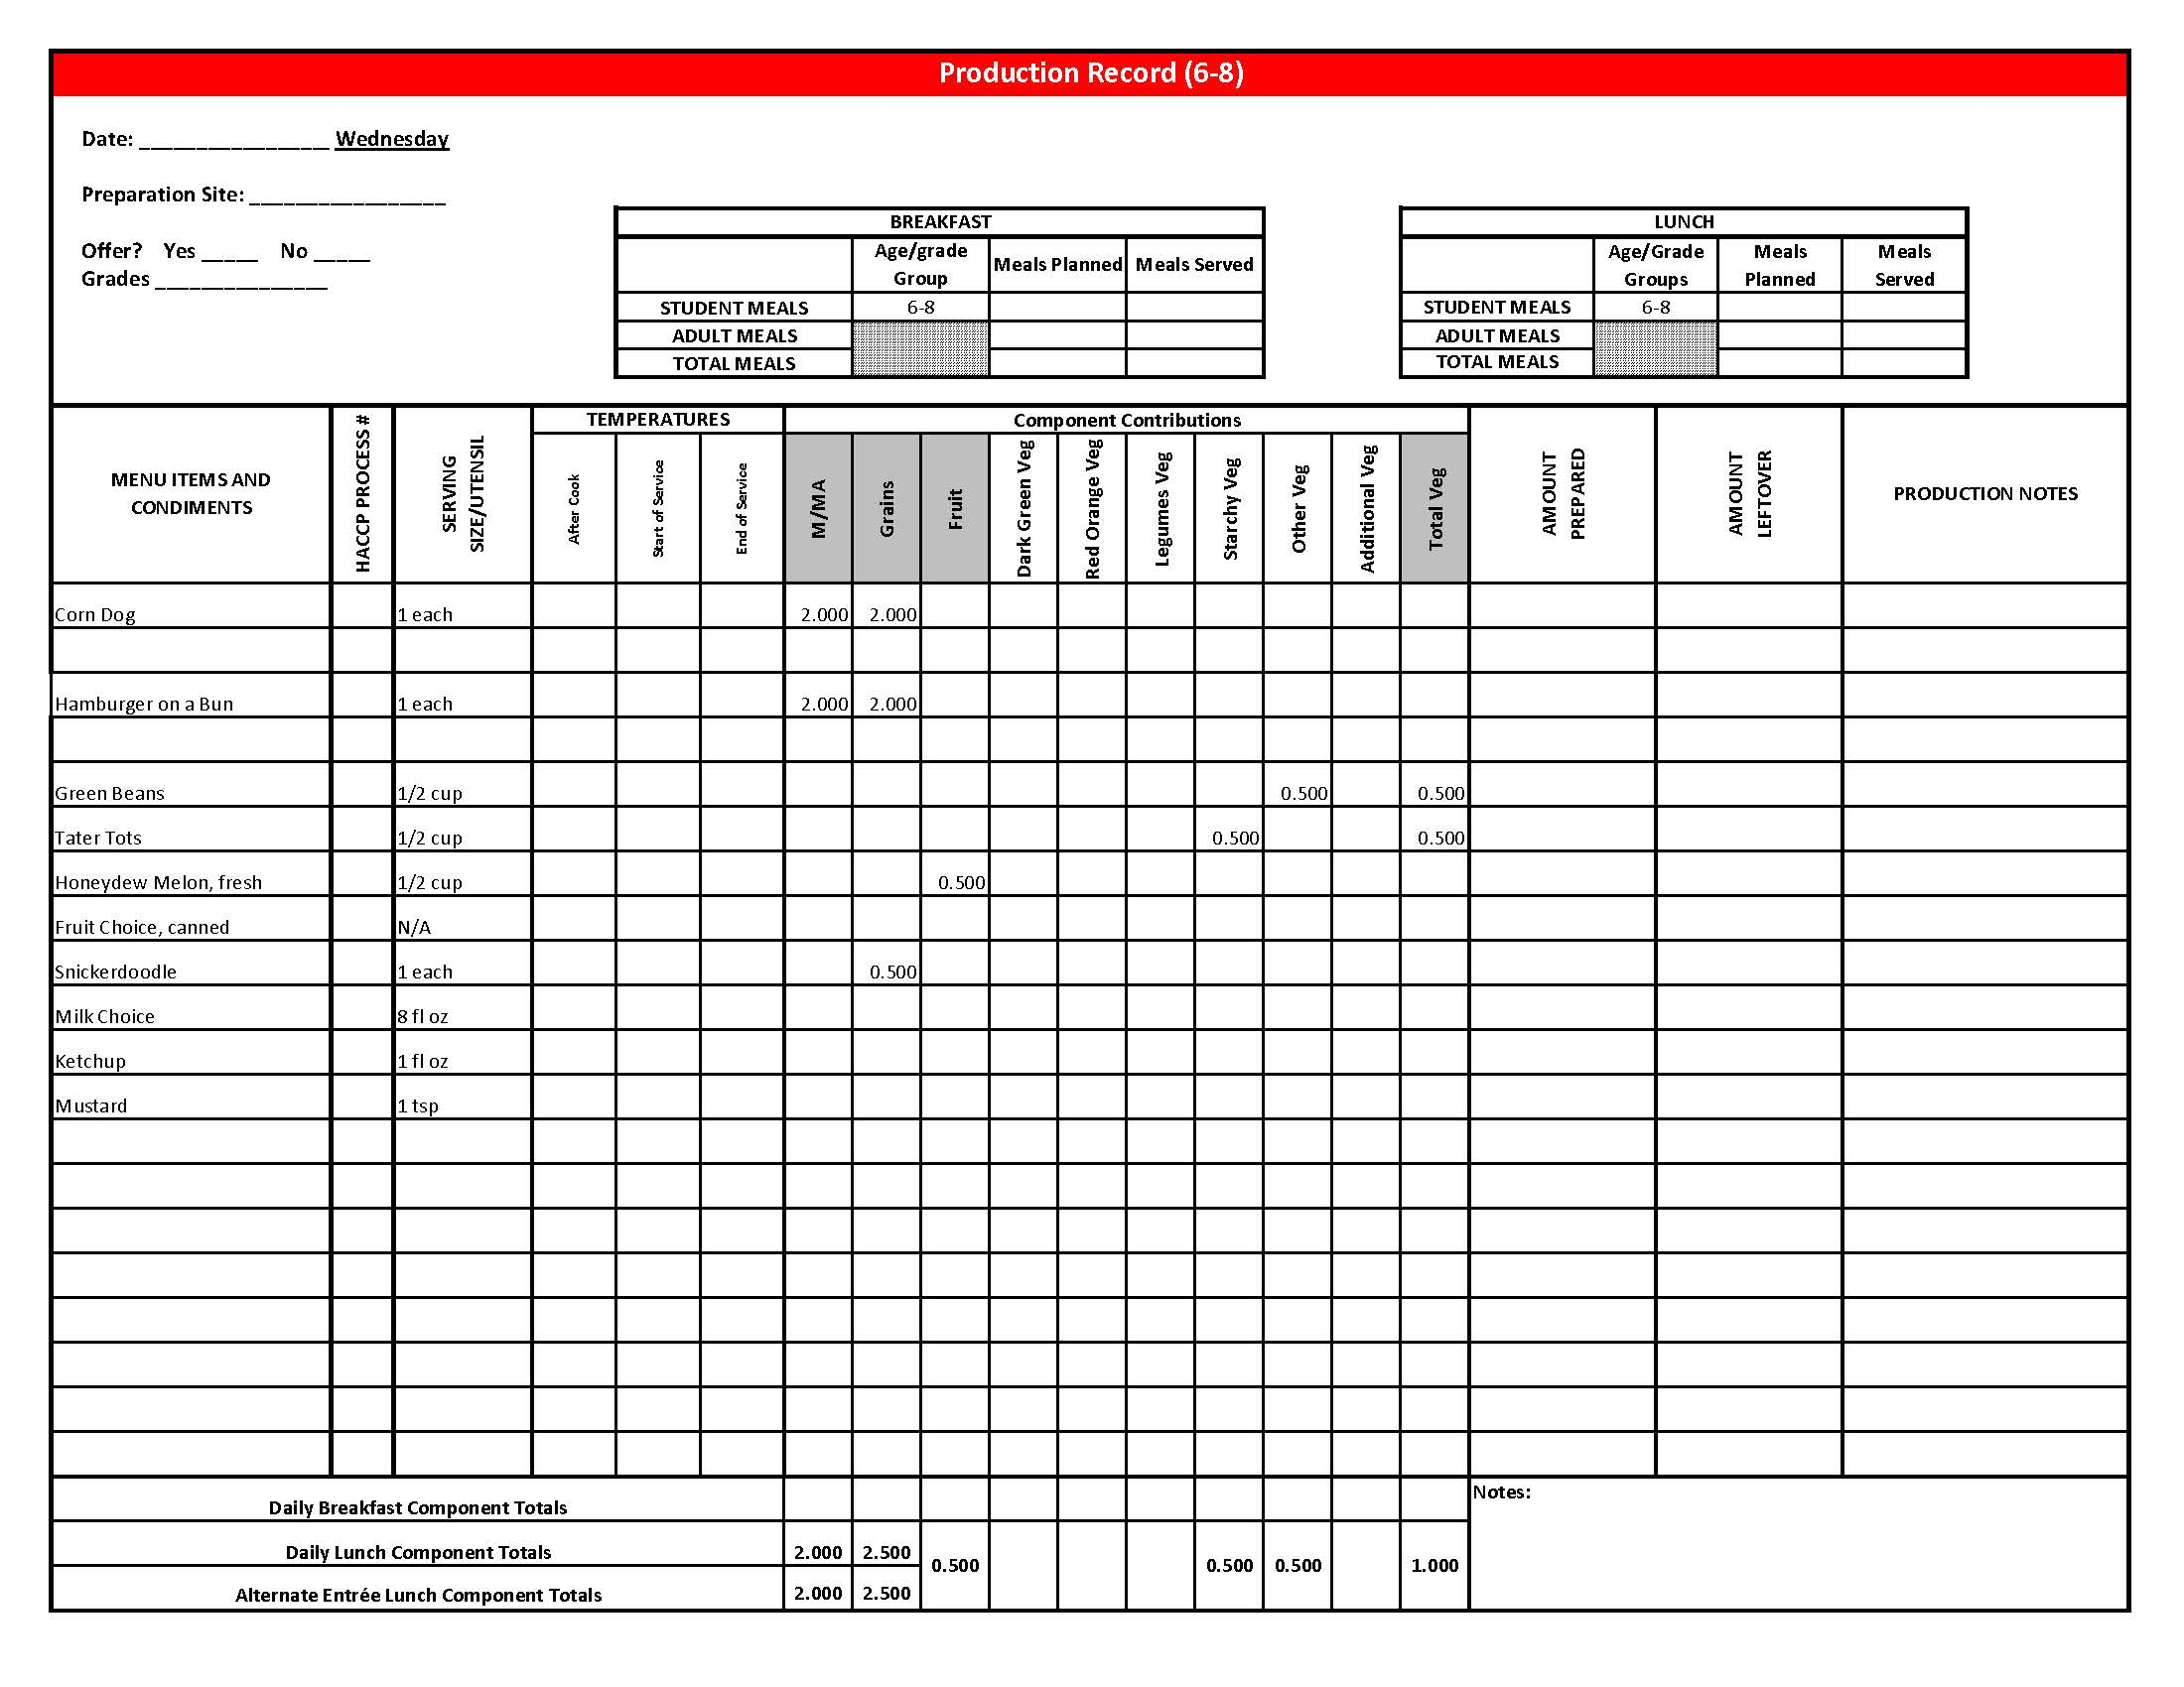

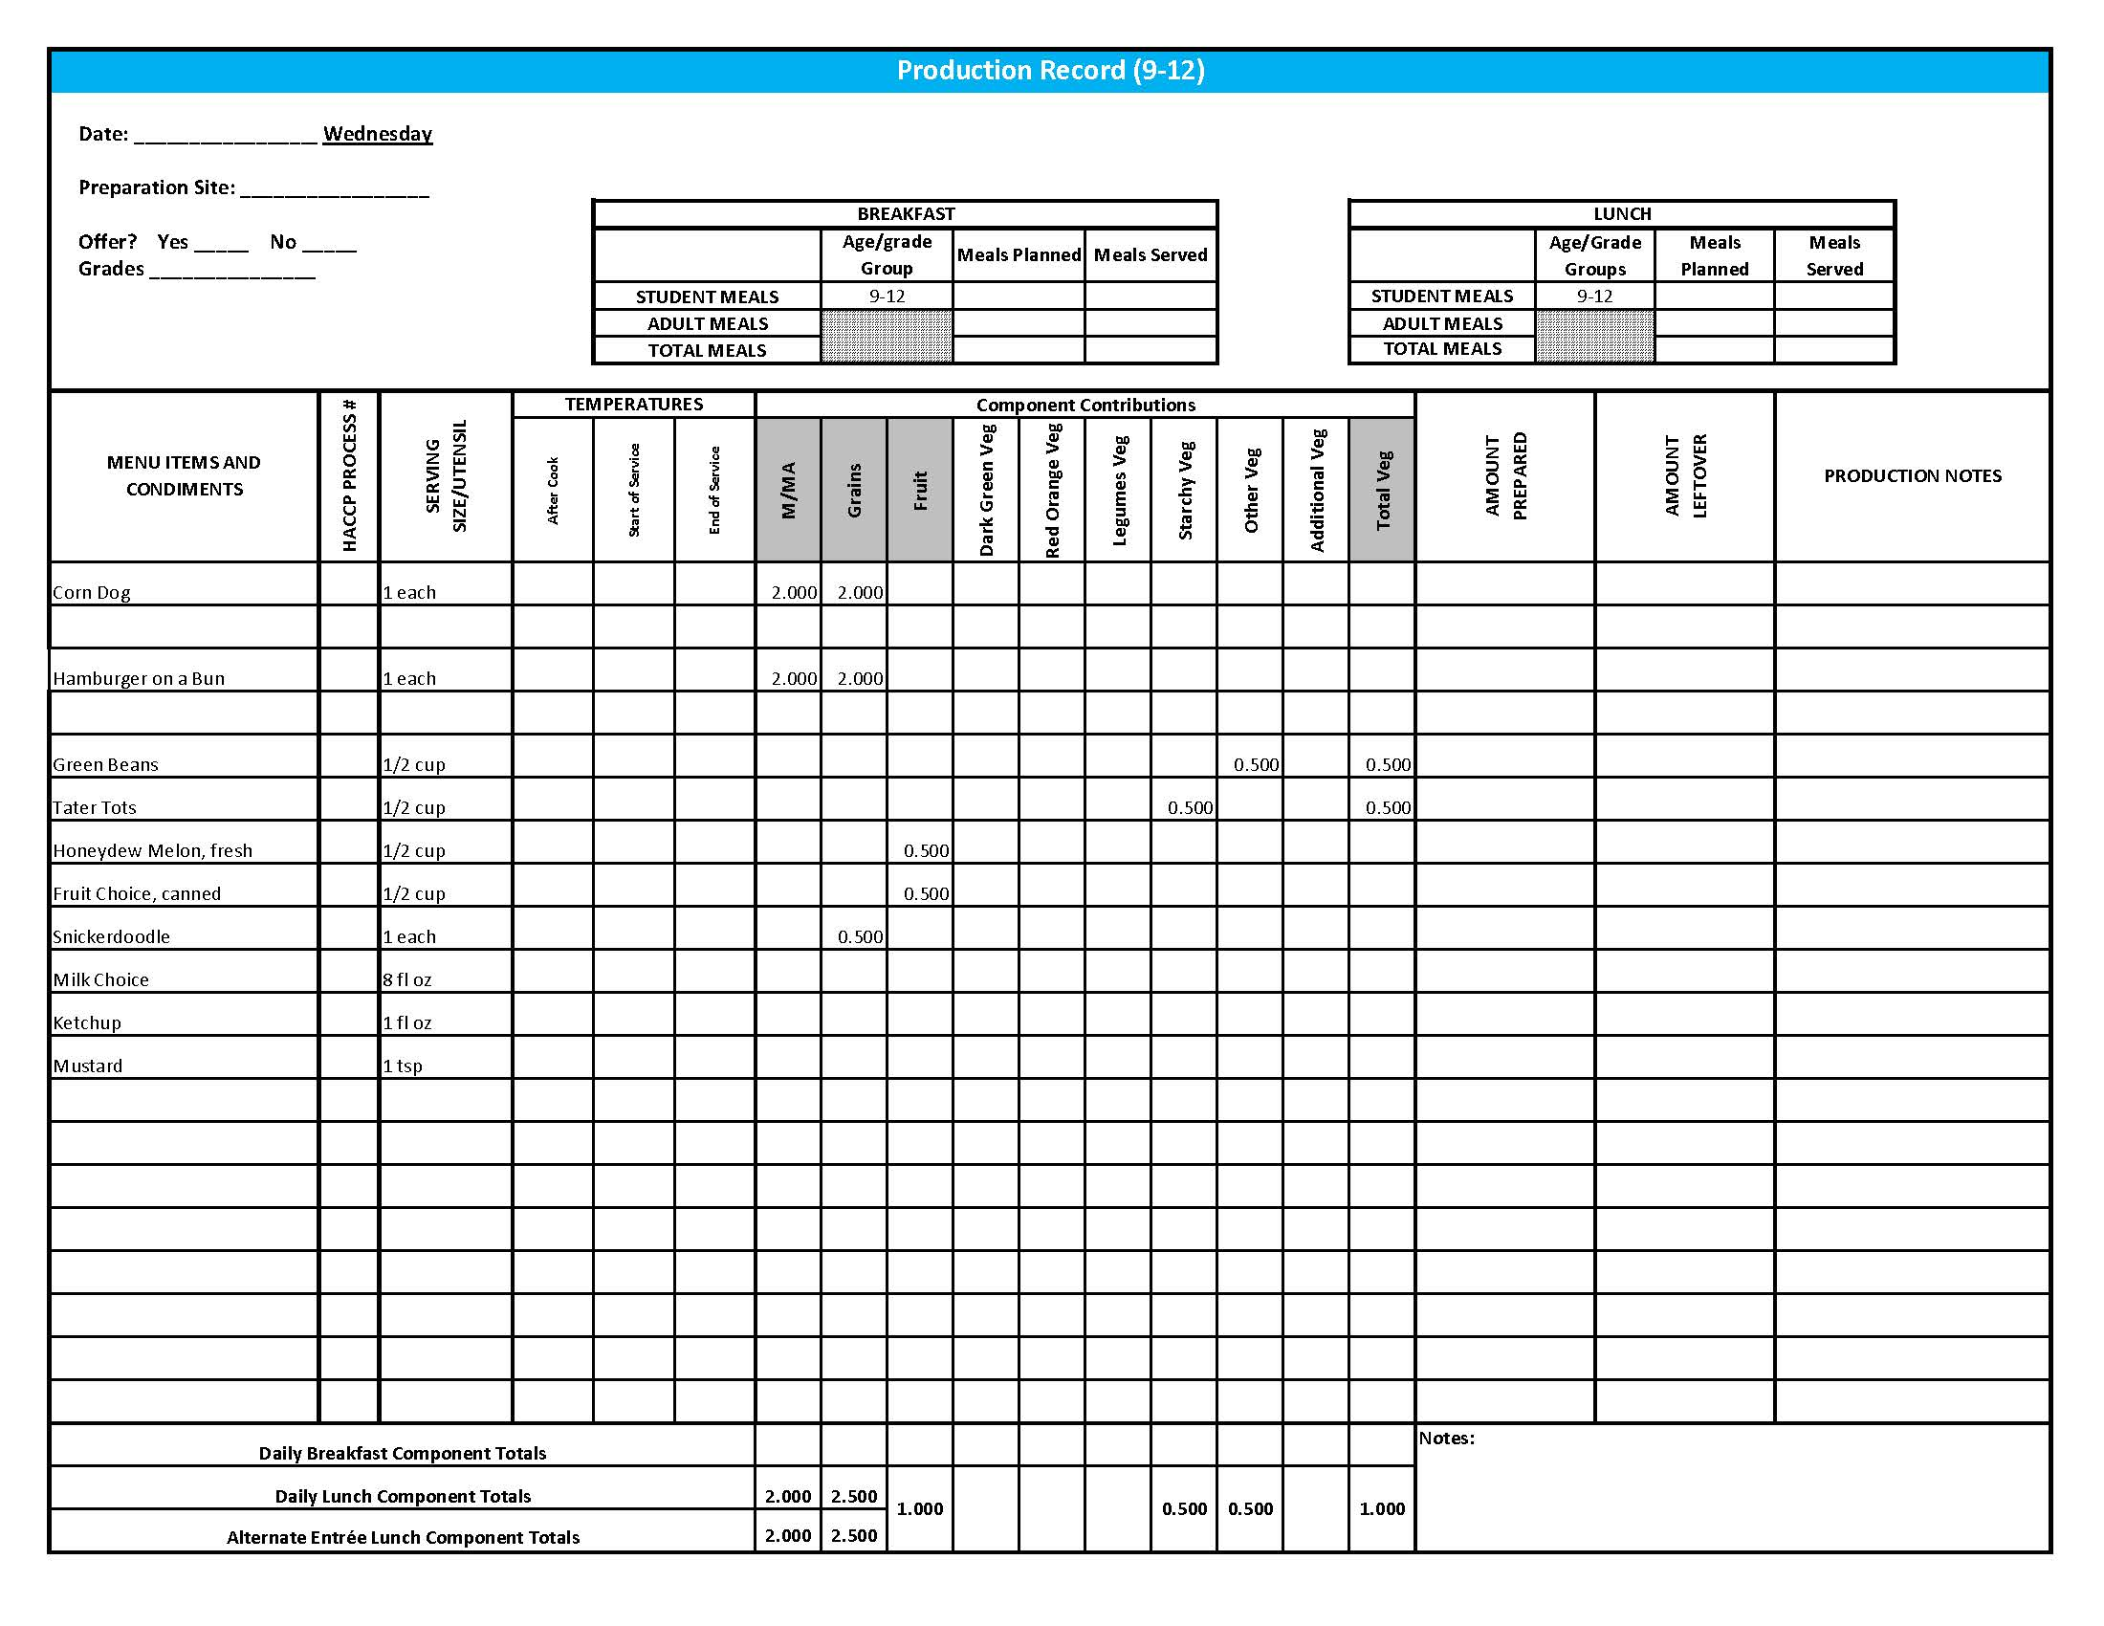

## Purchasing, Preparation & Serving Instructions

Week 3 – Thursday

|  |  |  |
| --- | --- | --- |
| **Menu Item** | **Purchasing & Preparation** | **Serving** |
| Chicken Quesadilla | * Prepare HKM Recipe 29, Chicken Quesadilla. * Purchase frozen pulled or diced cooked chicken with no skin and no added salt. * Purchase 8” whole grain tortillas, weighing at least 1.5 oz. * **CCP: Hold for hot service at 135°F or above.** | K-12: 1 Quesadilla |
| **Alternate Entrée:**  Yogurt & Blueberry Oat Muffin Meal | * Prepare HKM Recipe 28, Blueberry Oat Muffin or purchase pre-prepared whole grain-rich muffins that provide 1 oz equivalent Grain. * Purchase low-fat, flavored yogurt in bulk and pre-portion 1 cup (8 oz) servings. * **CCP: Refrigerate and hold at 41o F or below for cold service.** | K-12: 8oz yogurt,  2 muffins each |
| Tortilla Chips | * Purchase whole grain tortilla chips with no more than 50 mg sodium per oz. (Restaurant style usually has less sodium). * May be pre-portioned. Weigh a sample. Serve with gloved hands or tongs. | K-8: N/A  9-12: 1 oz |
| Black Bean & Corn Salsa | * Prepare HKM Recipe 81, Black Bean & Corn Salsa. * Refer to *Fruit & Vegetable Order Guide* for amount needed. * **CCP: Refrigerate and hold at 41⁰ F or below for cold service.** | K-8: N/A  9-12: ¼ cup |
| Broccoli Florets | * Refer to *Fruit & Vegetable Order Guide* for amount needed. Purchase fresh broccoli florets, ready to serve. * Wash broccoli. Cover and refrigerate until serving. * **CCP: Refrigerate and hold at 41⁰ F or below for cold service.** | K-12: ½ cup |

*Continued on next page*

## Purchasing, Preparation & Serving Instructions

**Week 3 – Thursday, continued**

|  |  |  |
| --- | --- | --- |
| **Menu Item** | **Purchasing & Preparation** | **Serving** |
| Carrots, baby, fresh | * Refer to *Fruit & Vegetable Order Guide* for amount needed. * Handle with gloved hands or serving utensils. Cover and refrigerate until serving. * Weigh or count number needed per portion. * **CCP: Refrigerate and hold at 41⁰ F or below for cold service.** | K-8: ¼ cup  9-12: ½ cup |
| Apple Salad | * Prepare HKM Recipe 121, Apple Salad. * Refer to *Fruit & Vegetable Order Guide* for amount needed. * **CCP: Refrigerate and hold at 41⁰ F or below for cold service.** | K-12: ½ cup |
| Fruit Choice, canned | Select an additional fruit choice to offer on the menu. The serving(s) offered must credit as ½ cup of fruit, to meet the minimum daily requirement, for grades 9-12.  *Note: The fruit choice is encouraged for grades K-5 and 6-8, but not required. The fruit choice is not included in the nutrient analysis for grades K-5 and 6-8. | K-8: N/A*  9-12: ½ cup |
| Ranch Dressing, Reduced Fat | * Purchase or prepare Ranch dressing containing no more than 6 gm of fat  per 1 fl oz. Purchase .8 gallons for every 100 1 fl oz portions. * **CCP: Refrigerate and serve at 41⁰ F or below if school-prepared dressing is served.** | K-12: 1 fl oz **or**  2 Tbsp |

**Pre-preparation for Week 3 - Friday:** Thaw beef under refrigeration.

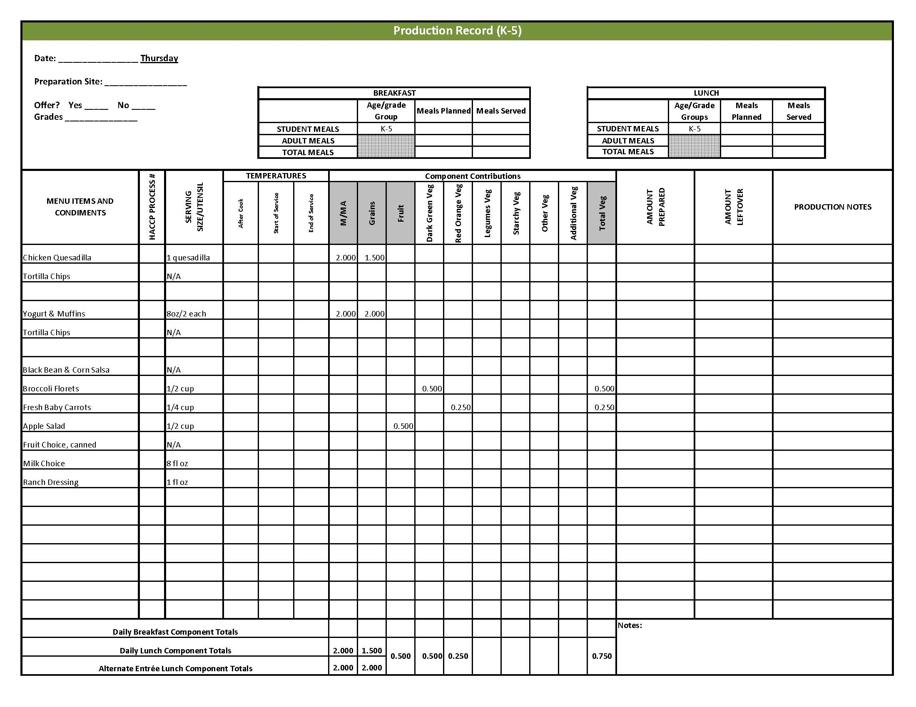

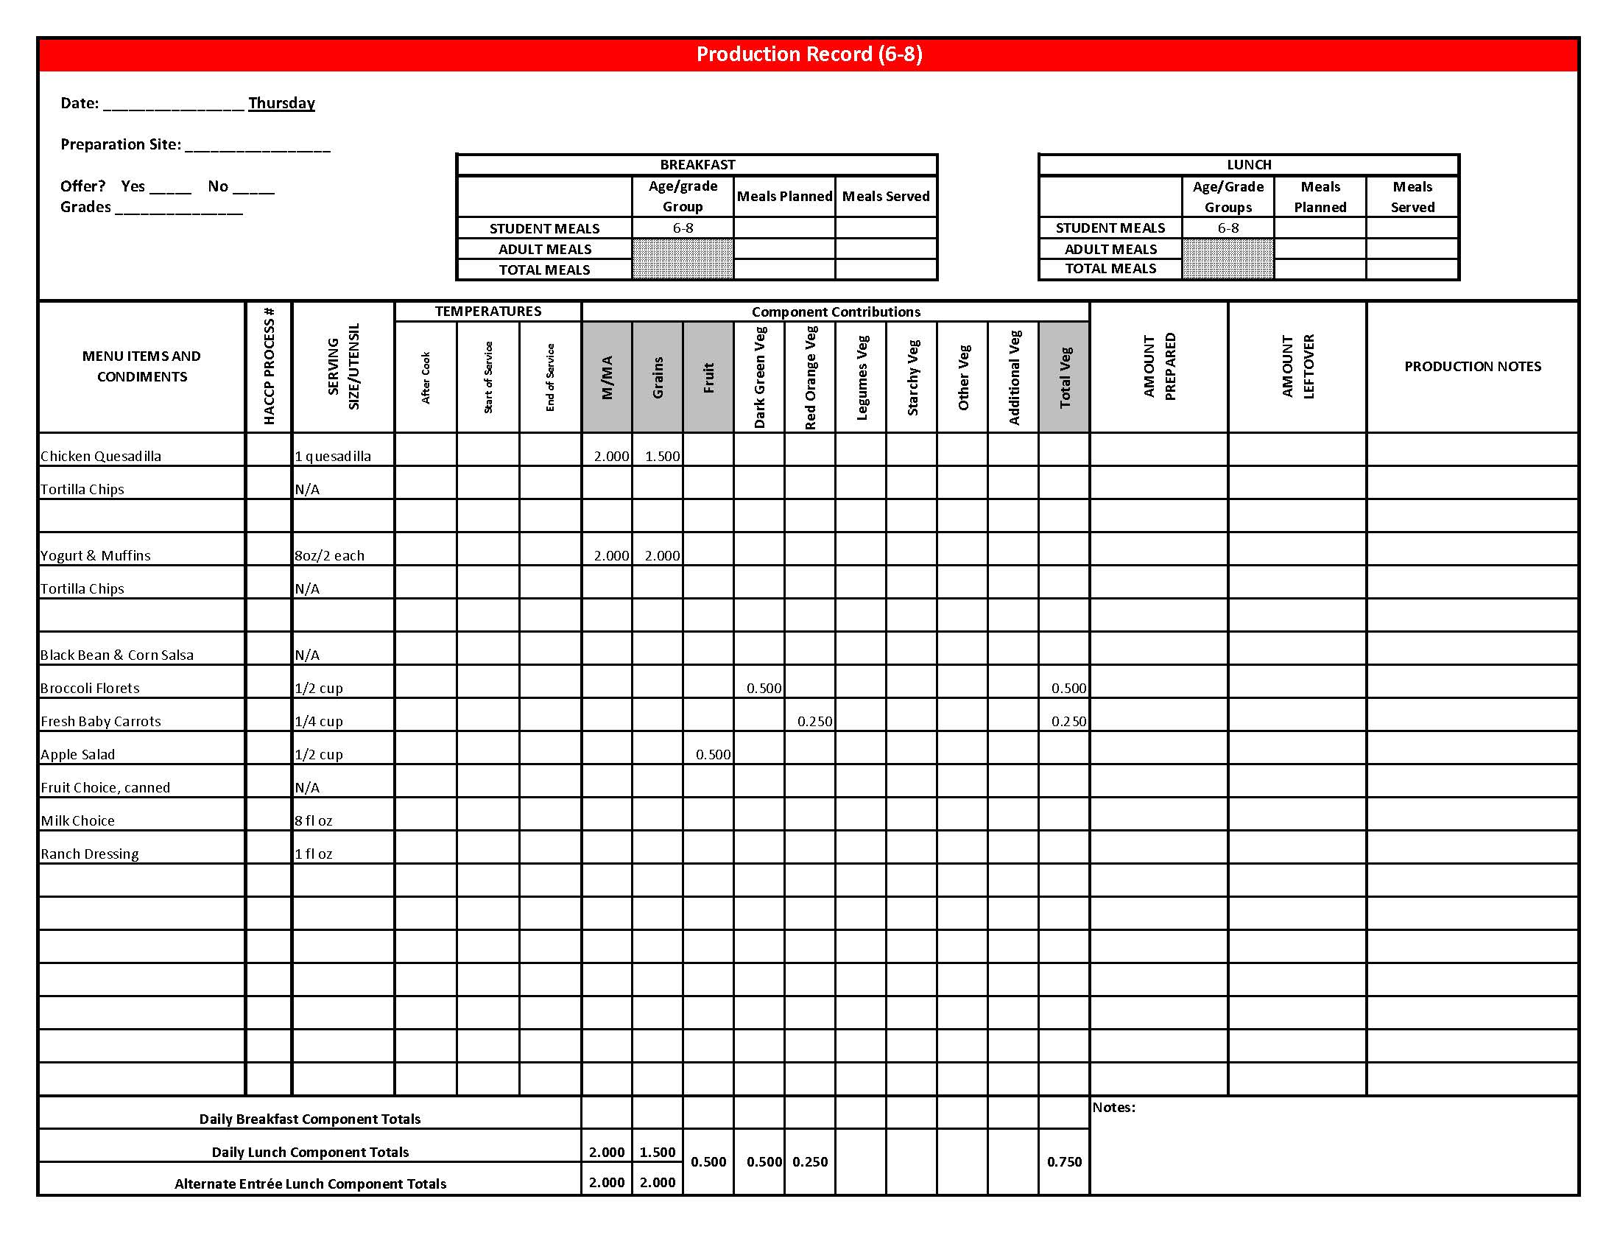

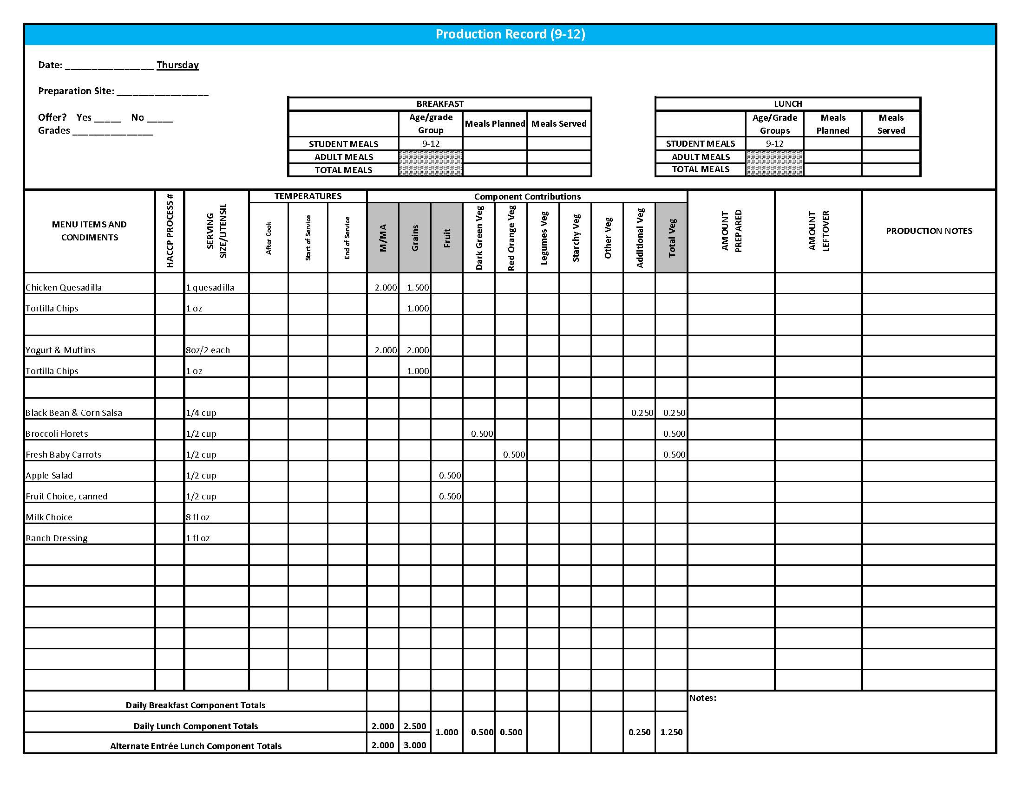

## Purchasing, Preparation & Serving Instructions

Week 3 – Friday

|  |  |  |
| --- | --- | --- |
| **Menu Item** | **Purchasing & Preparation** | **Serving** |
| Cowboy Cavatini | * Prepare HKM Recipe 32, Cowboy Cavatini. * Purchase 80/20 raw ground beef. * **CCP: Hold for hot service at 135°F or above.** | K-12: ¾ cup |
| Whole Wheat Roll | * Prepare HKM Recipe 877, Whole Wheat Rolls, Bread Sticks and Buns. | K-12: 1 each (1 oz) |
| **Alternate Entrée:**  Turkey & Cheese Sub | * Prepare HKM Recipe 144, Turkey & Cheese Sub. * Purchase lean, deli-sliced, turkey with no more than 500 mg of sodium per 2 oz serving. Product should be CN labeled or have a product formulation statement with crediting information. * Purchase a 2 oz whole wheat bun (first ingredient is whole wheat) or prepare HKM Recipe 877, Whole Wheat Rolls, Bread Sticks, Buns. * **CCP: Hold at 41⁰ F or below for cold service.** | K-12: 1 sandwich |
| Garden Salad | * Prepare HKM Recipe 164, Garden Salad. Refer to *Fruit & Vegetable Order Guide* for amounts of individual ingredients needed. * Handle salad with gloved hands, tongs or serving utensils. * May estimate serving sizes using measured portions as samples. * **CCP: Refrigerate and hold at 41⁰ F or below for cold service.** | K-12: 1 cup |
| Corn, steamed | * Purchase frozen or canned corn. Refer to *Fruit & Vegetable Order Guide* for amount needed. * If using canned corn, wipe tops of cans clean before opening. * Batch cook close to serving time by steaming or cooking in stock pot with minimal liquid. * **CCP: Hold for hot service at 135o F or above.** | K-12: ½ cup |
| Grapes, Fresh | * Refer to *Fruit & Vegetable Order Guide* for amount needed. * Wash grapes. Remove from stems or separate out into smaller clusters. * Cover and refrigerate until serving. * **CCP: Refrigerate and hold at 41⁰ F or below for cold service.** | K-12: ½ cup |

*Continued on next page*

Purchasing, Preparation & Serving Instructions

Week 3 – Friday, continued

|  |  |  |
| --- | --- | --- |
| **Menu Item** | **Purchasing & Preparation** | **Serving** |
| Fruit Choice, canned | Select an additional fruit choice to offer on the menu. The serving(s) offered must credit as ½ cup of fruit, to meet the minimum daily requirement, for grades 9-12.  *Note: The fruit choice is encouraged for grades K-5 and 6-8, but not required. The fruit choice is not included in the nutrient analysis for grades K-5 and 6-8. | K-8: N/A*  9-12: ½ cup |
| Milk | * Provide a variety of milk. May be 1% fat (unflavored) or skim (flavored or unflavored). * **CCP: Refrigerate and hold at 41⁰ F or below for cold service.** | K-12: 8 fl oz |
| Ranch Dressing, Reduced Fat | * Purchase or prepare Ranch dressing containing no more than 6 gm of fat  per 1 fl oz. Purchase .8 gallons for every 100 1 fl oz portions. * **CCP: Refrigerate and serve at 41⁰ F or below if school-prepared dressing is served.** | K-12: 1 fl oz **or** 2 Tbsp |
| Jelly | * Purchase .5 oz packets or purchase in bulk container. | K-12: ½ oz each **or**  1 Tbsp |
| Mayo-type Salad Dressing, reduced fat | * Purchase mayo-type salad dressing containing no more than 6 gm of fat per 1 fl oz. Purchase .8 gallons per 100 1fl oz servings. | K-12: ½ oz or 1 Tbsp |
| Mustard | * Purchase bulk or packets. If bulk, purchase 2 cups for every 100 1 tsp servings. | K-12: 1 tsp |

**Pre-preparation for Week 4 - Monday:** None

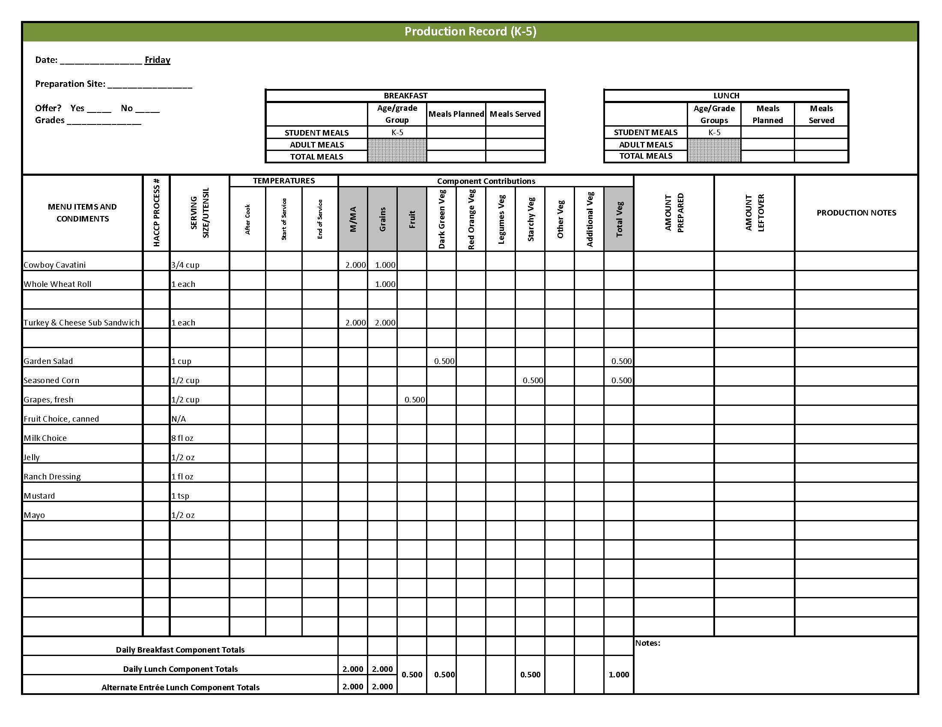

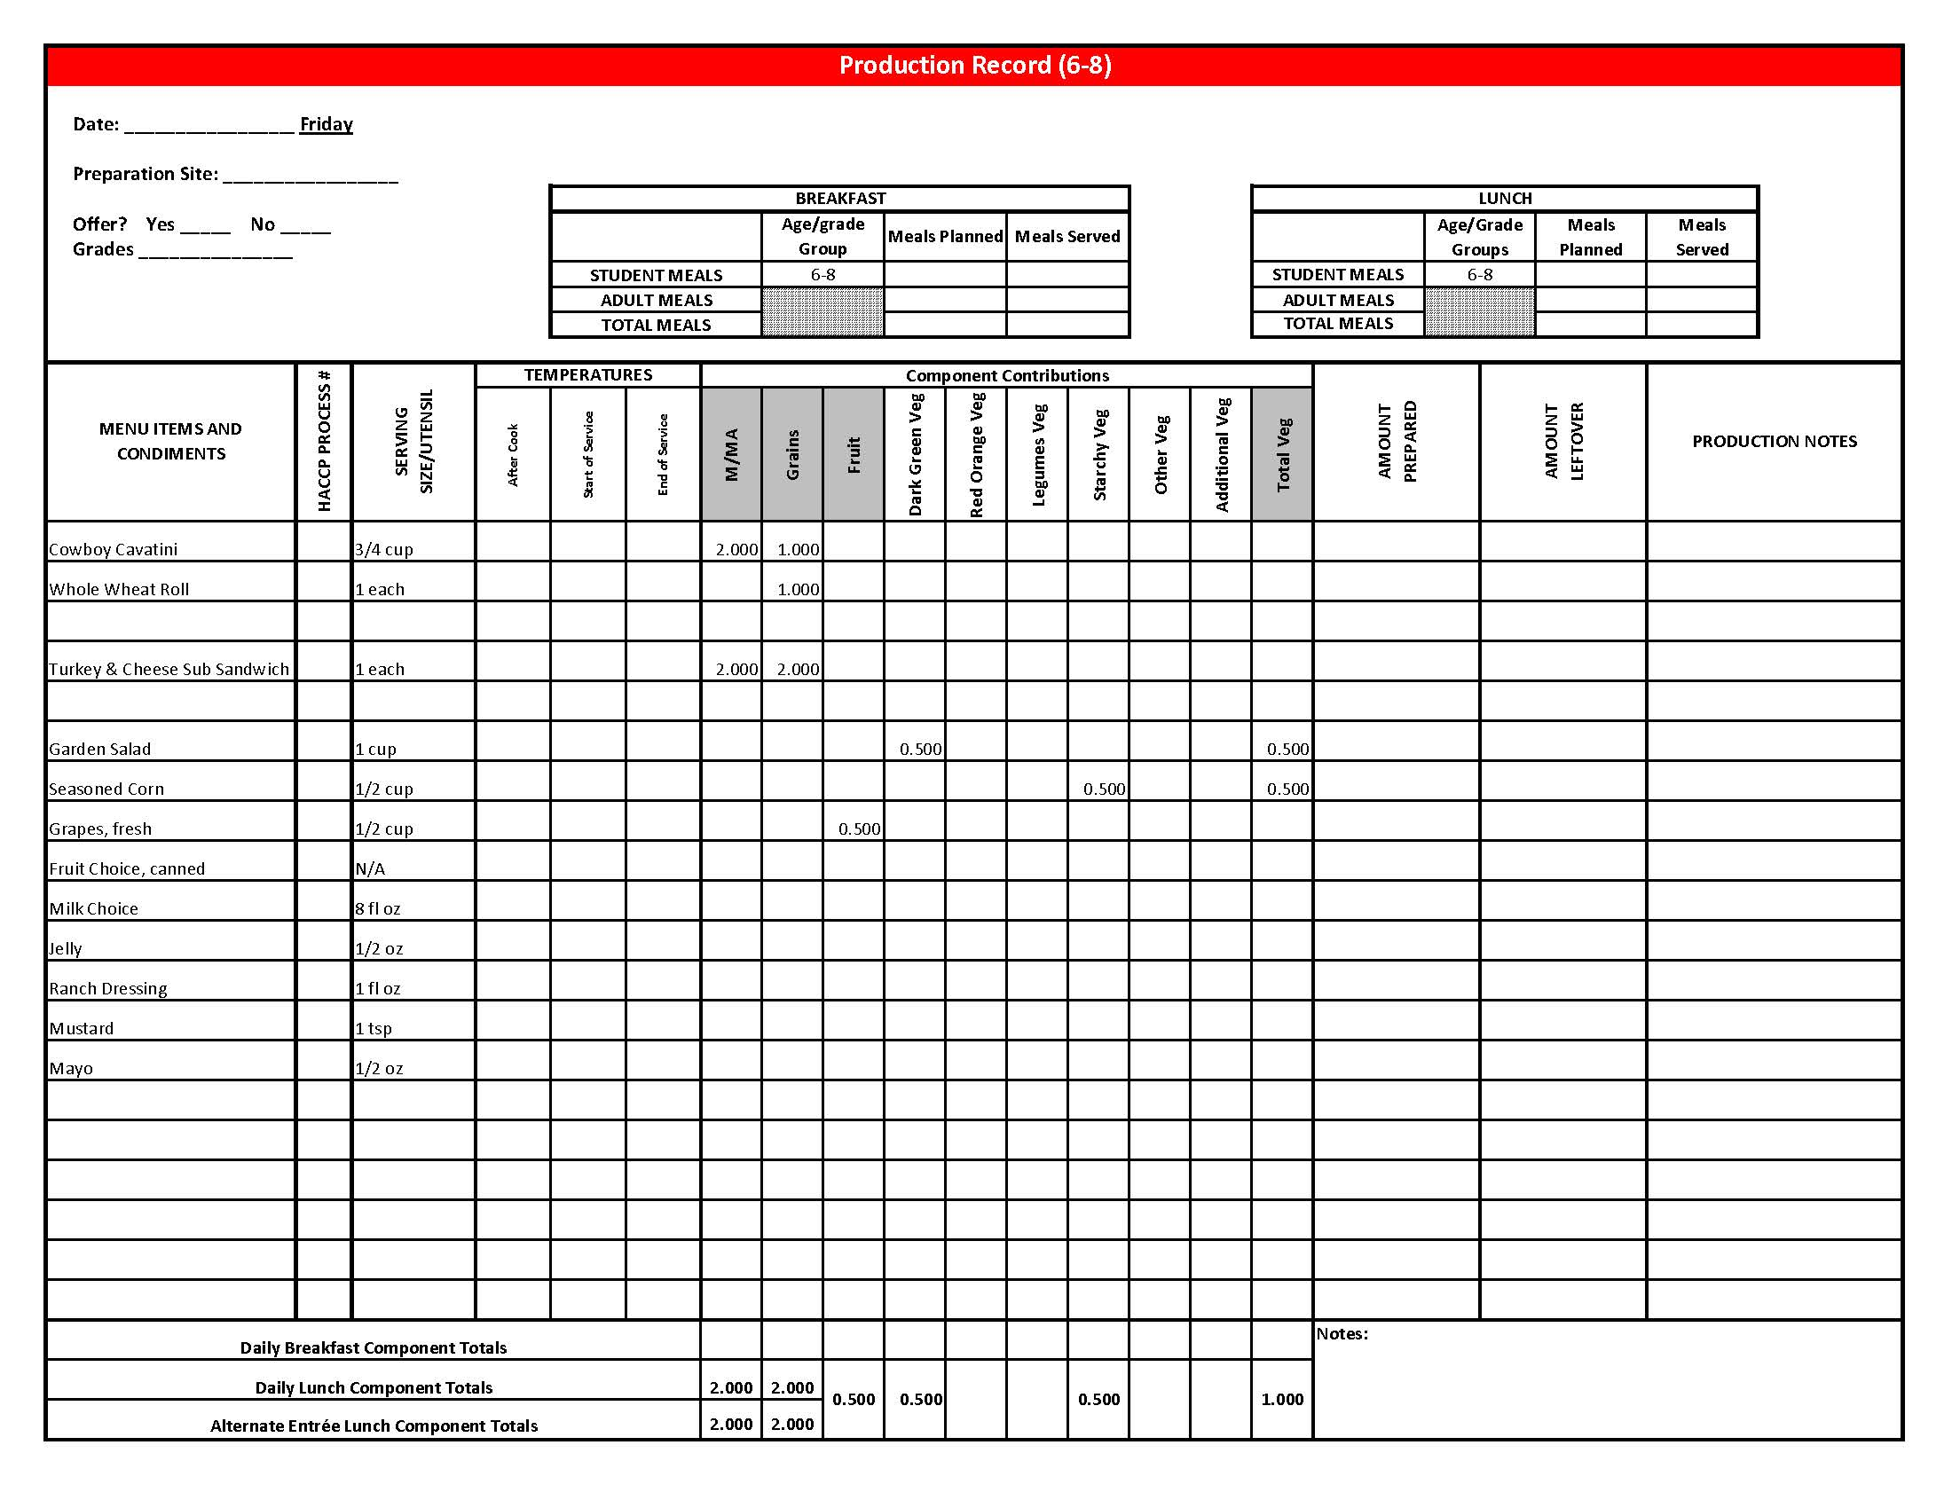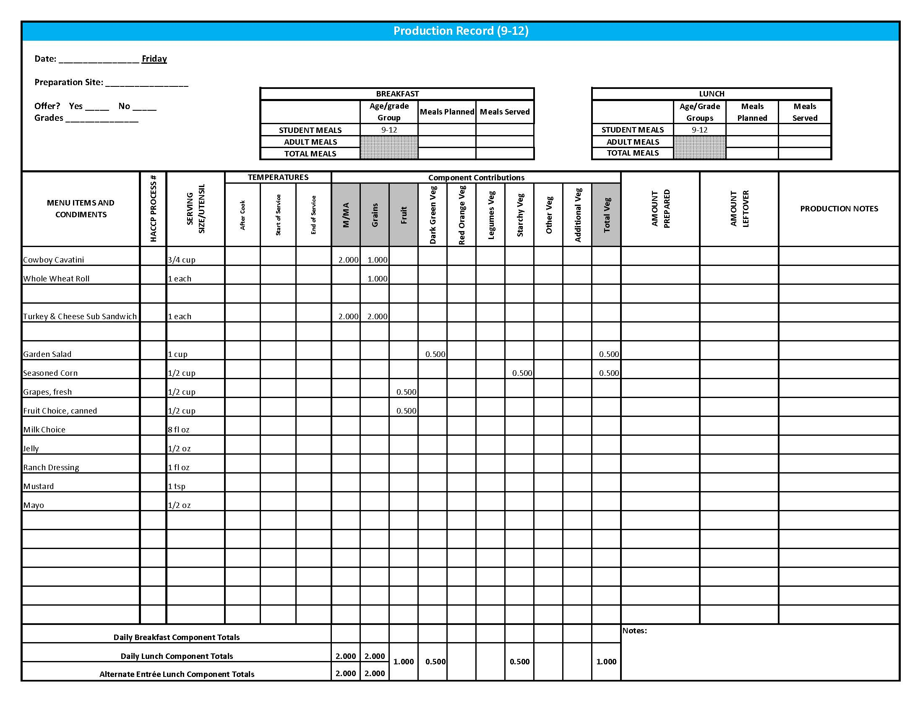

## Fruit & Vegetable Order Guide

**Week 3**

The chart below provides amounts to be ordered per 100 servings based on the serving sizes listed on Week 1 of *Healthier Kansas Menus Production Records* for students in grades groups K-5, 6-8, and 9-12. Amounts to order are based on standard yields and leveled serving utensils or weighed portions. Use the following procedures to determine the amounts to order:

1. **Forecast** the number of servings needed for each fruit and vegetable menu item for each grade group served.
2. **Divide** the number of servings needed by 100 for each portion size (K-5, 6-8 or 9-12).
3. **Multiply** the “Amount to order per 100 servings” by the factor determined in step 2 above for each portion size.
4. **Add** amounts needed for all serving sizes together to determine the amounts to order.

**Abbreviations Key: EP = Edible Portion AP = As Purchased lb = Pound oz = ounce # = Number**

|  |  |  |  |  |  |  |  |
| --- | --- | --- | --- | --- | --- | --- | --- |
| **Day** | **Fruit or Vegetable** | **K-5**  **Portion Size** | **K-5**  **Amount to Order per 100 Servings** | **6-8**  **Portion Size** | **6-8**  **Amount to Order**  **per 100 Servings** | **9-12 Portion Size** | **9-12 Amount to Order per 100 Servings** |
| Monday | Lettuce, Dark Green Leafy, AP | ½ cup | 9 lb 7 oz | ½ cup | 9 lb 7 oz | ½ cup | 9 lb 7 oz |
| Tomato, large, fresh, AP | ¼” slice | 5 lb 12 oz | ¼” slice | 5 lb 12 oz | 2 - ¼” slices | 11 lb 8 oz |
| Sweet Potato Puffs | ½ cup | 15 lb 13 oz | ½ cup | 15 lb 13 oz | ½ cup | 15 lb 13 oz |
| Cantaloupe, fresh, whole, 18 count, AP | ½ cup | 35 lb | ½ cup | 35 lb | ½ cup | 35 lb |
| Tuesday | Taco Soup | 1 cup |  | 1 cup |  | 1 cup |  |
| Corn, whole kernel, frozen |  | 7 lb |  | 7 lb |  | 7 lb |
| Pinto Beans, Canned | 2.75 #10 cans | 2.75 #10 cans | 2.75 #10 cans |
| Salsa, Canned | 1.75 #10 cans | 1.75 #10 cans | 1.75 #10 cans |
| Refried Beans, canned **OR** | ½ cup | 4.2 #10 cans | ½ cup | 4.2 #10 cans | ½ cup | 4.2 #10 cans |
| Refried Beans, dried |  | 9 lb 13 oz |  | 9 lb 13 oz |  | 9 lb 13 oz |
| Pears, sliced, canned in 100% juice or light syrup | ½ cup | 6.8 #10 cans | ½ cup | 6.8 #10 cans | ½ cup | 6.8 #10 cans |
| Tomato Salsa | ¼ cup |  | ¼ cup |  | ¼ cup |  |
| Tomato, crushed, salsa-ready, canned (for Tomato Salsa) |  | 2 #10 can |  | 2 #10 can |  | 2 #10 can |
| Jalapeno Peppers, canned (for Tomato Salsa) | 4 oz | 4 oz | 4 oz |
| Wednesday | Green Beans, canned | ½ cup | 4.6 #10 cans | ½ cup | 4.6 #10 cans | ½ cup | 4.6 #10 cans |
| Honeydew Melon, fresh, whole | ½ cup | 41 lb | ½ cup | 41 lb | ½ cup | 41 lb |
| Tater Tots, frozen | ½ cup | 15 lb 13 oz | ½ cup | 15 lb 13 oz | ½ cup | 15 lb 13 oz |

Fruit & Vegetable Order Guide

**Week 3, continued**

|  |  |  |  |  |  |  |  |
| --- | --- | --- | --- | --- | --- | --- | --- |
| **Day** | **Fruit or Vegetable** | **K-5**  **Portion Size** | **K-5**  **Amount to Order per 100 Servings** | **6-8**  **Portion Size** | **6-8**  **Amount to Order**  **per 100 Servings** | **9-12 Portion Size** | **9-12 Amount to Order per 100 Servings** |
| Thursday | Chicken Quesadilla | 1 quesadilla |  | 1 quesadilla |  | 1 quesadilla |  |
| Peppers, bell, green, AP |  | 2 lb |  | 2 lb |  | 2 lb |
| Onion, fresh, AP | 1 lb 4 oz | 1 lb 4 oz | 1 lb 4 oz |
| Corn, whole kernel, frozen | 5 lb | 5 lb | 5 lb |
| Tomato, fresh, AP | 2 lb 4 oz | 2 lb 4 oz | 2 lb 4 oz |
| Black Bean & Corn Salsa | N/A |  | N/A |  | ¼ cup |  |
| Black Beans, canned |  |  |  |  |  | 1 1/3 #10 cans |
| Corn, whole kernel, frozen | 3 lb 12 oz |
| Peppers, bell, green, AP | 1 lb |
| Peppers, bell, red, AP | 1 lb |
| Onions, red, AP | 5 oz |
| Picante Sauce | 3 ¼ cups |
| Broccoli, florets, fresh, EP | ½ cup | 7 lb | ½ cup | 7 lb | ½ cup | 7 lb |
| Carrots, baby, fresh, EP | ¼ cup | 7 lb 13 oz | ¼ cup | 7 lb 13 oz | ½ cup | 15 lb 10 oz |
| Blueberry Oat Muffin | 2 muffins |  | 2 muffins |  | 2 muffins |  |
| Applesauce, canned, unsweetened |  | 1 ½ #10 can |  | 1 ½ #10 can |  | 1 ½ #10 can |
| Blueberries, frozen, unsweetened |  | 5 lb |  | 5 lb |  | 5 lb |
| Apple Salad | ½ cup |  | ½ cup |  | ½ cup |  |
| Apples, fresh, #125-#138, AP |  | 10 lb 8 oz |  | 10 lb 8 oz |  | 10 lb 8 oz |
| Raisins, seedless, unsweetened |  | 2 lb |  | 2 lb |  | 2 lb |

Fruit & Vegetable Order Guide

**Week 3, continued**

|  |  |  |  |  |  |  |  |
| --- | --- | --- | --- | --- | --- | --- | --- |
| **Day** | **Fruit or Vegetable** | **K-5**  **Portion Size** | **K-5**  **Amount to Order per 100 Servings** | **6-8**  **Portion Size** | **6-8**  **Amount to Order**  **per 100 Servings** | **9-12 Portion Size** | **9-12 Amount to Order per 100 Servings** |
| Friday | Cowboy Cavatini | ¾ cup |  | ¾ cup |  | ¾ cup |  |
| Tomato Sauce, canned |  | 2.5 #10 cans |  | 2.5 #10 cans |  | 2.5 #10 cans |
| Corn, frozen OR | ½ cup | 18 lb 4 oz | ½ cup | 18 lb 4 oz | ½ cup | 18 lb 4 oz |
| Corn, canned |  | 5.2 #10 cans |  | 5.2 #10 cans |  | 5.2 #10 cans |
| Grapes, fresh, AP | ½ cup | 19 lb 4 oz | ½ cup | 19 lb 4 oz | ½ cup | 19 lb 4 oz |
| Garden Salad: | 1 cup |  | 1 cup |  | 1 cup |  |
| Lettuce, Romaine, AP |  | 6 lb 8 oz |  | 6 lb 8 oz |  | 6 lb 8 oz |
| Spinach, fresh, trimmed, AP | 6 lb 8 oz | 6 lb 8 oz | 6 lb 8 oz |
| Tomato, fresh, AP | 1 lb 5 oz | 1 lb 5 oz | 1 lb 5 oz |
| Carrots, fresh, AP | 15 oz | 15 oz | 15 oz |
| Cucumber, fresh, AP | 14 oz | 14 oz | 14 oz |