Healthier Kansas Menus

with Alternate Entrées

# C:\Documents and Settings\jmackey\My Documents\My Pictures\Microsoft Clip Organizer\j0349505.wmf

FALL WEEK 2 – DAILY PRODUCTION RECORDS

Child Nutrition & Wellness, Kansas State Department of Education

Revised July 2019

This publication has been funded at least in part with Federal funds from the U.S. Department of Agriculture, Food and Nutrition Service. The contents of this publication do not necessarily reflect the views or policies of the Department, nor does mention of trade names, commercial products, or organizations imply endorsement by the U.S. Government.

**For further information about this publication, please contact:** Child Nutrition & Wellness, KSDE, Landon State Office Building, 900 SW Jackson Street, Suite #251, Avenue, Topeka, Kansas 66612, 785-296-2276, Fax: 785-296-0232,

[www.kn-eat.org](http://www.kn-eat.org/)

In accordance with Federal civil rights law and U.S. Department of Agriculture (USDA) civil rights regulations and policies, the USDA, its Agencies, offices, and employees, and institutions participating in or administering USDA programs are prohibited from discriminating based on race, color, national origin, sex, disability, age, or reprisal or retaliation for prior civil rights activity in any program or activity conducted or funded by USDA.  
  
Persons with disabilities who require alternative means of communication for program information (e.g. Braille, large print, audiotape, American Sign Language, etc.), should contact the Agency (State or local) where they applied for benefits. Individuals who are deaf, hard of hearing or have speech disabilities may contact USDA through the Federal Relay Service at (800) 877-8339. Additionally, program information may be made available in languages other than English.  
  
To file a program complaint of discrimination, complete the [USDA Program Discrimination Complaint Form](http://www.ocio.usda.gov/sites/default/files/docs/2012/Complain_combined_6_8_12.pdf), (AD-3027) found online at: [http://www.ascr.usda.gov/complaint_filing_cust.html](https://www.ascr.usda.gov/filing-discrimination-complaint-usda-customer), and at any USDA office, or write a letter addressed to USDA and provide in the letter all of the information requested in the form. To request a copy of the complaint form, call (866) 632-9992. Submit your completed form or letter to USDA by:  
  
(1)   Mail: U.S. Department of Agriculture  
Office of the Assistant Secretary for Civil Rights  
1400 Independence Avenue, SW  
Washington, D.C. 20250-9410;  
  
(2)   Fax: (202) 690-7442; or  
  
(3)   Email: [program.intake@usda.gov](mailto:program.intake@usda.gov).  
  
This institution is an equal opportunity provider.

The following person has been designated to handle inquiries regarding the non-discrimination policies at the Kansas State Department of Education: Office of General Counsel, Landon State Office Building, 900 SW Jackson St, Suite #102, Topeka, KS 66612, (785)296-3201.

Healthier Kansas Menus recipes were developed by Child Nutrition & Wellness, Kansas State Department of Education or adapted from the following sources:

* *Food for Fifty,* Ninth Edition (1989) Grace Shugart, Mary Molt*.*
* *Healthier Kansas Menus – Breakfast,* Child Nutrition & Wellness, Kansas State Department of Education
* *Iowa Gold Star Cycle Menus*, Iowa Department of Education
* *Menus that Move,* Ohio Department of Education.
* *Fruit and Veggie Quantity Cookbook,* New Hampshire Department of Health and Human Services.
* *Preparing Whole Grain Foods,* Child Nutrition & Wellness, Kansas State Department of Education
* *Singing the Praises of Beans & Legumes*, Child Nutrition & Wellness, Kansas State Department of Education
* *USDA Recipes for Schools,* U.S. Department of Agriculture, Food & Nutrition Service, Child Nutrition Programs, 2006.
* USD 225 Fowler
* USD 234 Fort Scott
* USD 267 Renwick
* USD 306 Southeast of Saline
* USD 308 Hutchinson
* USD 320 Wamego
* USD 349 Stafford
* USD 364 Marysville
* USD 503 Parsons
* USD 512 Shawnee Mission

Thank you to the following schools for assisting with menu development and recipe testing:

* Logan Elementary School – USD 345 Seaman
* St. Joseph Catholic School – Mt. Hope, KS
* Winfield Scott Elementary School – USD 234 Fort Scott

## Menus for the Week

**PLEASE NOTE:**

Milk choice includes a variety of non-fat or 1% (flavored or unflavored) milk. One milk choice must be unflavored.

Reduced fat dressing is served with salads and fresh vegetables.

Menus were planned using all whole grain-rich products. Beginning July 1, 2019, at least half of the weekly grains in the school lunch menu and the school breakfast menu must be whole grain-rich.

|  |  |  |  |  |  |  |  |  |
| --- | --- | --- | --- | --- | --- | --- | --- | --- |
| **MONDAY** | **TUESDAY** | **WEDNESDAY** | **THURSDAY** | **FRIDAY** | **Weekly Nutrient Averages** | | | |
|  | K-5 | 6-8 | 9-12 |
| Mini Meatball Sub  **Or**  Fruit, Yogurt & Granola Parfait  Ranch Potato Wedges  Tossed Salad  Fresh Apple  Canned Fruit Choice  Milk Choice | BBQ Chicken Drumstick  Whole Wheat Roll  **Or**  Popcorn Chicken  Whole Wheat Roll  Baked Beans  Creamy Cole Slaw  Fresh Baby Carrots  Fresh Nectarine  Canned Fruit Choice  Milk Choice | White Chicken Chili  Cornbread Muffin  **Or**  Rock and Roll  Beef Wrap  Cherry Tomatoes  Cucumber Slices  Fresh Blueberries  Canned Fruit Choice  Milk Choice | Cheese Pizza  **Or**  Grilled Chicken Sandwich  Broccoli Florets  Fresh Baby Carrots  Diced Peaches  Fresh Fruit Choice  Milk Choice | Biscuits & Gravy  **Sausage Patty**  **(6-12)**  **Or**  Pepperoni Pizza  Fresh Sugar Snap Peas  Hash Brown Patty  Fresh Strawberries  Canned Fruit Choice  Milk Choice | **Calories**  **Sodium (mg)**  **% of Total Calories from Sat. Fat** | **618**  **837**  **6.8%** | **657**  **887**  **6.9%** | **803**  **1007**  **6.5%** |

C:\Documents and Settings\jmackey\My Documents\My Pictures\Microsoft Clip Organizer\j0349505.wmf

## Recipes for the Week

|  |  |  |  |
| --- | --- | --- | --- |
| Day | Recipe Name | Recipe Number | HKM Recipe  Page Number |
| Monday | Mini Meatball Sub  Ranch Potato Wedges  Tossed Salad | 132  131  74 | 25  56  62 |
| Tuesday | BBQ Chicken Drumstick  Whole Wheat Roll  Baked Beans  Creamy Cole Slaw | 130  877  188  20 | 2  91  50  52 |
| Wednesday | White Chicken Chili  Cornbread Muffin  Rock and Roll Beef Wrap | 128  127  133 | 43  69  30 |
| Thursday | N/A |  |  |
| Friday | Biscuits & Sausage Gravy  Angel Biscuits | 118  120 | 7  63 |

## Abbreviations

|  |  |  |  |
| --- | --- | --- | --- |
| **Abbreviation** | **What it Means** | **Abbreviation** | **What it Means** |
| HKM | Healthier Kansas Menus | Tbsp | tablespoon |
| EP | edible portion | tsp | teaspoon |
| AP | as purchased | CCP | Critical Control Point |
| fl | fluid | PC | portion controlled * |
| oz | ounce | w/ | with |
| lb | pound | M/MA | meat/meat alternate |
| gm | gram |  |  |
| mg | milligram |  |  |

* For example, purchase pre-portioned servings of condiments.

## Portion Guide

|  |  |
| --- | --- |
| **Ladles & Spoodles** | **Scoops** |
| 1 fl oz = 2 Tbsp | #50 = 3 3/4 tsp |
| 2 fl oz = 1/4 cup | #40 = 1 2/3 Tbsp |
| 3 fl oz = 3/8 cup | #30 = 2 Tbsp |
| 4 fl oz = 1/2 cup | #20 = 3 1/3 Tbsp |
| 6 fl oz = 3/4 cup | #16 = 1/4 cup |
| 8 fl oz = 1 cup | #12 = 1/3 cup |
|  | #8 = 1/2 cup |
|  | #6 = 2/3 cup |

## Purchasing, Preparation & Serving Instructions

Week 2 – Monday

|  |  |  |
| --- | --- | --- |
| **Menu Item** | **Purchasing & Preparation** | **Serving** |
| Mini Meatball Sub | * Prepare HKM Recipe 132, Mini Meatball Sub. * Purchase pre-cooked beef meatballs where 5 meatballs equal 2 M/MA (or use number of meatballs needed to provide 1 M/MA to K-8 and 2 M/MA to 9-12), and each meatball has no more than 60 mg sodium and no more than 2 g fat. If product is not Child Nutrition (CN) labeled, obtain a Product Formulation Statement. * Refer to *Fruit & Vegetable Order Guide* for amount spaghetti sauce needed. * **CCP: Hold for hot service at 135⁰ F or above.** | K-8: 1 sandwich  (made with 3 meatballs or number needed to provide 1 oz equivalent M/MA)  9-12: 1 sandwich  (made with 5 meatballs or number needed to provide 2 oz equivalent M/MA) |
| **Alternate Entrée:**  Fruit, Yogurt & Granola Parfait | * Purchase a fresh, frozen or canned fruit (packed in light syrup or 100% juice). Refer to *Fruit & Vegetable Order Guide* for amount needed. * Purchase low-fat, flavored bulk yogurt and portion 1 cup (8 oz) for each serving. * Purchase pre-prepared granola that provides 2 oz Grains per ½ cup serving; no more than 7 gm of fat; and no more than 180 mg of sodium per serving. * Assemble parfait with fruit and yogurt in one cup and granola in different cup. Recommend layering ½ cup yogurt, ¼ cup fruit, ½ cup yogurt and ¼ cup fruit. Portioning granola separately will help to keep granola fresh and crunchy. * **CCP: Refrigerate and hold at 41⁰ F or below for cold service.** | K-12: ½ cup fruit, 8 oz yogurt, ½ cup granola |
| Ranch Potato Wedges | * Prepare HKM Recipe 131, Ranch Potato Wedges. * Purchase frozen, ovenable, unseasoned potato wedges. Choose skin-on wedges for additional fiber. Refer to *Fruit & Vegetable Order Guide* for amount needed. * Weigh out each portion size indicated and use as a sample. * **CCP: Hold for hot service at 135⁰ F or above.** | K-12: ½ cup |
| Tossed Salad | * Prepare HKM Recipe 74, Tossed Salad. * Refer to *Fruit & Vegetable Order Guide* for amount needed. * **CCP: Refrigerate and hold at 41⁰ F or below for cold service.** | K-12: 1 cup |

*Continued on next page*

## Purchasing, Preparation & Serving Instructions

Week 2 – Monday, continued

|  |  |  |
| --- | --- | --- |
| **Menu Item** | **Purchasing & Preparation** | **Serving** |
| Apple Slices, Fresh | * Refer to *Fruit & Vegetable Order Guide* for amount needed. Purchase apples, size #125-138. * Handle with gloved hands. Rinse and remove core. Cut in 4ths or 8ths. * Dip in lemon, orange, pineapple juice, or antioxidant solution to preserve color. * Cover and refrigerate or store at room temperature until serving. * **CCP: Refrigerate and hold at 41⁰ F or below for cold service** | K-12: ½ apple |
| Fruit Choice, canned | Select an additional fruit choice to offer on the menu. The serving(s) offered must credit as ½ cup of fruit, to meet the minimum daily requirement, for grades 9-12.  *Note: The fruit choice is encouraged for grades K-5 and 6-8, but not required. The fruit choice is not included in the nutrient analysis for grades K-5 and 6-8. | K-8: N/A*  9-12: ½ cup |
| Milk | * Provide a variety of milk. May be 1% fat (unflavored) or skim (flavored or unflavored). * **CCP: Refrigerate and hold at 41⁰ F or below for cold service.** | K-12: 8 fl oz |
| Ranch Dressing, Reduced Fat | * Purchase or prepare Ranch dressing containing no more than 6 gm of fat  per 1 fl oz. Purchase .8 gallons for every 100 1 fl oz portions. * **CCP: Refrigerate and serve at 41⁰ F or below if school-prepared dressing is used.** | K-12: 1 fl oz **or**  2 Tbsp |
| Ketchup | * Purchase in bulk or individual packets (9-gm or 12-gm). If bulk, purchase 1 #10 can or .8 gallon for every 100 1-fluid oz servings. | K-12: 1 fl oz  **or** 2 Tbsp **or** 2 PC |

**Pre-preparation for Week 2 – Tuesday:** Thaw chicken under refrigeration.

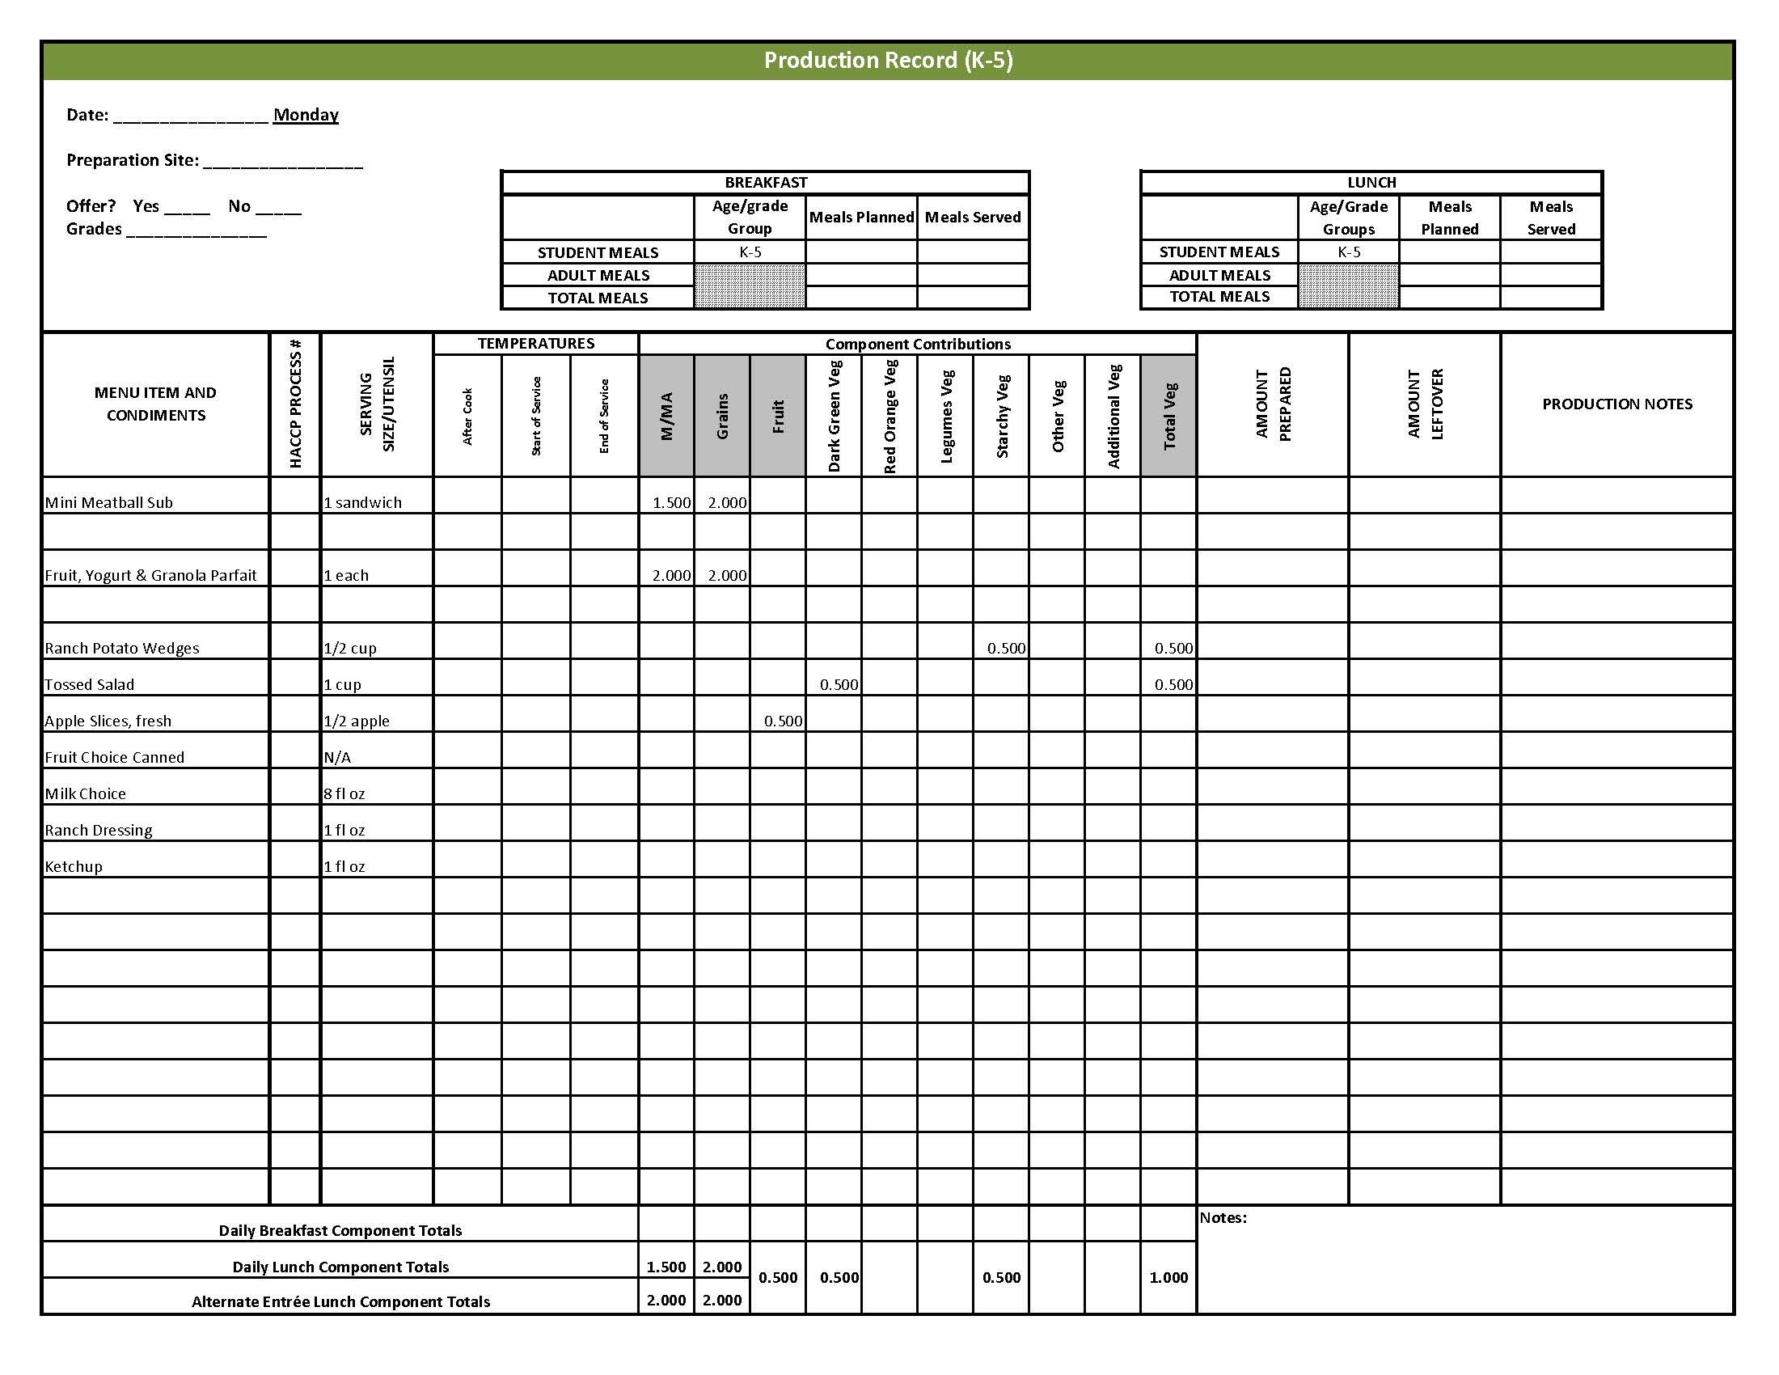

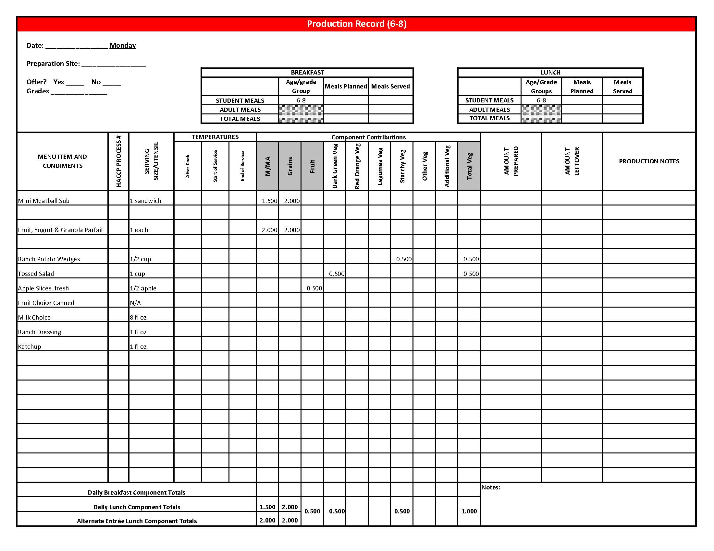

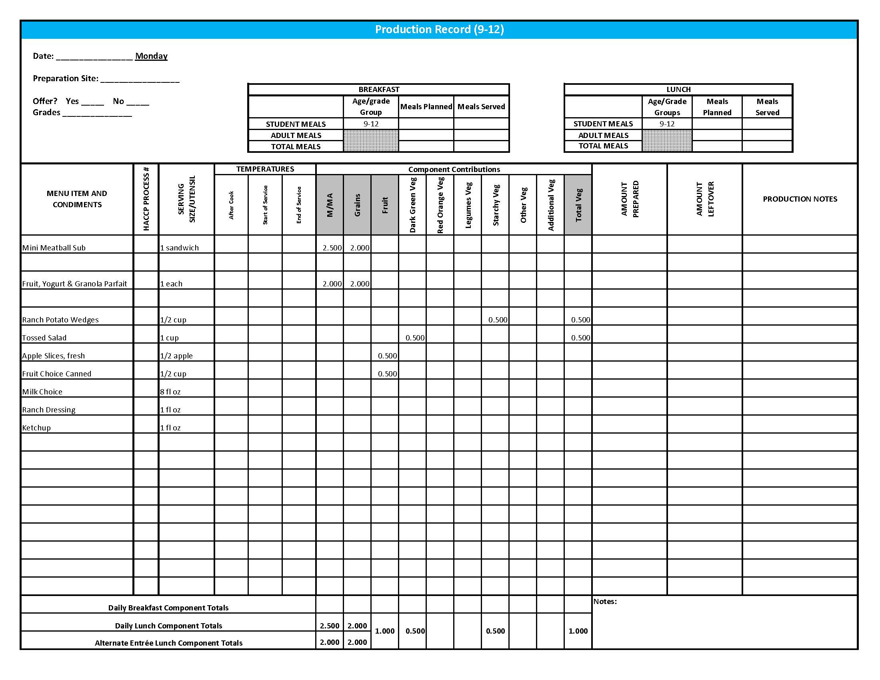

## Purchasing, Preparation & Serving Instructions

Week 2 – Tuesday

|  |  |  |
| --- | --- | --- |
| **Menu Item** | **Purchasing & Preparation** | **Serving** |
| BBQ Chicken | * Prepare HKM Recipe 130, BBQ Chicken. * Purchase raw, frozen chicken legs with skin that provide 1.5 oz equivalent M/MA per serving OR purchase a CN labeled, pre-cooked product that provides 1.5 oz equivalent M/MA per serving and prepare according to manufacturer’s instructions. If product is not Child Nutrition (CN) labeled, obtain a Product Formulation Statement. * **CCP: Hold for hot service at 135⁰ F or above.** | K-5: 1 drumstick  6-12: 2 drumsticks |
| Whole Wheat Roll | * Prepare HKM Recipe 877, Whole Wheat Rolls, Bread Sticks and Buns, 51%. | K-8: 1 each  9-12: 2 each |
| **Alternate Entrée:**  Chicken, popcorn | * Purchase pre-cooked, oven-ready popcorn chicken that provides 2 oz equivalent M/MA and 1 oz equivalent Grain, no more than 18 gm of fat; and no more than 290 mg sodium per serving. If product is not Child Nutrition (CN) labeled, obtain a Product Formulation Statement. * Heat according to manufacturer’s instructions. * **CCP: Hold for hot service at 135⁰ F or above.** | K-12: 15 pieces  (or number needed to provide 2 oz equivalent M/MA & 1 oz equivalent Grain) |
| **Alternate Entrée:**  Whole Wheat Roll | * Prepare HKM Recipe 877, Whole Wheat Rolls, Bread Sticks and Buns, 51%. | K-5: N/A  6-12: 1 each |
| Baked Beans | * Prepare HKM Recipe 188, Baked Beans or purchase canned baked beans. * Refer to *Fruit & Vegetable Order Guide* for amount needed. * **CCP: Hold for hot service at 135⁰ F or above.** | K-12: ½ cup |
| Creamy Cole Slaw | * Prepare HKM Recipe 20, Creamy Cole Slaw. * Refer to *Fruit & Vegetable Order Guide* for amount needed. * Purchase pre-shredded green cabbage. * **CCP: Hold for cold service at 41⁰ F or below.** | K-12: ¼ cup |

*Continued on next page*

Purchasing, Preparation & Serving Instructions

Week 2 – Tuesday, continued

|  |  |  |
| --- | --- | --- |
| **Menu Item** | **Purchasing & Preparation** | **Serving** |
| Carrots, baby, fresh | * Refer to *Fruit & Vegetable Order Guide* for amount needed. * Handle with gloved hands or serving utensils. Cover and refrigerate until serving. * Weigh or count number needed per portion. * **CCP: Refrigerate and hold at 41⁰ F or below for cold service.** | K-12: ¼ cup |
| Nectarines, fresh | * Refer to *Fruit & Vegetable Order Guide* for amount needed. * With gloved hands, wash nectarines. * Cover and refrigerate or store at room temperature until serving. * **CCP: Refrigerate and hold at 41⁰ F or below for cold service.** | K-12: 1 each |
| Fruit Choice, canned | Select an additional fruit choice to offer on the menu. The serving(s) offered must credit as ½ cup of fruit, to meet the minimum daily requirement, for grades 9-12.  *Note: The fruit choice is encouraged for grades K-5 and 6-8, but not required. The fruit choice is not included in the nutrient analysis for grades K-5 and 6-8. | K-8: N/A*  9-12: ½ cup |
| Milk | * Provide a variety of milk. May be 1% fat (unflavored) or skim (flavored or unflavored). * **CCP: Refrigerate and hold at 41⁰ F or below for cold service.** | K-12: 8 fl oz |
| Jelly | * Purchase .5 oz packets or purchase in bulk container. | 6-12: ½ oz each  **or**1 Tbsp |

**Pre-preparation for Week 2 - Wednesday:** Thaw chicken under refrigeration.

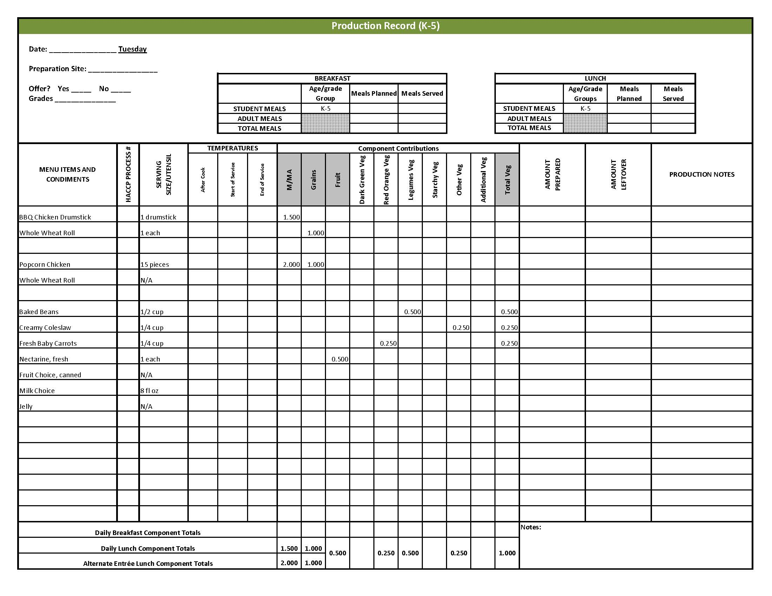

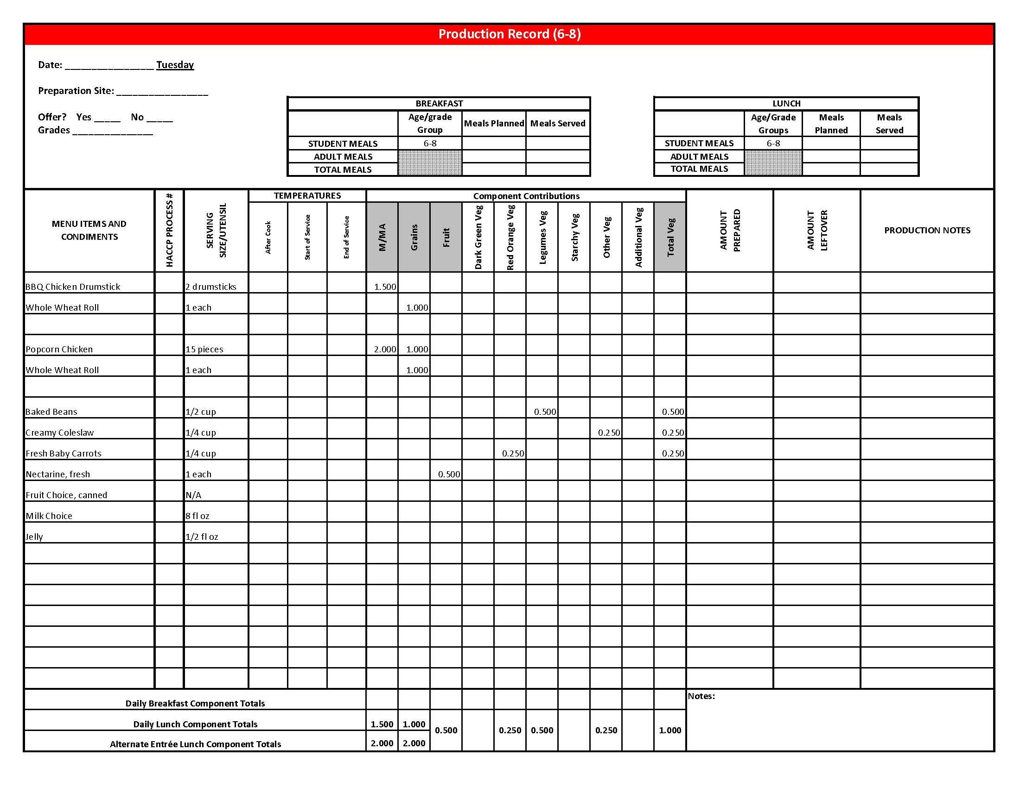

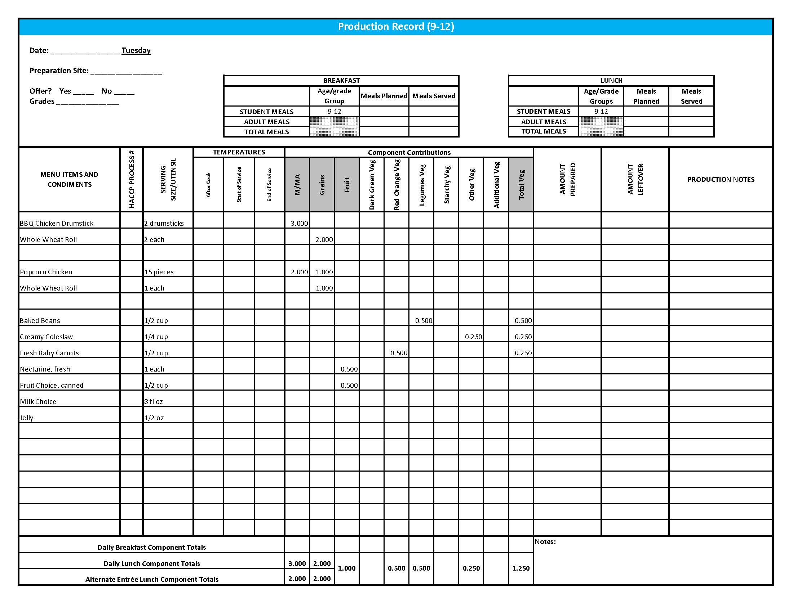

Purchasing, Preparation & Serving Instructions

Week 2 – Wednesday

|  |  |  |
| --- | --- | --- |
| **Menu Item** | **Purchasing & Preparation** | **Serving** |
| White Chicken Chili | * Prepare HKM Recipe 128, White Chicken Chili. * Refer to *Fruit & Vegetable Order Guide* for amount onions, great northern beans, and green chili peppers needed. * **CCP: Hold for hot service at 135⁰ F or higher.** | K-12: ¾ cup |
| Cornbread Muffins | * Prepare HKM Recipe 127, Cornbread Muffins. | K-8: 1 muffin  9-12: 2 muffins |
| **Alternate Entrée:**  Rock and Roll Beef Wraps | * Prepare HKM Recipe 133, Rock and Roll Beef Wraps. * Purchase 8” whole grain rich tortillas weighing 1.5 oz each. * **CCP: Hold for hot service at 135⁰ F or above.** | K-12: 1 wrap |
| Cherry Tomatoes | * Refer to *Fruit & Vegetable Order Guide* for amount needed. * With gloved hands, wash and stem tomatoes. * **CCP: Refrigerate and hold at 41⁰ F or below for cold service.** | K-9-12: 6 tomatoes (½ cup) |
| Cucumber Slices | * Refer to *Fruit & Vegetable Order Guide* for amount needed. * With gloved hands, wash and slice cucumbers. * **CCP: Refrigerate and hold at 41⁰ F or below for cold service.** | K-12: ¼ cup |
| Blueberries, Fresh | * Refer to *Fruit & Vegetable Order Guide* for amount needed. * With gloved hands, wash blueberries. * **CCP: Refrigerate and hold at 41⁰ F or below for cold service.** | K-12: ½ cup |
| Fruit Choice, canned | Select an additional fruit choice to offer on the menu. The serving(s) offered must credit as ½ cup of fruit, to meet the minimum daily requirement, for grades 9-12.  *Note: The fruit choice is encouraged for grades K-5 and 6-8, but not required. The fruit choice is not included in the nutrient analysis for grades K-5 and 6-8. | K-8: N/A*  9-12: ½ cup |

*Continued on next page*

Purchasing, Preparation & Serving Instructions

**Week 2 – Wednesday, continued**

|  |  |  |
| --- | --- | --- |
| Milk | * Provide a variety of milk. May be 1% fat (unflavored) or skim (flavored or unflavored). * **CCP: Refrigerate and hold at 41⁰ F or below for cold service.** | K-12: 8 fl oz |
| Ranch Dressing, Reduced Fat | * Purchase or prepare Ranch dressing containing no more than 6 gm of fat  per 1 fl oz. Purchase .8 gallons for every 100 1 fl oz portions. * **CCP: Refrigerate and serve at 41⁰ F or below if school-prepared dressing is served.** | K-12: 1 fl oz **or** 2 Tbsp |

**Pre-preparation for Week 2 – Thursday:** Chill peaches.

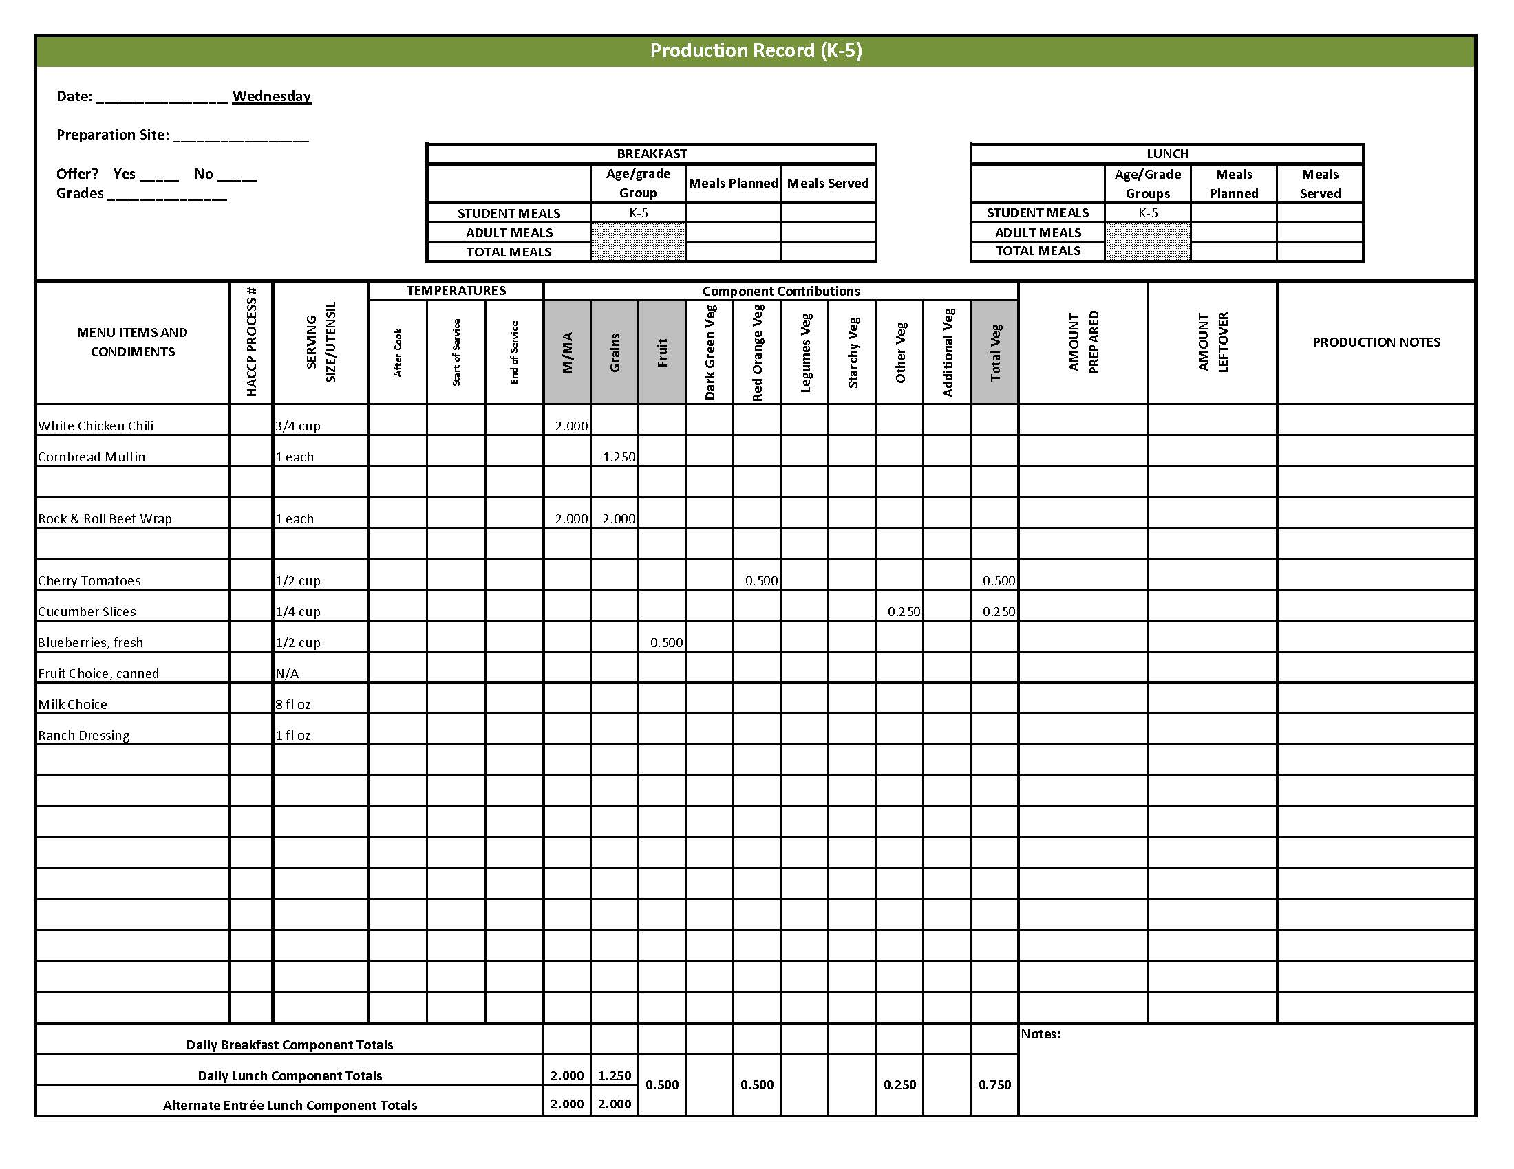

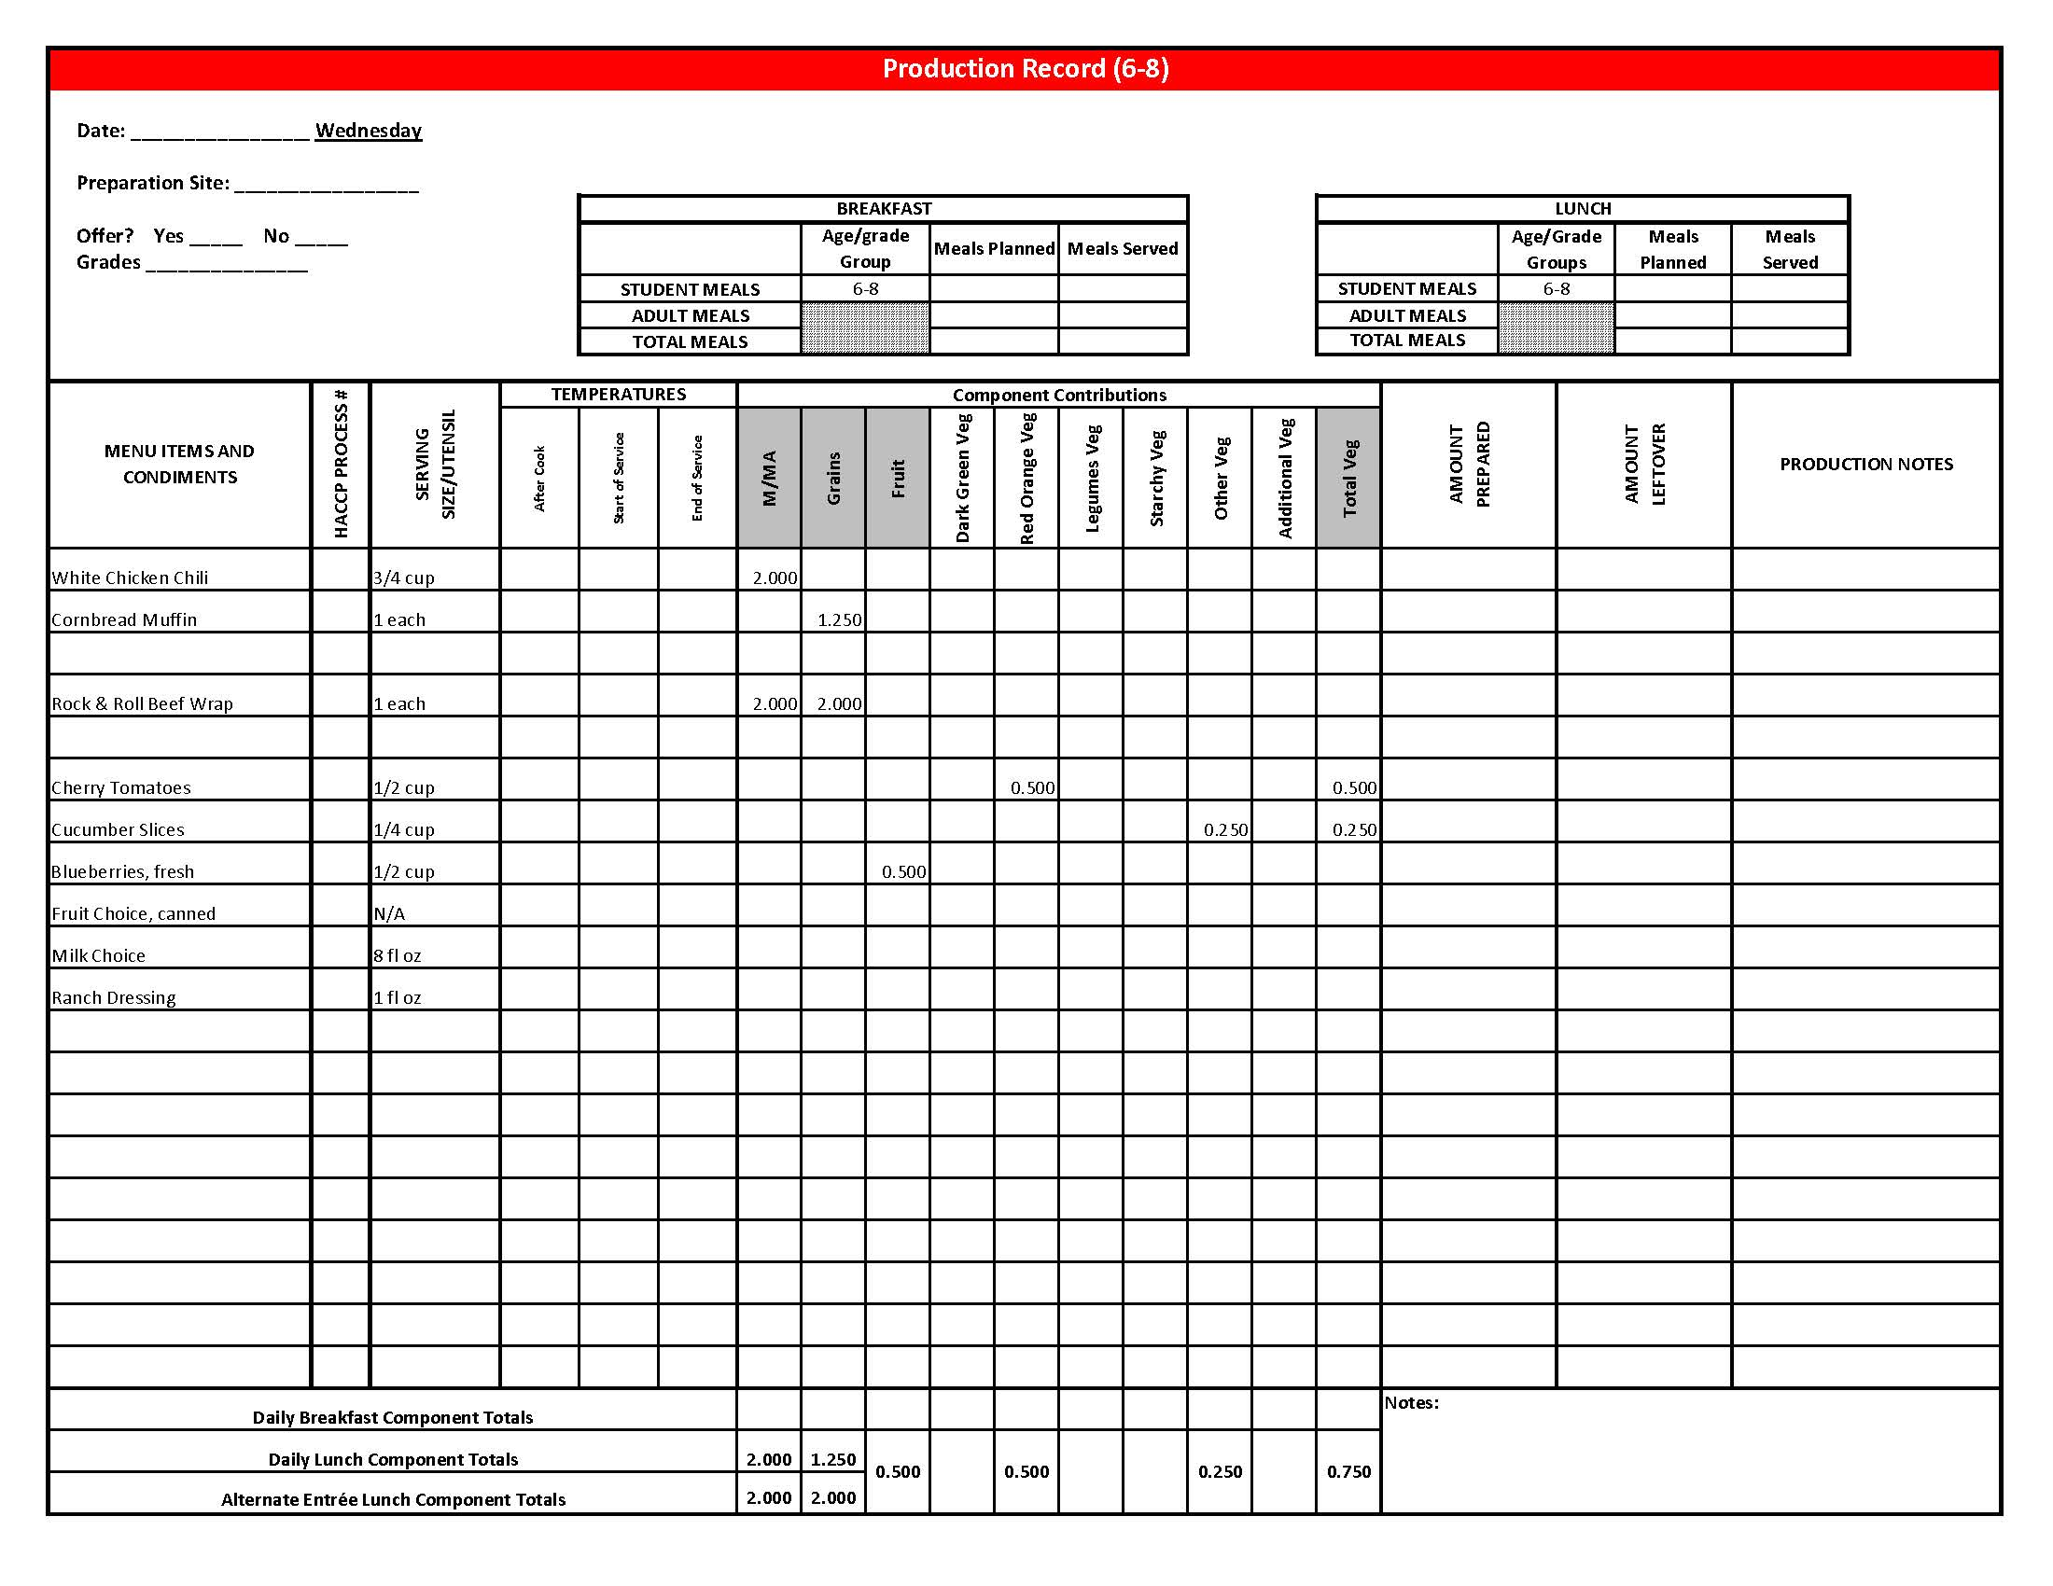

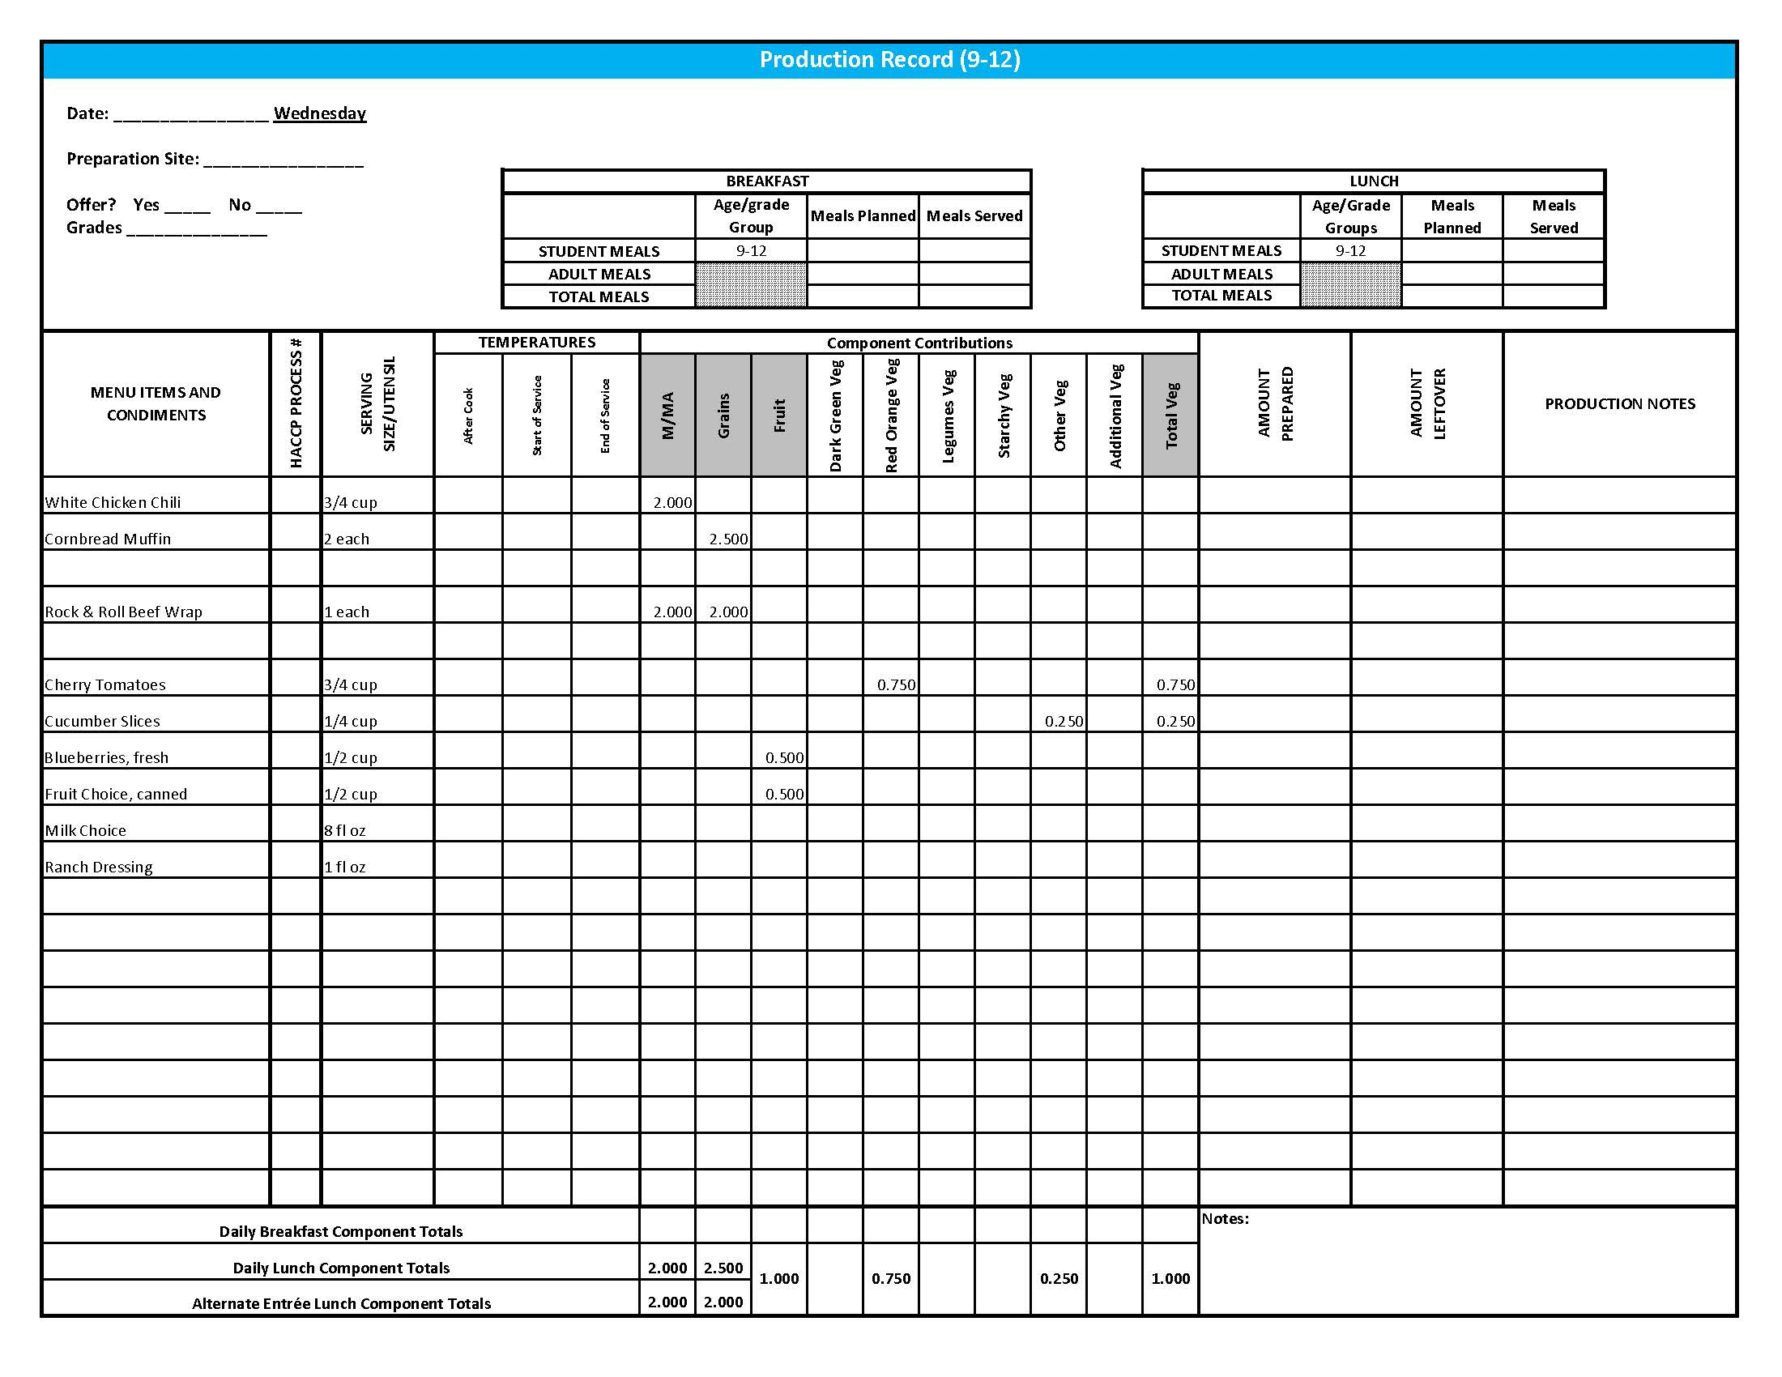

Purchasing, Preparation & Serving Instructions

Week 2 - Thursday

|  |  |  |
| --- | --- | --- |
| **Menu Item** | **Purchasing & Preparation** | **Serving** |
| Cheese Pizza | * Purchase pre-prepared cheese pizza that provides 2 oz equivalent M/MA and 2 oz equivalent Grains; no more than 8 gm of fat; and no more than 600 mg sodium per serving. If product is not Child Nutrition (CN) labeled, obtain a Product Formulation Statement. * Heat in oven according to manufacturer’s instructions. * **CCP: Hold for hot service at 135⁰ F or above.** | K-12: 1 piece |
| **Alternate Entrée:**  Grilled Chicken Sandwich | * Purchase pre-cooked, un-breaded chicken patties that provide 2 oz equivalent M/MA, no more than 3.5 gm of fat; and no more than 210 mg sodium per serving. If product is not Child Nutrition (CN) labeled, obtain a Product Formulation Statement. * Prepare according to manufacturer’s instructions. * Purchase a 2 oz whole wheat bun (first ingredient is whole wheat) or prepare following HKM Recipe 877, Whole Wheat Rolls, Bread Sticks, Buns, Hamburger Bun Variation. * **CCP: Hold for hot service at 135⁰ F or above.** | K-12: 1 each |
| Broccoli Florets | * Refer to *Fruit & Vegetable Order Guide* for amount needed. Purchase fresh broccoli florets, ready to serve. * Wash broccoli. * Cover and refrigerate until serving. * **CCP: Refrigerate and hold at 41⁰ F or below for cold service.** | K-12: ½ cup |
| Carrots, baby, fresh | * Refer to *Fruit & Vegetable Order Guide* for amount needed. * Handle with gloved hands or serving utensils. Cover and refrigerate until serving. * Weigh or count number needed per portion. * **CCP: Refrigerate and hold at 41⁰ F or below for cold service.** | K-12: ½ cup |
| Peaches, canned, sliced | * Purchase slices peaches packed in light syrup. Refer to *Fruit & Vegetable Order Guide* for amount needed. * Chill cans overnight. Wipe can tops clean before opening. Drain, cover, and refrigerate until serving. * Serve with slotted utensil. Level utensil when serving. * **CCP: Refrigerate and hold at 41⁰ F or below for cold service.** | K-12: ½ cup |

*Continued on next page*

Purchasing, Preparation & Serving Instructions

Week 2 – Thursday, continued

|  |  |  |
| --- | --- | --- |
| **Menu Item** | **Purchasing & Preparation** | **Serving** |
| Fruit Choice, fresh | Select an additional fruit choice to offer on the menu. The serving(s) offered must credit as ½ cup of fruit, to meet the minimum daily requirement, for grades 9-12.  *Note: The fruit choice is encouraged for grades K-5 and 6-8, but not required. The fruit choice is not included in the nutrient analysis for grades K-5 and 6-8. | K-8: N/A*  9-12: ½ cup |
| Milk | * Provide a variety of milk. May be 1% fat (unflavored) or skim (flavored or unflavored). * **CCP: Refrigerate and hold at 41⁰ F or below for cold service.** | K-12: 8 fl oz |
| Ranch Dressing, Reduced Fat | * Purchase or prepare Ranch dressing containing no more than 6 gm of fat  per 1 fl oz. Purchase .8 gallons for every 100 1 fl oz portions. * **CCP: Refrigerate and serve at 41⁰ F or below if school-prepared dressing is served.** | K-12: 1 fl oz **or** 2 Tbsp |
| Ketchup | * Purchase in bulk or individual packets (9-gm or 12-gm). If bulk, purchase 1 #10 can or .8 gallon for every 100 1-fluid oz servings. | K-12: 1 fl oz  **or** 2 Tbsp **or** 2 PC |
| Mustard | * Purchase bulk or packets. If bulk, purchase 2 cups for every 100 1 tsp servings. | K-12: 1 tsp |

**Pre-preparation for Week 2 - Friday:** Thaw sausage under refrigeration.

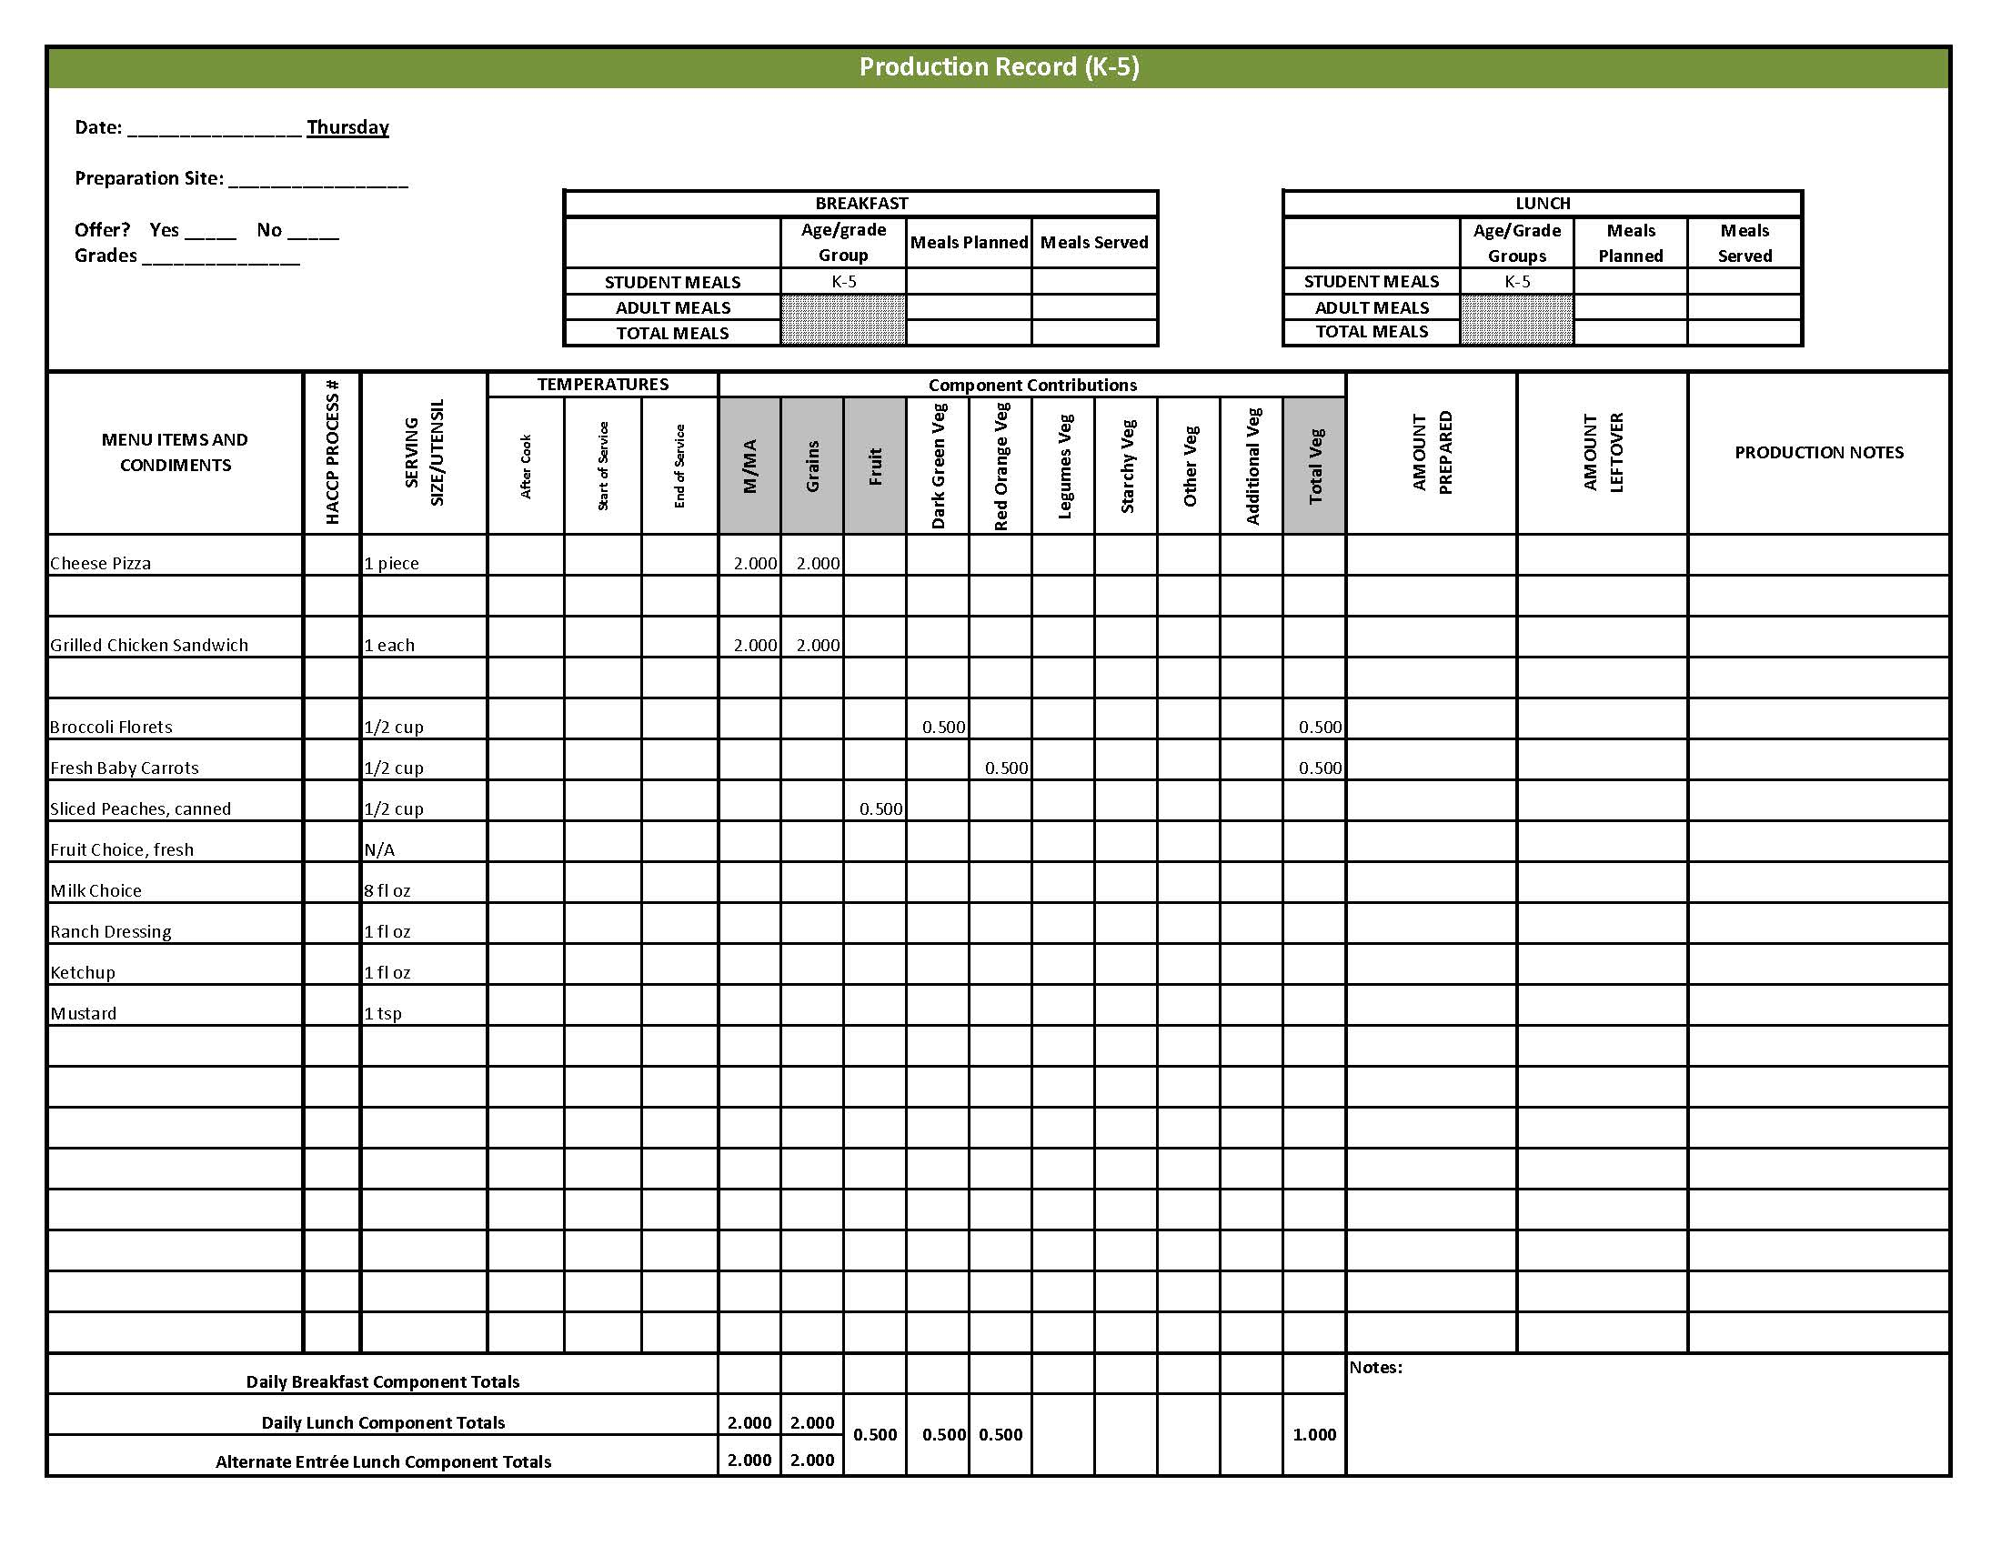

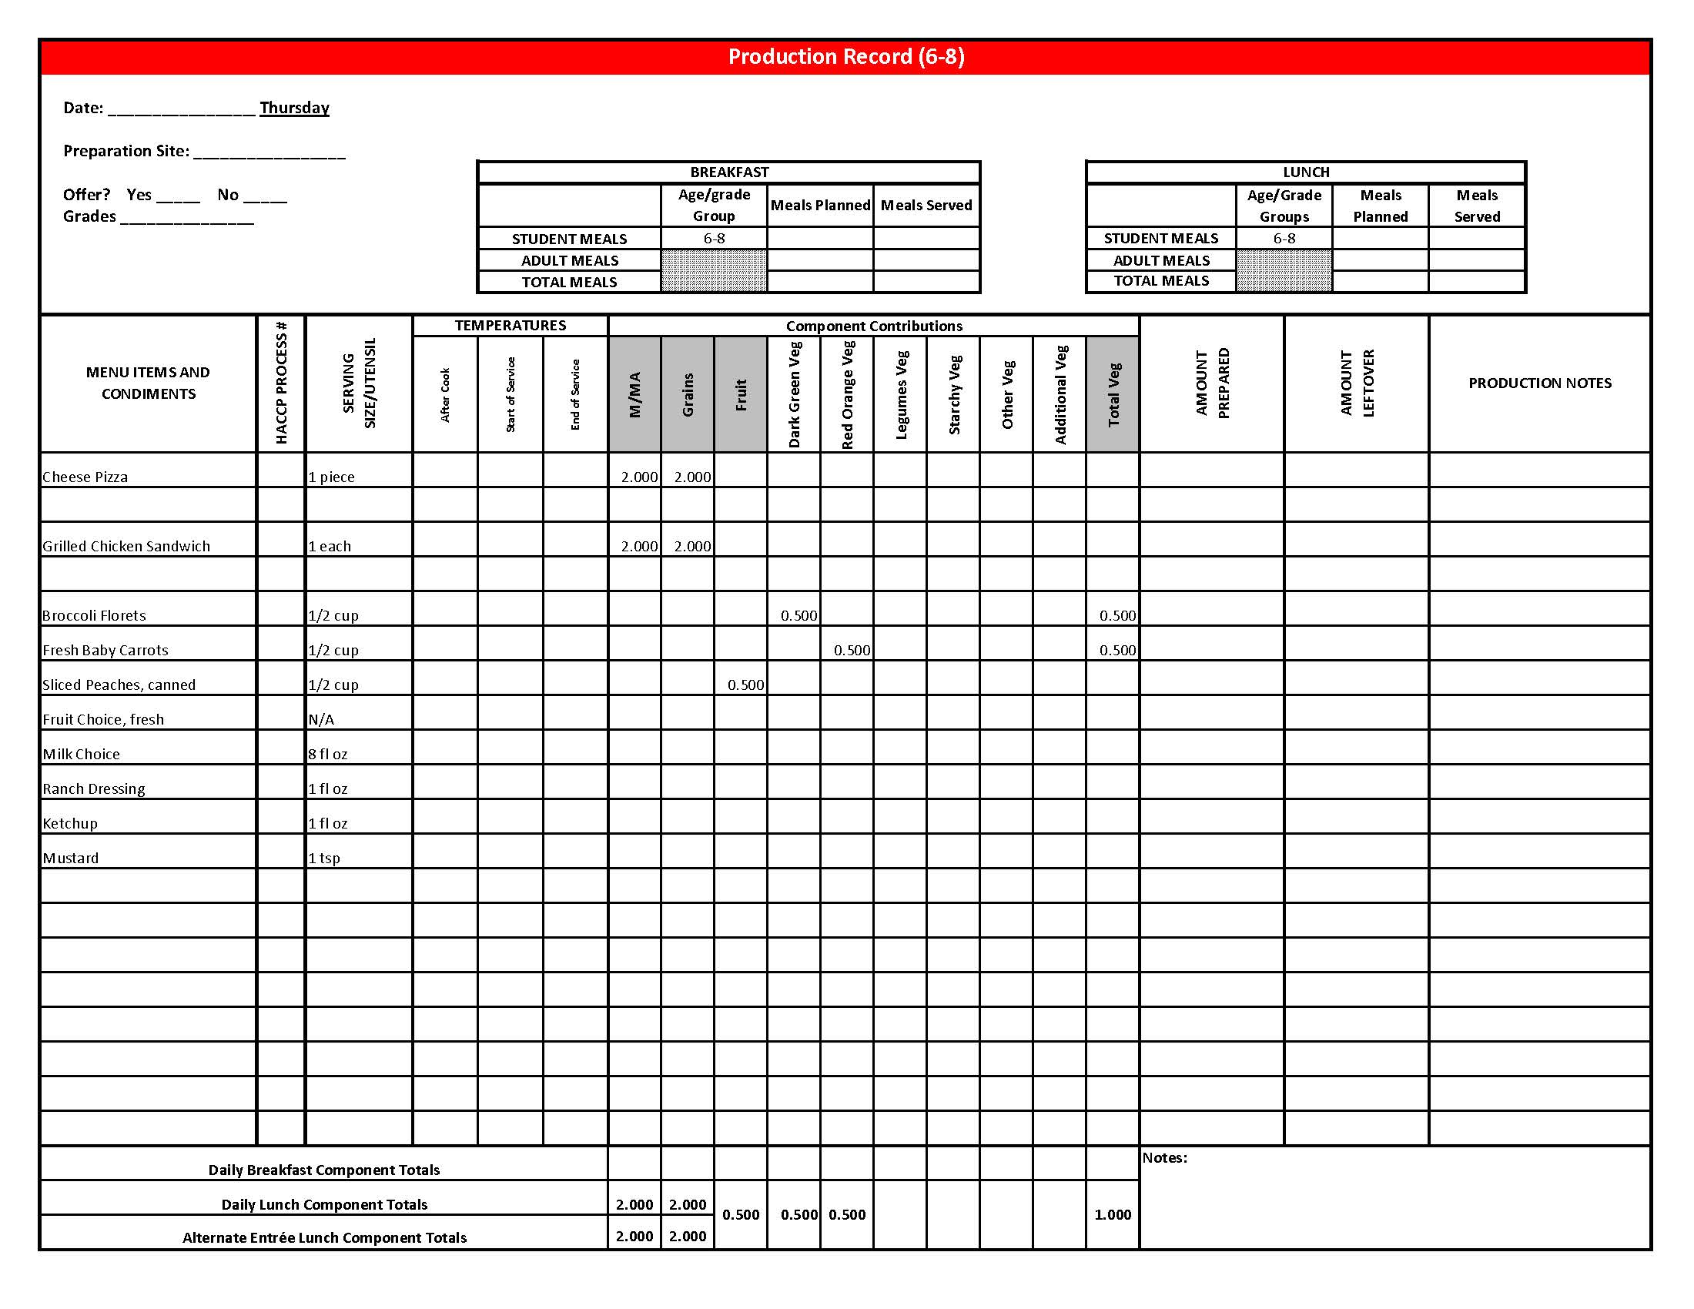

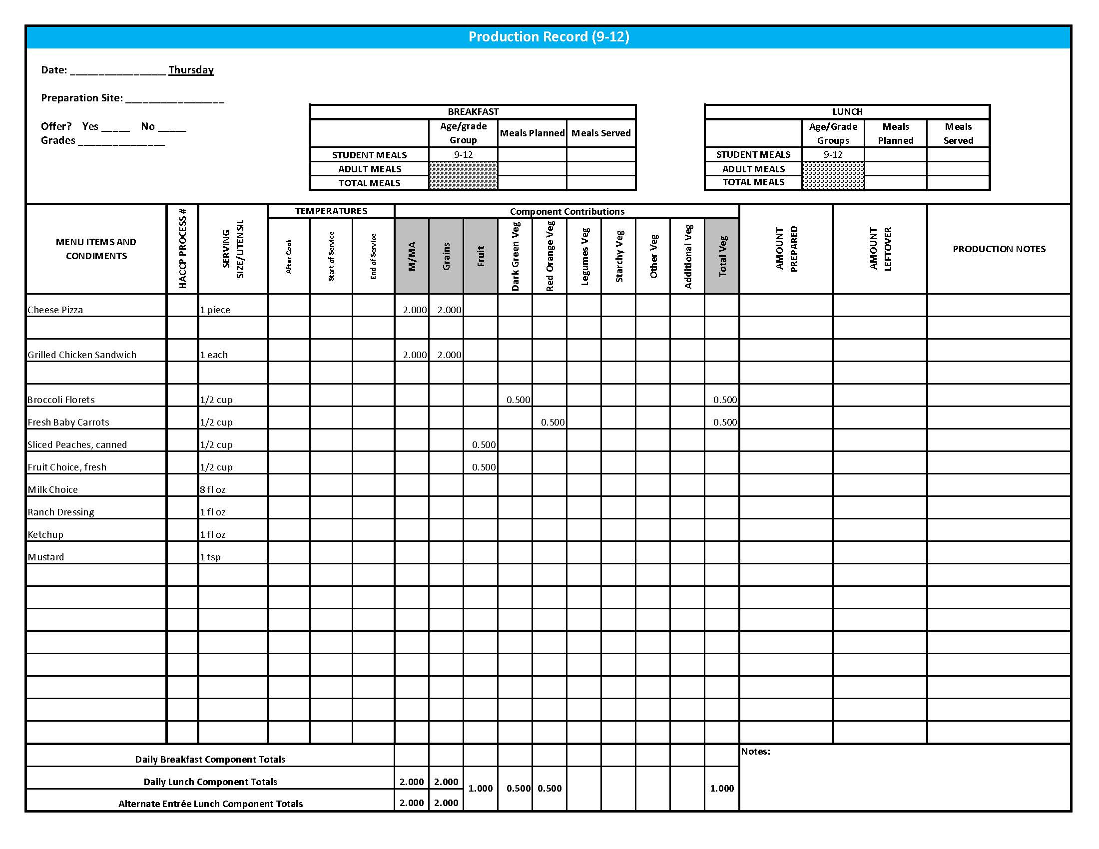

Purchasing, Preparation & Serving Instructions

Week 2 – Friday

|  |  |  |
| --- | --- | --- |
| **Menu Item** | **Purchasing & Preparation** | **Serving** |
| Biscuits & Sausage Gravy | * Prepare HKM Recipe 118, Biscuits and Sausage Gravy. * If purchasing biscuits, purchase whole grain rich biscuit that provides 2 oz equivalent Grains. * If preparing biscuits, prepare HKM Recipe 120, Angel Biscuits. * **CCP: Hold gravy for hot service at 135⁰ F or above.** | Biscuits  K-12: 1 biscuit  Gravy  K-12: 3 oz |
| Sausage Patty, turkey | * Purchase pre-cooked turkey sausage patties where 1 serving provides 1 oz equivalent M/MA, contains no more than 360 mg of sodium and no more than 8 grams of fat. If product is not Child Nutrition (CN) labeled, obtain a Product Formulation Statement. * Heat according to manufacturer’s instructions. * **CCP: Hold for hot service at 135⁰ F or above.** | K-5: N/A  6-12: 1 each |
| **Alternate Entrée:**  Pepperoni Pizza | * Purchase pre-prepared pepperoni pizza that provides 2 oz equivalent M/MA and 2 oz equivalent Grains; no more than 9 gm of fat; and no more than 600 mg sodium per serving. If product is not Child Nutrition (CN) labeled, obtain a Product Formulation Statement. * Heat in oven according to manufacturer’s instructions. * **CCP: Hold for hot service at 135⁰ F or above.** | K-12: 1 piece |
| Hash Brown Patty | * Purchase 2.25 oz hash brown patties. * Refer to *Fruit & Vegetable Order Guide* for amount needed. * Follow manufacturer’s directions for baking and holding. Batch cook. * **CCP: Hold for hot service at 135⁰ F or above.** | K-8: 1 patty  9-12: 2 patties |
| Sugar Snap Peas, fresh | * Refer to *Fruit & Vegetable Order Guide* for amount needed. * Handle with gloved hands or serving utensils. Cover and refrigerate until serving. * Weigh or count number needed per portion. * **CCP: Refrigerate and hold at 41⁰ F or below for cold service.** | K-12: ½ cup |

*Continued on next page*

Purchasing, Preparation & Serving Instructions

Week 2 – Friday, continued

|  |  |  |
| --- | --- | --- |
| **Menu Item** | **Purchasing & Preparation** | **Serving** |
| Strawberries, fresh | * Refer to *Fruit & Vegetable Order Guide* for amount needed. * With gloved hands, wash strawberries. * **CCP: Refrigerate and hold at 41⁰ F or below for cold service** | K-12: ½ cup |
| Fruit Choice, canned | Select an additional fruit choice to offer on the menu. The serving(s) offered must credit as ½ cup of fruit, to meet the minimum daily requirement, for grades 9-12.  *Note: The fruit choice is encouraged for grades K-5 and 6-8, but not required. The fruit choice is not included in the nutrient analysis for grades K-5 and 6-8. | K-8: N/A*  9-12: ½ cup |
| Milk | * Provide a variety of milk. May be 1% fat (unflavored) or skim (flavored or unflavored). * **CCP: Refrigerate and hold at 41⁰ F or below for cold service.** | K-12: 8 fl oz |

**Pre-preparation for Week 3 - Monday:** None

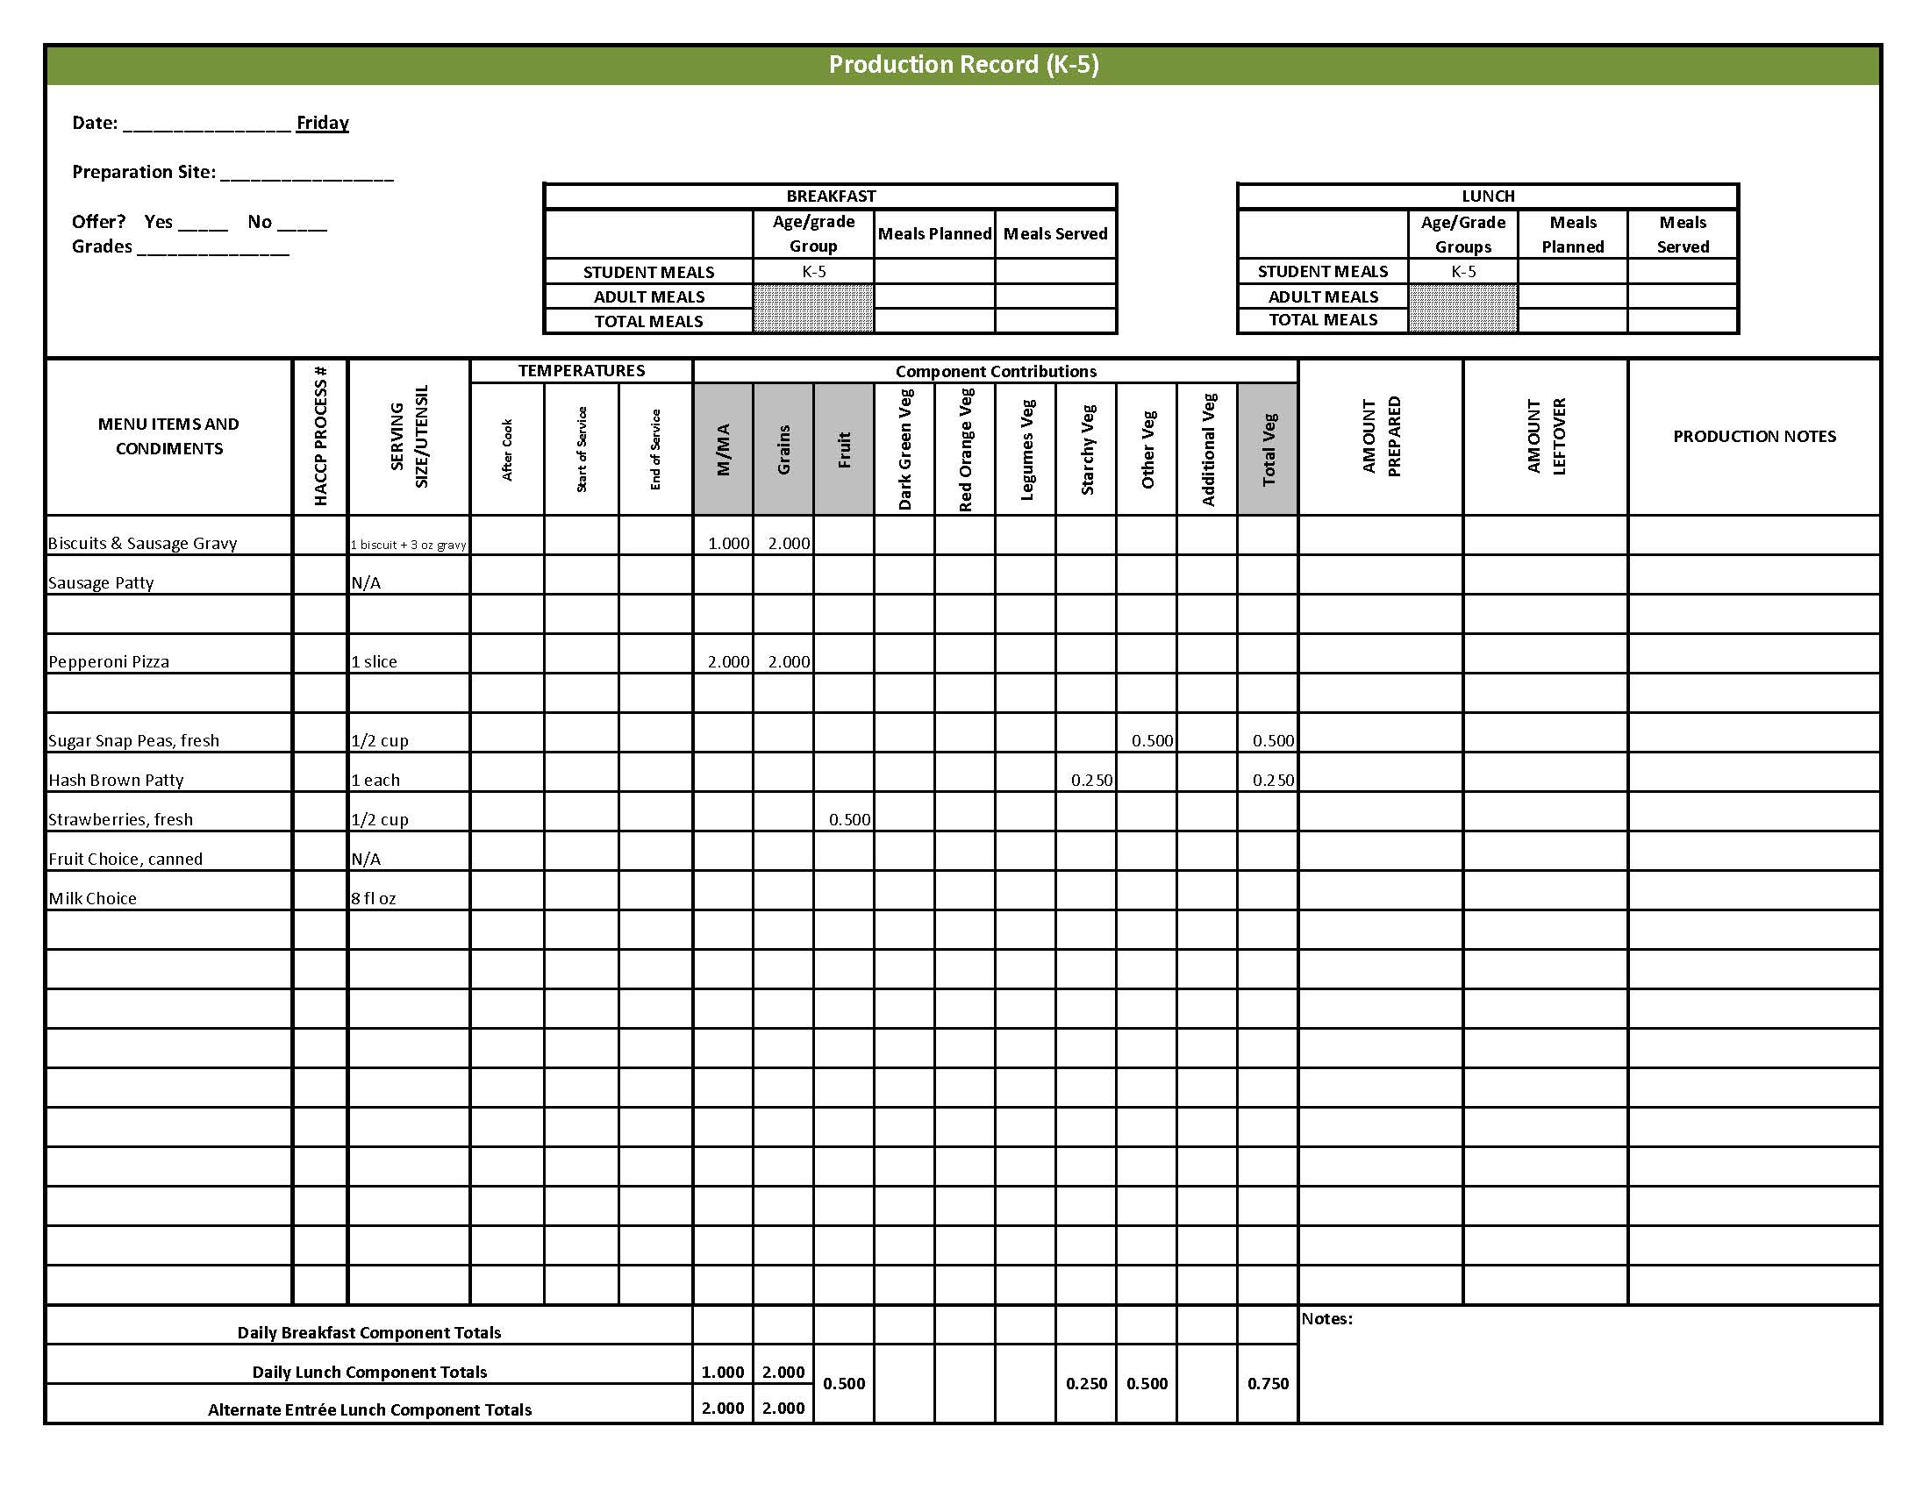

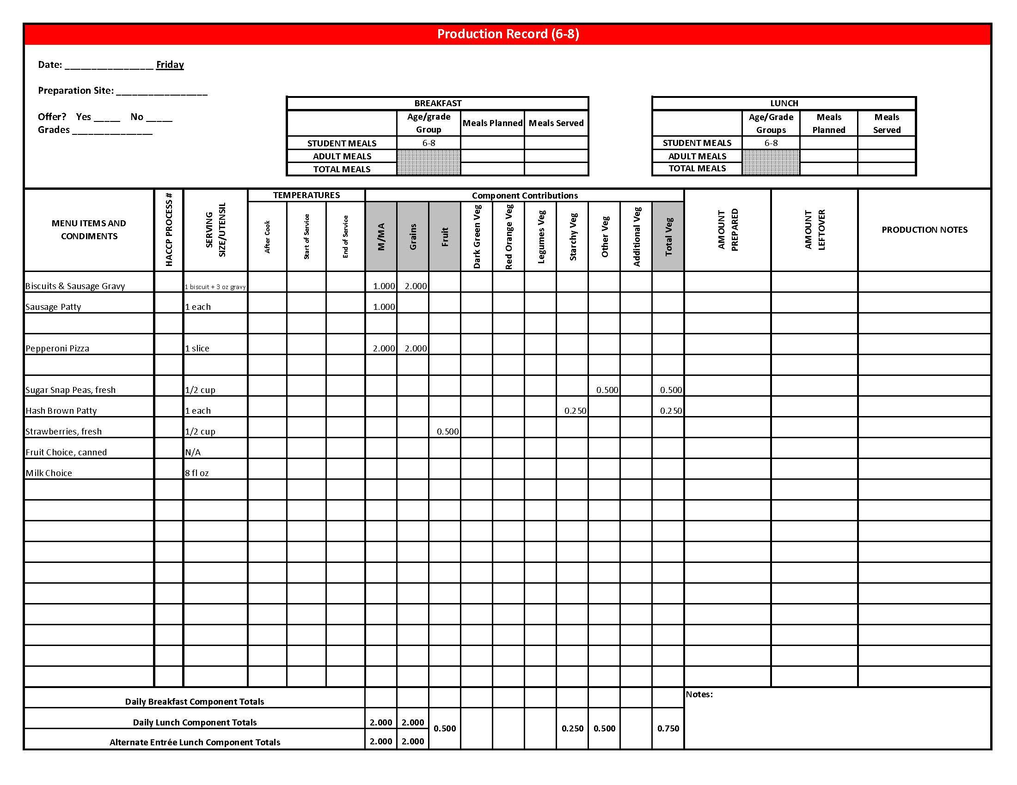

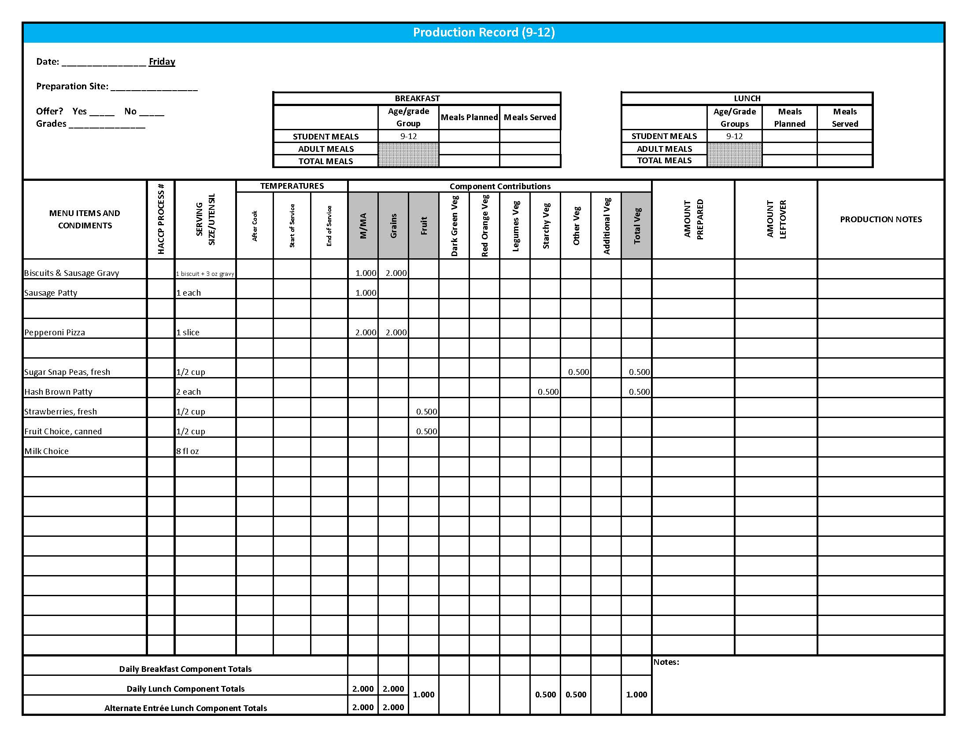

Fruit & Vegetable Order Guide

**Week 2**

The chart below provides amounts to be ordered per 100 servings based on the serving sizes listed on Week 1 of *Healthier Kansas Menus Production Records* for students in grades groups K-5, 6-8, and 9-12. Amounts to order are based on standard yields and leveled serving utensils or weighed portions. Use the following procedures to determine the amounts to order:

1. **Forecast** the number of servings needed for each fruit and vegetable menu item for each grade group served.
2. **Divide** the number of servings needed by 100 for each portion size (K-5, 6-8 or 9-12).
3. **Multiply** the “Amount to order per 100 servings” by the factor determined in step 2 above for each portion size.
4. **Add** amounts needed for all serving sizes together to determine the amounts to order.

**Abbreviations Key: EP = Edible Portion AP = As Purchased lb = Pound oz = ounce # = Number**

|  |  |  |  |  |  |  |  |
| --- | --- | --- | --- | --- | --- | --- | --- |
| **Day** | **Fruit or Vegetable** | **K-5**  **Portion Size** | **K-5**  **Amount to Order per 100 Servings** | **6-8**  **Portion Size** | **6-8**  **Amount to Order**  **per 100 Servings** | **9-12 Portion Size** | **9-12 Amount to Order per 100 Servings** |
| Monday | Spaghetti Sauce, canned |  | 2.1 #10 cans |  | 2.1 #10 cans |  | 2.1 #10 cans |
| Potato Wedges, IQF, frozen | ½ cup | 17 lb | ½ cup | 17 lb | ½ cup | 17 lb |
| Tossed Salad | 1 cup |  | 1 cup |  | 1 cup |  |
| Spinach, fresh, trimmed, AP |  | 7 lb |  | 7 lb |  | 7 lb |
| Romaine Lettuce, AP | 7 lb | 7 lb | 7 lb |
| Apples, fresh, #125-138, AP | ½ apple | 13 lb 10 oz  or 50 each | ½ apple | 13 lb 10 oz  or 50 each | ½ apple | 13 lb 10 oz  or 50 each |
| Tuesday | Baked Beans | ½ cup |  | ½ cup |  | ½ cup |  |
| Beans, baked, canned, vegetarian |  | 4.25 #10 cans |  | 4.25 #10 cans |  | 4.25 #10 cans |
| Tomato Sauce, canned | 6 cups | 6 cups | 6 cups |
| Carrots, baby, fresh, EP | ¼ cup | 7 lb 13 oz | ¼ cup | 7 lb 13 oz | ¼ cup | 7 lb 13 oz |
| Creamy Cole Slaw | ¼ cup |  | ¼ cup |  | ¼ cup |  |
| Cabbage, fresh, green, shredded ready to use |  | 6 lb |  | 6 lb |  | 6 lb |
| Carrots, fresh, AP |  | 12 oz |  | 12 oz |  | 12 oz |
| Nectarines, fresh | 1 nectarine | 45 lb 10 oz | 1 nectarine | 45 lb 10 oz | 1 nectarine | 45 lb 10 oz |

Fruit & Vegetable Order Guide

**Week 2,** continued

|  |  |  |  |  |  |  |  |
| --- | --- | --- | --- | --- | --- | --- | --- |
| **Day** | **Fruit or Vegetable** | **K-5**  **Portion Size** | **K-5**  **Amount to Order per 100 Servings** | **6-8**  **Portion Size** | **6-8**  **Amount to Order**  **per 100 Servings** | **9-12 Portion Size** | **9-12 Amount to Order per 100 Servings** |
| Wednesday | White Chicken Chili | ¾ cup |  | ¾ cup |  | ¾ cup |  |
| Onions, yellow, AP |  | 3 lb 8 oz |  | 4 lb |  | 4 lb |
| Great Northern Beans, canned, low sodium | 3.25 #10 cans | 3.25 #10 cans | 3.25 #10 cans |
| Green Chili Peppers, canned, diced | 15 oz | 15 oz | 15 oz |
| Tomatoes, cherry, AP | 6 tomatoes | 16 lb 10 oz | 6 tomatoes | 16 lb 10 oz | 6 tomatoes | 16 lb 10 oz |
| Cucumber, fresh, AP | ¼ cup | 8 lb 2 oz | ¼ cup | 8 lb 2 oz | ¼ cup | 8 lb 2 oz |
| Blueberries, fresh | ½ cup | 23 lb 13 oz | ½ cup | 23 lb 13 oz | ½ cup | 23 lb 13 oz |
| Thursday | Broccoli, florets, fresh, EP | ½ cup | 7 lb | ½ cup | 7 lb | ½ cup | 7 lb |
| Carrots, baby, fresh, EP | ½ cup | 15 lb 10 oz | ½ cup | 15 lb 10 oz | ½ cup | 15 lb 10 oz |
| Peaches, cling, sliced, canned in 100% juice or light syrup | ½ cup | 5.6 #10 cans | ½ cup | 5.6 #10 cans | ½ cup | 5.6 #10 cans |
| Friday | Hash Brown Patties, frozen, 2.25 oz each | 1 each | 14 lb 1 oz  or 100 each | 1 each | 14 lb 1 oz  or 100 each | 2 each | 28 lb 2 oz  or 200 each |
| Sugar Snap Peas, fresh | ½ cup | 20 lb 10 oz | ½ cup | 20 lb 10 oz | ½ cup | 20 lb 10 oz |
| Strawberries, fresh, whole, AP | ½ cup | 19 lb 4 oz | ½ cup | 19 lb 4 oz | ½ cup | 19 lb 4 oz |