Turnip

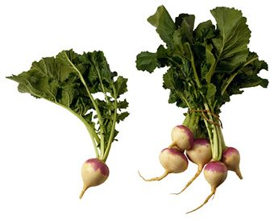
Available fresh from Kansas:
- August through November

Nutrition Information:
- Roots are a good source of vitamin C.
- Greens (leaves) are a good source of Vitamin A, folate, Vitamin C, Vitamin K, and Calcium

Origin:
- Native to Europe.
- Very important to ancient Romans.
- Has been used as a vegetable for human consumption since prehistoric times.
- Was brought to America in 1541 and planted in Canada. Was planted in Virginia by the colonists in 1609.

Did you know turnips:
- are part of a saying, “I didn’t just fall off the turnip truck!” When someone says that, they are letting someone know that they are not uninformed and gullible.
- are a root vegetable like carrots and beets? Both the root and the leaves at the top can be eaten. The turnip greens are much more nutrient dense than the roots.
- were once believed by Persians to be able to treat the common cold?
- were used to make the first jack-o-lanterns? This was an Irish tradition and pumpkins did not start to be carved until that tradition came to America.
- come in all shapes and colors, from round to cylindrical and pink to black?

Beet Humor:
- Knock Knock
Who’s There?
Turnip!
Turnip who?
Turnip the heat, it’s cold in here!

Turnip Activity:
- How many words can you make using the letters in the word TURNIP?

Answers: 27 - Input, Print, Pint, Punt, Ruin, Runt, Trip, Turn, Unit, Nip, Nit, Nut, Pin, Pit, Pun, Put, Rip, Run, Rut, Tin, Tip, Urn, In, It, Nu, Pi, Up

