Native American Tortillas in a Bag
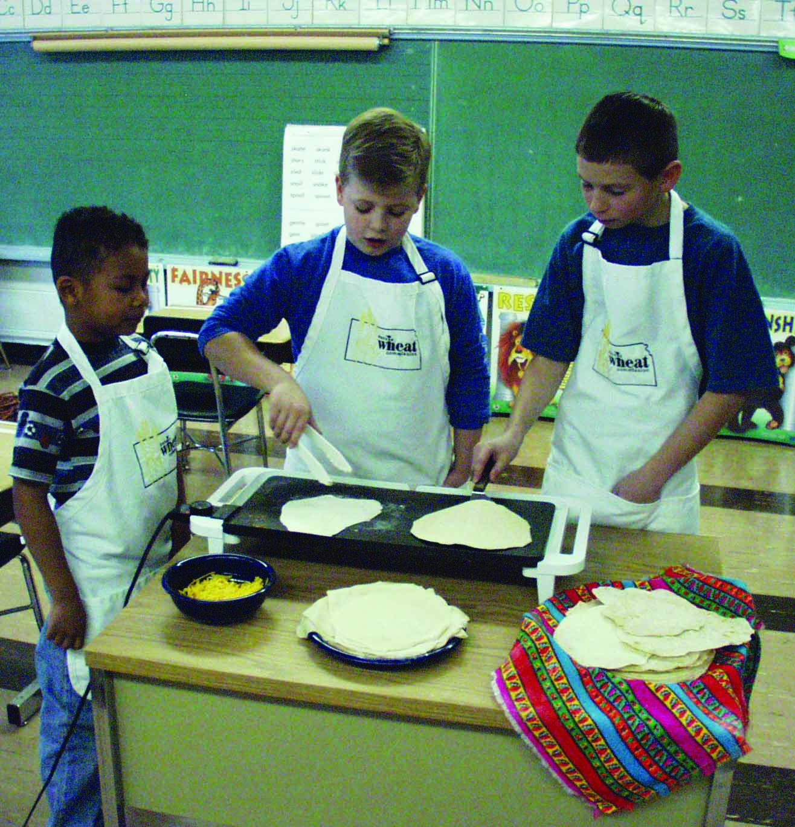
1 1/2 cups all-purpose flour*
1 teaspoon baking powder
1/2 teaspoon salt
2 tablespoons shortening
1/2 cup hot water
In a large self-locking plastic bag, combine flour, baking powder and salt. Close bag and shake to mix. Add shortening and work into flour until fine particles form. Add the hot water and knead the dough in the bag until it forms a ball.
Remove dough from bag and place on a lightly floured work surface; knead 15 strokes. Divide into six equal pieces; shape into balls. Cover; let rest 15 minutes.
On a lightly floured surface, roll each piece as thin as possible. Roll from the center out, turning several times to form an 8-inch circle.
Heat an ungreased griddle or skillet over medium heat. Cook until the surface begins to bubble and the under side is speckled golden-brown, about 15-20 seconds. Cook other side. Stack tortillas under a cloth as they are done and serve warm. Makes 6 tortillas.
*Variations: Use 1/2 cup corn meal and 1 cup all-purpose flour, or use 3/4 cup whole wheat flour and 3/4 cup all-purpose flour.
Quick Meal Idea: Lightly brush cooked tortillas with oil. Bake tortillas on baking sheets in a 400 degrees F oven 4 minutes. Top with browned ground beef or pork, black beans, onion, chopped tomato, shredded mozzarella cheese and Parmesan cheese. Season with dried oregano leaves. Return to the oven; heat 10 minutes or until cheese is melted.
Nutrition Information: One tortilla provides 150 calories, 4.5 g total fat, 0 mg cholesterol, 230 mg sodium, 24 g total carbohydrate, .5 g dietary fiber, 3 g protein.

Posted on Kansas Wheat Commission website.

